**Paljoussanat 1**

little / a little / few / a few / many / much / more / most / most of

We had a party the other night. At midnight there were only 1) __________ people left, 2) _______________ had gone home. There was 3) __________________ wine left, the guests had drunk 4) _______________ it. 5) ______________ people had anything to eat. Perhaps they had already eaten. How 6) _______________ people came to your party? Quite 7) ____________________ . We had invited even 8) ____________________. How 9)______________________ money did you spend? – Not a lot. I don’t have 10) ____________________ money to spend on parties.

**Paljoussanat 2**

a lot of / a lot / little / a little / less / the least / few / a few/ fewer / the fewest / many / much / more / the most

1. My grandmother gave me _______________________ money.
2. Are there any people here? No, only ____________________
3. Is there any tea left in the pot? Just _____________________
4. How _______________________ tourists visit Finland annually? - ______________ in summer but not

___________________________ in winter.

1. How _______________________ time do you have? – Not ________________ ; tomorrow I will have

___________________________ though.

1. I’m lucky to have _______________________ friends, not too ___________________, though.
2. _____________________ people visited me on my birthday. I wonder where everyone was?
3. I’ve got __________________ money. I don’t need to borrow any.
4. He had __________________ money. He couldn’t afford to buy a new pair of shoes.
5. There are _____________________ people in Jyväskylä, _______________ in Turku, but ___________________ people live in Helsinki.
6. _____________________ time is spent watching TV, ________________ on outdoor activities but _____________________ is spent sleeping.
7. The situation is serious. There are _____________________ rivers in Europe which are not polluted.
8. The country with _____________________ people per square kilometer must be Finland.
9. Scientists have _______________________ hope of finding a cure for cancer before the year 2010.
10. She had ______________________ time to study than Paul but had _________________ points in the test.
11. Give that girl ____________________ opportunity and she will start to spread rumours.
12. There were too __________________ people at the concert – we couldn’t see the band.
13. There were _____________________ at the concert.
14. There’s not so ___________________ work to do this week.
15. I’ve got ________________________ work this week.

**Paljoussanat 3**

Humans and their factories take up 1) ___________________ (paljon) space in the biosphere. 2) ___________________________ (kuinka paljon kauemmin) can we keep on expanding our share at the expense of that of other species? No one knows what the future holds, but at present it seems painfully obvious that there are 3) ____________________________ (liian paljon) inhabitants on our planet. Although the population explosion is a major problem, there are also 4) _____________________________ (melko paljon) other reasons why the current situation is alarming. One of them is our Western lifestyle which consumes 5) __________________________ (niin paljon) energy that it makes 6) ___________________________ (aivan liian paljon) demands on our limited resources. A single nuclear family in Los Angeles consumes 7) ______________________ (paljon) if it has two or more cars, a swimming pool and a meat-based diet. In a developing country, it takes 8) _____________________ (suuri määrä) people, perhaps an entire village , to make the same demands on the ecological resources. Therefore, although our earth has 9) ___________________ (paljon) problems, we shouldn’t put the blame on others. How can we ask poor peasant farmers in Brazil to safeguard rainforests, when they don’t have access to half as 10) _______________________ (useat) natural resources as we do?

**Paljoussanat 4**

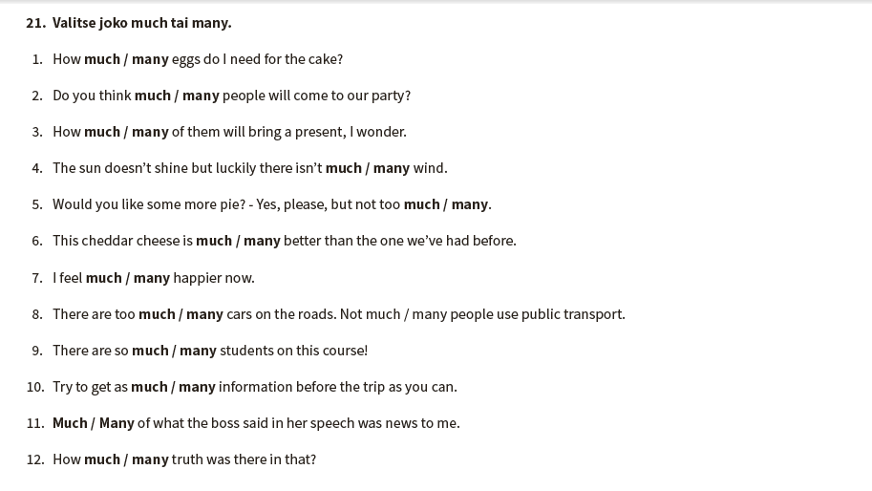

**Paljoussanat 5**

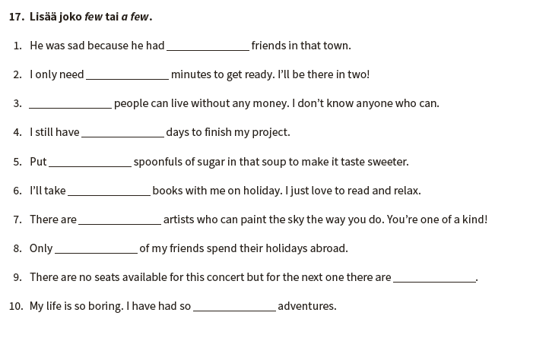

**Paljoussanat 6**

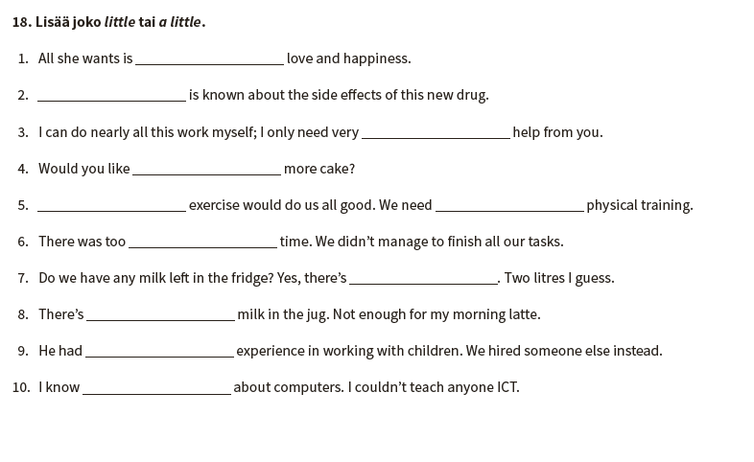

**Paljoussanat 7**

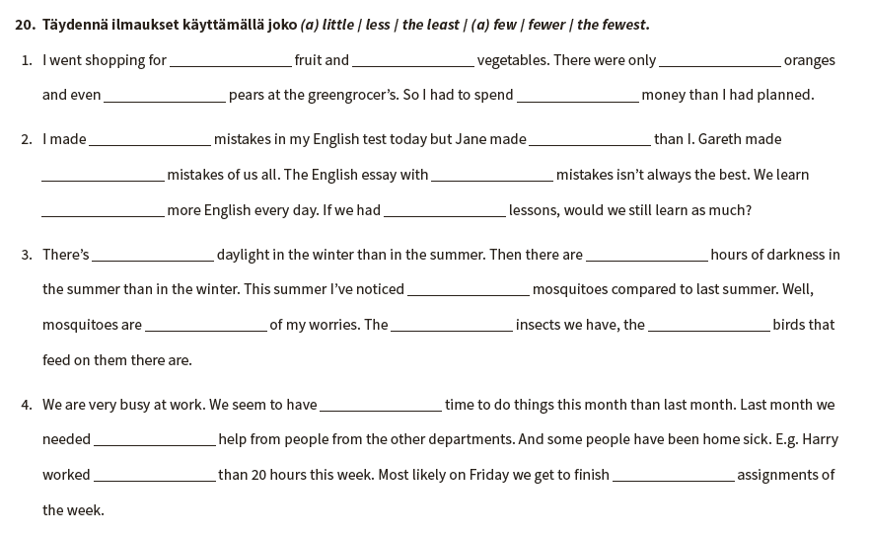

**Paljoussanat 1**

1. a few
2. most
3. little
4. most of
5. few
6. many
7. a few
8. more
9. much
10. much

**Paljoussanat 2**

1. a lot of
2. a few
3. a little
4. many / a lot / many
5. much / much / more tai a lot
6. a lot of tai few /many
7. few
8. a lot of tai a little
9. little
10. many / more / the most
11. a lot of / less tai more / the most
12. few
13. the fewest
14. little
15. more tai less / fewer tai more
16. the least
17. many
18. a lot of
19. much
20. a lot of / a little / little

**Paljoussanat 3**

1. a lot of/lots of/a great deal of
2. how much longer
3. too many
4. quite a few
5. so much
6. far too many
7. a lot
8. a large number of
9. a lot of / lots of / a great deal of
10. many

**Paljoussanat 4**

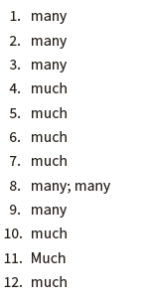

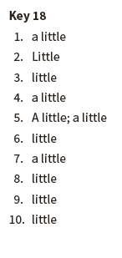

**Paljoussanat 6**

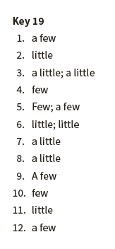

**Paljoussanat 7**

