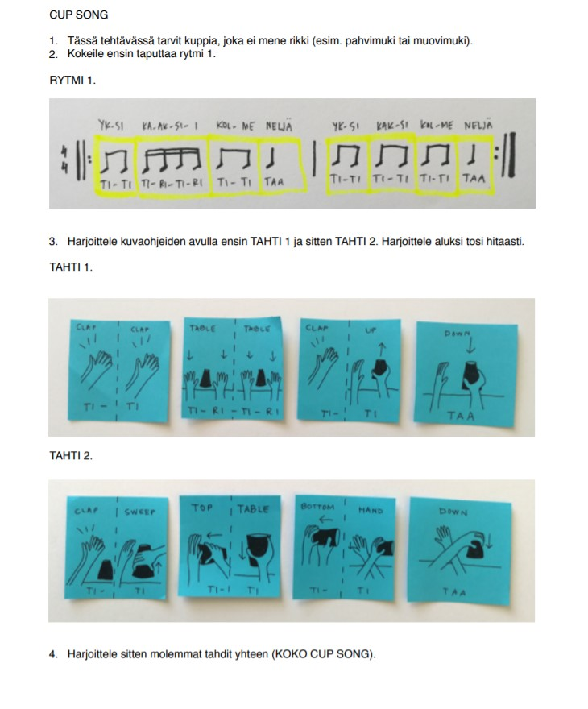
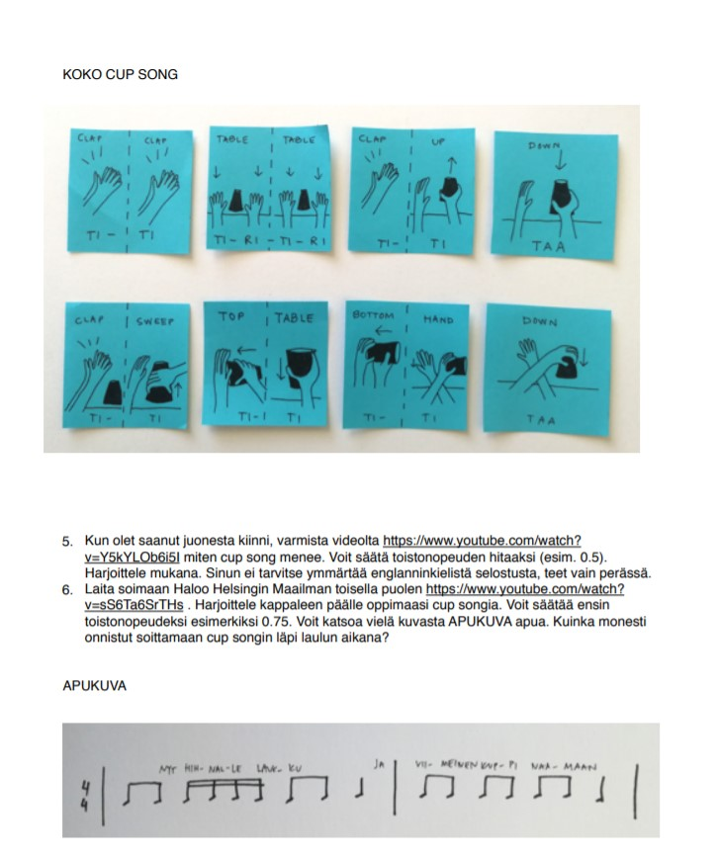

Linkki: https://www.youtube.com/watch?v=Y5kYLOb6i5I

