Peda.net introduction letter for guardians

Kerava Department of Education and Teaching

Dear guardian,

”Hi Mom and Dad, would you like to hear what I learned in kindergarten?”
Do you feel as a parent that your child never says those magical words? Or tell you what he or she has done in kindergarten even when you ask? Not to mention what he or she has learned? The situation is familiar to many parents. As parents, we want to be informed of what is done and learned in day care, but sometimes it is difficult for the child to talk about the events of the day or the week at home.
The digital portfolio highlights everyday pedagogy, the child's interests and learning. In the city of Kerava's early childhood education, digital portfolios are used in all units to support the development of a pedagogical operating culture. The idea of a digital portfolio is based on growth folders, which are widely used in early childhood education to make a child's experiences, development and learning visible. The digital portfolio combines home and early childhood environments and increases the opportunities for parents to participate in their children's day-to-day activities in kindergarten.
We are happy to invite you to collaborate, as guardians play an important role in working on digital portfolios; you can bring us information through pictures and videos from home. You can get more information about digital portfolios from the Peda.net online service and from the kindergarten staff. You will receive instructions from the staff on how to create a Peda.net username and a publication permission form.
Once you have read the material, returned the publication permission to the daycare staff and created the username for Peda.net, we will be ready to start!
If you have any questions or need support, contact the adults in your child's group. They know how to guide you and, if necessary, they are in contact with Peda.Net managers.

Best regards,

Happy regards,
Firstname Lastname
Day Care Center Director
XXXXXX Day Care Center
tel. XXXXXXXX

Guardians’ peda.net process instructions

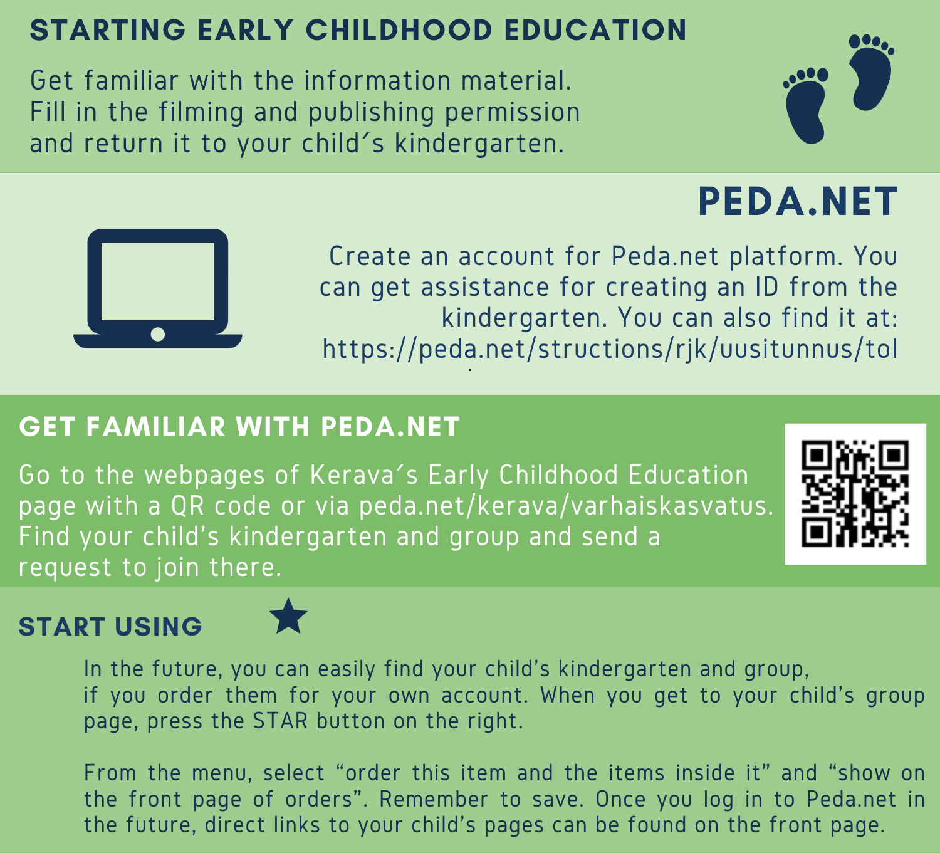

You can create a username directly at https://peda.net/ohjeet/rjk/uusitunnus/tol

You can access the Kerava early childhood education page at peda.net/kerava/varhaiskasvatus.

