Vox Aurea

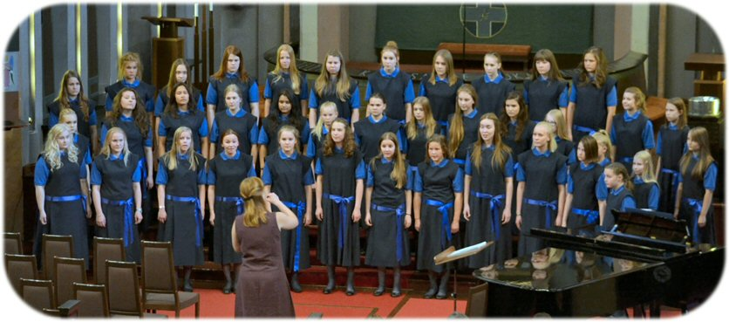
The Vox Aurea (”Golden Voice”) choir from Jyväskylä, Finland consists of 40-50 singers aged 11-18 selected by means of auditioning. Many of its members are drawn from the KolmeKuutoset choir for younger children as well as from the music specializing classes. The conductor of the choir is Sanna Salminen and the voice trainer is Tuuli Lehtomäki.

The Vox Aurea was founded in 1968 and its first conductor was Torsten Lindfors. His successor, Kari Ala-Pöllänen, was appointed conductor of the illustrious Tapiola Choir in 1994. Under Pekka Kostiainen since 1994 the choir continued to exel in varied and demanding repertoire the emphasis being on modern works, most of them composed by Pekka Kostiainen. Sanna Salminen, who had previously worked as the voice trainer and assistant conductor of the Vox Aurea for several years, started conducting the choir in 2009. Salminen brought new things, for example a lot of multicultural influences, to the repertoire of the choir.

The Vox Aurea has been one of the top choirs in Finland for over 45 years. The choir has been awarded in various national and international choir competitions and it makes recordings regularly under the record company Alba.

Sanna Salminen
The conductor of the Vox Aurea choir, Sanna Salminen, works as a university teacher in Music Pedagogy under the Department of Education at the University of Jyväskylä. She graduated with a master’s degree from the University of Jyväskylä in 2000. Her main subject was Music Education and during her studies she specialized in conducting and multicultural music. She has performed and led various instrumental and vocal groups, for example medieval and renaissance music, Thai music, South African music, Klezmer music, Finnish folk music, classical music and pop music.
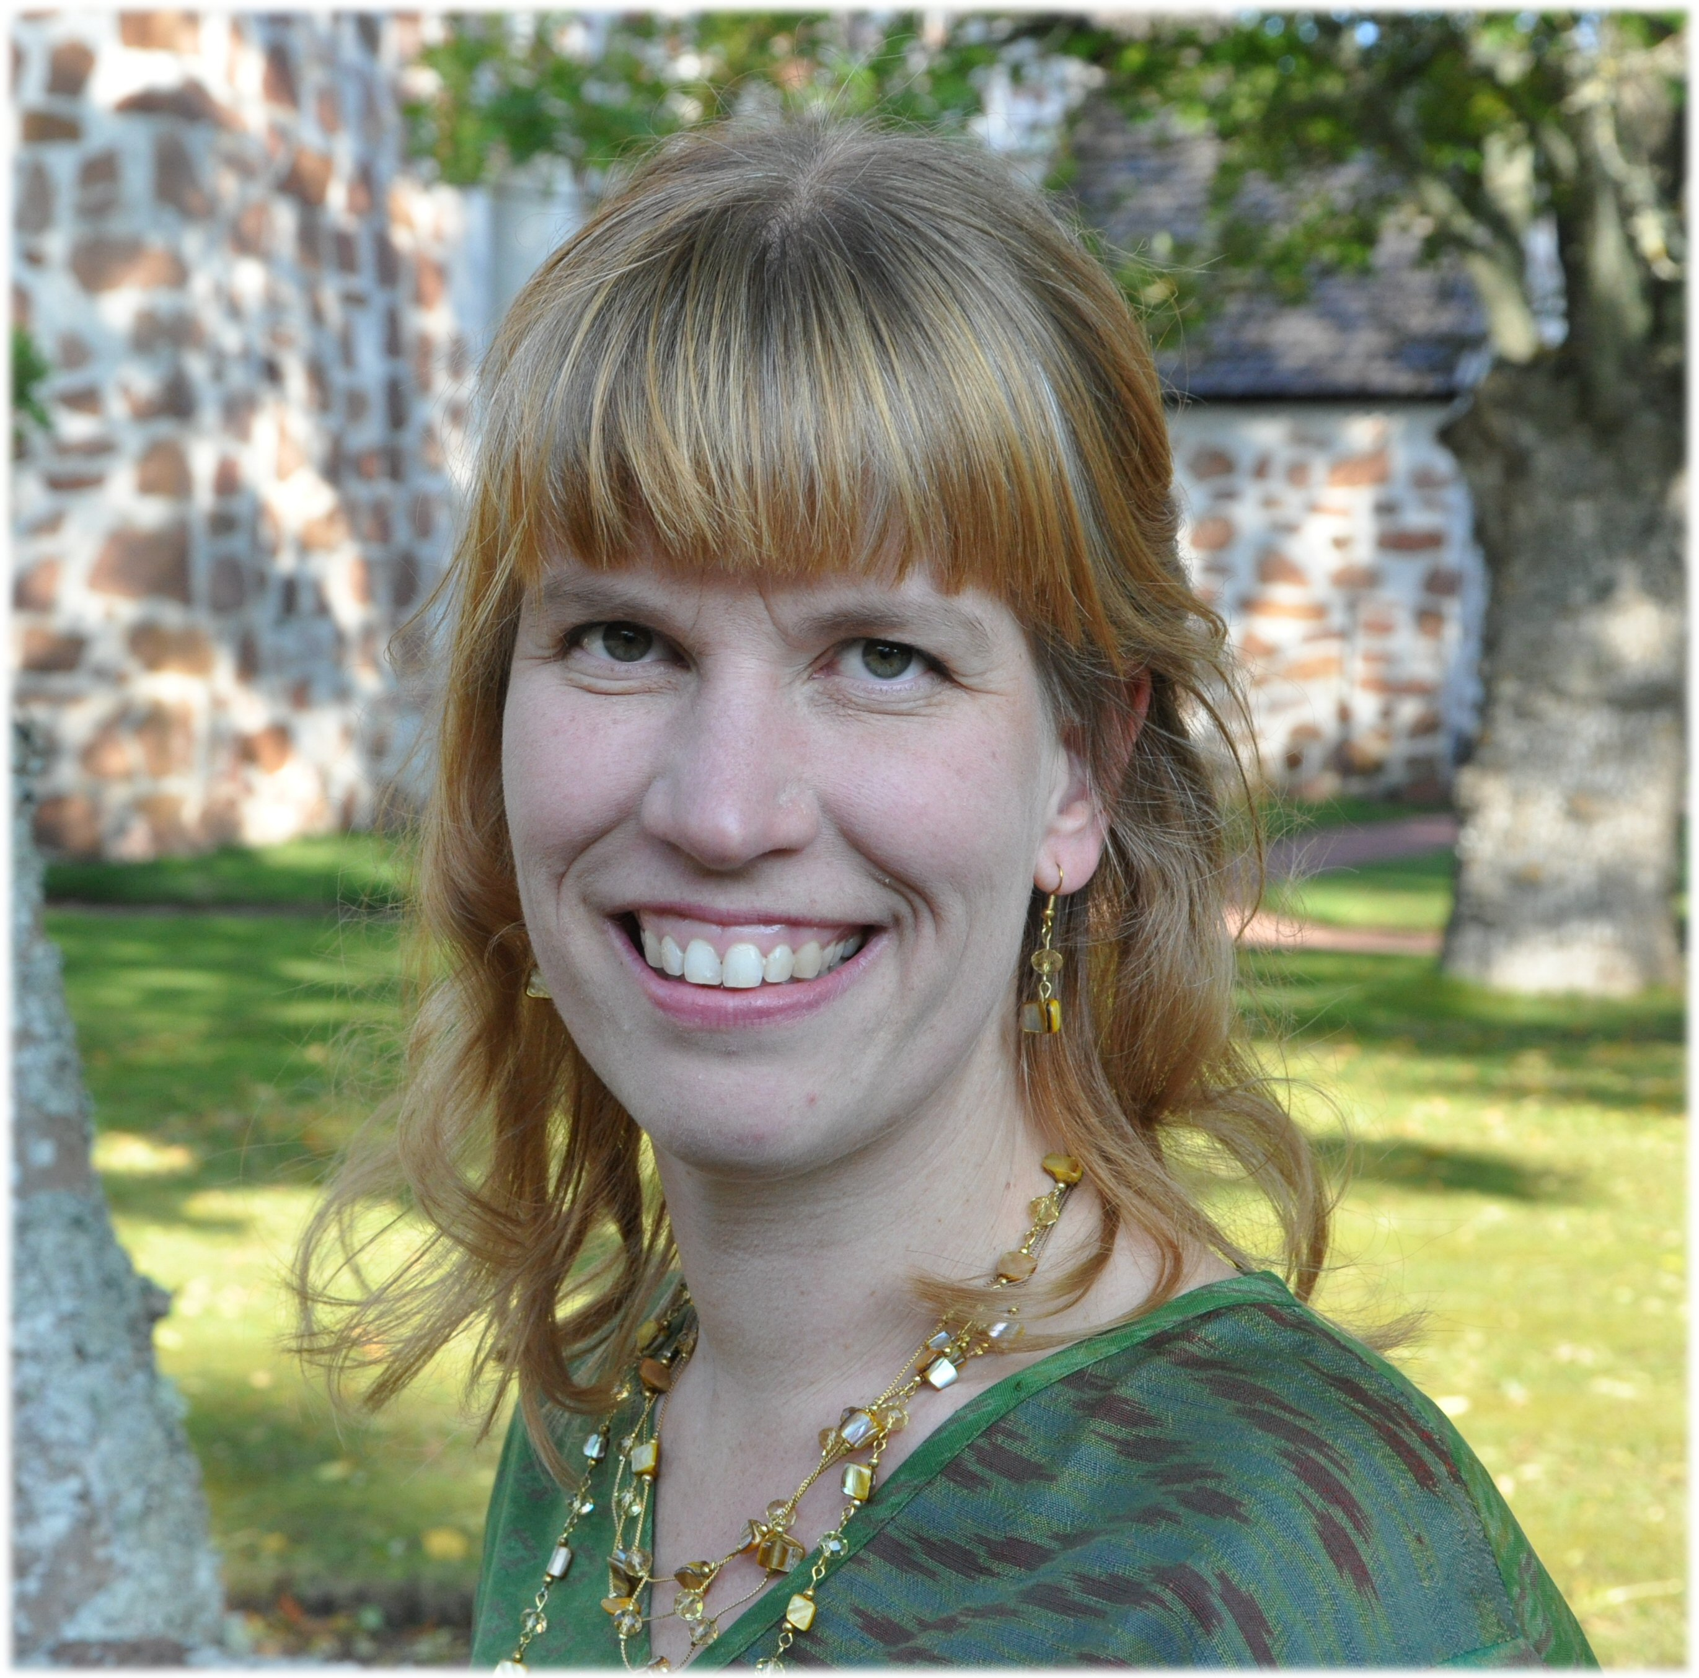
Salminen was the voice trainer and assistant conductor of Musica Chamber Choir and Vox Aurea Children’s Choir from 1998 to 2006. She also started and conducted Ruamjai Chamber Choir from 2000 to 2009. Sanna Salminen has worked as a researcher and a teacher in a co-operation project with the Department of Music in South Africa since 2000. Her licentiate thesis from the field was completed in 2004. Salminen’s main instruments are the viola, the violin and the medieval fiddle. She is also known for making school music books, arrangements, compositions and running workshops.

