My Own Sensational **School in a Box**

Imagine you have been asked to create a ‘School in a Box’ for an international charity. These boxes are sent out to help communities devastated by natural disaster or war in setting up an educational provision again. The box and contents should be hardy, reasonably small and able to withstand rough journeys into areas where roads may have been washed out and villages destroyed. What could you get into your box that might be useful to all pupils anywhere? What innovations would your box have to make it the most effective teaching tool possible? What special items might you include to help the pupils and teachers through very difficult times? Research existing schools in a box from UNICEF and the mobile schools programme (www.mobileschools.org) to give you some inspiration!

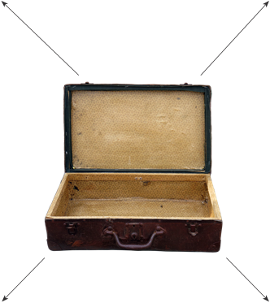box made of list of items inside

particular innovation special items