**Boat, Bus or Box -**

**Schools of the World**

**When you got up this morning, you more than likely prepared yourself for a day at school at home because of the current Corona Virus situation here in Finland. Normally you are in a school with brick walls and large windows, classrooms and a library. For millions of pupils around the world, their education does not come in a red brick and whiteboard package. It comes as a bus or a boat or an aeroplane of supplies. Their education might take place in a forest, a cave or a refugee camp. They might learn using the most up to date mobile and internet technology or be educated without pens and paper. In a tent. The reasons for this are myriad – they might live in a warzone or have experienced a natural disaster or live in poverty in one of the world’s largest slums. They might live far removed from towns or cities where education would normally take place. Here are a few stories from the real world of education!**

**Education – For Everyone**

In first-world countries, education is seen as a right to be enjoyed by all children and young adults. In many areas of the world however, this is not the case. Education in much of the developing world is the privilege of the wealthy and families must make great sacrifices to send their children to school. Fortunately, in an effort to ensure that all the world’s children are able to gain some level of education, charities are set up to help children and their parents when circumstances are difficult.

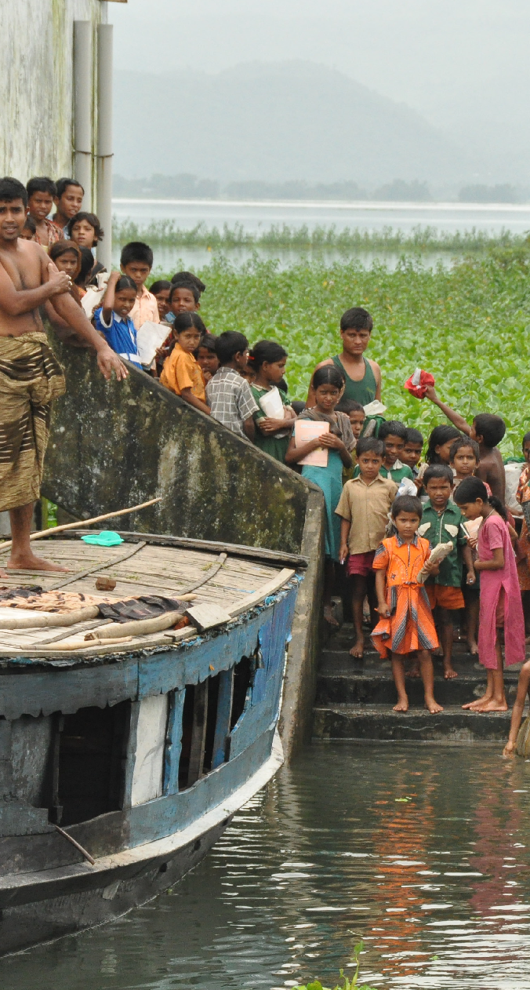

Photocourtesy of Marufish (@flickr.com) - granted under creative commons licence – attribution. (Cropped) S

ee license [here](https://creativecommons.org/licenses/by-sa/2.0/legalcode)

India has more street children than any other country. Hundreds of these children live, beg and work around train stations in the country’s busy cities. In 1985, Inderjit Khurana, a teacher from Bhubanaswar, could ignore the children no longer. She decided to try to help those young people making a living from the busy commuter traffic. The children rely on begging and selling things in those few short minutes as the trains pull into the stations. Khurana realised that, other than when trains arrived, the children were just waiting around on the platforms. She decided to take advantage of these times. She began with storybook sessions, inviting children to join her in reading stories in between the trains’ arrivals. Soon the children wanted to learn to read the stories she told them by themselves and school became a daily occurrence. Beginning with eleven students, Khurana now has a foundation that runs twelve platform schools, has job training schemes for older pupils and has helped over 6000 children.

In Cambodia the situation is similar. Cambodia actually has a fully public education system, meaning that education for all should be free. Often students cannot afford books and uniform however, or they may be asked to subsidise the teachers’ salaries because they are paid so poorly. This puts education far out of reach for many young people. Often families also need their children working to earn money and cannot spare them for education. This is the case in the huge slum of Stung Mean Chey. Here, more than 10,000 people live beside the city dump and work there collecting discarded items