

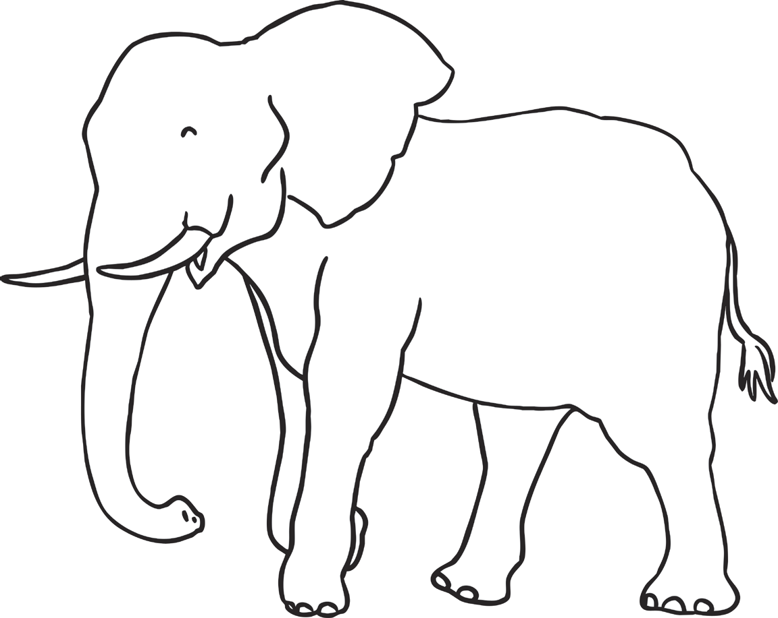

Cut and stick the words to label the parts of an elephant
Parts of African Animals
A baby elephant might hold on to this when it is walking.
An elephant uses this to suck up water and pick up food.
These help to cool an elephant down if it flaps them.
An elephant uses these to dig and find food.
ears
tusks
trunk
tail

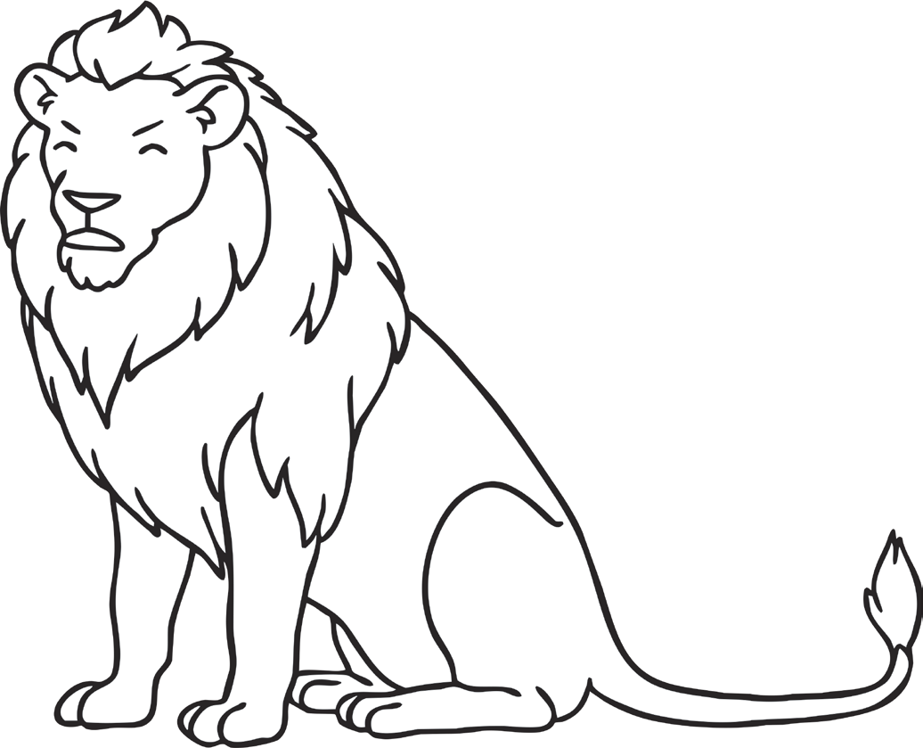
Cut and stick the words to label the parts of a lion.
Parts of African Animals
A lion uses these to see. It can see well at night.
A lion use these to rip and tear food.
A lion can use these to hear things far away.
This can be found only on a male lion.
teeth
tail
mane
claws
eyes
A lion has a long one of these. It helps it to balance when it runs.

These are very sharp
ears

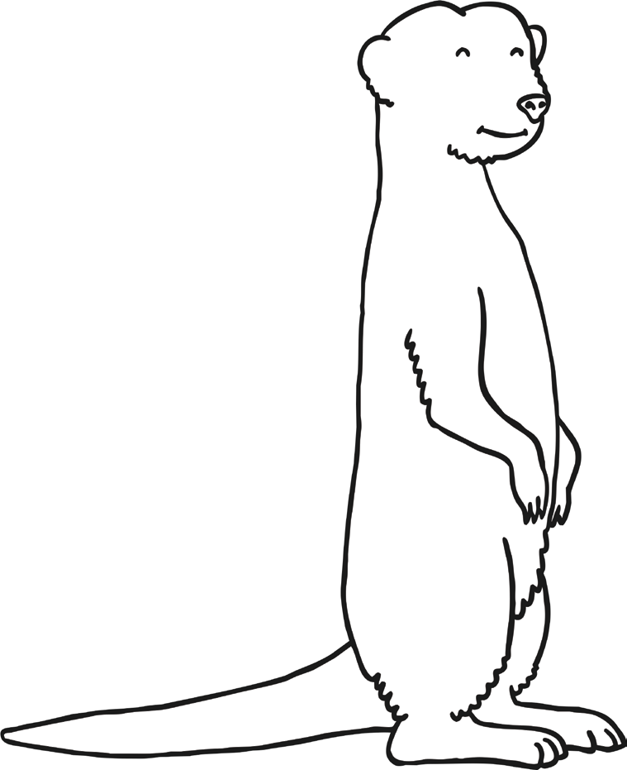
Cut and stick the words to label the parts of a meerkat
Parts of African Animals
A meerkat stands on its back ones to look out.
It is long and thin. A meerkat uses it to balance.

A meerkat uses these to dig.
These are small and round and help the meerkat to hear.
claws
legs
ears
tail


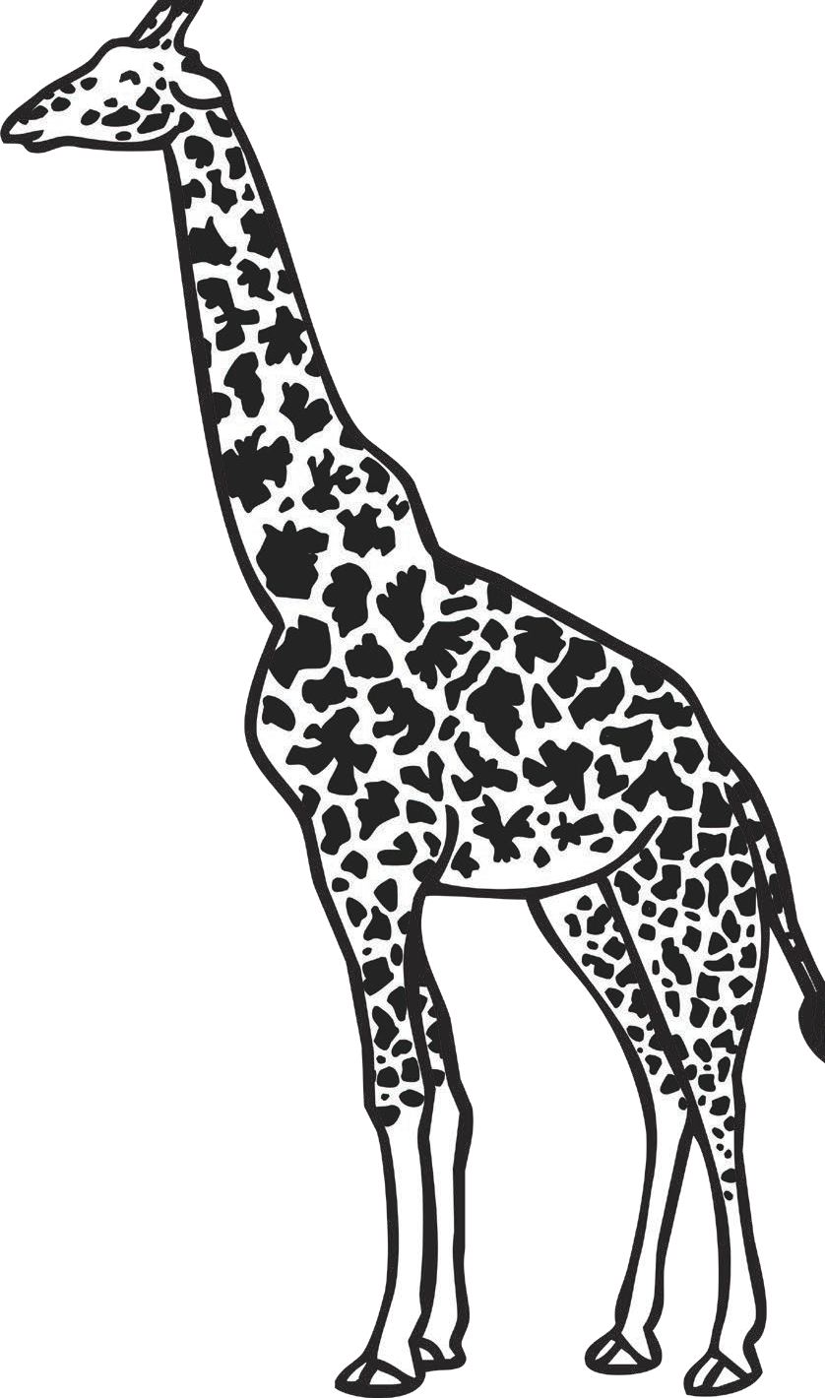
Cut and stick the words to label the parts of a giraffe.
Parts of African Animals
tongue
neck
ears
spots
A giraffe needs this to reach food on tall trees.
A giraffe uses these to hear. They are little.
A giraffe uses this to reach leaves. It is blue.
A giraffe has these all over. Every giraffe has a different pattern.

Cut and stick the words to label the parts of a zebra.
Parts of African Animals

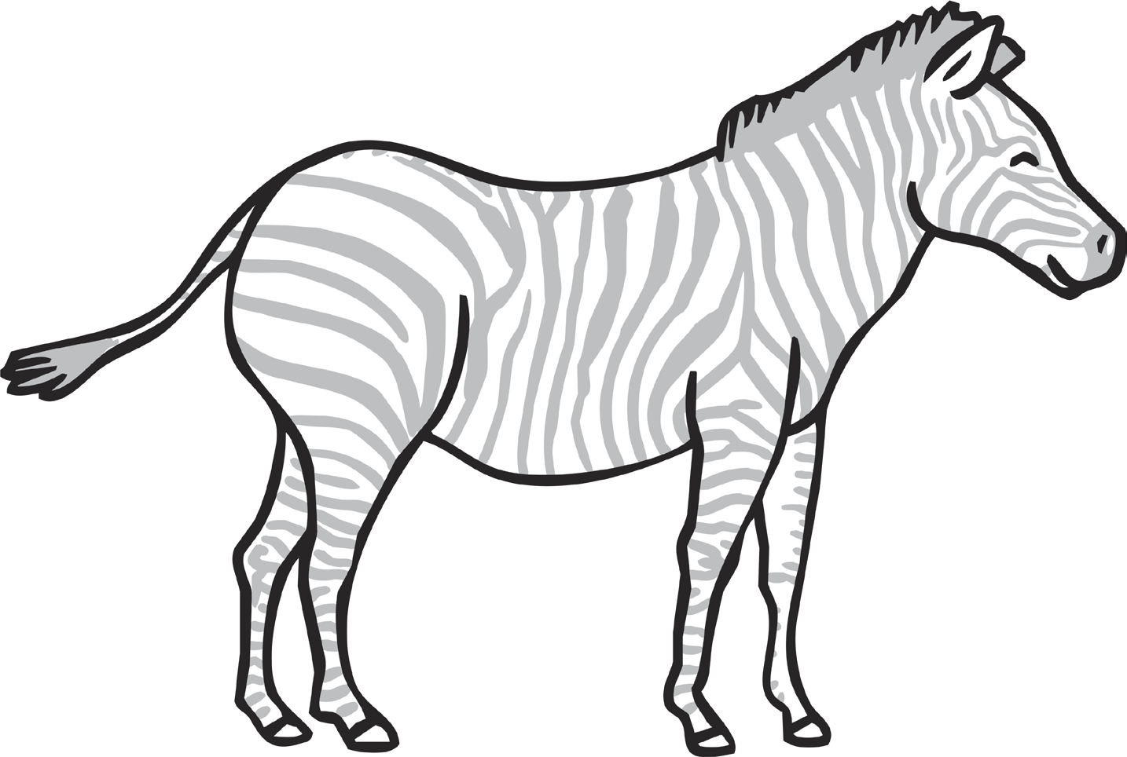

eyes
tail
ears
stripes
legs

A zebra uses this to swat away flies.

These help a zebra to see predators around it.
A zebra uses these to camouflage itself.
A zebra uses these to run away from predators.
These are upright and large to help a zebra hear predators.

