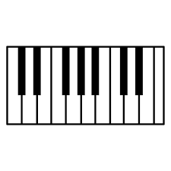

E

D

A

E

G

D#

Eb

C#

Db

A#

Bb

G#

Ab

D#

Eb

F#

Gb

C#

Db

PIANON KOSKETTIMIEN NIMET

F

C

B

(H)

F

D

C