Finland Kalevala-poems attachment

Kantele

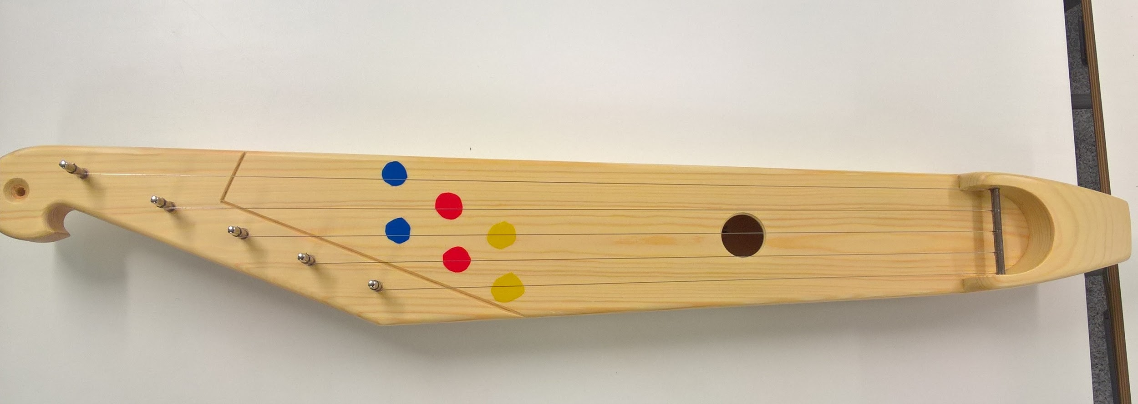
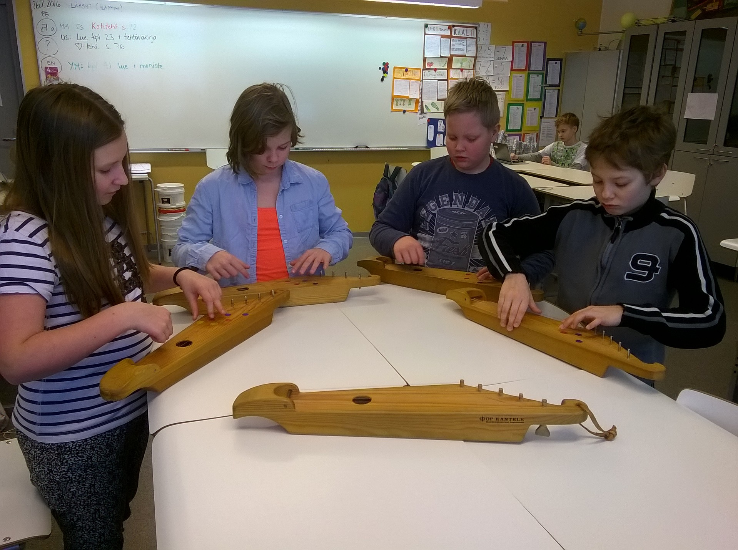

Note sheet
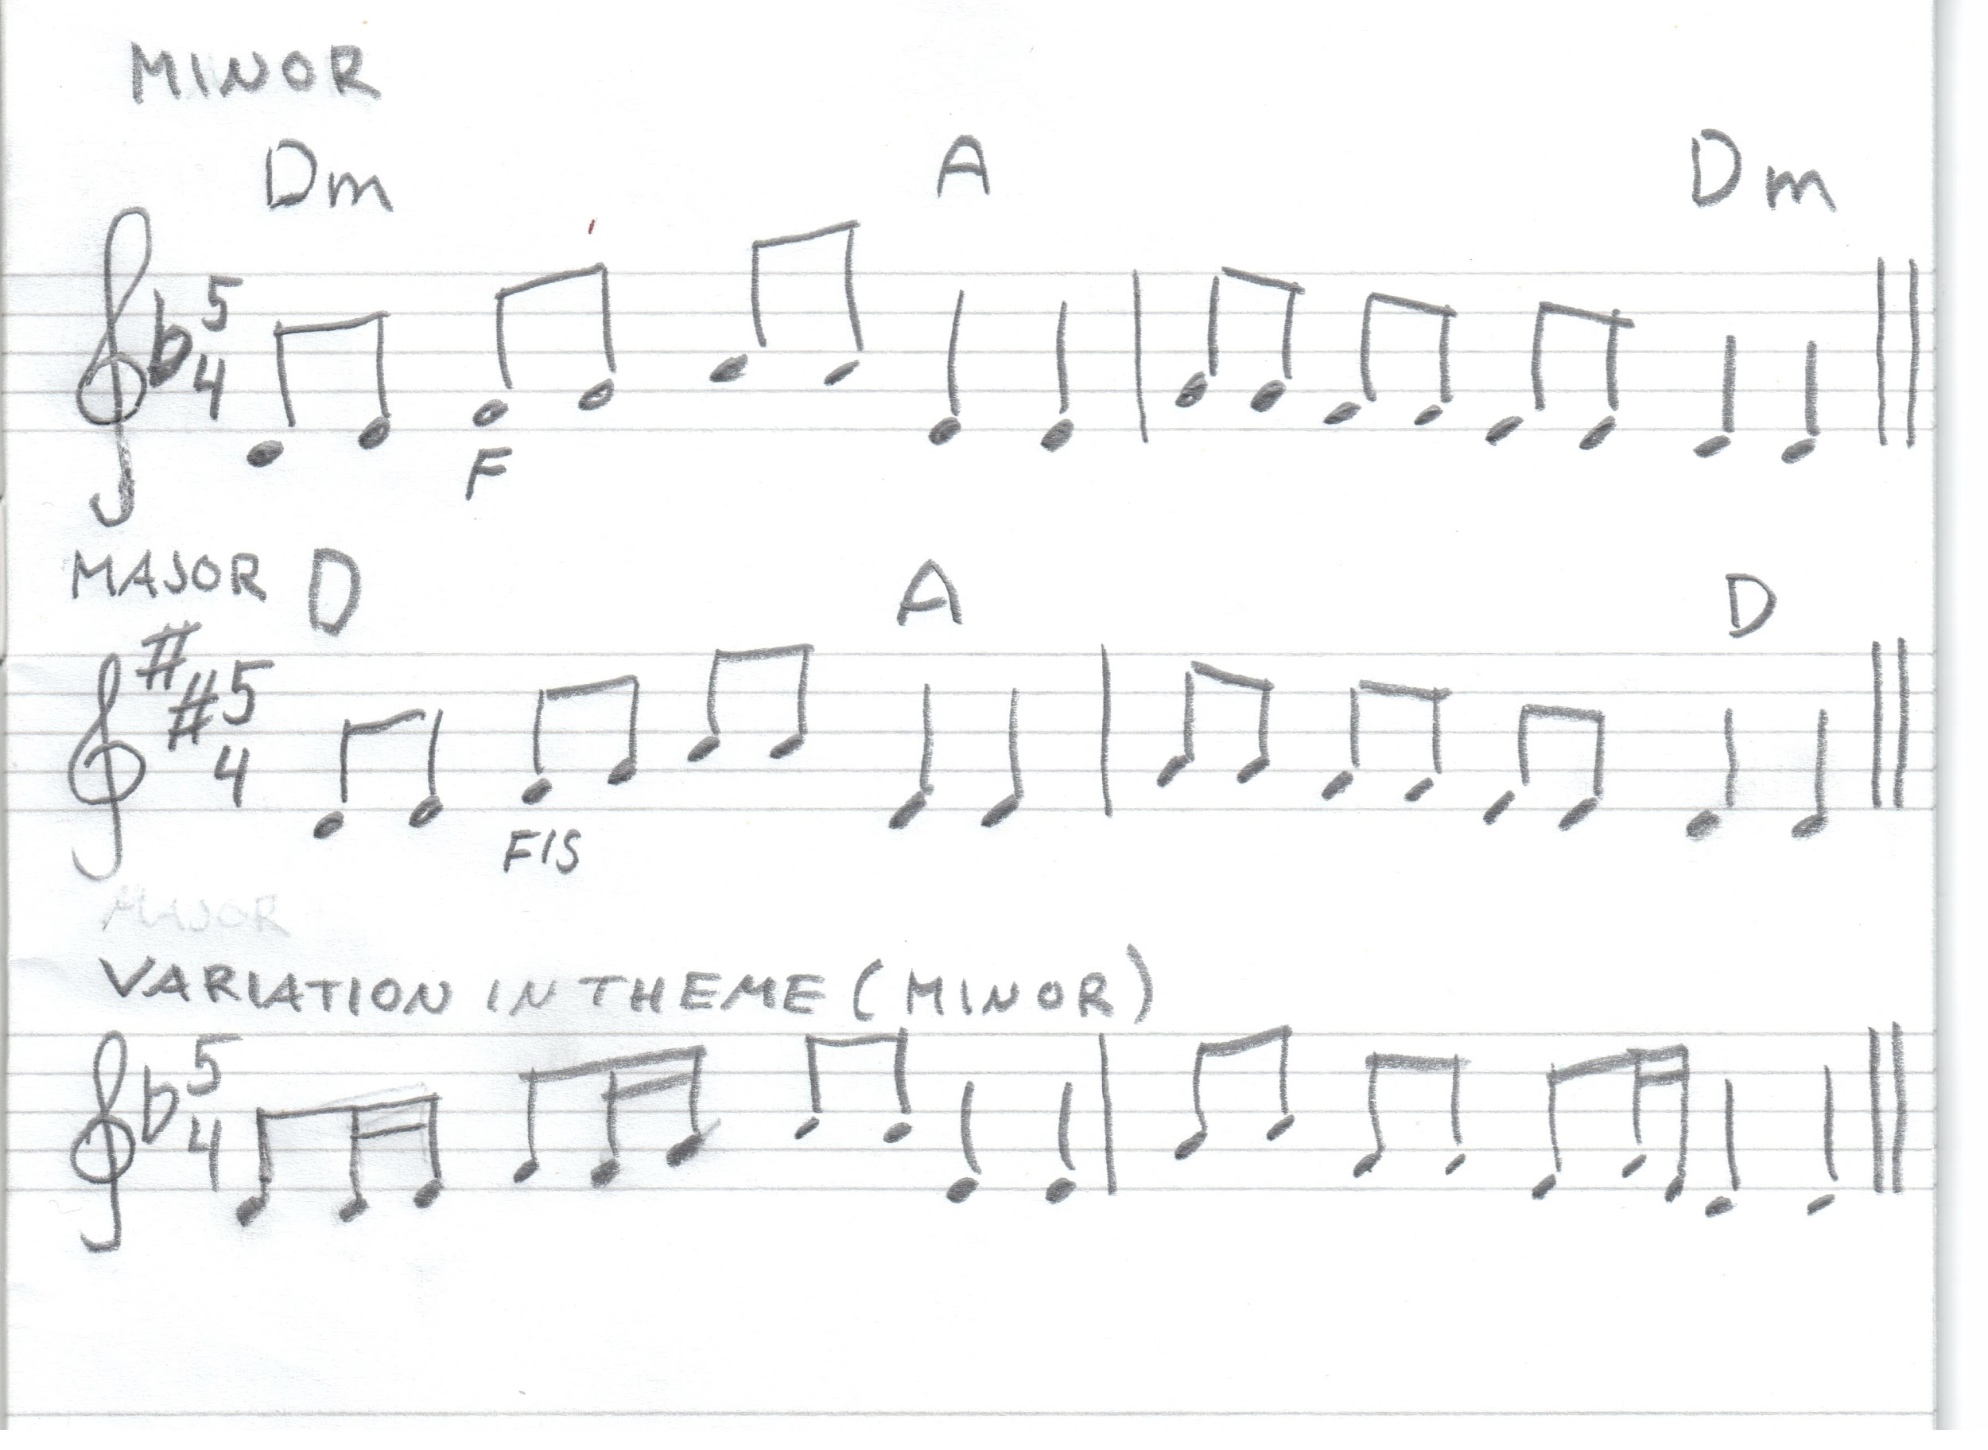

Kalevala Runes in English:
http://www.sacred-texts.com/neu/kveng/

Kalevala Melody:
https://www.youtube.com/watch?v=hNm-SkZ33Ds

https://www.youtube.com/watch?v=A8UfdehDqm4

