HORIZON TO THE FUTURE -PROJECT
BITTERFELD WORKSHOP
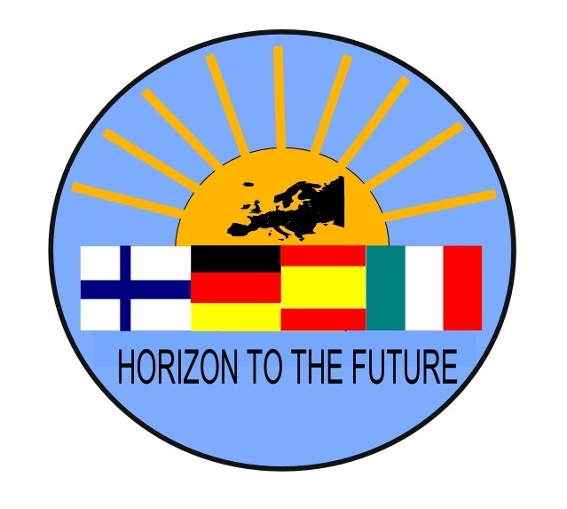
TEACHER´S TEAM´S MEETINGS SESSIONS

24.10.2016 QUALITY WORKSHOP

Participants: Sven, Eeva, Montse, Javi, Alfredo, Olga, Sanna

GALICIAN TEAM PRESENTS THEIR IDEAS FOR QUALITY

QUALITY
Galician team have had changes; one teacher has moved away from the project team.
Santiago, is now the teacher who is responsible for quality.

For quality it is very important to:
- Register all the meetings
- Register all activities

Ideas:
- Every school writes a mid-report
- clear, not too long
-the first mid-report´s instructions are good
-deadline 15th of February 2017
-upload it in edmodo
- Galician team makes a conclusion
-they read all the reports and makes a conclusion → we discuss it in the Coruna TN.
- Galician team will organize all the materials for right folders in Edmodo.

Javi made a point: quality is about the personal experiences, but he thinks we have to have numbers and %:s to show our success in the project.
Javi suggests that we should have a minimum level for success in different issues.
Some of questions of the questionnaires should be for quantitative information.
→ maybe Javi and Santiago can prepare this and we talk more about it in Coruna´s TN.

We have to remember that we have 5 groups who we have to evaluate all the time:
Students
Teachers
Families
Impact of the project → for other students
→ for other teachers

25.10.2016

Participants: Sven, Eeva, Montse, Javi, Alfredo, Olga, Sanna, Mauro and Francesca
Today we have Italian team with us and we continue with QUALITY -theme.

Sanna presented the Horizon to the Future -project´s homepage. It is important to remember that she needs all the information from other schools to upload to the homepage.

Edmodo is also very important to remember!

