
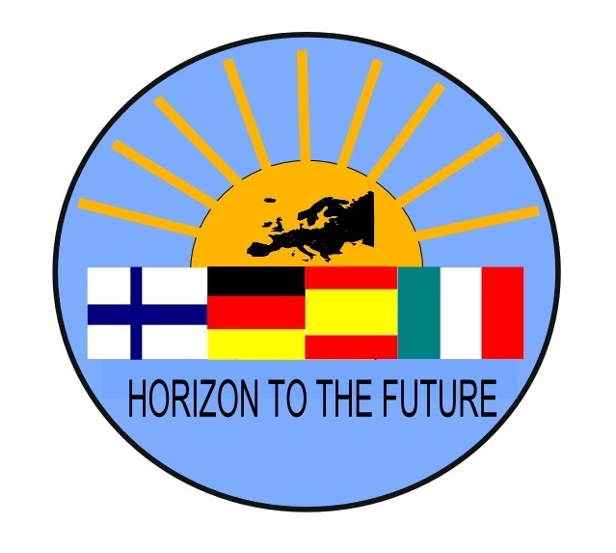
HORIZON TO THE FUTURE -PROJECT

MEMO of The 5th TRANSNATIONAL MEETING
Civitavecchia, Italy 26th to 29th September 2017

Participants: Annex I

Tuesday 26th of September, 9.00 - 16.00

9.00-10.30 School tour with the students and teachers.

10.30 Sanna begun the meeting
She highligted that now all the same persons are present who were already doing the planning of the whole project in the winter 2014-15 !! :)

Marta volunteered to be the secretary

1st Issue:
Italian team presented the program for the TN-meeting. There will be the same visits as in the workshop, that way teachers can evaluate are these visits beneficial for the workshopweek.

2nd Issue:
Cambre´s workshop evaluation: Bea presented the slides that she had prepared.

1. Student´s surveys: workshop´s evaluations aren´t really good. The group was about 60 people, too big for these activities. Peer to peer mediation had the worst evaluation. One idea is to split up the group to talk about sensitives topics.
Improve of English language had a high evaluation.
Also we can prepare an interview before travelling for students, to know their motivation and encourage them to be open-minded.
Involve students into workshop´s organisation could be also interesting.
It´s important too to include practical activities after lectures.

2. Teacher´s survey: workshops should be more practical. Sanna asked for more details about the teachers´ seminar that was written and promised in the application. For the practical reasons (no extra space at the school and the exams at the same time) the lectures were at the same time, there could have been discussion etc after lecture just for teachers.
What´s is the teachers seminars in Galicia? Teachers were learning together with students. It´s important to include it in the report how it happened.

3. Familie´s surveys: good evaluation. Galician team had problems to find families, because they had to find about 9 new hostfamilies.
Galician team wanted more flexibility to exchange dates of the meetings. But in our project the content is about a process: and that means that certain events happen in a certain order.

3rd Issue:
Secretary: Sanna

TIMETABLE INFORMATION OF ITALIAN WORKSHOP

Mixed international small groups will create an entreprise for selling or making of something. Groups can invent their business idea themselves, and there will be italian students working as mentors. At the end of the week there will be a video (about 2 minutes) where groups explain their business.

Ideas for teachers seminar: Italian team could present their streghts = how to co-operate with companies. There could be session for just the teachers where we share information of our schools:
What does the companies expect from students when they work as a treinee?
What´s the company´s benefits to work with a school?

Previous task for teachers
Teachers write a short report about the co-operation they do with the companies in our schools. Are the students doing periods in entreprises? How does it work? What does the companies think of them..??
During the workshop week we will find two hours to share these informations in a teacher seminar.

4th Issue:
Lunch in the cafeteria where students cooks the food and serve it. We experienced the trainee´s work in practise!! And the lunch was very good and nicely served :)

5th Issue:
Visit to local enterprise called Molinari, which manufactures famous liquer called Sambuca. We visited all the manufacturing facilities and heard about the process and details about the company.
It was interesting that only 8 persons are making the actual product, but 100 persons are marketing it ! Those parts of the work which are possible for machines, are given for machines, but people are still needed... :)

After dinner in the seaside Pizzeria, we took of to have a Gelato in the centre... and we met a young lady who has participated in our project´s first workshop in 2015 in Montmeló Spain!! And now we just happen to meet her here and still she remembers some of us! This was a great meeting!!!!! :)
(the photo is in Horizon -facebook group)

Wednesday 27th of September, 9.00 -

Fish market and the acricultural professions! :)

Starting the meeting at 10.30, Sanna was the secretary.

1st Issue:

Planning the workshopweek´s tasks..

BEFORE THE WORKSHOP:
1.Every school prepares an Advertisement (video) of your school. 2 min. The aim is to try to ”sell” your school!

2.To raise the awareness the students write a personal report of the topic
”Which of my skills and abilities could make me a good entrepreneur? ”,
these reports are dealt at your school BEFORE the workshop. In the end of the week there will be a conclusion.

Working with the stereotypes -session. In the first day of the workshop. About 1,5 hours. Sanna gives the instructions.
1.Country groups collect ideas about sterotypes they connect with the other countries.
2.In mixed groups: the students affirm (say yes) or correct the ideas (deny)
3.Country groups again: they give a reflection of the sterotypes that where presented
4.Country group presents their conclusion to the audience
One italian student per group is resonsible of the work.
The namelists in advance for Italian team and they make groups ready.

We have to emphasize the social aspect!!!!
1.Whatsapp group for the students before the workshop! We work as last spring: one Italian student Daniel is the admin, all schools have a responsible students who invits all the others to join it. This whatsapp group will be open ASAP.
2.The accommodation in 3 or 4 persons in a room: could it be organized in mixed group, after discussion we decided not, because we respect their privacy and there are lots of social activities.
3. All the activities are in the mixed groups!

At 11.30 came Eleonora from the city council, she helps the students to start a business. She helps the firms in the first phase, with commercial and intrenational networkings.

EVENING ACTIVITIES?!? => Joutsa, Cambre, Montmelo and Bitterfeld
We have to have evening actitivies also together in order to enhance the social aspect.
-”cultural evening” on MONDAY: icebreaking activities 1-2 from each country (put them in Edmodo)
-on Tuesday: typical snacks from every country
-Maybe thursday: bowling + pizza (TimeOut) costs about 10-12€..
-on Friday the final party in a sport garden
other ideas: tennis and volleyball are free.. map and orienteering.. the daytrip to Rome will last the whole day..

2nd Issue: eGuide
Eeva was the secretary

E-guide
Sven presented the E-guide from their school's website.
E-guide needs more material and Jacob would put more information in it.
All didactic plans are in the Edmodo, picture's and other material are also in project's website and each school's own websites.

E-guide is the starting page, so maybe the first page might need a short presentation of the project and link to the project's website.

3rd Issue: The university

4th Issue: Lunch in the trainees´ restaurant
Discussing about future projectplans togetger. Luka presented two ideas: One idea could be concerning the carindustry (formula, rally, car factories, the education and entrepreunership in that field) or having longer exchanges (maybe 2 weeks) so that student can study in a partnerschool and get credits out of it. Javi presented idea concerning economical studies and the awareness of the students towards econimical issues.
We made compliments to the group of chefs! :)

5th Issue: Tour around the old centre, guided by Patrizia and Franzesca and 3 students (Daniel, ? And ?), whilts walking we were changing ideas for the social evening activities during the workshop week.

6th Issue: Starting to work with the final report
Meeting was held in the hotel´s pool at 17.15-18.00. Italian team was not present.
We continued with this topic on Thursday, it´s written in cursive letters.

- the chapter 6 in the final report needs to written together, impact, dissemination, sustainebility.
-we are using google drive for writing these. One document for these topics.
Italy dissemination, Coruna impact+quality, Montmelo sustainebility.
- Annexs for the report, because there are only certain amount of characters for the answers. As Bea said: ”it´s a matter of marketing”.
*Dissemination – the summaries to google drive.
*Feedbacks&Activities: 10th of December > to use it also in eGuide
*Bridge connections: Sanna uploads the document to Google Drive and everyone can write there.
  - Long-term impact: a new google-questionnaire for half of the all students who has travelled from each country. Open questions. Questionnaire for both students and teachers about the long-term impact they feel the project have had. Marta promised to make them.
  - Summary of all the feedbacks: To use the data that has been collected after every workshop. Javi?? In what format? Maybe to choose about 5 topics out of it.
  - The eGuide: we have to plan carefully what to put there: the impact of the project must be shown there.. and the learningexperiences both students and teachers have had!
  - The summarising evaluation task Sanna has made has to done until 10th of December.
  - The Bridge -activities could be one Annex, that shows the connections between different workshops. Every team can say their comments to the draft.
  - Javi had an idea of doing the SWOT -analysis again and then compare them! We decided not to do swots again.
  - Sanna wants to send the final report in the middle of June!

Thursday 28th of September, 9.00–15.00 and 17.30-19.00

Bea was the secretary
1st Issue: eGuide
Focusing in this is very important because it's our only result. What should be included?.
German team considers there should be four categories: Home; projects with different categories; schools with general information of them and finnally information of Erasmus.
We discuss about which categories include: Didactic plans and the results.
We conclude:
Categories: each school or each topic of the mobilities/worshop (such as emotions) and long term results. Then, each of the workshop will include these three sections:
- Topic
General description, maybe a good photo
Theoretical issues. Here different methods we can include other options about them, useful information.
Didactic plans
- Application: what happened
We discuss what's about including photos: not include too many.
Presentations and videos and every team can choose what to include.
- Feedbacks of wich workshop
We include here the conclusions we have already made after each workshop.

We conclude not to double the information. So, at the beginning: Explain what' s the e-guide about, who we are and we can insert a link to the website.
Include the name of the responsible or his/her name to facilitate the contact and communication.

We discuss about legal aspects: using Creative Commons License.
Frauke sais that at the end FAQ information, after the Long Term Results. Frauke will be in charge of this.
Questions will be such as:
- How many students did you include
- How did you prepare the workshops
- How did you made mixed groups
- How did you choose the students
Sanna commits us to check the mobbility tool, we have to include every student one by one. And about time table, and we discuss about the final meeting. We conclude that the DATES for the FINAL MEETING are from 10th to 12th of April in Joutsa.

2nd Issue: Visiting the ancient Roman Baths, 3 students were our guides

3rd Issue: Lunch at trainee´s restaurant
Discussing the official program and evening activities during the Civitavecchia workshop.
Ideas: a trip to castle > how much does the bus cost?

4th Issue: Working with GoogleDrive
At 17.30- the final GoogleDrive -session in the hotel´s conference room

-A new Horizon documents -folder has been opened in the GoogleDrive
-All the contact persons are now invited there, they can invite their collagues there
-Horizon -document folder has 4 documents:

1.Final Report = means all the issues asked in chapter 6.
Impact is for everyone: Bea opens a chart, which every country fills up. Deadline end of February.
Susteinebily: Marta writes description about it, others continue. Deadline end of February.
Dissemination: Italian team writes a description, others continut

2.Evaluation of teams = teams evaluate their workshop, seminar, TN-meeting and eGuide materials

3.Bridge activities = add any issue you feel has been the connecting issue between workshops. This data will be used in the eGuide! By the end of February

4.What has happened between activities = what kind of Dissemination have you done in your school

Ending the meeting in Civitavecchia at 19.00. Sanna thanked all the participants for their contribution! :)

28.9.2017
Sanna Pienmäki

