Workshop week „Communication“
- in Bitterfeld, Germany -
- Autumn 2016 -

Topics:

- theory of communication (verbal, non-verbal, active listening, „four ears“ model)
- School mediation
- Methods of presentation
- debating competition
- debate training: theoretical background
- practical debate training 1: point of view speech & disputation
- practical debate training 2: Socrates dialogue
- practical debate training 3: fish bowl discussion
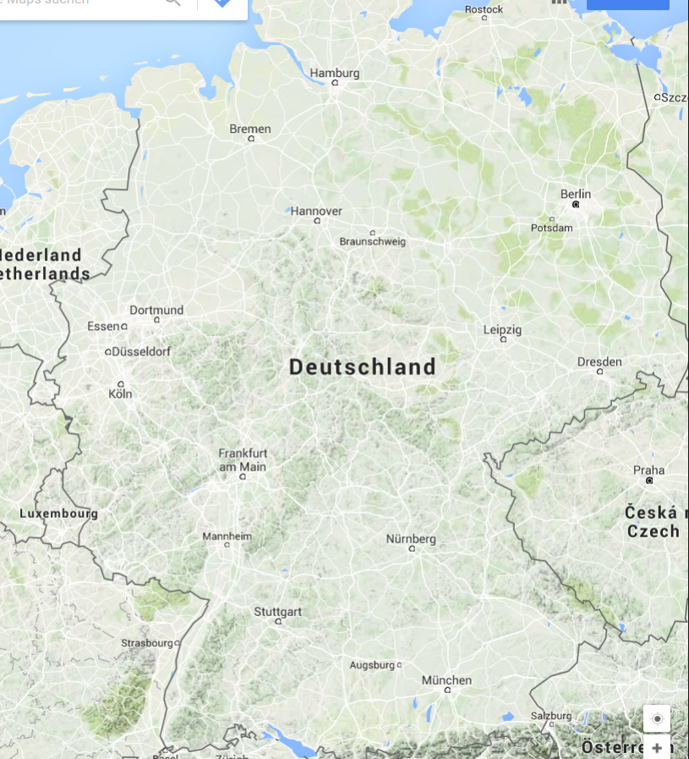
- practical debate training 4: panel discussion
Bitterfeld

