We started our Finnish Erasmusproject with introducing the theme to school teachers and to students. There were about twenty students and four teachers who were interested to join. Each of them made a short introduction video about themselves. Introduction Pages were also written to our school webpages. For the first four months we started to get to know each other on our weekly meetings and had very interesting conversations about ways to reduce environmental harm.

We had several weekly assingments, for example we calculated our carbon footprint, studied invisible waste, measured the time we spend at shower, photographed our consuming habits. Our results can be seen at Instagram @erasmuspyhis2019. We also made promises concerning what we can do to reduce environmental damage. Just before christmas we gathered on one afternoon and made handmade soap and reusable foil as christmas gifts.
Erasmus day was at our school on 12.10.2019. Students made digital Kahoot!-Games about sustainability, about 100 students attended!
Furthermore, we practiced innovating English-learning methods through getting to know eTwinning as a communication platform and shot a video about the facilities of our school in English for our partner schools. Other digital platforms we used were Padlet and Adobe Spark.
We organized a winterfest at Pyhäselkä school in February 2020. The whole school attended and also parents and families were invited. There were lots of action outside and inside. We planned a room for small children, and our enthusiastic students read fairytales. We prepared handmade soap and reusable foil. All the profits were directed to environmental fundraising.

In March 2020 the mobility to Martinique: we spent an afternoon with students, teachers, parents and a Martiniquan couple Ville and Laura preparing local food and learning local customs and traditions.
Mobility was cancelled

In April there was a morning assembly at local Radio and at school. We also prepared posters “why sustainable living is important”

In Autumn 2020 we planted tulips, daffodils and other flowers in the school yard.

In December 2020 we spent an afternoon tasting organic and local food: dried fruits, fruits, vegetables, milk, liquorice etc.
In May 2021 we organized an electric toy car race for students which was powered by an exercise bike.

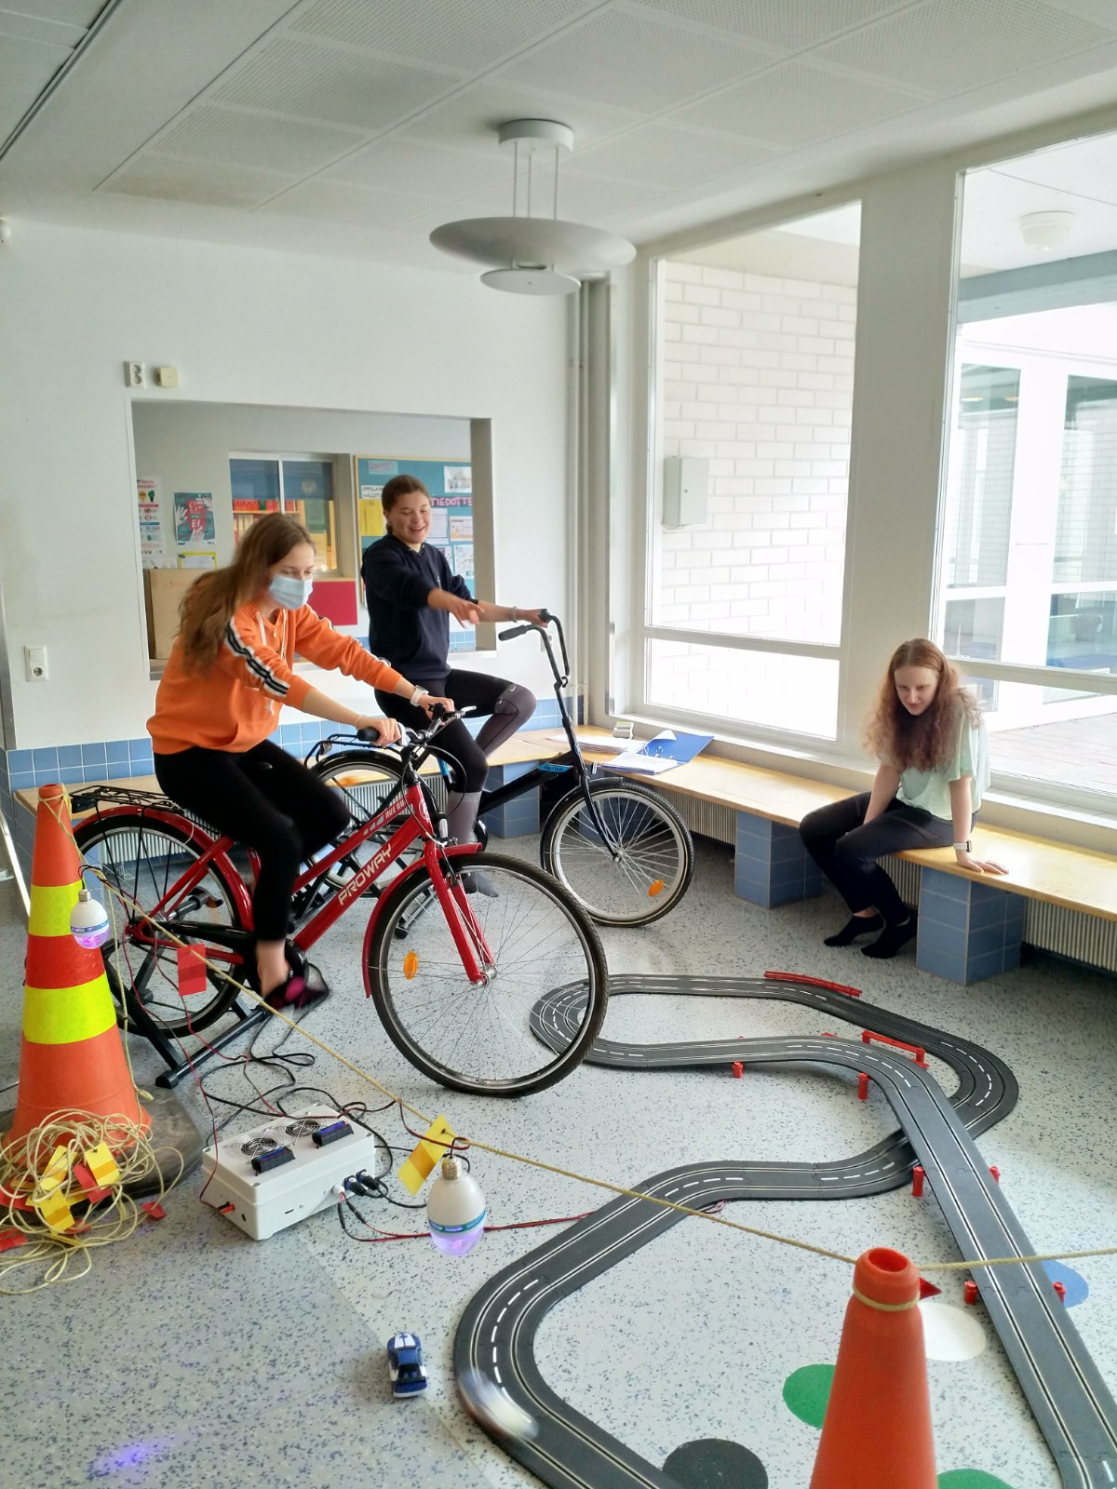
In our school we recycle garbage for example glass, paper, bottles and bio-waste.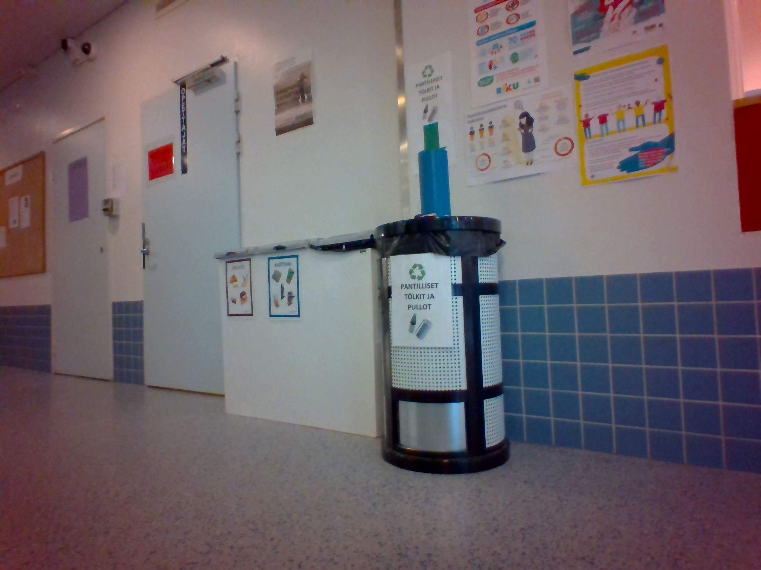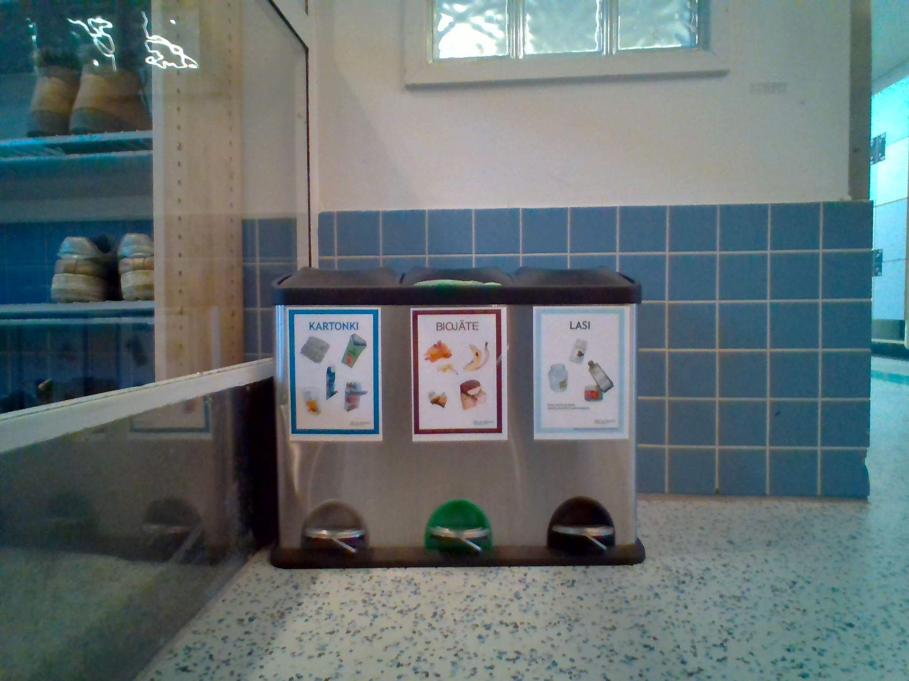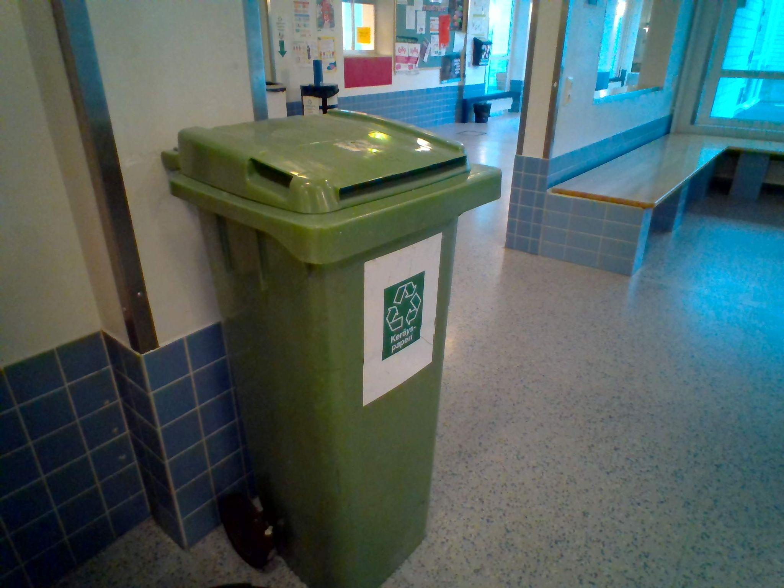

This autumn we have been preparing tasks for the Spain mobility. This picture is from one of our club meetings.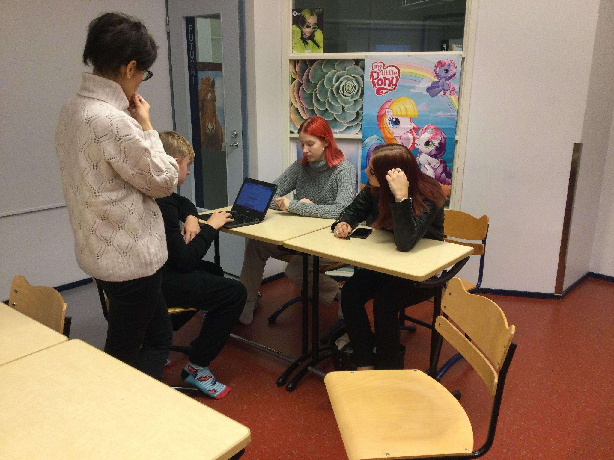

Here were are testing our game for mobility.

