Revision / Complex numbers and polynomials

1.
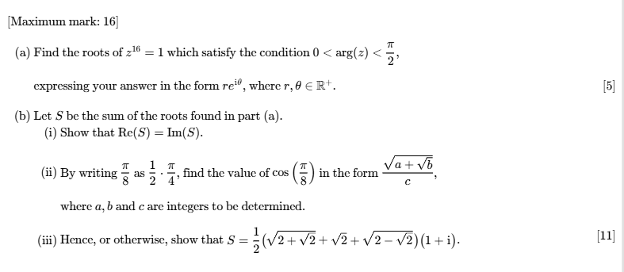
2. 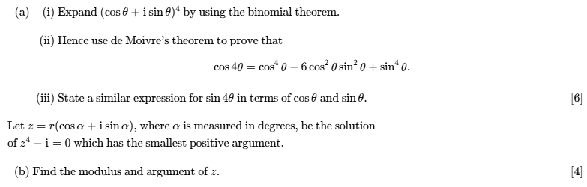

3. 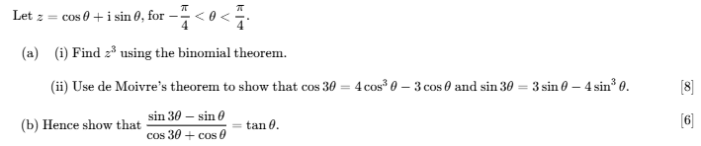

4.
