Final exams / logarithms (36 marks)

1.
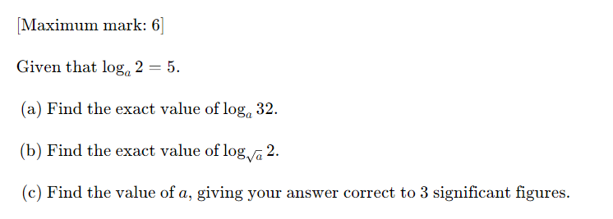
2.

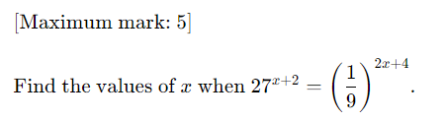

3.
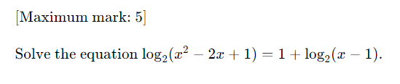
4.
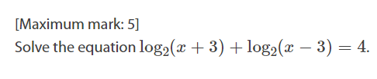

5.

