WELCOME TO

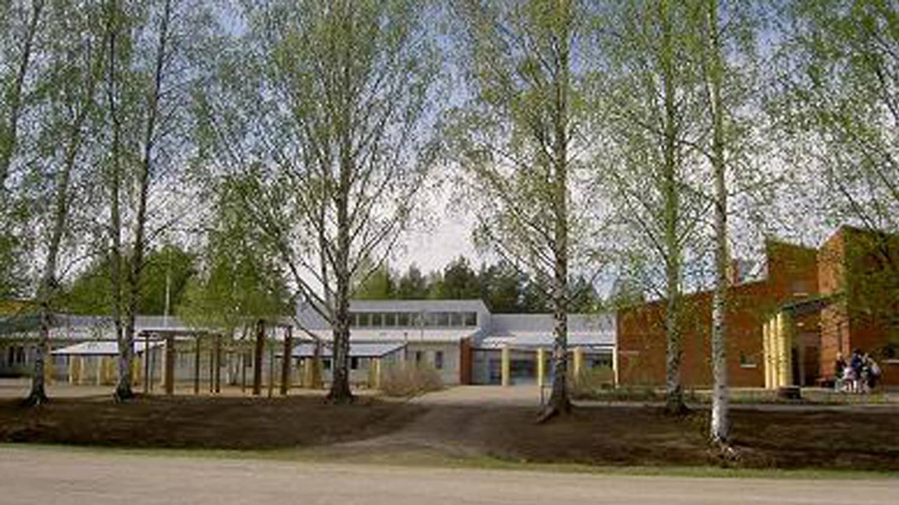

NIITTYLAHTI
SCHOOL

Welcome to visit Niittylahti School
Niittylahti School is an elementary school in Joensuu, North Karelia, with approximately 245 students. Our students are in grades 1-6, ranging from 7 to 13 years old. The school has a staff of 21, including 16 teachers and 5 teaching assistants.
Niittylahti School is a so-called two-stream school, meaning that there are two separate classes (A and B) for each grade level. Additionally, the school has one special education class designed for children facing specific challenges in their studies, with 10 students from grades 1-4.

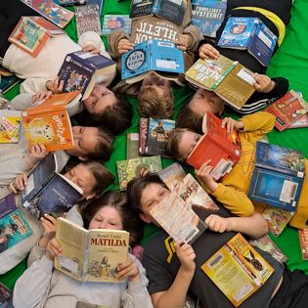
Established in 1898, Niittylahti School has been at its current location since 1970. The school has undergone several expansions, and currently, most students study in a temporary white modular building on the premises.

Class Schedule
1st period 8:30 – 9:15
2nd period 9:30 – 10:15
3rd period 10:15 – 11:15 (including lunch)
4th period 11:45 – 12:30
5th period 12:45 – 13:30
6th period 13:30 – 14:15
Breaks 9:15 – 9:30 11:15 – 11:45 12:30 – 12:45
Lunch Class-wise between ten and eleven o'clock.
School Location
The school is located approximately 12 kilometers from Joensuu Market Square at Kummuntie 9.
Buses To reach Niittylahti School from Joensuu city center, take bus number 103.
The bus departs from the school toward Joensuu city center around: 13:20 14:15 15:15 16:20 Be at the bus stop on time! Payment in cash or with Waltti mobile (two zones) on the Frontpage - jojo-english (joensuu.fi).
Erasmus Contact Teachers
Reetta Ullgren +358 50 357 0515
Jaakko Sivonen (Principal) +358 50 443 1424

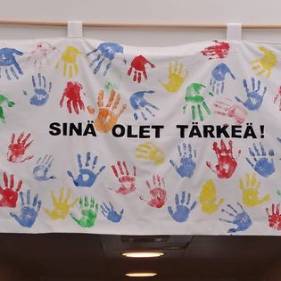

Joensuu
Joensuu is the capital of North Karelia with approximately 78,000 residents, most of whom live in the city center. The geographical area of Joensuu extends all the way to the Russian border. Known as an educational city, Joensuu hosts the University of Eastern Finland Joensuu Campus, with the largest group of students studying to be teachers. Joensuu also has a university of applied sciences, vocational school, and several high schools. Additionally, the European Forest Institute is located in Joensuu.
Joensuu offers a lot to see and experience. For more information on visiting attractions and leisure activities, visit visitjoensuu.fi.

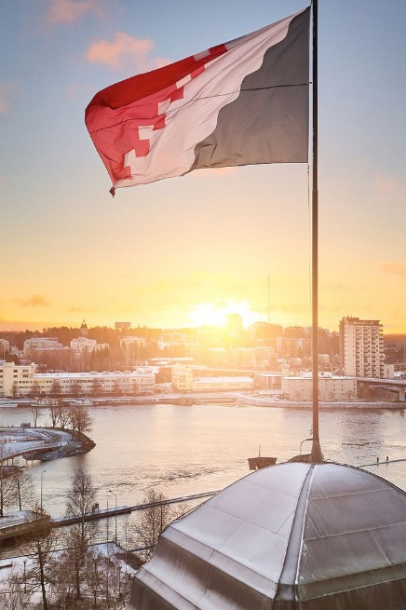

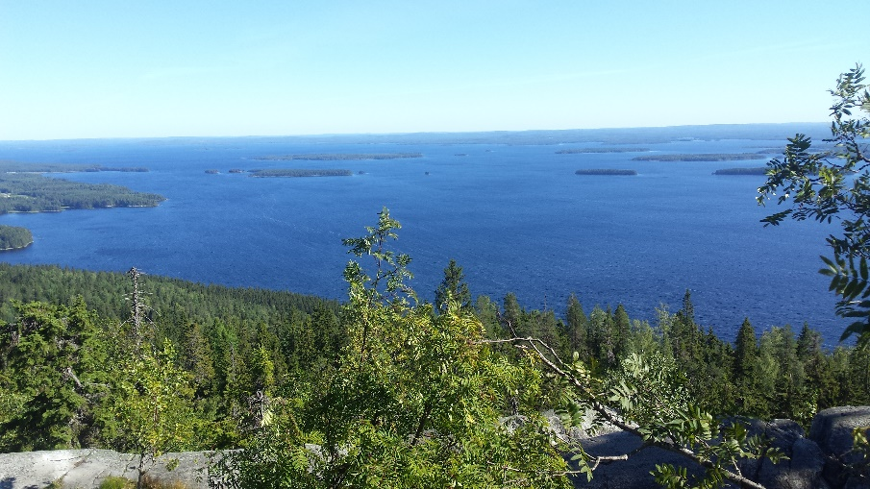

North Karelia
Joensuu is situated in North Karelia, a region known for its popular tourist destination, Koli, and its national park. For more information on visiting North Karelia, check out visitkarelia.fi.
Welcome to North Karelia and Niittylahti School!"

