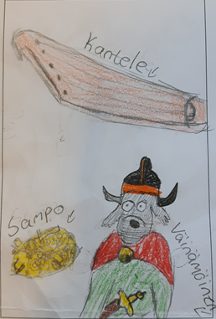
I recommend you this book
Title:
The canine Kalevala__

Writer:
Mauri Kunnas

Setting: In Kalevala

Characters: Lemminkäinen, Lemminkäinen’s mom, Väinämöinen, Annikki, Ilmari, The maiden of the North, Joukahainen, Joukahainen’s mom, A voiper, Louhi, master of the North, Ahti, Iku-turso, swan of Tuonela and a monstruous pike.

The book is about: From Kalevala.

This book is good because: It is little bit exciting and so funny.

