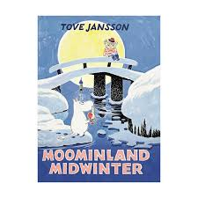
I recommend you this book
Title:
Moominland Midwinter

Writer:
Tove Jansson

Setting:
It´s in moominvalley

Characters:
Sniff, Moominpappa, Little my, too-ticky, Snufkin, Moominmamma, the hemulen, The snork Maiden, The Groke, The muskrat, thingummy and bob.

The book is about:
Moominfamily wake up of winter

This book is good because:
it´s good because have Moominfamily

