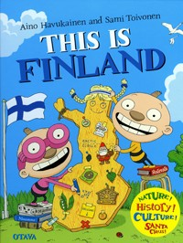
I recommend you this book
Title:
Tatu and Patu : This is Finland

Writer:
Aino Havukainen and Sami Toivonen

Setting:
Different places in Finland

Characters:
Tatu, Patu, Venla, some families, Santa
claus, and elves.

The book is about: Two boys from Odville are visiting different
places in Finland and get know some traditions.

This book is good because: It is REALLY funny, and nice to read. I recommend it
for kids (for grown up’s too). It’s good bedtime story!

