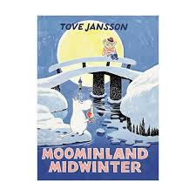

I recommend you this book

Title:

Moominland Midwinter

Writer:

Tove Jansson

Setting:

It´s in moominvalley

Characters:

Sniff, Moominpappa, Little my, too-ticky, Snufkin, Moominmamma, the hemulen, The snork Maiden, The Groke, The muskrat, thingummy and bob.

The book is about:

Moominfamily wake up of winter

This book is good because:

it´s good because have Moominfamily