I recommend you this book

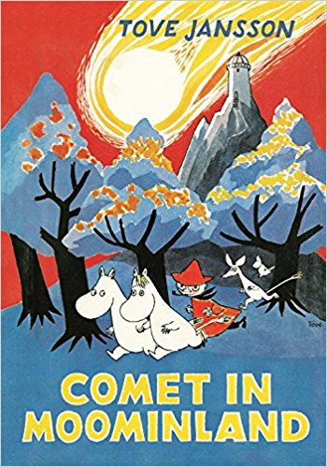Title:

Comet in Moominland

Writer:

Tove Jansson

Setting:

Moominland, Moomins house, Force and New Bridge

Characters:

Moomimtroll, Sniff, Moominpappa

Moominmamma, Hemulens, snufkin,

Little My, Mymble, Too-Ticky, Fillyjonk,

Hattifatters, Thingumy, Bob, Groke,

Stinky and The Muddler

The book is about: First Moomintroll, Little My and Sniff go in the star tower and they hear in Moominland come the comet. I don’t wont spoil no more.

This book is good because: Because this book is interesting and exiting.