Feedback zum Erasmus+ Projekt (SchülerInnen) / Feedback on the Erasmus+ project (students)

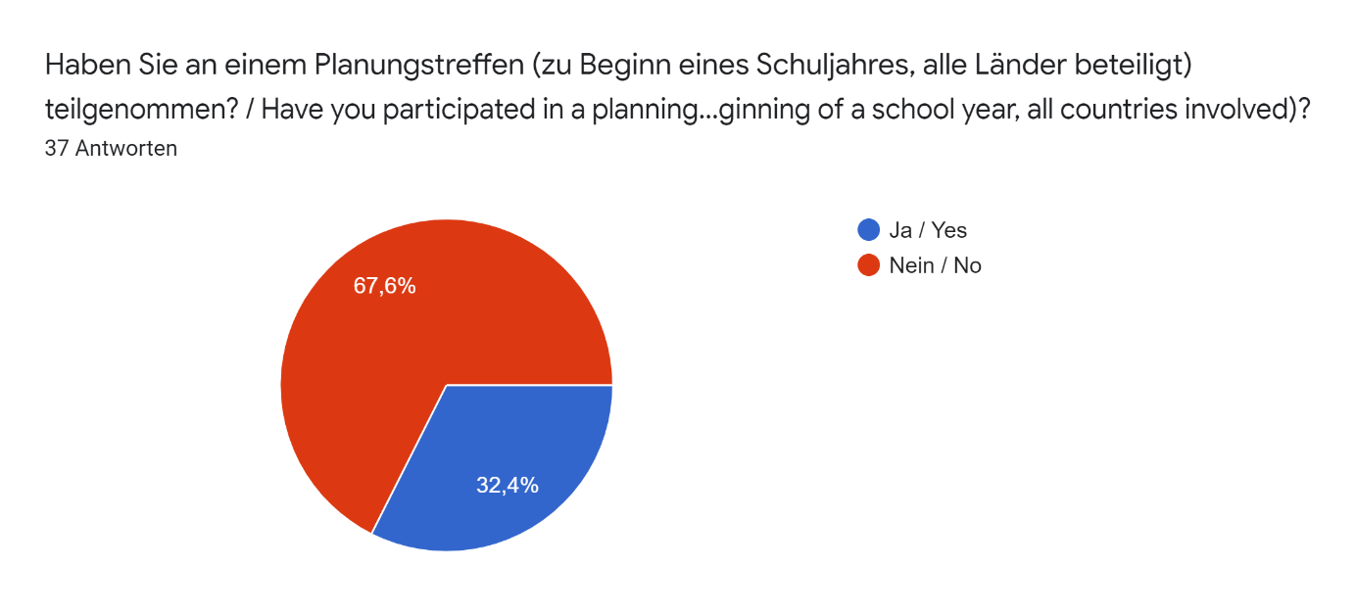

Rückmeldung zum Planungstreffen / Feedback on the planning meeting

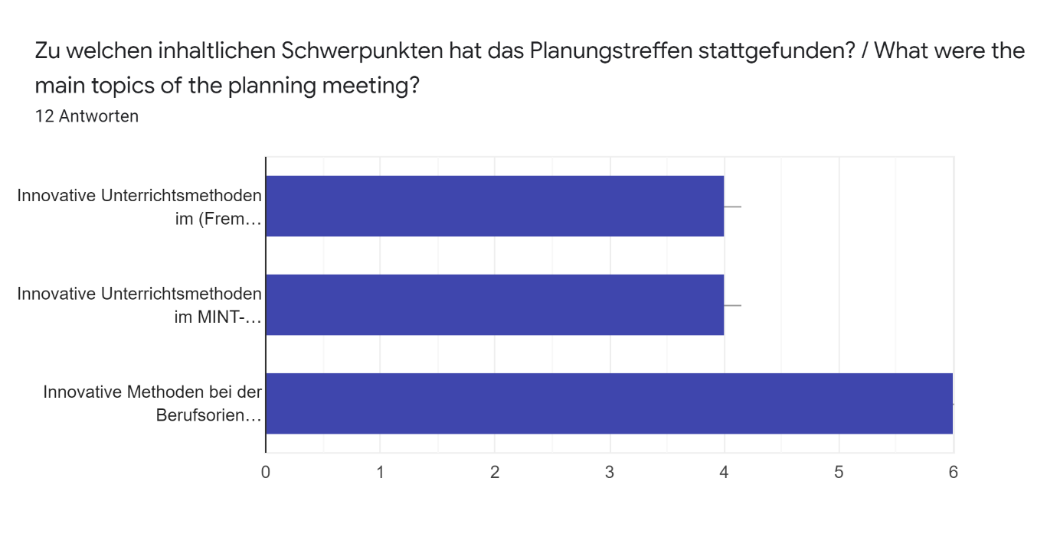

Welche inhaltlichen Themen haben Sie bearbeitet? / What topics did you work on?

How to learn Maths in the 21st century

School systems / preparation of students for their working life (career counselling, study guidance, ...).

Mathematics, Physics and usage of computers in STEM subjects.

Technik an Schulen bzw. allgemeine Unterrichtsmethoden

How does our school help about career orientation

I worked with different study systems and how student counselling works in diffrent schools

Counselling

Digitale Unterrichtsweisen

die Rolle der Schule bei der Entwicklung sozialer Kompetenzen

Hungarian - Polish friendship

Better and more efficient method for learing foreign languages.

Welche Ideen konnten Sie für Ihre Schule mitnehmen? / What ideas could you bring to your school?

There could be more study counsellings in our school

Tests, counselling

There were some computer programs/websites presented that we hadn't thought of in Finland, so some of these were implemented in our school. Also using teamwork more extensively in STEM-subjects was a thing that was implemented in our school.

Less lessons

More interactive and autonomous language lessons.

Spielerisches Lernen und berufsorientiertes Forschen

Wenn es möglich ist, an einem ähnlichen Programm teilzunehmen

Kahoot, photomath, geogebra...

Kahoot!, Photomath, geogebra...

Making a matrix

Ganz allgemein, dass es in anderen Ländern, wie beispielsweise Finnland, viel mehr Technik an Schulen genutzt wird und dies auch sehr gut umsetzbar ist, weshalb es auch hier wichtig wäre, mehr Nutzen davon zu ziehen.

1- Ensure a direct link with the labour market with: a map of local training and schools, a map of the jobs and profiles sought at the local level, close collaboration between schools and companies. 2- Meet the professionals according to the lessons/sectors chosen by the student to discover concretely new professions.

Welche Ideen fanden Sie gut, waren aber an der eigenen Schule (noch) nicht umsetzbar? / Which ideas did you find good, but could not (yet) be implemented at your own school?

I don’t know

-

Using measurement equipment/other equipment that could be connected to computers/computer programs.

I

A more conversational lesson.

Apps für das Handy, um spielerisch zu lernen. Allerdings war das an meiner Schule aufgrund von fehlendem WLAN nicht umsetzbar.

Eine ganze Klasse kann an einem solchen Programm teilnehmen

Learning on laptop.

Learning on laptop

To have a person who gives us career orientation advice

Da es leider schon mehr als zwei Jahre her ist kann ich mich nicht detailliert daran erinnern, was vorgestellt wurde.

1- Ensure a direct link with the labour market with: a map of local training and schools, a map of the jobs and profiles sought at the local level, close collaboration between schools and companies. Indeed, the development of those tools can take some time (a budget must be alloted, development take time if we want the project to be well done...).

Was konnten Sie ganz allgemein von diesem Treffen mitnehmen? / What did you generally gain from this meeting?

Lots of new friends from different countries :)

New ideas on how to find a career path

The meeting in Frankfurt gave me insight into other schools´ teaching methods. There were differences, most notably that in Finland and England used more technological softwares and computers to teach and learn STEM-subjects. Also the meeting showed me differences between Finnish school (my school) and German school. For example, in Germany there is more discussions/debates in the classes than in Finland. On the other hand there were a lot of similarities.

My english improved

New ideas and methods for learning languages.

Allgemein konnte ich von dem Treffen mitnehmen, wie unterschiedlich die Schulsysteme in Europa sind. Und wie wichtig der Austausch ist, um sich weiter zu entwickeln.

Ich habe viel Erfahrung und Freunde gemacht. Ich habe viele Sprachen geübt.

Now I can speak English much better. I could hang out with a lot of new students from other countries. I can use modern methods for learning.

Now I can speak German and English much better

I have a Polish friend

Dass alle Länder ihre eigenen Unterrichtsmethoden nutzen und alle ihre Vor- und Nachteile haben und es deswegen wichtig ist, sich untereinander auszutauschen.

We gained open-mindedness, a certain maturity and millions of ideas ! We understood that the school system is in a constant evolution and must evolve with the society : it must cater for the students and the current and future society. (We will also remember some meetings, smiles and of the general desire to share for improving our future !)

Was hätte verbessert werden können? / What could have been improved?

Das Planungstreffen an sich habe ich als sehr positiv in Erinnerung.

Nothing, everything worked fine

Alles war sehr gut.

Not much.

English

No general remarks !

Die Organisation vom Treffen -> besser strukturiert und geplant, eventuell dass auch die Schüler öfter zu Wort kommen und man sich gegenseitig über eigene Erfahrungen austauschen kann.

The tasks could be more understandable (for those who don't speak perfect English)

I don’t know

The meeting was well organised, but I think that reliability of the school´s computers could have been better.

Evaluationstreffen / Evaluation meeting

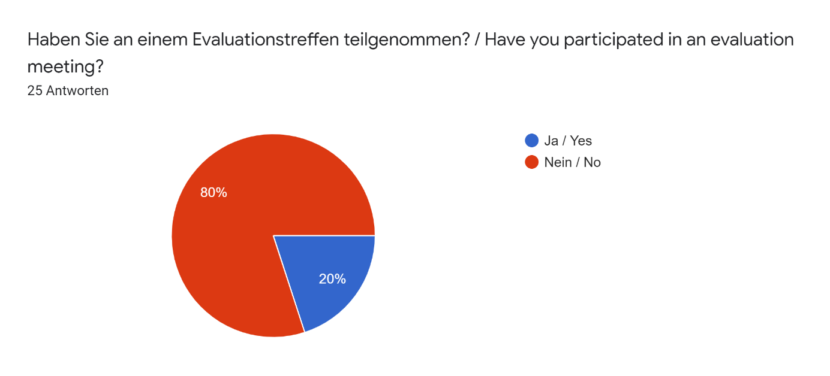

Rückmeldung zum Evaluationstreffen / Feedback on the evaluation meeting

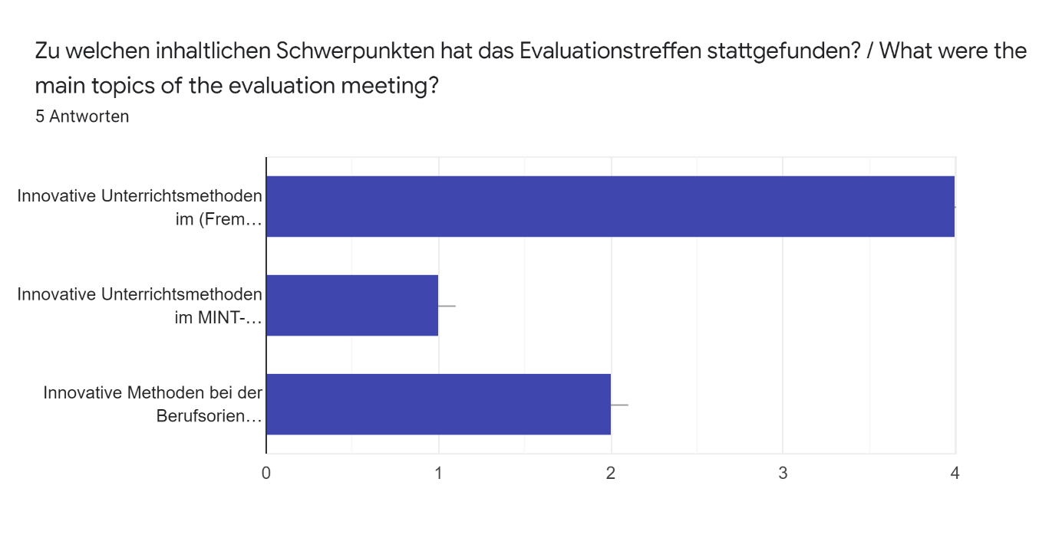

Konnten Sie bei diesem Treffen von Veränderungen / Verbesserungen der Methoden an Ihrer Schule berichten? / Were you able to report changes / improvements in methods at your school at this meeting?

Yes 2 Antworten

Offenerer Umgang mit dem Smartphone als Unterstützung im Unterricht (zum Beispiel als Wörterbuch)

We had a discussion about the differences I had witnessed. It was eyeopening to see how different our schools teaching methods were compared to other ones.

Yes, I was. My group made a presentation which contained comparisons between our school and others in connection with new teaching methods. Then, in the end we summarised our experiences and listed the improvements at our school.

Haben Sie bei diesem Treffen weitere neue Methoden kennengelernt? / Did you learn about other new methods at this meeting?

Yes 2 Antworten

Nein

Yes, I did. Most of these new methods were different digital applications.

I did. it was eye opening to see the different methods of individual / collective cultures.

Was konnten Sie ganz allgemein von diesem Treffen mitnehmen? / What did you generally take away from this meeting?

We learned how teachers in a foreign country teach and what kind of methods the students learn with. We saw what kind of subjects they have and how they study for them. I really enjoyed the foreign language classes. ( English and German)

In general, it was a very useful event. I was able to know new methods of teaching and learning as well. In addition, I really enjoyed that meeting as I felt myself at a serious conference and I found it so interesting.

Es wurde ein Erasmus-Plakat erstellt und mir wurde die Dimension des Erasmusprojekts (Teilnahmeländer, Projektdauer, Projektinhalte und Erlebnisse) bewusst

There is no "advanced way" of teaching. All methods are different and some try to make learning easier but it really comes down to personal attitude.

I learnt about History.

Was hätte verbessert werden können? / What could have been improved?

The only the thing I did not like is that the presentations were unnecessarily long. They contained a lot of details instead of a general summary of each nation's own methods, experiences and suggestions.

Es ging vor allem um Erasmus und nicht um Methoden des Unterrichts primär, weswegen ich jetzt nicht so viel zu der Evaluation sagen kann. Ich habe zu den Unterrichtsmethoden nur einen Fragebogen ausgefüllt.

I'm sorry it has been so long since my trip / meetings. I had a blast and nothing striked me as negative.

In languages

I liked everything about the school and the way of teaching.

Kurzeitaustausch / Short term exchange

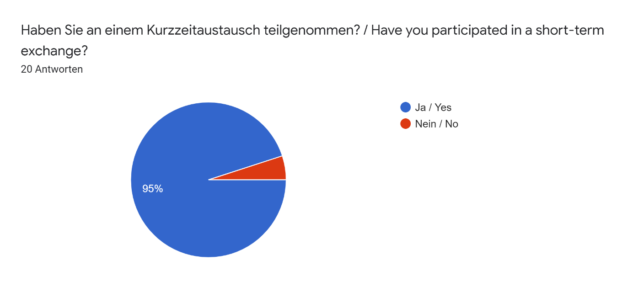

Kurzzeitaustausche / Short term exchanges

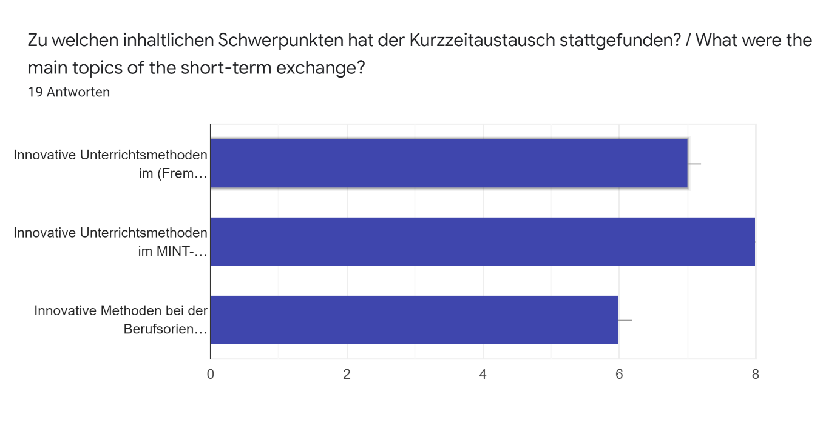

Bei welchem Arbeitgeber haben Sie Ihr Kurzzeit-Praktikum absolviert? / With which employer did you complete your short-term internship?

Wellis

Kein Praktikum

With children daycare

I didn’t do any internship while I was an exchange student.

Atplast

I don’t remember the name of it but it was in a old factory building where people made graffiti’s and other art

at a library

Our employer was a school in Hungary.

Unternehmen für Bürobedarf

táncsics mihály gimnázium

Keinem

School

I did my internship in primary school.

I helped out in a charity shop in West Kirby. It's called Oxfam.

Helmholtzschule (+Dahlmannschule)

Schule in Polen

Easy notes

primary school / Oxfam

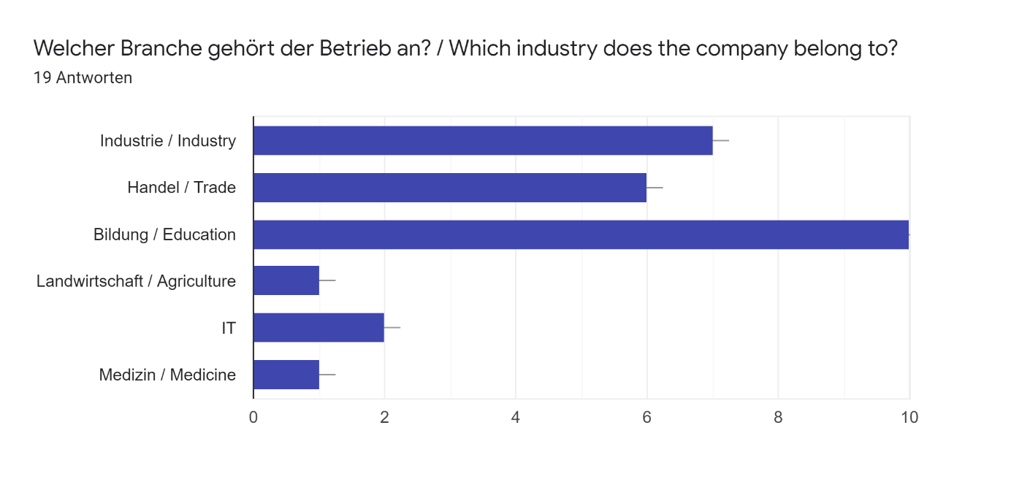

Welche Erfahrungen haben Sie bei Ihrem Kurzzeit-Praktikum gemacht? / What experiences have you had during your short-term internship?

At Wellis we had a brief introduction to the company and its origins in Dabas. Wellis is a bit of a success story in Dabas as the founders grew up there and now have a company that employs 500 people from the area. We also had a tour of the factory to see how the hot tubs were produced from start to finish. We also did another form of work experience at the Gimnazium, making hand cream in the school labs.

-

i made a poster about Hungary

Das Ziel unseres Austausches war unter anderem, von den anderen Erasmus+ Ländern die digitalen Methoden in naturwissenschaftlichen Fächern kennenzulernen. Am Überraschendsten war vermutlich, dass in England im Erdkundeunterrricht Drohnen benutzt werden, um die verschiedenen Erdböden und Flüsse durch Luftaufnahmen zu analysieren. Meine beste Erfahrung war, dass wir dort im Biologieunterricht ein Schweineherz und eine Schweinelunge sezieren durften. Diese Untersuchung war wirklich eine einmalige Chance, die definitiv auch geholfen hat, die biologischen Fachbegriffe und Prozesse besser nachzuvollziehen, indem wir die Organe hautnah sehen konnten. Abgesehen vom Schulischen habe ich auch die ungarische Küche, Volkstänze und Musik kennengelernt

I experienced the work one has to do, when working in a small store. As an example filling books in a shelf or talking to customers.

Keine

I had the chance to see how an average day goes in a charity shop. Mostly I had to split the items into groups and then put them on the shelves. Also, I had to put a price tag on those items.

Ich habe erfahren wie ein Produkt vermarktet wird

It was nice to see how kids learn things in other country.

We painted graffiti’s

Industriearbeit ist nicht wirklich etwas für mich, da es eine sehr eintönige Arbeit ist

I experienced high-level contributions, the willingness of helping to the others in their own advancement, and the desire of making long term relations. After the exchange, I became very optimistic, mostly because of the attitudes I saw. It helped me make my own path in life and of course, was a great opportunity for language acquisition. Not only I got observations in different school life (ex. arrangement and the procession of classes) but I was also touched by the different cultures and the style of living that people represent. (They weren't down-to-earth, were much more friendly and patient than the people in my country. What is more, they spend more time with their loved ones.)

Very positive. We looked around the Wellis factory where they made their hot tubs and also had a talk on the business.

I think that i just help her to take care of children (playing, eating and teaching something small)

/

Wie der Alltag in einem anderen Land abläuft mit einer anderen Kultur und welche Möglichkeiten und Zugänge Jugendliche und Kinder in Bezug auf Bildung und die Berufswahl haben.

We atemped lesson in three different schools, a kindergarten, a technical college and a school teaching from 6th to 1st grade I beleive. And visited them as well.

I learned things about biology, chemistry and physics

Ich habe erfahren, wie ein kleines Unternehmen mit einer innovativen Idee, versucht sich auf dem Markt zu etablieren.

Gab es Unterschiede zu Ihren Praktikumserfahrungen im eigenen Land ? Wenn ja, welche? / Were there any differences to your internship experience in your own country? If so, which ones?

I think the work experience at Wellis was very different to the experiences I've had in the UK. We visited a large scale factory in Hungary where the work experiences I've done have been more local and small scale, such as working at a local shop.

no

Insgesamt ist mir aufgefallen, dass in Ungarn weniger Technik benutzt wurde, als in Deutschland. Vor allem durch die Corona-Zeit sind wir intensiv auf das Arbeiten mit Tablets und Google-Classroom umgestiegen. Im Vergleich zu den Praktika, die ich in Deutschland absolviert habe, kann ich eindeutig sagen, dass ich in Ungarn sehr viel mehr praktische und realitätsnahe Erfahrungen gemacht habe, für die wir in unserem gewöhnlichen Unterricht keine Zeit gehabt hätten. (Herstellung von Handcreme, Analyse von unterschiedlichen Gesteinen, Sezieren von Organen...)

Only a small language barrier.

Keine

Here in Hungary I've haven't had an intership yet, but I had to do community work ( it's a requirement to do 50 hours of community work before our finale examinations) and it was very similar to my intership in England.

Bei easy notes wurden die Praktikanten noch stärker in die Prozesse einbezogen.

They have different methods to teach.

I had no internship in finland

Nein

Honestly, the program in the different countries is basically the same that is why I suppose, there're no considerable differences. Although, if one needs to be mentioned it would be the difference btw. the attitude of teachers towards the newcomer students, since in Germany I had much help, "freedom" (ex. more time alone, could choose my lessons, teachers spent time with me showing and explain different things) I was also handled as equal, thus I felt more confident, and that is why I felt that I'm the part of that community.

The way that the company was run and the way the employees worked was different in Hungary than the UK

I think it was quite same than in Finland. My mom did that job in home for many years before she changed carieer. So it was very similar what i have seen at home.

/

.

Mainly what we found were cultural differences, such as a sauna in a gymnasium in the technical college, children being allowed to have their bottle of soda on their table.

Ja, es gab Unterschiede, da es ja auch ein anderer Praktikumsplatz war. Ich habe in Deutschland ein Praktikum in einer staatlichen Einrichtung gemacht, während ich in Polen in einem Unternehmen gearbeitet habe.

Was konnten Sie ganz allgemein von diesem Besuch mitnehmen? (optional) / What in general did you take away from this visit? (optional)

I learnt a lot about life and school life in Hungary. Sitting in on the different year groups lessons was really insightful to see how they were taught differently as well as picking up a few facts. I also got to experience Hungarian culture with trips to Budapest to sightsee and Kecskemet to watch Anna Karenina. Overall, the visit was a great experience and I'm glad I got to make some new friends along the ay.

-

I didn´t know about the Oxfam cooperation yet and i think its really good to have something like this, that helps people in trouble with selling old stuff, people dont need anymore.

Ich konnte viel über Menschen lernen

Ich habe gesehen, wie eine Schule in Polen organiziert ist und funktioniert. Desweiteren konnte ich bei meinem Praktikum lernen wie ein Ausländisches Produkt auf den deutschen Markt gebracht werden kann und könnte mich an diesem Prozess aktiv beteiligen.

It was amazing experience. I learned very much English and new ways to learn things. It was also new country to me and that that I was there sometimes alone, without other people from my school was new to me.

Take delight that you had the chance to perceive. Utilize your new relationships and experience. Learn from a new perspective (meaning time in school, with your families, free time and "workplace"). Learn that people might vary and that's sightliness, but we all belong together. Above all, cultivate and enjoy.

There are big differences in lifestyle and education. Fascinating to see how people live

I saw the diffrences in teaching. I think that now i appreciate my countrys teaching methods more.

Die verschiedenen Unterrichtsmethoden, die praktiziert werden. Vor allem die Schüler\*innen aus Polen sinf mir im Gedächtnis geblieben, die vor allem in der Nutzung von moderner Technik sehr weit waren. Auch die finnländischen Methoden, die vor allem sehr individuell an der Lernenden orientiert waren, haben mich beeindruckt. In Frankreich selbst war der Unterricht erstaunlich steif und frontal und das Fremdsprachenniveau recht niedrig (,was eventuell sogar zusammenhängt?). An sich war die Schule sehr gut ausgestattet und auch auf praktischen Unterricht ausgelegt, was ich sehr positiv fand. Allerdings waren sowohl das Gebäude, als auch die Lehrgegenstände schon in die Jahre gekommen.

Neue Kontakte in unterschiedlichen Ländern wie zum Beispiel Finnland, Ungarn und England

Ich habe die Lebensweise aus einem anderen Land kennengelernt.

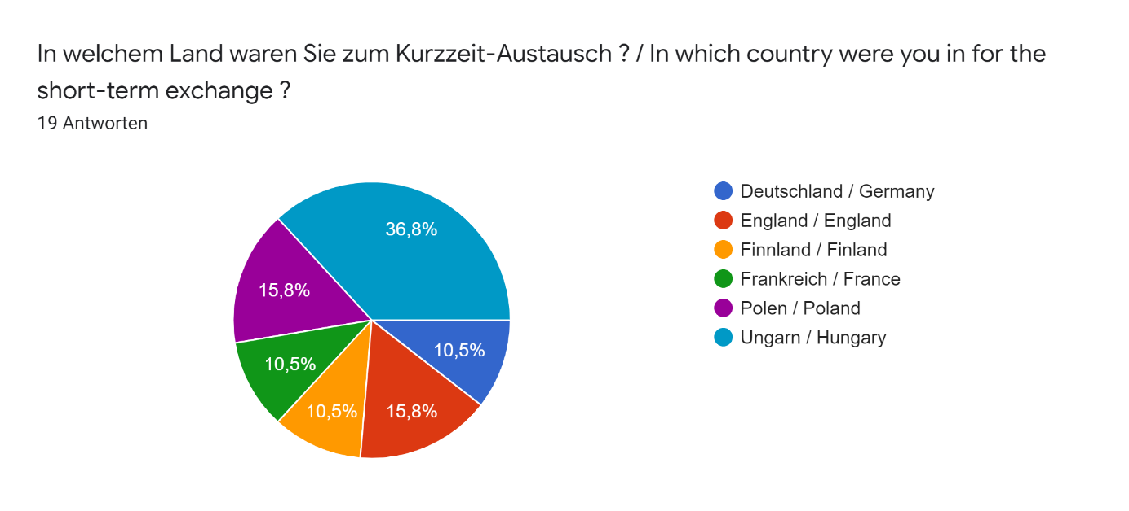

Kurzaustausch in Deutschland / Short exchange in Germany

Konnten Sie Unterschiede in der Vermittlung der Inhalte feststellen? Wenn ja, welche? / Were you able to identify differences in the way the content was communicated? If so, which ones? 2 Antworten

No i wasn’t able

Not really, everyone made their bests.

Welche Besonderheiten haben Sie bei der Gastschule erkennen können? / What special features did you notice at the host school? 2 Antworten

The day’s were a lot longer than in finland

Student friendly teaching methods, nice inner and outdoor places, no cells in school, experimental education, strict but also truthful student-teacher realtionships.

Kurzaustausch in England / Short exchange in England

Konnten Sie Unterschiede in der Vermittlung der Inhalte feststellen? Wenn ja, welche? / Were you able to identify differences in the way the content was communicated? If so, which ones? 3 Antworten

-Verry good digital methods used in school (includes better Pc´s) -Way more Experiments made in Chemistry Class -every Teacher has it´s own Classroom => different design with Posters in every room

No, I wasn't

Not much. It was almost same than we have.

Welche Besonderheiten haben Sie bei der Gastschule erkennen können? / What special features did you notice at the host school?3 Antworten

-Girls school -Fingerprint used in Cafeteria insted of students ID -entire House for Upper Classes to rest in lunchbrakes -school uniforms -way more Subjects than in Germany (Cooking/ Design class/ Psychology /Theater class) -you only have your 5 A-level subjects in the higher Classes

The canteen at the host school was more popular and way better than in my school. Also, the library was bigger and it contained books which are popular among teenagers nowadays.

The school waa way much bigger than my school in Finnland. They have those passes or things like that what they need to wear. And they also have school uniforms which we don't have.

Kurzaustausch in Finnland / Short exchange in Finland

Konnten Sie Unterschiede in der Vermittlung der Inhalte feststellen? Wenn ja, welche? / Were you able to identify differences in the way the content was communicated? If so, which ones? 2 Antworten

No it was quite similar

Viel direktere Wissensvermittlung

Welche Besonderheiten haben Sie bei der Gastschule erkennen können? / What special features did you notice at the host school? 2 Antworten

The teachers had a very close relationship with the students

Kleine Gruppen, angenehme Aufenthaltsräume, digitale Unterrichtsmethoden

Kurzaustausch in Frankreich / Short exchange in France

Konnten Sie Unterschiede in der Vermittlung der Inhalte feststellen? Wenn ja, welche? / Were you able to identify differences in the way the content was communicated? If so, which ones? 2 Antworten

Teaching was quite just sitting and listening. Not so much with videos or pictures. I would liked More talking with other students in groups and open things. Lessons was bit longer too than i have used to.

Wie schon beschrieben war der Unterricht in Frankreich sehr frontal und steif. Die Schüler\*innen wurden wenig bis gar nicht eingebunden und hatten so wenig Möglichkeit die Sprache, die sie lernen sollten, auch zu sprechen. Auch fand der Unterricht auf Französisch statt, was das Einfühlen in die englische Sprache schwierig macht. Es wurde meist als Einstieg ein Film oder anderes Medium genutzt, um in das Thema einzuleiten, wohingegen in meinem Unterricht entweder die Lehrbücher oder ein gelesenes Werk genutzt wurden. Viel stärker als in meinem Unterricht wurde ein Uningsheft für Zuhause in den Unterricht eingebunden und auch sonst hatte ich den Eindruck, dass vor allem die Sprache schriftlich zu beherrschen das Hauptziel war.

Welche Besonderheiten haben Sie bei der Gastschule erkennen können? / What special features did you notice at the host school? 2 Antworten

Everyone was so concentrated to studying and very polite to the teachers. I dont see that so much in Finland. They got much homework and everyone had them done.

Die Schule hatte Räume, in denen der Umgang mit Pflegebedürftigen und Babys gelernt werden konnte. Außerdem gab es Räume, in denen Aufgaben unter Aufsicht erledigt wersen sollten. Und natürlich eine sehr gute Cafeteria

Kurzaustausch in Polen / Short exchange in Poland

Konnten Sie Unterschiede in der Vermittlung der Inhalte feststellen? Wenn ja, welche? / Were you able to identify differences in the way the content was communicated? If so, which ones? 3 Antworten

Meiner Meinung nach ist in Deutschland der Unterricht abwechslungsreicher und auch digitalisierter z. B. PowerPoint, one note etc.

Jaa. Im Vergleich zu unserem eigenen System werden die Schüler an polnischen Schulen größtenteils theoretisch über Ihre Möglichkeiten in der Berufswelt informiert und haben keine praktischen Erfahrung wie zum Beispiel der Besuch einer Uni oder 2-3 Praktika während der Schulzeit.

Ja, in machen Fächern, wie französisch hatte ich das Gefühl, dass meine Schule da thematisch weiter ist. In Geschichte auf dem selben Stand, nur ein andere Schwerpunkte.

Welche Besonderheiten haben Sie bei der Gastschule erkennen können? / What special features did you notice at the host school? 3 Antworten

Profilklassenmit Schwerpunkten

Es war eine Oberstufenschule Und alle Schüler waren sehr offen und kommunikationsfreudig. Es hat ein guter Austausch zwischen den Schülern aus den unterschiedlichen Ländern stattgefunden und auch die Gastfamilien der Schüler waren sehr freundlich.

Es ist ein anderes Schulsystem.

Kurzaustausch in Ungarn / Short exchange in Hungary

Konnten Sie Unterschiede in der Vermittlung der Inhalte feststellen? Wenn ja, welche? / Were you able to identify differences in the way the content was communicated? If so, which ones?7 Antworten

There were some differences in the way students were taught at Dabas Gimnazium. In a grade 7 english lesson, there was a lot more class interaction, where the students were able to play a word game to learn english vocabulary. In another english lesson with older students, they used a 'Buzz in' website to answer questions and used 'quizlet live' online flashcards to teach; this also was something new to me. In one history lesson, powerpoints were used, similar to the lessons I've had, however, the teacher also incorporated quizzes and question and answers.

I think the method were almost the same in Finland and in Hungary.

Habe ich schon in der vorherigen Frage beantwortet. In Ungarn wurden eher weniger digitale Medien genutzt, jedoch wurden die naturwissenschaftlichen Themen mit sehr vielen und hilfreichen Versuchen erklärt. Sowohl in Chemie, Biologie als auch in Physik und Mathe haben wir für jede Aufgabe Versuche gemacht.

Eigentlich war alles ziemlich ähnlich und ich kannte vieles auch aus Deutschland

there seemed to be a more University style teaching approach where students made their own notes

I don't think there were much difference, because just like in France (from what I have experienced) they work on one theme during a certain amour of time. They introduce this theme with with any kind of media they can find (video, text,...). They try to speak in the language they teach as much as possible. Well there might be a difference I found, for the younger one who were learning German the teacher had made them learn a song, I found this idea really interesting as children are having fun singing and still learning vocabulary because they also analyze the song with their teacher.

Welche Besonderheiten haben Sie bei der Gastschule erkennen können? / What special features did you notice at the host school?7 Antworten

At Táncsics Mihály, they had 10 minute breaks between every lesson and a school radio that was run by the students. I also noticed that students are seen more as colleagues compared to my school. Lessons are more conversational and discussion based, depending on the class sizes, and less focused on notetaking and copying off the whiteboard. The school also had a points system for each form and if they gained enough points, they could have days off. Also, there were no after school or lunch time clubs.

It was a much bigger than our school.

Die Lehrer und Schüler hatten in Ungarn engere Beziehungen zueinander als in Deutschland. Die Schule hatte eine professionellere Schutzkleidung für die naturwissenschaftlichen Fächer und auch extra Räume, in denen nur Versuche durchgeführt wurden.

Sie war eher klein und alle Schüler und Lehrer waren irgendwie sehr familiär

It was a lot smaller, the school was nicely decorated with subjects and experiences

All the classroom were decorated by the students according to the lessons that were taught inside of them. They were also showing the cup and medal they won in different events such as sportive one, and that's something we don't really have in France. And they also had a hut inside the school for the younger ones with plenty of pillows around it.

I don’t know

Allgemeine Evaluation / General evaluation

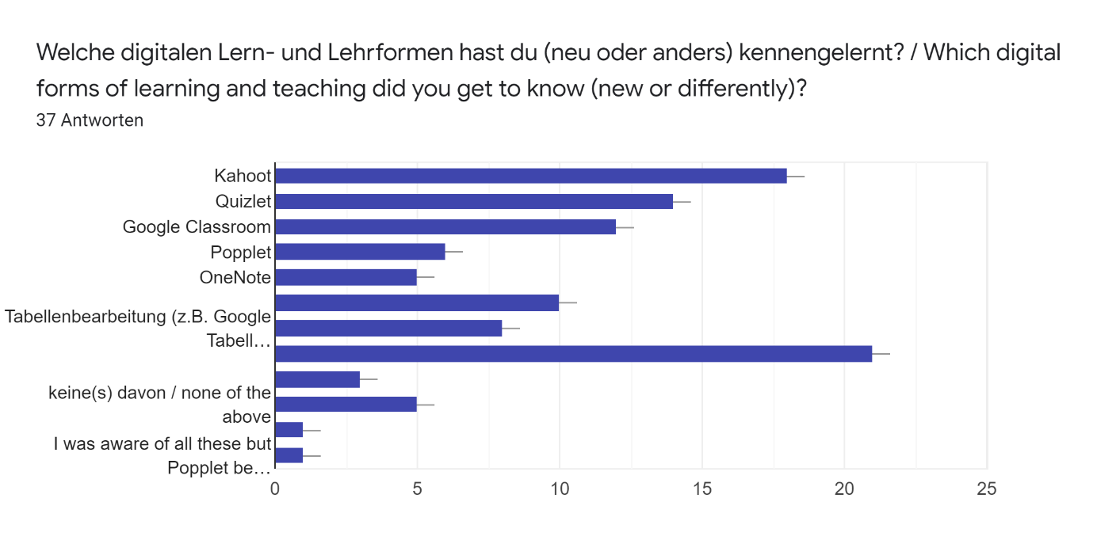

Welche innovativen (nicht digitalen) Methoden haben Sie neu kennengelernt? / Which innovative (non-digital) methods have you newly gotten to know?

* 4 Antworten

Nothing 2 Antworten

Conversational lessons.

keine

„Sprachenräume“: in einigen Klassenräume wurde nur eine Sprache unterrichtet und dieser Raum war mit Flaggen und anderen Dekorationen geschmückt. Man kommt also in einen Raum und einem „Land“ an

Weiß ich leider nicht mehr genau.

Matrix

Durch die anwesenden Finnen eine deutlich engere Betreuung der Lernenden.

The new methods I newly gotten are digital methods only

Bekannte Spiele in Fremdsprachen spielen, viel praktische Arbeit im MINT Unterricht

I think that i havent learn anything new because i havent been in school since 2019 when i gratuaded.

The students in Finland had to show their own presentations to their classmates in classes, which I enjoyed. I think it's an excellent way of learning and remembering the things they learn about. We don't really have to do presentations in my school because the teachers make them and show them to us instead.

I've met with those before.

Kahoot, Quizlet, Popplet

Teacher using applications such as kahoot with their students. It's a nice way to check whether or not a lesson is understand and we the students, are having fun while using it.

The most important was groupwork. In our school groupwork exercises were downplayed before the project and I was quite surprised when I saw that during most of the lessons teachers gave groupwork exercises to their classes in France.

small whiteboards for students to be handet out in lessons.

learning at school thanks to games

I new all the methods before, although I'm not practising all of them.

A grade 7 english vocabulary game 'King of the Words'

The new methods I have newly gotten are digital methods only.

nothing

/

Teaching by building/crafting things and making team projects with little guidance how to do them.

I didn’t learn new digital methods.

Das Lehrprinzip

Arbeiten mit Drohnen für Luftaufnahmen;

making your own notes

Microsoft Teams

None

Mind maps und kreative Darstellungen in Form von Schaubildern

Keine

Dieses Spiel für Mathematik die Aufgabe mit den Tischtennisbällen

Welche Inhalte und Ideen konnten Sie von den anderen Nationen an die eigene Schule mitnehmen? / What content and ideas could you take from other nations to your own school?37 Antworten

That we could have more digital learning

I don’t know

-

I think we could also do more projects in Finland.

More learning together. In Finland its more likely for students to learn individually and alone. Not in study groups or with friends etc.

All were famialiar or already in use

I think More talking together and playing and learning at the same time

We could have more building/crafting-based studying methods and more team projects with different kinds of ways to make them (for example a play, a game)

Laptops in School /more subjects

Die Nutzung von mobilen Endgeräten zum individuellen Lernen

We need to be more relaxed

Wie man einen guten vortrag hält

In Finland, the students had to listen to audios with headphones. The speaker's voice is much clearer that way than listening to the audios with a radio. You can also concentrate more as you can't hear other students. My school could use this kind of method to listening exercises. The students could also use laptops during the lessons.

Das Sprachenraumkonzept und kahoot

Arbeit in Kleingruppen und neuen Methoden

keine

Well working while having fun is definitely something I'd like to see in France. Our lessons are someyimes too academic, everything is about the using the word and speaking proper English Wich is totally understandable. But the point of learning a language is to be able to communicate with other persons. And students tempt to forget it as in France the only kind of motivation we have is to get a good mark for the vocabulary test. But with applications like kahoot or just little games in class learning becomes more playful.

More interactive lessons.

The school card to open the doors, the really good snack bars

Spielerisches Lernen, schulexterne Projekte in der Schule unterstützen und starten, anstatt sich auf schulinterne Projekte zu beschränken (Beispiel: Schüler entwickeln in der finnischen Schule eine App und bringen sie in den Playstore)

Small group arranged groups, comulsory readings in foreign languages, more projects to presentate (skills development)

I could take the idea of improved groupwork exercises and making projects instead of giving simple homework.

Es ist eine fantastische Erfahrung, wenn sie daran teilnehmen können.

We should use more digital methods. It would be better if we had less lessons like in other counties.

We should use more digital methods. It would be better if we have less lessons

There was some kind of lining up thing in history class, where students took papers where was some things that has happened in history and then they lined up in the right order. That could be nice to do in own classes too.

learning in little classes (around 15-20 students)

Matrix

We mostly use these apps in Hungary as well and now we have to use more technology because of the pandemic.

having more interactive teaching and making our own notes

I think more discussion-based learning would be beneficial

writing tests online or in kahoot

Das häufigere Nutzen von GeoGebra in Mathe

In England hab ich gesehen, dass man besonders viel mit Whiteboards an Schulen gearbeitet hat, was sehr hilfreich ist und man hier auch definitiv umsetzen sollte.

Dass man zum Beispiel Praktiker über einen längeren Zeitraum anbietet, um wirklich eine Möglichkeit zu erhalten den Beruf tief greifender kennen zu lernen

Dass Programme wie Excel usw. auf dem Lehrplan stehen

The use of interactive apps for diversifing teaching materials as Poplet, Quizlet... and so making the teaching more "personalized" in front of the student's needs.

Konnten Sie hiervon erste Umsetzungen an der eigenen Schule beobachten? Wenn ja, welche? / Have you been able to observe the first implementations at your own school? If so, which ones?37 Antworten

There has been more digital learning

No

-

I think I didn’t get any implementations.

I haven't. Unfortunately my trip was during my last school year. But I know for a fact that my school knows what they are doing. :) They are also keen to trying new stuff regularly.

Yes, all

Yes quite many. talking and playing was already in the language lessons

No, I haven't been able to.

way more use of Digitan Methots

Das digitale Lernen wurde stärker in den Fokus gerückt und eingebunden.

No i have not

Wir haben in Chemie mal Kahoot gespielt und in Kunst auch

We use more digital forms of learning, like kahoot or quizlet than we used to.

Vertiefte Nutzung von Google-Office-Anwendungen, Google-Classroom und der Umgang mit Smartphones

Schulwlan, Arbeit mit Tablets

nein

The teachers who did some of those exchanges definitely started using applications like kahoot or quizlet.

As I graduated soon after the trip, no.

Yes.

Ja, viele Lehrer\*innen haben in den lettzten Jahren angefangen Google Classroom und Power Point zu benutzen. Außerdem haben wir ab und zu die Möglichkeit Quizlet zu spielen.

Yes, my school uses Word documnets, Excel, different kinds of presentations and sometimes kahoot.

Since the end of the project I have been able to observe the implementation of using more mobile applications and more groupwork exercises. Teachers also give us more projects to carry out in a longer deadline instead of simple homeworks.

Viele Kinder konnten an vielen Auslandreisen teilnehmen.

Yes, we use kahoot regularly. There are much more digital methods than before.

Yes, we use kahoot regularly, we do more presentations and there are much more digital methods than before

No, not yet.

no, I don't

No I haven't

As I've mentioned we use those apps at my schook as well, but we mostly use Quizlet and presentations.

Not really, but Mr Thomas does already teach in the University style

I haven't yet seen these implementations, probably due to coronavirus.

no

Flipped Learning; das Hochladen von Erklärungsvideos oder von PowerPoint Präsentationen, die mit einem Ton unterlegt werden (von Lehrern). Außerdem nutzen wir seit Neustem auch zumPad, eine Seite, auf der alle zusammen über den Link zur Seite ihre Ergebnisse zu einem bestimmten Thema zeitgleich eintragen können. Ein weiteres Tool, Mentimeter, wo die Schüler gemeinsam eine Art MindMap erstellen können, indem jeder einige Begriffe zum Thema eingibt, die dann an dem Beamer erscheinen.

Es lässt sich definitiv sagen, dass sich unsere Schule in Sachen wie Technik in den letzten zwei Jahren gut weiterentwickelt hat. Dienste wie Kahoot werden im Unterricht angewendet, aber auch Classroom. Auch wurden an unserer Schule Tablets zur Verfügung gestellt, was ein guter Schritt ist.

Ne

Einbindung von Programmen wie z. B. Excel im Unterricht

Yes, we noted that teachers work more and more with diverse methods as mind map, videos, ..., or new apps like Kahoot, Socrative or Google Classroom (especially during the lockdown).

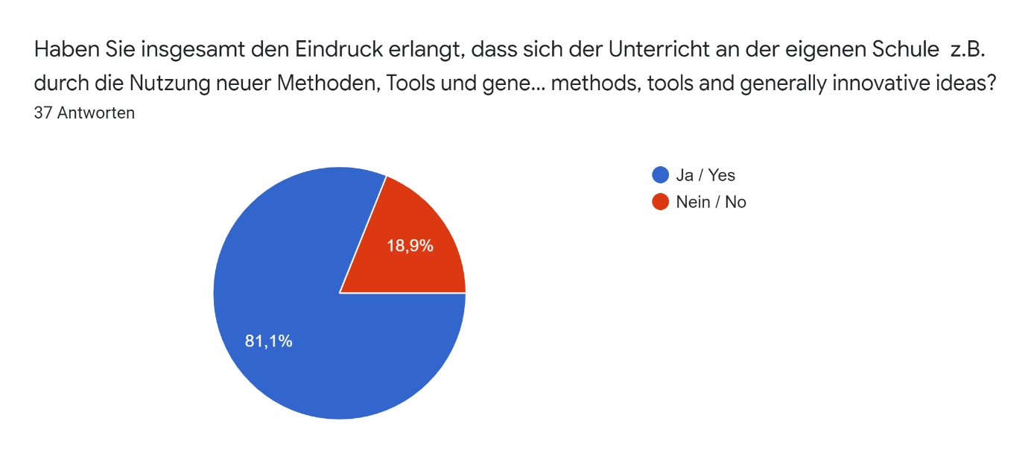

Welche Ideen sollten in Zukunft an der Schule (weiter)verfolgt werden? / Which ideas should be (further) pursued at the school in the future?

-

2 Antworten

Using laptops, interactive lessons

1 Antwort

We need to learn the languages more time

1 Antwort

More Subjects like a Craft course.

1 Antwort

Kleinere Lerngruppen, die enger und nach individuellen Bedürfnissen betreut werden.

1 Antwort

Nutzung des Classrooms und Präsentationstools. Auch Kahoots und Quizzlets sind sehr hilfreich zum (spielerischen) und gemeinsamen Üben von Lehrinhalten. Nicht so effektiv finde ich die Nutzung von komplizierten Tabellen, Excel usw., da man für die Nutzung dieser Tools eine extra Einführung und Erläuterung benötigt, um sie sinnvoll und produktiv nutzen zu können.

1 Antwort

Die Kinder können von Sprachen in ausländische Programmen lernen.

1 Antwort

Digitaler werden wie in Finnland

1 Antwort

keeping it traditional and not commercialising it

1 Antwort

Google Classroom

1 Antwort

Kleinere Gruppen

1 Antwort

Lernen durch die Verknüpfung von den Sinnen

1 Antwort

Writing test that have a/b/c answers to choose from

1 Antwort

Everything should be illustrated

1 Antwort

Using the digital methods more

1 Antwort

I don’t know

1 Antwort

Even more digital learning

1 Antwort

Home-Schooling präzisieren. Mehr Dokumente online zur Verfügung stellen und öfter mit beispielsweise iPads in Kontakt kommen, da es sehr hilfreich sein könnte.

1 Antwort

I guess sky is the limit for trying something new. You don't know when you've hit the goldmine until you're sitting on one. And there isn't anything bad with trial and error.

1 Antwort

Our school should focus on further improving usage of digital methods in studying/teaching and also increasing teamwork/pairwork and doing them in different styles, not just by doing a presentation.

1 Antwort

School should keep up with trends and technology

1 Antwort

It would be great to use more technology in other classes too, as we usually use technology only in language class.

1 Antwort

More digital based learning such as 'Quizlet Live' and 'buzzing in' to answer questions

1 Antwort

The main ideas should involve creativity, pleasurable environment, focused classes supported by IT, out of school learning experience

1 Antwort

Weiterhin die Benutzung von alten/gängigen Unterrichts Methoden. Neue/Digitale Methoden sind nur sinnvoll, wenn diese an passenden Stellen eingesetzt werden. Oftmals sind diese kompliziert und überflüssig und erschweren das Lernen und verstehen.

1 Antwort

The ideas that I have mentioned before should be further pursued at the school in the future. Groupwork helps students to learn how to cooperate with others and digital methods makes school more enjoyable for younger students. On the other hand, I think we should keep textbooks in use, too.

1 Antwort

Group learning, more exercises together

1 Antwort

little classes in order to learn in good conditions

1 Antwort

More interactive lessons, a more conversational tone, the use of technology.

1 Antwort

E-learning, using laptops, interactive lessons.

1 Antwort

Students should not learn just in order to get good marks. Penfriends are hence a really good idea and students should have more of them, as we can only learn a language by using it everyday.

1 Antwort

All already are

1 Antwort

Die Einsetzung von Medien und digitalen Diensten. Außerdem die kreaive arbeit und durch handwerkliches Schaffen sich an Themen heranzuarbeiten.

1 Antwort

Interaktives Lernen mit dem Smartphone über kahoot oder Quizlet, da das sehr spaßig ist

1 Antwort

Those already in place (such as the use of new ineteractive softwares) would require further investigation.

1 Antwort

Maybe we can alway make the digital learning methods better.

1 Antwort

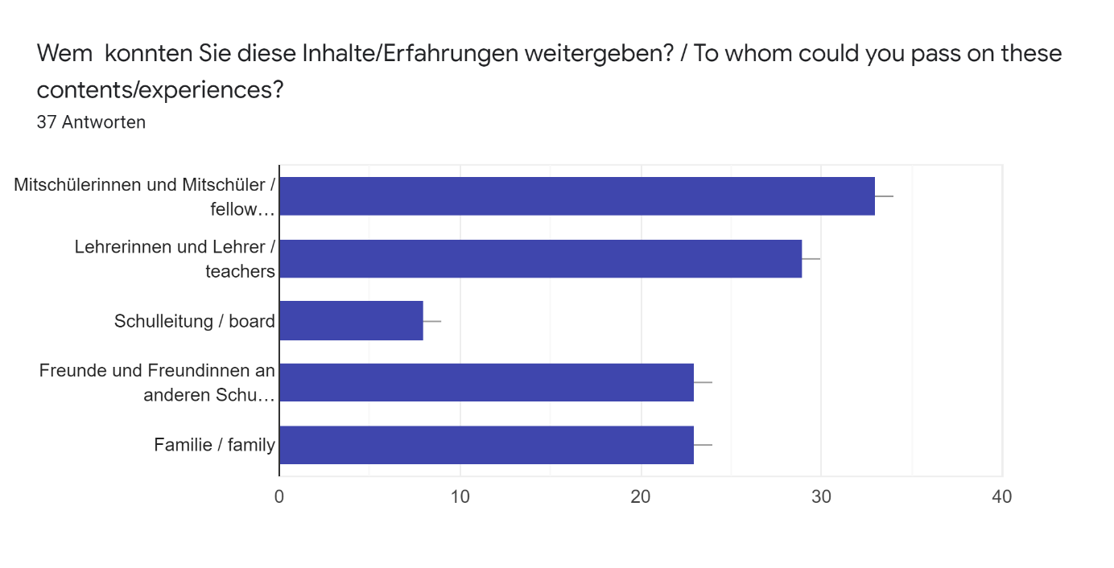

Beschreiben Sie bitte Ihre Erfahrungen! Alles, was Ihnen einfällt, kann für uns hilfreich sein! / Please describe your experiences! Anything you can think of may be helpful for us!37 Antworten

The experience was really good

I think that meetings are instuctive in every way and i hope that they will continue in the future.

It was fun and very educational experience. It was nice to get to know how others countries schools and culture work.

I think exchange was wonderfull and it’s always nice to see how things work in another country. You should keep doing these projects still!

Erasmus+ was one of the best experiences I had within my school years. Thank you for giving me an eyesight to differencies within schools and most importantly great memories :)

All went well, it was planned well. No complaints.

School changes are good way to see good in your own country and you find new things to your countrys teaching methods

I enjoyed being part of the Erasmus program by attending the Frankfurt meeting in autumn 2018 and hosting a German student for a week in autumn 2018. The program gave me a possibility to further explore and get to know German culture. I also liked to pass on our school's methods and Finnish culture to other students and teachers. This project was a great way to enhance European cooperation and mutual goals by sharing best methods to others and taking on new methods.

It was verry nice to experience an other Countrys school System, and I think i learned a lot of helpfull things for my future. Its nice To see all the differences, and commonalities between the British and German people. The fakt, that I had to speek English all day helped me to jump out of my comfort Zone, and this really improved my English Skills.

Vor allem das Leben in der Gastfamilie war großartig, um einen guten Einblick in das Lernen zu bekommen

In my opinion one week is not enough, maybe two. Otherwise i think this program is helpful.

Es war großartig diese Menschen kennenzulernen ich hatte viel Spaß und es war wirklich sehr aufregend ich wünschte ich könnte so eine Erfahrung nochmal machen.

I had a really interesting and memorable experience in Finland. The lessons were enjoyable and the teachers were nice just like the students. The methods the teachers used for teaching were interesting. I also liked the idea of using laptops in classes.

Das Treffen in Finnland war für mich vor allem ein Ausprobieren von Methoden, von denen ich mir aber nicht vorstellen kann, dass einige an unserer Schule funktionieren würden, da die Arbeitsmentalität anders ist (noch sehr analog und auf das Papier als Medium fokussiert) und die Umgewöhnungsphase langwidrig sein könnte. Außerdem wäre eine Befürchtung, dass bei den ganzen Anwendungen mit Spaß-Charakter der eigentliche Lerninhalt womöglich untergeht, da man von den neunen Technologien „abgelenkt“ ist.

Ich kann aus 2 1/2 Tagen in der Schule und 2 Tagen im Praktikum nicht viel mehr berichten, ich wäre daher auch dafür das die Austauschwochen länger gestaltet werden und auch der Austausch mit anderen Schulen intensiviert wird.

Ich habe im Allgemeinen eine ganz andere Art von Schule in Polen kenngelernt. Nicht nur das Schulsystem war anders, sondern auch die Atmosphäre in der Schule. Es gab viele soziale Projekte von der Schule aus. Beispielsweise sammelte man Essen, was dann zur Weihnachtszeit an arme Menschen gespendet wurde. Die Menschen haben mich sehr warmherzig aufgenommen und mir alles gezeigt und erklärt.

I can't think about anything but I just wanted to thank you for the job you've done!

In our schools, the teachers usually explain everything, and the students mostly just listen. In France, it seemed that lessons were more interactive.

We went to a factory where we learnt about the birth of an undertaking.

Ich habe mich vor allem gefreut viele Menschen meines Alters aus ganz Europa kennenzulernen. Meiner Meinung nach stärken gerade diese Projekte ein junges Europa. Mit vielen, die ich durch dieses Erasmusprojekt kennengelernt habe, habe ich noch ab und zu Kontakt und sehe auf sozialen Medien, was sie gerade machen. Außerdem kriege ich so einen Blick von Jugendlichen auf beispielsweise die politische Situation im jeweiligen Land, was mir persönlich hilft die Lage zu verstehen und in mir Interesse weckt, dem selber nachzugehen.

To tell the truth, I could not say anything wrong except the usual unorganised feeling at the begining but that all went away. I loved those days there. The sphere that surrounded me was wonderful. People and even the stranger ones were helpful and patient. My host families were just like my own one at home, I enjoyed the things we did together (dinners, halbe-halbe, training) and the fact that they involved me in their lives. In the school, although I was a bit older I felt like a first year old who experiences the world. I really liked the literature class in the museum that was the way that literature must be taught. Thank you All for this phenomenal journey!

Participating in Erasmus+ was a life-changing experience for me. When I travelled to Lamballe people were very friendly and helpful. The only problem that I experienced was that we did not have too much time for special activities because we had to spend the most of the days at school. I do not mean entertainment as I am aware of the real purpose of this project. But I missed cultural activities, for example visiting to local museums.

Ich denke, dass es war ein nützliches Programm. Die Kinder konnten neue Kulturen kennenlernen und sie haben die Sprache geübt.

Everybody was kind. I had a really good time. The lessons were interesting. Everything went good. I can't mention any bad things. I am really grateful.

The lessons were interesting, everything went good. I have met a lot of new people. I'm really grateful. It was a good experience

This experience was amazing. It's amazing that this was possible and it was an eyes-opening experience. I learned some new things and learned to speak more English. I also became a bit more confident and independent. The host family was super nice and they showed and told me different things about the city and the country. Everybody at school was nice and they made me feel welcomed. They also asked a lot of questions about Finnland and it was nice to tell them about my homecountry.

I discovered that we can go at school for just 4 or 5 hours, which is enough for studients who are sometimes better in class than french studients who work for 7 or 8 hours per day at school. That's a great form of organisation which have to be exported in France. Thanks to it, french studients will not be as tired as they are today.

Our trip was amazing, my host family was so kind. The most memorable moments for me are the programs with my host boy.

I really enjoyed my time in England. I found there education system very interesting and different from ours( they have longer breaks, but they can also choose which classes they want to participate in, they don't have textbooks and they have to wear uniforms). They also start the school an hour later than we do, but we finish at the same time. The public transportation in England is more developed than in Hungary, the trains are way faster.

I had an amazing time. It was great to see how they live because it is so different to us

Overall, my short exchange to Hungary was a great experience, one that I've never had before! I had a great time in an outside the school and I'm really glad I was chosen to attend the trip!

I had a great time because of the people who were surrounding me

Schlußendlich kann ich sagen, dass es für mich wirklich überraschend war, dass ich sehr wenige Probleme beim Verstehen der Naturwissenschaften auf Englisch hatte, da sie auf jeder Sprache im Prinzip gleich funktionieren. Meine restlichen Erfahrungen habe ich schon auf der ersten Seite beschrieben. ;)

Ich finde, dass mein England Austausch mir das englische Schulsystem sehr nahe gebracht hat und ich jetzt auch eine Vorstellung habe, wie verschieden Unterricht an anderen Schulen aussehen kann, auch wenn sich Inhalte kreuzen. Übermittlung der Inhalte spielt eben eine sehr große Rolle und mir hat das Projekt gezeigt, dass es definitiv Luft nach oben in Sachen wie Technik in deutschen Schulen gibt.

Mir hat der Austausch sehr gut gefallen und war eine tolle und bereichernde Erfahrung nicht nur in meiner Schullaufbahn sondern auch in meinem Leben generell. Zusammen mit unseren Lehrkräften und einer weiteren Schülerin hatten wir die Möglichkeit unsere Schule zu präsentieren und Ideen und Eindrücke der anderen Länder zu sammeln. Insbesondere der Einblick in die Kultur, die kulinarische Welt und das Familienleben in Polen hat mir sehr gut gefallen. Die Interaktion mit der polnischen Gastfamilie hat einwandfrei funktioniert und durch den Austausch haben sich Kontakte und Freundschaften in verschiedenen Ländern entwickelt.Ich würde diese Erfahrung und den Austausch mit Erasmus jedem weiter empfehlen und auch immer wieder gerne machen.

Ich habe erfahren dass in Polen nicht wirklich Klausuren sondern nur Tests geschrieben werden

Myself, a comrade and 3 teachers left from September 7 to 11, 2019 in Poland. (So we arrived by car after 2 consecutive flights.) I enjoyed being welcomed into a Polish family, to a student with whom I immediately got along. I enjoyed discovering a new language, city and culture. Just as I found it very rewarding to discover other education and guidance systems and all that other countries could bring us through work stations as well as micro-teaching. I enjoyed the activities offered, although there was an activity called "Career counselling city rally" which was a bit tricky since we didn’t necessarily know Polish ! More generally, it was a memorable stay, short and very dense in meetings and knowledge but absolutely enriching ! So that when the time of the return came, we left ideas and memories full head !