Evaluation Erasmus+ Lehrkräfte

Planungstreffen / planning meeting
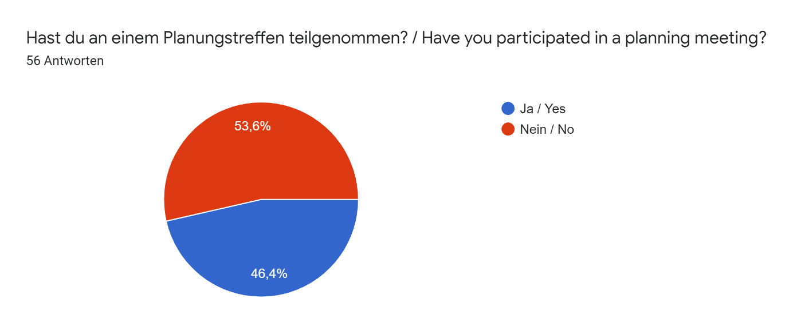
Rückmeldung zum Planungstreffen Feedback on the planning meeting
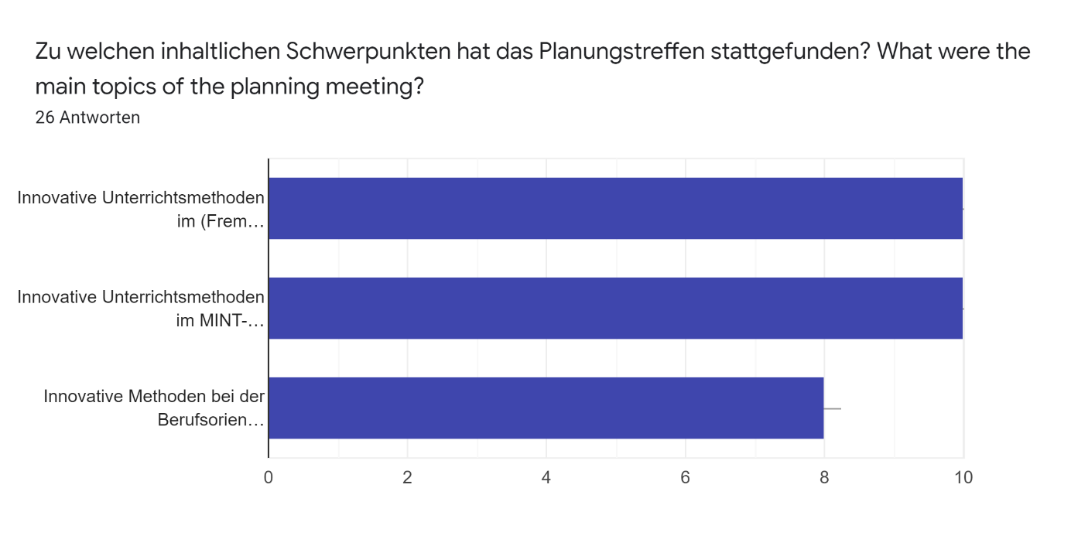

An welchen Themen hast du konkret gearbeitet? What topics did you work on?
26 Antworten
Entdeckendes Lernen im Fach Mathematik
Traditional and digital methods in Hungarian Education.
Schwerpunkte bei der Berufsorientierung
Math and science
We focused on the use of technology in STEM subjects.
Worked on delivering new methods to language learners in the UK
Career planning
Maths
E- learning methods
Arbeiten mit Matheapps
sciences
oral and written expression
Differents lessons
Innovative Unterrichtsmethoden im Biologie-Unterricht
Vorstellung der Berufsorientierung der HHS, Kennenlernen der anderen Programme zur Berufsorientierung der Partnerschulen
Koordination
Verschiedene Modele des Sprachunterrichts. Anwendung der IT-Technologien zum Fremdsprachenunterricht. Innovative Methoden.
We worked on how every school is providing different kind of career orientation for their students.
perception of local history, similarities and differences
Einführung moderner methodischer Unterrichtsmethoden im Englischunterricht (z.B. Vokabellernen durch Plattformen wie Kahoot)
Career planning
Using Popplet for developing reading comprehension skills (in France). How to use assertive communication techniques in career orientation (in Poland). I also held presentations in both countries.
How to use assertive communication techniques in career orientation. I also helped my colleague with the presentation.
Reading comprehension in the first language
History
All

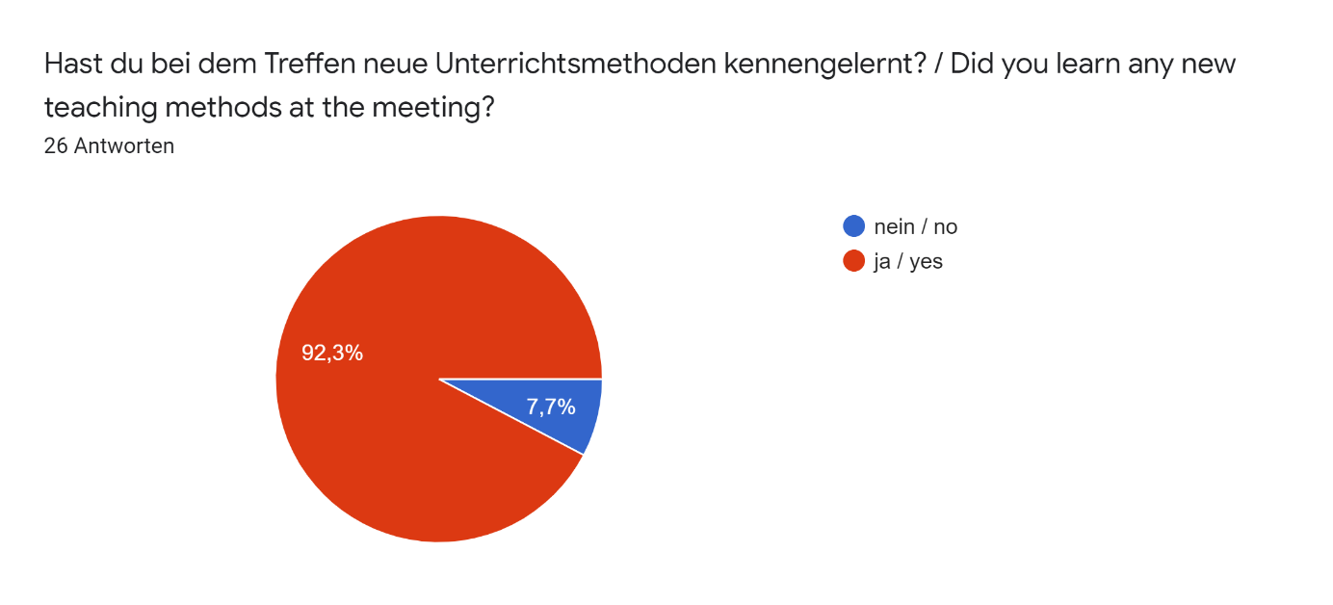

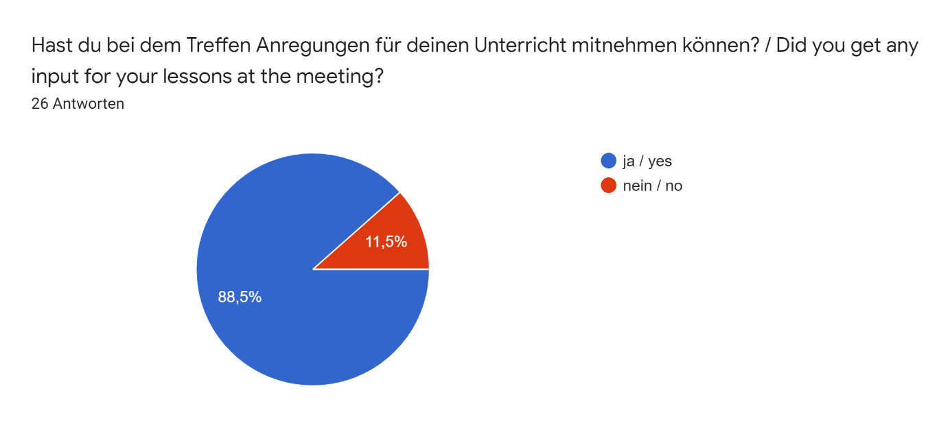
Welche Ideen fandest du gut, waren aber an der eigenen Schule (noch) nicht umsetzbar? / Which ideas did you find good, but could not (yet) be implemented at your own school? 26 Antworten
Den lebensweltlichortientierten Ansatz
Teamwork, projects using digital devices
Entscheidungstreffen in der Gruppe - eine Matrize
Computer-assisted learning with DragonBox
The meeting was based around using technology, there were lots of innovative ideas for using technology for different subjects, however not all were suitable for Maths (my subject). It was very interesting to see the different methods of teaching however.
The remote learning for students who are at home unwell
Platform with career orientation tests and information
Support classes at lunchtime for sixth form
Learning by the internet
Arbeiten mit Apps, aber leider haben die Schüler*innen noch kein eigenes Tablet und die Schule kein W-Lan
?
distance learning
Nothing
Digitalische kontrollierte Aufgaben Im Biologie-Unterricht (es gibt keine digitalische Ausgerät in jeden Klassraum)
entrepreneurship
WiFi-basierter Unterricht mit iPads
Sprachenlernen nicht als selbst an sich, sondern bilinguall in einem aneren Schulfach, z.B. im Sportunterricht oder erste Hilfe. Es fehlt bei uns Lehrer, die ihr Fach in der Fremdsprache unterrichten koenten.
Many schools had quite wide range what they are offering as career orientation for their students. I think we should provide more contacts to universities, face-to-face meetings with our old stundets and university personel here in our school but also in universities too. More info and experiences with career options is the key.
discussion as a teaching method
zu diesem Zeitpunkt war Videotelefonie noch eine rechtliche Grauzone
Practice for students, platform with tests about career orientation
The Finnish method of creating a business plan as a group/team work activity and flipped learning.
Our school should apply more practical teaching methods in career orientation.
Practical views on teaching - dealing with the elderly
source text working
All good ideas

Was konntest du sonst von diesem Treffen mitnehmen? / What else could you gain from this meeting? 26 Antworten
Anregungen für den experimentellen Zugang zur Mathematik
Prof. Matin Kramer - Lessons as an adventure
Biznesplan in den Gruppen
I got new friends and meet some old ones. Nice getaway-room experience!
It was very interesting to discuss teaching methods with teachers from other countries and how we approach different methods. It gave me time to reflect on my own teaching and allowed me to take away some methods to try.
I enjoyed all aspects
Changing information, widen my thinking about working with students in this subject,
Friendly staff
way of preparation of e learning
nicht so viel
?
partners for new exchanges
Innovation
Gute Idee im Biologie-Unterrict
schöne Erfahrungen, nette Begegnungen, kulturellen Austausch
Einblicke in das Schulsystem
Neue Kontakte mit der Schulleitung und der ganzen Schulgemeinschaft, was zum neuen unabhaengigen parellen Schueleraustausch gefuehrt hatte. Im zweiten Projektjahr haben wir die franzoesische Schule besucht, leider wegen Coronavirus ist der Gegenbesucht in Polen nicht zu Stande gekommen. Oefter habe ich solche Aplikationen wie: kahoot, quzizz, qiuzlet gebraucht.
Lots of good conversation and time with collegues from every country. It was so nice to meet everybody and share common ideas of our profession. Hopefully we can meet again!
the possibility of participating in other lessons and talking to students about working methods
-
I learned a lot nad was inspired
I had the opportunity to compare the school systems of the participating countries. I was also able to learn some interesting teaching methods and I had interesting discussions with the other collegaues.
It was useful for me to get to know other nations' teaching methods in career orientation.
The use technology- sky lessons for example.
teachers staff meeting
Unsure

Was hätte verbessert werden können? / What could have been improved? 26 Antworten
Mehr Praxisorientierung
-
Wenn es mehr Zeit gegeben hätte, hätte man noch eine Werbung des Produkts oder Dienstleistung drehen koennen.
Nothing special, maybe more free time and conversations with teachers from other countries.
More time observing lessons in our own subject areas would have been beneficial.
I found the structure very good
More time for each point of this meeting
More involvement with the maths team
nothing
fällt mir nichts ein
?
longer stays
Interactive participation
Präsentation von Lehrbüchern aus verschiedenen Ländern, Vergleich der Lehrpläne, Abschlussvergleich
mehr Schüler*innen den Austausch ermöglichen
Verlängerung der Aufenthalte für Schüler, mehr Schüler beteiligen
Mehr Gruppenarbeit, mehrere Workshops
Can't say anything, the whole schedule and program was pretty good actually. Nice job!
the opportunity to participate in teachers' councils or training courses
Aufgabenverteilung
More time for meeting
We could have more discussions on the findings of the microteaching sessions .
There's only one thing: I would have been more delighted to have more lesson observations in Poland.
It would have been better if we could have observed more lesson.
student homework
It was all good.

Evaluationstreffen / Evaluation meeting
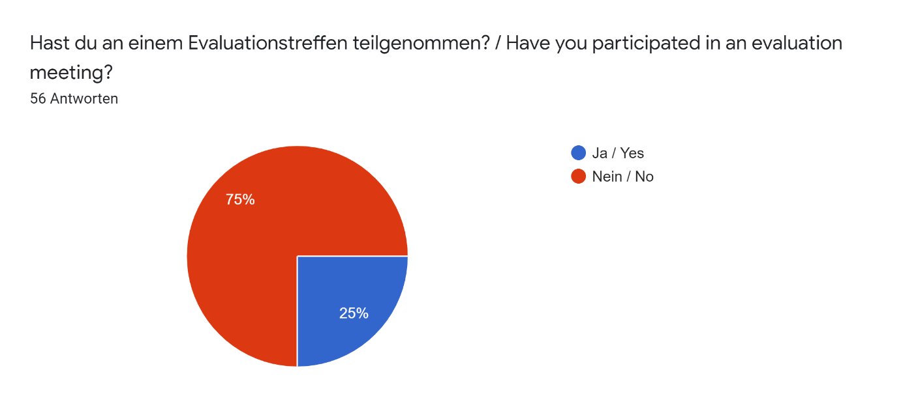
Rückmeldung zum Evaluationstreffen Feedback on the evaluation meeting
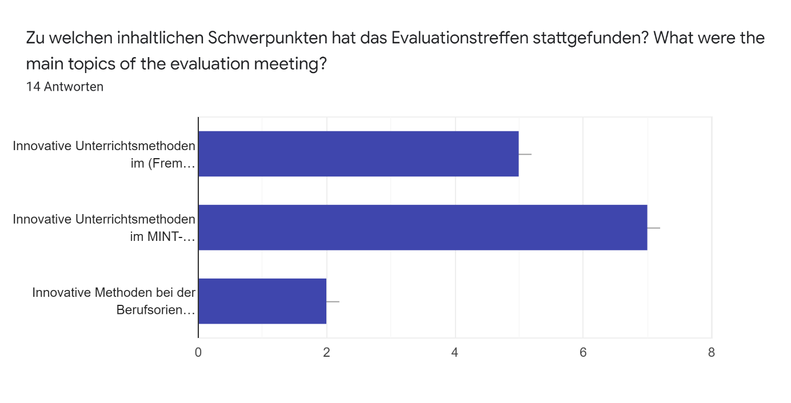
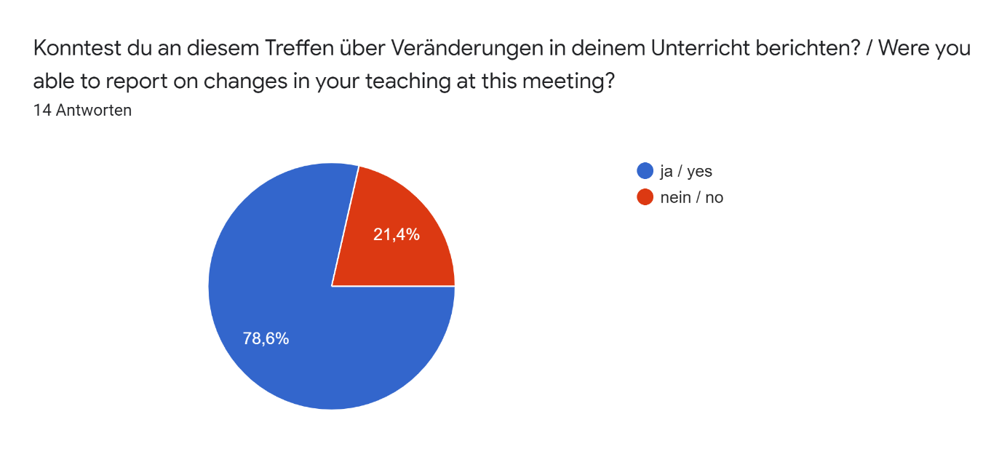
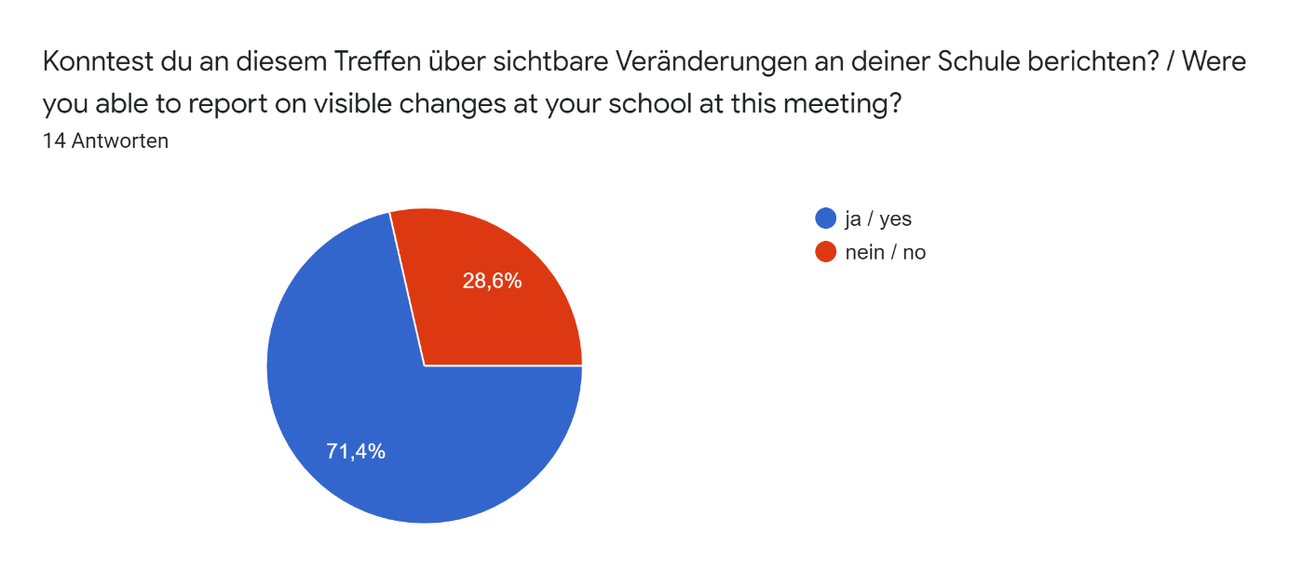
Hast du bei der Evaluation weitere Inspirationen für den Unterricht gefunden? Wenn ja, welche? / Did you find further inspiration for your teaching during the evaluation? If so, which ones?
Passion for the subject. Also using the Hungarian teaching software - Mozia
yes, some new teaching methods
one of the inspirations is to move away from homework and use lesson time to work with source text. Instead of assignments, I decided to make young people interested in writing reviews of films and readings related to the topic of the classes
Use of software used in Language lessons and links to businesses.
ore frequent use of information technology during revision lessons that test mastery of the material
Use of QR codes enabling students to find information.
neue on-line Unterrichtsmethoden,
Yes, I did. For example, I should apply group work activities more often in teaching.
How to encourage younger students to take on responsibility for their own learning, including self monitoring of behaviour
Drones would be interesting to test in teaching science.
Not at the evaluation, only during the observations.
Psychology of learning
Sie können auch Schaufensterunterricht geben, aber das wirkliche Leben zeigt das nicht

Was konntest du ganz allgemein von diesem Treffen mitnehmen? / What did you gain from this meeting in general?14 Antworten
We are trialling the software with a possible view to purchase. really loved meeting fellow teachers (and students) from other other fellow European nations - some of the information is now used within our geography Teaching at WKGS.
Friends again! And very interesting biology laborations with lungs and a heart.
pleasant to work with other countries
Review and consolidation which encouraged me to improve my teaching practices
Es gibt Zeiten, in denen nur traditioneller Unterricht verwirklicht werden kann (Aufgrund der Stunden, die ich besucht habe, habe ich dies auf Anfrage erlebt).
What did you gain from this meeting in general.
The relaxed nature of teaching at the school, albeit smaller in size than where I teach.
How students had independence to learn and how they were given skills for world of work within school setting (making hand cream in school labs).
another experience
I had the opportunity to compare the school systems of the participating countries. I was also able to learn some interesting teaching methods and I had interesting discussions with the other collegaues.
A new and more open attitude towards methods and teaching.
on-line Werkzeug, das ich bislang nicht benutzt habe
team working

Was hätte verbessert werden können? / What could have been improved?
I enjoyed the whole event.
communication
Everything was perfect!
We could have more discussions on the findings of the microteaching sessions .
The whole experience was enjoyable and worthwhile.
It would be good to have some kind of future review so that we can discuss changes or improvements we have made
I was satisfied and it was well organised.
first of all, the opportunity to meet local representatives of the authorities responsible for education, as well as the opportunity to conduct lessons
It was an enjoyable and interesting experience.
nohing
alles war perfekt
die digitalische Ausgeräte der Klasseräume
More time could have been devoted to non-typical and little-known teaching tools

Kurzzeitaustausch / Short term exchange
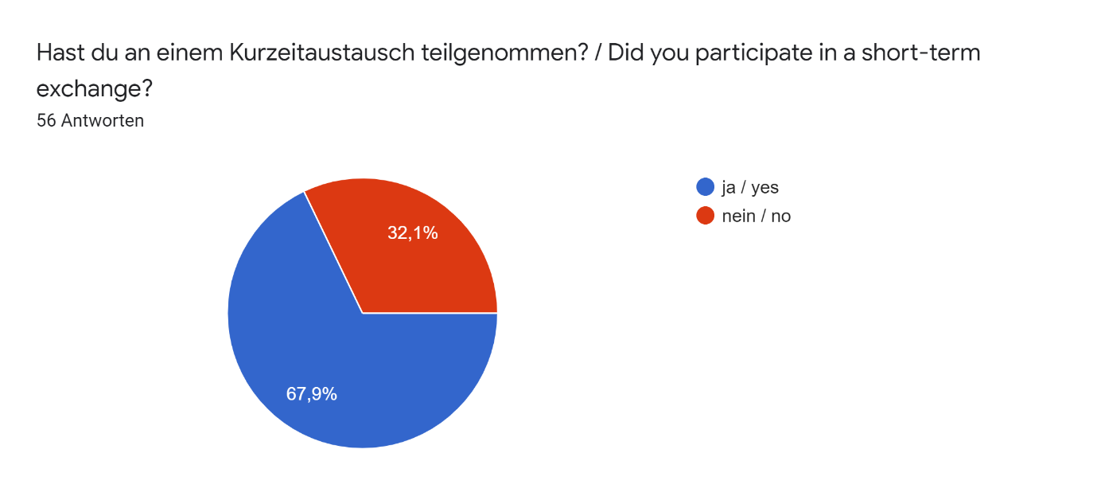
Kurzzeitaustausch / Short term exchange
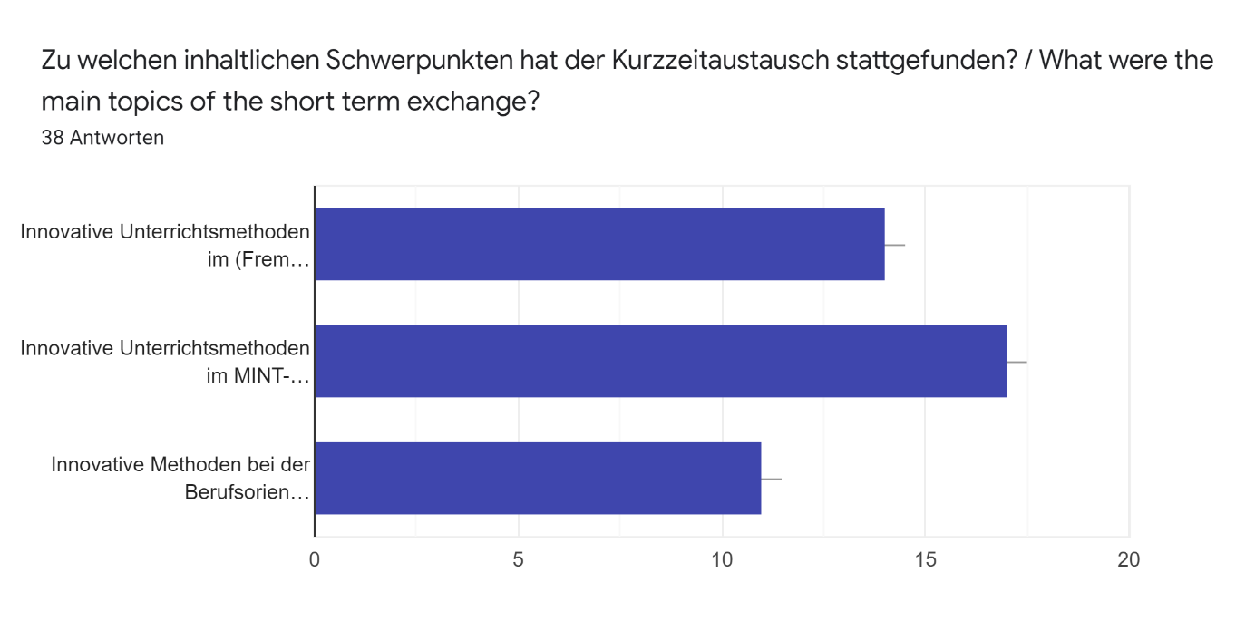
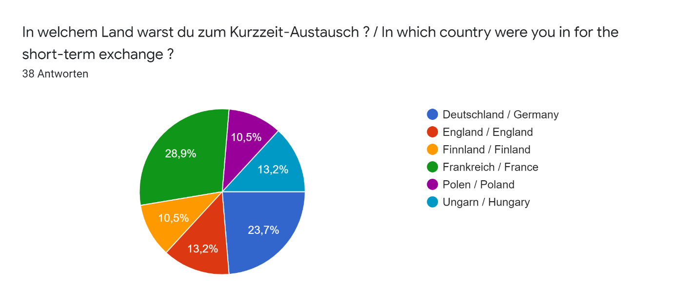
Kurzaustausch in Deutschland / Short term exchange in Germany
Konntest du Unterschiede in der Vermittlung der Inhalte feststellen? Wenn ja, welche? (Didaktik/Methodik) / Were you able to identify differences in the way the content was communicated? If so, which ones?9 Antworten
In Helmholtzschule pupils and teachers discussed much the topics they had on lessons. In Finland we are not used to use discussion as a didaktik tool so much.
NO
Ich glaube, egal wo man ist, jeder tut sein Bestes
During the lesson observation it was clear that there was a slightly more relaxed approach to the students in the classroom. However the teacher did question and answer similar to us and the content of the lesson was very much the same. The main difference was in the teachers school day as they had the freedom to go home in between lessons.
Ich habe keine Unterschiede festgestellt.
Conversations about current topics are used as a teaching method in all lessons and subjects, and theory is taught through practical examples.
Not to much extent, but difference of the notation used in Mathematics was significant
Obwohl die Methoden unterschiedlich sind, nutzt jeder die Möglichkeiten des Faches.
Students more often work in groups / pairs, independently analyzing tasks, which is the basis for a joint analysis of solutions,.

Welche Besonderheiten hast du bei der Gastschule erkennen können? Beschreibe genau! / What special features did you notice at the host school? Describe in detail!9 Antworten
Pupils and teachers don't use computers or phones as a didaktik tools during the lessons. Pupils couldn't use phones even during breaks.
I HAVE BEEN IN TWO SCHOOLS AND EVERYONE IMPLIED SOMETHING DIFFERENT. I REALLYLIKED THE PHYSICAL LABORATORY IN FRAKFURT
Die Stunden haben 90 Minuten lang gedauert. Sie waren nach Punktsystem bewertet. Es war für die Schüler selbstverständlich, dass sie während der Schule ihre Handys nicht benutzt haben.Sie hatten eine Stunde Mittagspause, wo sie sogar die Schule verlassen konnten. Die Schule hat an einigen Tagen fast bis 17 Uhr gedauert.
It was very interesting to see how the Science lessons in particular were taught as I am a chemist. It was good to see how the students interacted in the lessons and with the teacher.
Die Stunden haben 90 Minuten lang gedauert. Sie waren nach Punktsystem bewertet.
Teachers used many different ways to teach, swApping from one method to another several times during the lesson.
One teacher was particularly good at using a smart tablet. I have now got a personal tablet and use it in my classroom regularly.
Es gibt einen großen Gemeinschaftsraum, in dem Gemeinschaftsveranstaltungen abgehalten werden können (Konzert, Ball, Zeremonie, Abspielen)
a canteen and the possibility of buying a hot meal for students and teachers; the possibility of doing homework at school between lessons and the resulting longer stay at school

Welche Erfahrungen hast du bei der Betreuung des Kurzzeit-Praktikums gemacht? / What experiences did you have while supervising the short-term internship?9 Antworten
German school system and everyday practices have very many similarities with finnish school system
I do not have
Die Betreuer haben für uns alles getan, damit wir ihre Gastfreundschaft genießen können.
I enjoyed meeting the teachers from the different countries and sharing our experiences in education. I also enjoyed observing lessons at the host school and taking a tour around the school which enabled us to compare teaching methods and school day to in the UK.
Die Betreuer haben für uns alles getan, um ihre Gastfreundschaft genießen zu können.
Students of school are very keen on different kind of topics and activity during lessons.
The best part of this was having a whole week to not worry and just reflect on my own teaching practices and pick up new ideas.
Leider waren nur zwei von uns Biologielehrer, aber wir waren uns mit dem französischen Kollegen über die Besonderheiten des französischen und ungarischen Biologie-Unterrichts einig.
??
Was konntest du ganz allgemein noch von diesem Treffen mitnehmen? (optional) / What else did you generally pick up from this meeting? (optional)5 Antworten
NEW EXPERIENCES AND USE OF THE IDEAS OF OTHER TEACHERS
viel Erfahrung, Neuigkeiten, neue Methoden, sehr nette Menschen, nette Schüler, neue Freunde, die wunderschönen Ausflüge
Viel Erfahrung, neue Methoden, neue Freunde
The best thing is the culture of conversation during lessons, which works well and gives very good results.
Da ich selten Deutsch spreche, war es gut, die Sprache ein wenig zu üben

Kurzaustausch in England / Short term exchange in England
Konntest du Unterschiede in der Vermittlung der Inhalte feststellen? Wenn ja, welche? (Didaktik/Methodik) / Were you able to identify differences in the way the content was communicated? If so, which ones?5 Antworten
Es ist schwieriger, eine Fremdsprache durch eine andere Fremdsprache zu unterrichten. Es benötigt viel mehr Empathie und Vorstellungskraft des Lehrers.
Content was communicated in the same way as in Hungary, I had a chance to attend Spanish and German lessons as a language teacher. They had smaller groups, and used their native languge more than we do. For me it was very valuable as I had the opportunity to observe the classroom languge of the teachers.
In England the basics of how we and they teach are pretty same. Of course in England it's seems to be more accurate to follow national curriculum and here in Finland teachers can decide more what we are going to learn and how. But it's not that black and white either.
Yes, in England, education is more theoretical than in France. Teachers used the interactive whiteboard a lot and projected everything they did.
In all the classes studens relied a lot on their mother tongue in case of learning grammar, vocabulary, claryfying context or the teacher’s instructions.

Welche Besonderheiten hast du bei der Gastschule erkennen können? Beschreibe genau! / What special features did you notice at the host school? Describe in detail!5 Antworten
Die Schüler sind sehr motiviert, arbeiten gerne mit. Ihre Sprachkompetenzen in Deutsch sind hörer als bei den polnischen Schülern, in Spanisch vergleichbar. Die Schüler kommunizieren sich gern in Fremdsprachen, obwohl sie Fehler begehen, aber das stört nicht die Kommunikation. Sie geniessen das einfach und haben viel Spaß daran.
1. The difference in their daily routine: they start their days with an assembly. 2. The special privileges the school leavers have: different clothing, the limited number of subjects for the A levels. I consider this a very effective way to prepare for university life and for the exams. As in Hungray students in their final years have to attend lots of lessons, even music or Art, although it has nothing to do with their exams. 3. The student council- the meeting was very different from our meetings, usually we have frontal meetings with a leader (a teacher), but there they used groupwork and project work to discuss certain issues. In my oppinion it is fundamental for young people to learn how to work together and come to a consensus and face the challenges of group work and problem solving as they will have to do this soon in the world of work.
I observed history lessons mostly and most memorable lesson was when young stundents were learning charleston dance! How nice! I also liked how well the stundents took part in conversations during lessons and how they had pretty good arguments to back up their opinions.
The students wear uniforms and it was a girls' school. The classes were in "competition" and the classification was posted in the corridors. Student work are displayed proudly everywhere. In high school, the number of lessons is more limited; students can choose at least three. In our school, there was no staff of "school life" to mentor students.
All the classrooms were equipped with electronic boards and the materials used by the teachers were digitalised. The only paper-materials were students’ workbooks.

Welche Erfahrungen hast du bei der Betreuung des Kurzzeit-Praktikums gemacht? / What experiences did you have while supervising the short-term internship?5 Antworten
Die Schüler, die in der Interkulturalität heran wachsen, offener, kooperativer und kontaktfruediger sind als Schüler aus Mittelosteuropa. Bei dem Austausch lernen sie voneinander.
It was indeeed an invaluable learning experience, the opportunity teach in another country, interact with a new education system, and collaborate with foreign teachers.
We didn't have the short-term internship during the trip.
We attended and participated in the classes. We visited the town of Wist-Kirby and Liverpool. We helped in a charity shop.
Observing German, French, Spanish and English lessons, some of which were to prepare for final exams; very nice and friendly atmosphere; meeting involved students and dedicated, helpful teachers; broadening horizones and raising motivation in our students, interesting ideas and solutions in school
Was konntest du ganz allgemein noch von diesem Treffen mitnehmen? (optional) / What else did you generally pick up from this meeting? (optional)3 Antworten
Die Arbeitsatmosphäre und Lernklima
It was so nice to meet our English friends/colleagues again! It's sad that Britain is leaving EU. Hopefully we can still meet each other in the future!
raising cultural awareness (teachers and students), sharing and discussing school problems with English teachers, comparing experiences
Kurzaustausch in Finnland/ Short term exchange in Finland
Konntest du Unterschiede in der Vermittlung der Inhalte feststellen? Wenn ja, welche? (Didaktik/Methodik) / Were you able to identify differences in the way the content was communicated? If so, which ones?15 Antworten
Der Unterricht war sehr mediengestützt, was ich als positiv wahrgenommen habe.
In French: -
Yes, very good use of flipped learning techniques during lessons at our host school in Finland.
Sixth Form lessons were very informal
Yes
More teacher led in French school
- Die SuS waren deutlich leistungsbereiter als die Schülerinnen und Schüler in Deutschland - Dokumentenkamera stark eingesetzt, vor allem in Kombination mit Whiteboard - Ergebnisse werden meist nicht wirklich ausführlich besprochen - Es wird wenig geschaut, ob die S. wirklich das alles verstanden haben - Keinerlei Diskussionen über Hausaufgaben oder andere Dinge - Wenig Nachfragen generell --> SuS nehmen alles als gegeben hin - Leistungsbewertung sehr schwer möglich, da wenig Interaktion zwischen Schülern - Hohe Sozialkompetenz der S. untereinander - Ausdrucke oft in Farbe - Unterricht oft sehr frontal
Generell war die Vermittlung in Finnland sehr frontal, mit einigen interessanten Ausnahmen
I observed remote teaching of a language lesson, the innovative use of virtual reality and flipped learning amongst other more conventional approaches.
different points of view considering the various countries
Frankreich: Im Physikunterricht wurde ein klarer Schwerpunkt auf das selbstständige Experimentieren der SuS gelegt. Das Experiment und seine Auswertung war sehr klar vorgegeben. Es waren dabei einige Besonderheiten zu beachten und es war insgesamt auf einem erhöhten Niveau. SuS meiner Schule hätten dieses Experiment so nicht durchführen / auswerten können. Im Gespräch mit der Lehrkraft zeigte sich, dass dieses Experiment eine herausragende Stellung im nationalen Curriculum hat und gezielt vorbereitet werden muss. Exemplarisch zeigte sich hier, wie zentrale Bildungsvorgaben zu einer noch stärkeren Steuerung führen, als sie es in Deutschland tun. In diesem Zusammenhang wurde das selbstständige Experimentieren hier eher als "antrainiert" empfunden und die Selbstständigkeit war durch die sehr klaren Vorgaben keine Selbstständigkeit im Sinne eines naturwissenschaflichen Erkenntnisprozesses. Die Schüler arbeiteten mit Computermodellen. Sie benutzen die Modelle dabei nach Vorgaben. Im naturwissenschaftlichen Bereich nahm ich vor allem ein instruiertes Lehren/ Lernen wahr.
nein, nicht wirklich
Ja, es war mir als Sportlehrer neu, den Schülern freien Zeitraum zur Gestaltung und zum Ausüben einer Bewegungsform zu geben. Wir bauen Bewegungsformen Schritt für Schritt auf. Hier war zuerst das Ziel klargestellt, dann die Schüler bekamen Zeit (Tage) sich zu tranieren . Wenn sie wollten konnten sie die Hilfe der Lehrer je nach Wunsch in Anspruch nehmen.
during classes, teachers more often rely on working with source texts, use discussion forms and also do less homework, making better use of the lesson time
greater freedom of the teacher's work
Welche Besonderheiten hast du bei der Gastschule erkennen können? Beschreibe genau! / What special features did you notice at the host school? Describe in detail!15 Antworten
Den Schülern ist es möglich, in den Themenbereichen jahrgangsübergreifend zu arbeiten. + Die Kollegen hatten ihren eigenen Klassenraum, was die abwechslungsreiche Unterrichtsgestaltung vereinfacht.
In French: Smaller groups. Teamwork. Many digital devices
Informal nature of teaching and staff-student relationships.
The impressive facilities for students to gain non academic skills
visual electronic devices
Very good hospitality
- Vertretungskonzept mit eigenem Raum und einer Aufsicht - Schulen deutlich besser ausgestattet (Notebooks, Personal im Sekretariat --> haben auch Entschuldigungen bearbeitet)
Innovative oder wichtige Fächer wie "eigene Firma" oder "Hauswirtschaft"
The effect of the timing of the school day was the most striking. With substantial breaks, the students appeared more focused during lessons and the teachers were better able to prepare between lessons and appeared more relaxed and organised. Student's enjoyed flipped learning and were able to work at their own pace. the teacher was able to give individual attention although I felt this would be more difficult with the larger class sizes at our school.
ability of many pupils to speak English fluently
Frankreich: Die SuS waren sehr freundlich und interessiert. Insgesamt nahm ich die SuS als sehr fleißig wahr. Im Laufe des Schultages und dann auch noch mit Hausaufgaben bei Ganztagsunterricht wird täglich ein enormes Lernpensum bearbeitet.
andere Schulkultur
Die Kollegen arbeiten mit den Schülern in kleineren Gruppen als wir. Sie haben die Möglichkeit den Schülern eine Sportart im Praxis zu zeigen. Golf am Golfplatz, Schwimmen in derSchwimmhalle..., (wir nicht) Die Schüler bekommen ein Heftchen mit nützlichen Infos über den Lehrstoff/ über das Lehrmaterial/ Anatomie/ Wissenswertes usw.
first of all, the work atmosphere is not based on traditional questioning of knowledge, the student discusses with the teacher more often, is a partner in the discussion, avoiding homework, if necessary, it is possible to stay on the so-called supplementary lessons
openness, full teacher-student cooperation, good communication skills
Welche Erfahrungen hast du bei der Betreuung des Kurzzeit-Praktikums gemacht? / What experiences did you have while supervising the short-term internship?15 Antworten
Ich habe gelernt, dass das deutsche Schulsystem durch einfache technische Mittel stark verbessert werden könnte und eine jahrgangsübergreifende Öffnung möglich wäre, um die Begabungen der Schüler gezielter zu fördern.
In French: Dear welcome; Similar levels and methods in mathematics and science education; Many digital devices
Observation of a wide variety of lessons. A trip to a university with students due to choose undergraduate courses next year. A trip to a Yoga session put on as part of the school's extra curricular programme on a Friday afternoon.
Enjoyed interacting in the foreign language with my host family
digital media’s
Lessons in the school and visit to a primary school.
/
Das Lernen und Lehren hat sich nicht groß zu unserem Land unterschieden. Evtl. war es ein wenig digitaler.
The student's were well looked after and very involved with their host families. They were able to observe many of the same lessons we were in and also had the opportunity to complete work experience and enrichment activities.
pupils form different countries working together and using the same language
Frankreich: Die Betreuung der beiden Praktikanten erschien mir eher unproblematisch und deren Erwartungen wurden weitestgehend erfüllt.
-
Die Schüler haben kaum realistische Vorstellung, wie ein richtiger Arbeitstag aussieht. Es wäre deswegen sehr wichtig dieses Erlebnis ihnen mehrmals zu zeigen.
my students had an unlimited opportunity to participate in any form of school and out-of-school activities, I also could not complain about boredom, I did not have time to participate in all the activities planned for me, I would say that I would even extend the duration of my stay to 10 days
the ability to observe remote work
Was konntest du ganz allgemein noch von diesem Treffen mitnehmen? (optional) / What else did you generally pick up from this meeting? (optional)8 Antworten
-
assessment
Solche Erfahrungen sollte jeder mal gemacht haben. Es ist toll mal über den Rand hinaus zu schauen
possibility to get new acquaintances and friends
Frankreich: Für mich waren die "kulturellen" Unterschiede bzw. Gemeinsamkeiten besonders interessant. Die Aspekte Privatschule, eher ländliche Schule, nettes Kollegium, Lehreralltag / Räumlichkeiten ... waren interessant.
Verständnis für andere Schulsysteme und Arbeitsweisen der Leitung
Die Wichtigkeit des Sprachwissens, Den Mut mit anderen Leuten ( sogar von völlig anderen NAtionen) zu kommunizieren. Ein Heft zusammenstellen, in dem die Schüler einen JAhresplan bekommen- was unterrichtet wird.
for me it was another opportunity to refresh my language skills and conduct lessons in a foreign country
Kurzaustausch in Frankreich / Short term exchange in France
Konntest du Unterschiede in der Vermittlung der Inhalte feststellen? Wenn ja, welche? (Didaktik/Methodik) / Were you able to identify differences in the way the content was communicated? If so, which ones?0 Antworten
Auf diese Frage liegen noch keine Antworten vor.
Welche Besonderheiten hast du bei der Gastschule erkennen können? Beschreibe genau! / What special features did you notice at the host school? Describe in detail!0 Antworten
Auf diese Frage liegen noch keine Antworten vor.
Welche Erfahrungen hast du bei der Betreuung des Kurzzeit-Praktikums gemacht? / What experiences did you have while supervising the short-term internship?0 Antworten
Auf diese Frage liegen noch keine Antworten vor.
Was konntest du ganz allgemein noch von diesem Treffen mitnehmen? (optional) / What else did you generally pick up from this meeting? (optional)0 Antworten
Auf diese Frage liegen noch keine Antworten vor.
Kurzaustausch in Polen/ Short term exchange in Poland
Konntest du Unterschiede in der Vermittlung der Inhalte feststellen? Wenn ja, welche? (Didaktik/Methodik) / Were you able to identify differences in the way the content was communicated? If so, which ones?4 Antworten
Meistens war der Unterricht sehr lehrer*innenzentriert ausgestaltet; die Lehrer*innenvorträge wurden teilweise durch Power-Point-Präsentationen bzw. durch digital präsentierte Materialien unterstützt.
In England we deliver far more detailed infomation related to post 16 careers and career development throughout the last two years of schooling for students
Die meisten Methoden waren die gleichen und, wie wahrscheilich überall, es hang vom Lehrer ab, welche Methoden verwendet wurden.
No
Welche Besonderheiten hast du bei der Gastschule erkennen können? Beschreibe genau! / What special features did you notice at the host school? Describe in detail!4 Antworten
Die Lehrer*innen hatten in der Regel eigene (Fach-)Räume, in die die Schüler*innen für ihre jeweilige Unterrichtsstunde gekommen sind. Die Räume waren entsprechend der Fächer dekoriert und ausgestattet; dies hat meines Erachtens nach positiv die Vermittlung der Inhalte und Kompetenzen unterstützt.
It is a far more relaxed and informal environment - far less stress than UK schools. Students thrive and excel here due to independent ownership of learning
Disziplin war besser in Polen, keine Handys im Unterricht (falls nicht gefordert), das Willen zum Lernen höher.
Polish students weren't afraid to talk in a foreign language, for example English. The teachers didnt make a problem if somebody was lating from the lessons.
Welche Erfahrungen hast du bei der Betreuung des Kurzzeit-Praktikums gemacht? / What experiences did you have while supervising the short-term internship?4 Antworten
Insgesamt hatte ich eher wenig Kontakt zu dem Schüler und der Schülerin, die während unseres Aufenthalts ein Praktikum in einer polnischen Firma absolviert haben; in einem von uns zwei Lehrerinnen initiierten Treffen mit dem Schüler und der Schülerin haben diese aber vorrangig von positiven Erlebnissen während ihres Praktikums berichtet.
Delivered and observed lessons relating to post school / university / gap year options. Observed lesson structures and delivery for Sixth Form students
1. Ich glaube, das wir in Finnland sogar zu sanft mit unseren Schülern umgehen. 2. Mobiltelefone sind praktisch, aber man kann gute Resultate auch ohne erreichen. 3. Schulen spiegeln die Gesellschaft, es ist also schwer zu sagen, welche Unterschiede auf die Schulen und Unterricht und welche auf die gesellschaftlichen Faktoren zurückzuführen sind.
.
Was konntest du ganz allgemein noch von diesem Treffen mitnehmen? (optional) / What else did you generally pick up from this meeting? (optional)1 Antwort
The UK provides a large selection of resources and opportunities for students through school initiatives. Other European schools place the onus on the students themselves to investigate post school options.
Kurzaustausch in Ungarn / Short term exchange in Hungary
Konntest du Unterschiede in der Vermittlung der Inhalte feststellen? Wenn ja, welche? (Didaktik/Methodik) / Were you able to identify differences in the way the content was communicated? If so, which ones?5 Antworten
No
Teaching styles differed depending on the subjects observed. Some were more teacher led and used less technology and others encouraged more independence from the learners.
The language teaching methods were the same as ours.
Not so many
In Hungary teaching was very efective and there were about 30 - 40 pupils in classroom. Pupils were very interered in learning. My own lesson was Fenomenal based method in teaching Geography.
Welche Besonderheiten hast du bei der Gastschule erkennen können? Beschreibe genau! / What special features did you notice at the host school? Describe in detail!5 Antworten
Preparation all meeting, opportunity to join the lab
The independence the students had and the relaxed nature of the teaching environment. Students worked hard and got on well with teachers.
Small groups, allowing a good level of oral exchanges. Motivated dynamic teachers.
School days are shorter - the students can enjoy spaces and rooms to rest or to study by themselves
In Dabas school was very good equipments in laboratory to make investigation in chemistry, physics and biology. There was special laboratory person in laboratory. Lot of different material in biology.
Welche Erfahrungen hast du bei der Betreuung des Kurzzeit-Praktikums gemacht? / What experiences did you have while supervising the short-term internship?5 Antworten
Have lessons with all Comenius student
Observation of lessons in a range of subjects, afternoon where schools gave presentations about the range of careers training and experiences in schools, a trip to Budapest, meal with members of two other schools.
Participating in a german language class so that we could see what it's like for the pupils. Visiting a bilingual creche.
English and German lessons + adult lessons at a vocational school
Interior of Dabas school was very interesting. Lot of things of schools history and very nice interiors like Erasmus corner. Lot of good ideas like World media/news wall. Also there was lot of cooperation with local companies like Wellis Company and Vitafort. Also cooperation with local radio and television broadcasting.
Was konntest du ganz allgemein noch von diesem Treffen mitnehmen? (optional) / What else did you generally pick up from this meeting? (optional)5 Antworten
New point of view for teaching biology and chemistry
It was interesting to see how the students were encouraged to be independent: getting selves across site to PE Department, that the school had an onsite radio and links established with local business.
That we all encounter the same problems.
Nice relationships between the teachers and the students
I pick up lot of ideas to example developing laboratory classroom in our school. Also cooperation with local companies was very interesting. In futere we must develope distant learning and network cooperation in teachingmethods between cooperation schools.

Allgemeine Evaluation / General evaluation
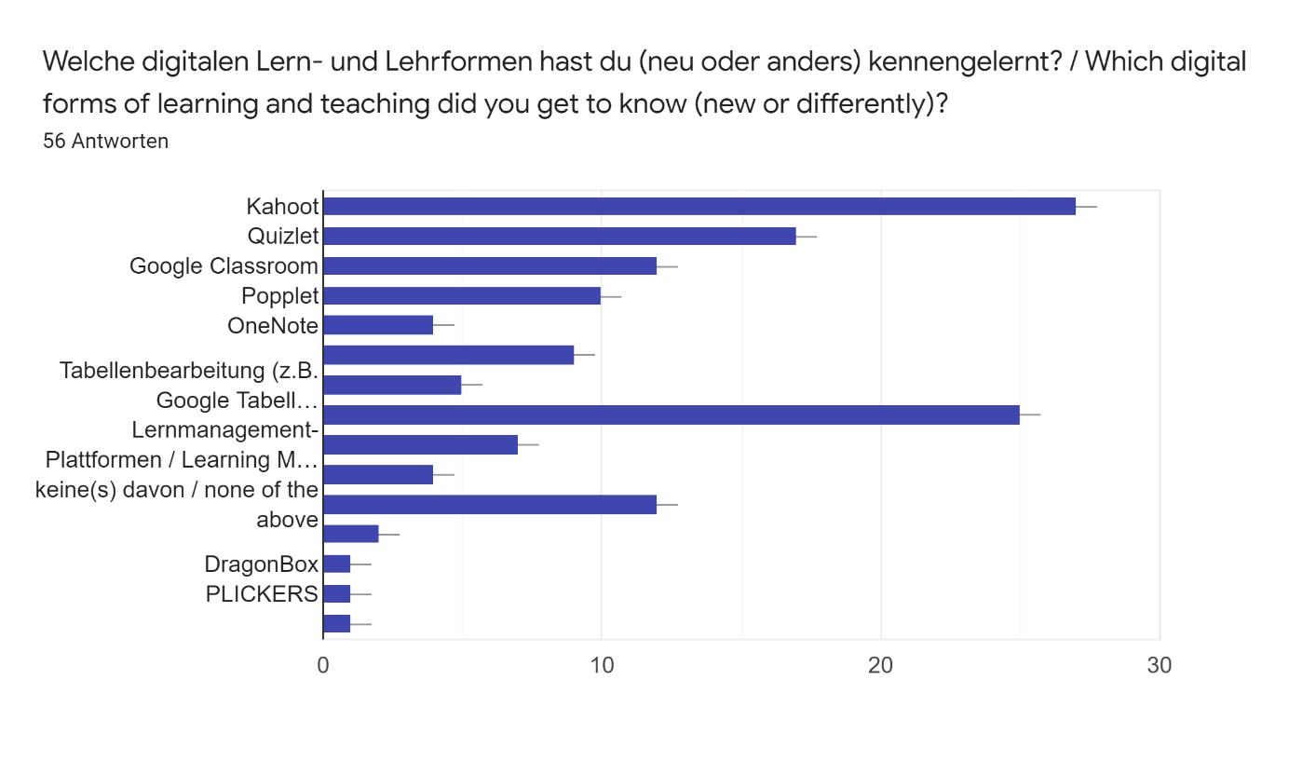
Welche innovativen (nicht digitalen) Methoden hast du neu kennengelernt? / Which innovative (non-digital) methods have you newly gotten to know?56 Antworten
-
keine
Some science experiments
N/A
None
Teaching and learning outside the school
Prof Martin Kramer: Lessons as an adventure
Anwendung der Spiele, wo die Schüler miteinander sprechen müssen
Nothing special, only distance learning because covid-19.
Customised text book for the History course, written by the History teacher - used for flipped learning activities.
TEACHING GAMES
Punktsystem, die Kinder sind selbst Mentoren von den anderen
We now use google classroom regularly and I already used Kahoot.
Google classrooms
Kahoot
none
Präsentationen von Aufgaben mit Hilfe der Schüler ( lebendes Koordinatensystem)
Flipped learning
?
Kahoot
I applied the old method of teaching conversation by combining its group work.
The use of a small boards with markers- each student was given a small board with a marker and they had to write their answers on the board when it was requested by the teacher. It is very useful to check the whole group very fast.
Pupils' participation
Modellierung zB in der Physik-Unterricht
I know them all, but not all of them
QR codes and was told about/had exam based on new online examination system.
entrepreneurship
How lessons were more relaxed in terms of way learning was approached.
Nothing I didn't already know.
instruiertes Experientieren auf erhöhtem Niveau
dass ehemalige Schüler*innen der Schule die aktuellen Schüler*innen in Selbstorganisationskompetenzen schulen (Pflicht-Workshop für eine bestimmte Jahrgangsstufe); dass Schüler*innen an einem von der Universität organisierten Debatten-Wettbewerb teilnehmen, um ihre Kompetenzen im argumentativen Bereich praktisch erproben und üben zu können
Arbeit mit Tablets
Quizlett. Lernplattformen: Teams, Moodle - auf Grund vor allem des Lernens auf Distanz im Zeitalter der Corona. Auf diese Art und Weise haben wir 100 prozentig das Ziel des Projektes erreicht.
Nach einem Lernprogramm (anhand Begleitheft)- arbeiten die Schüler in ihrem eigenen Tempo
In Poland 2019 we had this kind of "detective practice" where you had to connect different kind of evidence together and make some conclusions. And also in Poland there was this kind of a "buying attributes practice" which was pretty interesting.
any
source text analysis combined with discussion
creating and promoting open-minded attitudes in students to make them more involved in learning process
_
discussion activities
The Finnish method of creating a business plan as a group/team work.
The Finnish method of creating a business plan.
A method of dealing with old texts.
Ich habe in Polen keine für mich neuen digitalen Methoden kennengelernt.
Ich habe mir nur die digitalen Methoden gemerkt, weil das für mich wichtig war
the remote work
Unsure
more group working
Sportlesson with traditional Hungarian dance

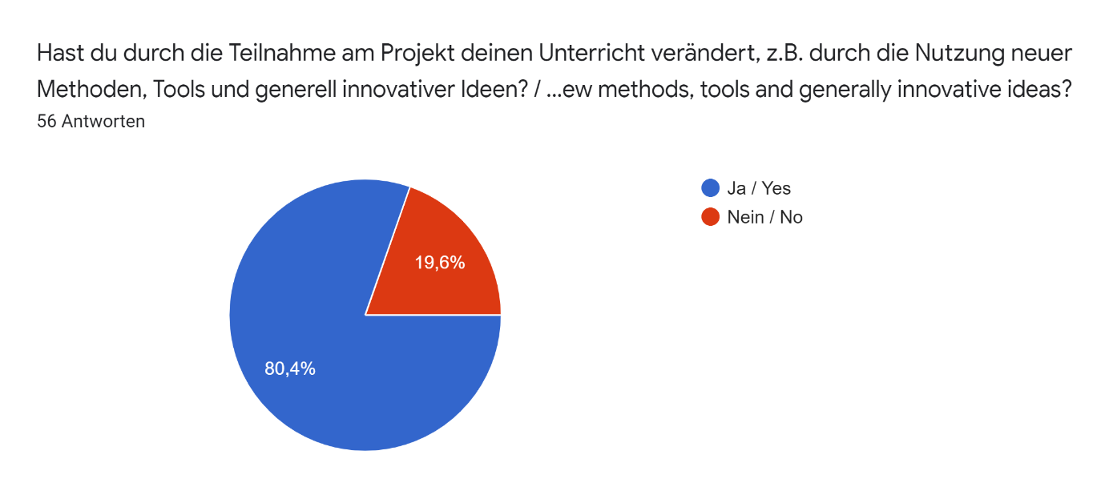

Welche Inhalte und Ideen konntest du von den anderen Nationen an die eigene Schule mitnehmen? / What content and ideas could you take from other nations to your own school?56 Antworten
Health and safety in the lab. Also use of Mozaweb.
I use discussions as a learning tool with pupils more than before
Ich arbeite vermehrt mit PPT und verfolge gerade in der Oberstufe das Prinzip des Flipped Learning.
The lessons are an adventure using digital devices
Intensive Gruppenarbeit statt des frontalen Unterrichts
More problem-based learning, more laborations.
Techniques for distance learning (demonstrated in an English language lesson) for students at remote locations (local primary schools) n
I have since used some of the ideas put forward with my own classes and they responded well.
Prezi
Applications, educational programs, experiences
alle Ideen, die ich sehr gut, nützlich und machbar gefunden habe. Zum Beispiel ich sammle die Handys Anfang eines Klassenausfluges immer zusammen. Ich bewerte, wenn die Schüler an den Stunden auch "mündlich" teilnehmen.
One place for planning career with a computer, magazines, leaflets etc.
The use of technology in the classroom and how it can be used effectively. Also giving the students more freedom to come up with their own ideas/creations.
Visualiser
positive attitude to learning
/
using the internet to teach chemistry
Alle Methoden
Etwas mehr flipped Learning einbauen
Observing a remote language class enabled me to quickly adopt some of the techniques used, when I had to start teaching remotely due to Covid.
?
more digital use / less busy days
Exercises in pairs and groups are used to introduce new learning topics. The whole class then discusses the topics and makes conclusions about them.
More project and group work
discussions between students and teachers
A focus for new young students to monitor their own behaviour and progress more effectively
es ist möglichkeit, die Anatomische und Fiziologische Modellen in der Biologie-Unterricht zu bauen
better equipment of classrooms, especially in computer hardware and software, also available for students
Giving students more independence, for example students travelling between split site, independence in lessons.
-
Use of software for teaching and assessing that was used in a Language lesson.
Kahoot.
Cahoot
Idee eines Debatten-Wettbewerbs
Arbeit mit Tablets
Arbeit auf der Lernplatform, mehr Gruppenarbeit
Die Schüler können vor der Gruppe eine Bewegungsform vorstellen /presentieren- Infomaterial zusammenstellen- daraus - Aufgaben entwickeln lassen
Well that "detective practice" at least, and "buying atributes practice" too
Better recognition of students, their work and their mistakes.
Digital tools ex.: Kahoot
the fact that you discuss with students more than burden yourself with unnecessary content
Well-prepared, effective materials preparing for final exams; classrooms equipped with electronic boards and digitalised materials used by teachers. Using video materials, smartphones with some applications in classes.
diverse Klassenkonstellationen, Konzepte der Binnendifferenzierung
I will take everything if it depends on me
To continue to be interactive and promote discussion
As for the digital methods, we often use Quizlet as a warm-up activity in English lessons. Besides we've been using more group work activities and other cooperative techniques in teaching.
I've gained ideas how to use role-play activities in my lessons in connection with career orientation.
The use of vocabulary building with games.
Bearbeitung von neuen Texten.
Wie gesagt, neue digitale Methoden, die ich im Unterricht eingesetzt habe. Sehr interessant fand ich den on-line Unterricht der finnischen Kollegin
greater confidence in remote work
Unsure
.
keine
Visit in local companies and cooperation with companies. Cooperation with local newspapers Iitinseutu
Konntest du hiervon erste Umsetzungen an der eigenen Schule beobachten? / Have you been able to observe the first implementations at your own school? If so, which ones?56 Antworten
no
-
nein
I think pupils are more eager to discuss when I courage them to do so
Oben genannte Methoden habe ich bislang in der E und Q-Phase, sowie während des Homeschoolings auch in der 8. Klasse durchgeführt.
Google Classroom, Geogebra, teamworks, playing learning
Ergebnisse der Gruppenarbeit und Zufriedenheit der Lerner
No re Mozaweb but hope to soon. Yes to Google Classroom.
Much more use of distance learning with lockdown. Video conferencing in the classroom now much more widespread.
Yes in my own classroom.
Google Classroom
Yes. Checking knowledge using the plickers application.
Ja, Jahr für Jahr beobachte ich es auch von den anderen Kollegen.
Some such as google classroom
Yes
Not yet
/
No re Mozaweb but hope to soon. yes to Google Classroom.
Ja
Ja, flipped Learning als der Lockdown kam
As above
use of more digital devices
Unfortunately not
We introduced certain digital forms of teaching and after an evaluation meeting where we presented them, I realised that our collagues strated to use them too. We also have a competition in our school where Popplet was used by the students.
Students are more comfortable to participate
Not sure about any school wide implementations that have been made as a result of the program but there has been a focus on getting students to engage with GoogleClassroom and for us to try more student led approaches.
Ja, ich machte ein Modell. zb. Wie bewegen die Flügel der Insekten mit den Muskeln des Tors?
No
Not yet.
Not yet due to lockdown.
Kahoot
Cahoot
noch nicht; grundsätzlich gibt es in Deutschland aber schon einen Debatten-Wettbewerb ("Jugend debattiert")
Ja. Einsatz von iPads im Unterricht
Beim Distanzlernen Ausnutzung der Lernplatformen. Andere Sitzordnung im Unterricht mehr fue Gruppenarbeit oder Partnerarbeit beim Fremdsprachenunterricht.
Ja
We've given more weight on how we look outside as a school. This year the amount of our new first year students doubled which was pretty good result.
Digital tools ex.: Kahoot and Google Classroom (during lockdown)
do less homework and discuss more
Using more often video materials, smartphones with some applications in classes and at home. Better equipped classrooms.
_
As for the digital methods, we often use Quizlet as a warm-up activity in English lessons. Besides we've been using more group work activities and other cooperative techniques in teaching.
Unfortunately not yet.
Yes, mainly in language lessons, especially the use of applications.
Das Engagement bei neuen Texten ist besser.
Ja, es hat den Unterricht auf jeden Fall attraktiver gemacht
introduction of remote work
Not yet
.
I think that students are more communicative and they notice better what happens in school. Also they have new ideas.

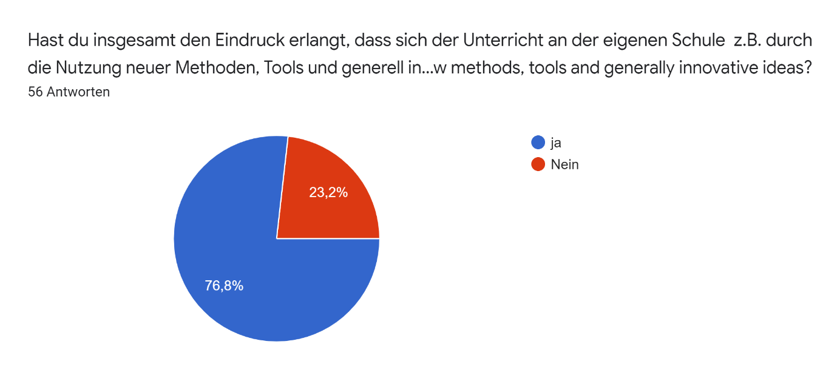

Welche Ideen sollten in Zukunft an der Schule (weiter)verfolgt werden? / Which ideas should be (further) pursued at the school in the future?56 Antworten
Use of 3D software
Platform dedicated to career planning
To do more co-operative work with my collegues
Die Einführung fester Lehrerräume und das jahrgangsdurchlässige Unterrichten.
teamworks, playing learning
Gruppenarbeit, Kleingruppenarbeit, solche Unterrichtsaktivitäten, die Kommunikation unterstützen
DragonBox could be tested, if we only had the money.
Maybe the use of video conferencing programs for collaboration with other schools.
I was able to take away some teaching methods and new technology to try in my classroom. Some worked really well and others were not so effective.
Unsure
Exchange of experiences between teachers.
Punktsystem
General use of technology
Google forms
Looking at interactive teacher methods and fun class activities.
Die Lehrkräfte sollten wie in der Austauschschule sich mehr auf den Unterricht konzentrieren können und sollten in anderen organisatorischen Aufgaben entlastet werden.
learning by the internet
Doppelte Stunden
Schule zukunftsfähig gestalten. Die Digitalisierung muss weiter voranschreiten.
Change the school day to start slightly earlier and extend breaks to enable school to function more calmly.
human interactions between the countries are very good!
digital teaching
I would like to implement a teaching in which the current topic is the basis for the application of the theoretical framework.
All the digital forms of teaching.
New methods of participation
A focus for new young students to monitor their own behaviour and progress more effectively
Vergleich der Abschlussaufgaben in Biologie in EU-Ländern
diversifying activities and giving initiative to students, as well as using various educational platforms
Maybe online systems, like the new exam system, will be developed as a result of the need to teach from a distance.
entrepreneurship
More independence for students.
use of tablets
Ich denke, dass der Digitalisierungsschub, der durch Corona ausgelöst wurde, viele Impulse gebracht hat und bringt und die Innovationsimpulse, die durch Erasmus an die Schule gekommen sind nun teilweise überdeckt bzw. ablöst. Es sind nun Konzepte erforderlich, die einen stärkeren Austausch über diese Impulse und die eigenen Erfahrungen damit innerhalb des Kollegiums vereinfacht.
Lehrerräume
Schulentwicklung im Bereich der Digitalität
Weitere Entwicklung der Schlusselkompetenzen der Lehrkraefte und der Schueler. Menschliche Relationen weiter entwickeln, Ausstausche fortsetzen.
Neben dem NAtionalen _Lehrplan wäre es gut mehr Zeit für alternative Lehrsoffe im Jahreslaufplan einzubauen. Meiner ANsicht nach die Kollegen im Ausland haben dafür etwas Möglichkeit.
Nothing particular, we've pretty good system right now and everyone is developing their own teaching all the time.
Welcoming our partners (teachers and students!)
greater innovation in using computers only as tools and not as primary sources of information
Good balance between demanding and friendly atmosphere in classes; using in language teaching all types of technology to make this process more effective
alles in Bezug auf den Onlineunterricht
Promotion of students independence and ability to take ownership of their future
I think more career orientation activities should be pursued at the school in the future.
As I am a Maths teacher,I think more digital tools should be used in teaching science subjects to make students' understanding easier and to make the teaching material more interesting.
The teaching of social competences with the help of project work and openness towards each other.
Ich finde es im Allgemeinen sehr wichtig, dass Lehrer die Möglichkeit haben, dem Unterricht von Kollegen zu folgen.
Vielleicht der on-line Unterricht, der vor allem während der Covid-pandemie sehr nutzlich sein kann
further computerization
Using online technology
more interactive teaching, more projects for students
-
Laboratory classroom. Teaching with Teams, distant learning.

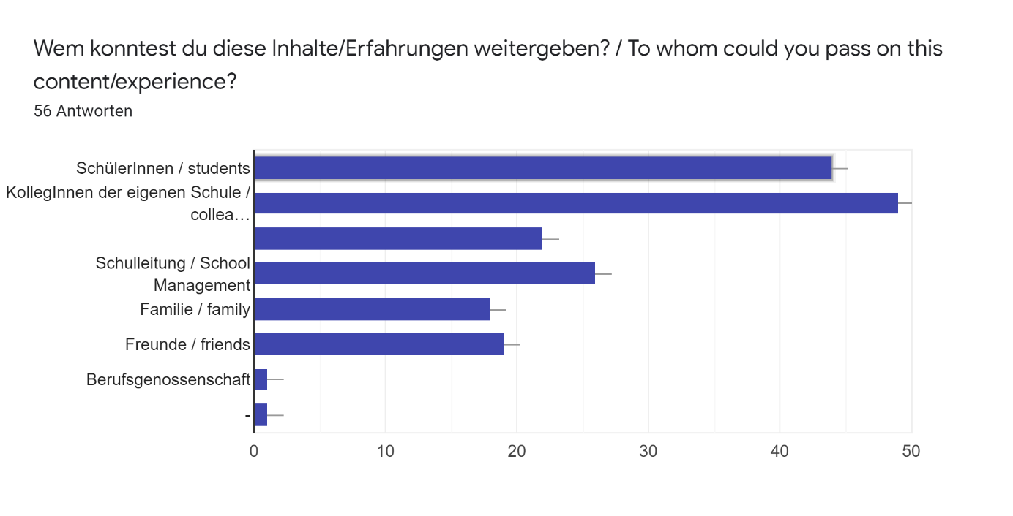

Welche Inhalte konntest du den anderen Nationen mitgeben? / Which contents could you provide to the other nations?56 Antworten
I did a Geographic information Systems (GIS) introduction lesson
-
I refer to answers before on this form.
das entdeckenlassende Lernen, das wir in Finnland nur wenig beobachten konnten
the difference in teaching between west and east
Unterstützung des Dialogs und der Partnerschaft
Proudly do your own stuff! You are good the way you are.
Unsure
I showed an app that allows users to make a good connection between algebraic equations and their graphs. This allows pupils to make connections between the two and supports their learning at GCSE level. I hope that this may have benefitted some of the other nations in their own qualifications.
Not sure
I do not know. I think that such visits to schools in other countries are very inspiring.
Punktsystem
No comment
N/a
The interactive style
/
Using different way of teaching by using the internet, and making on line lessoons
Digitale Methoden
weiß ich nicht
I would advise them to look at Matti Rantonen's virtual learning techniques.
?
cooking?
A teaching method in which the student decides for himself or herself what and how he or she studies a particular subject (e.g. psychology). The teacher evaluates the student's progress in the subject based on the material produced by the student. Mainly suitable only for upper secondary school students (17-19 years).
Work with students at the high school documentation center
Not sure.
Ideen, Aufgaben zum Üben des Lehrplans
the lecture method is no longer interesting for students, you should use new technologies more often and do not forget about a good introduction to the topic
Use of Google classroom.
Kenntnisse der Berufsorientierung an der HHS
Sharing of resources and experience.
Ideas for groupwork.
Keine genaue Ahnung. Ich denke, man hat einandere gegenseitig inspiriert.
Überlegung, dass das Fach Ethik/Philosophie eine größere Rolle im Fächerkanon spielen könnte
Notwendigkeit der Förderung der MINT-Fächern
Moeglichkeiten der Motivation der Schueler, wenn sie eine Fremdsprache als zweite Fremdsprache lernen. Die Rolle des Lehrers als Tutor, Coach usw. Spiele im Fremdsprachenunterricht.
spielerisch unterrichten, mehr Spiele beim Lernen- weniger Theorie, mehr Praxis machen, die Schüler motivieren
Perhaps some digital tools and methods
I don't think our system is very innovative, but we try to improve students' oral skills, autonomy and critical mind. We put the students into activity from everyday situations and they must know how to argue on wide subjects.
A unit on ecology
being open to change and being able to apply someone else's experience
Good balance between demanding and friendly atmosphere in classes; using in language teaching all types of technology to make this process more effective
Kommunikation mit den Schülerinnen und Schülern in der Fremdsprache, kooperative Lernformen, Classroom-Management
_
Post 16 career options and year out possibilities
Popplet and assertive communication techniques.
I could provide the other nations with lots of information in connection with career orientation activities at our school .
I just observed the lessons.
?
Meine digitalen Methoden, z.B. QR-Codes
try to be more open to innovation
Unsure
.
Unterricht anhand wichtiger Fragestellungen
School management because we have good network with headteacher in cooperration schools
Welche weiteren Erfahrungen während des Projektes waren für dich besonders von Bedeutung? / What other experiences during the project were particularly important to you?56 Antworten
Networking and talking to students and hearing their aspirations.
Pupils in German come from different cultures. School seemed to be a very important way to assimilate them to society.
-
get to know the life and work of local teachers
Austausch mit Kollegen und Kolleginnen aus Partnerschulen
School is still the same around the world! Teachers are the same, students are the same... We have differences, but it's still the same. And I can manage with my English. :)
Excellent opportunity to experience working conditions in other schools, especially the workload, daily routines and work-life balance of schools in Finland.
I enjoyed every aspect of the experience and feel that I would never have the opportunity to collaborate with teachers from other nations had I not been asked to take part. I enjoyed seeing how the school that we visited functioned day-to-day as well as discussing teaching styles with colleagues. It was nice to socialise outside of the school day and I enjoyed getting to know the teachers from different nations. It was interesting to share in our different cultures.
The chance to learn more about education in other countries
Demonstration lessons from every country.
Wir haben einige Tage auch in einer Grundschule verbracht. Die Schüler von dort konnten Arbeitsplätze besuchen, wo sie sich anschauen konnten, was sie dort machen, um ihnen später bei der Berufswahl zu helfen
Meeting teachers from other countries, changing ideas about working with students in general, inspiring eachother to be open-minded, curious etc.
No comment
friendship and teaching methods
Visiting the primary school and observing English being taught
/
I learnt how to prepare on line lessons
Eine Vorlesung wurde von einem berühmten Fachman präsentiert.
So ein internationaler Austausch ist einfach etwas ganz tolles und spannendes. Schade, dass das Programm eingestampft wird.
Cultural exchange with the amazingly welcoming staff at Litin Lukio. Sauna's, music, fabulous food and great company!
the exchanges about education system in other countries but not particulary innovations.
communication / sharing and common aims
The best things I have seen is the culture of conversation during lessons, which works well and gives very good results. It helps the students to have a deeper and more personal understanding of the subject and develops their thinking skills and understanding of other people.
It developed our collaborative competnce and technological pedagogical knowledge.
Discussions with high school teachers
Developing friendships and partnerships
Hausordnung der Schule, Lehrgang, Unterrichtszeit, Zeit der Pausen zwischen den Stunden, Kontrollieren, Prüfung, Benotung usw
cultural exchange
Experiencing the education system in a different country, observing lessons and seeing how the school ran.
der internationale und interkulturelle Austausch mit den Kolleg*innen
Experiencing education system in different country was really interesting both from observing lessons and seeing the work/life balance of colleagues from different countries and expectations from schools, for example use of data and targets, expectations of pupils in terms of support, etc.
Speaking to other teachers, sharing ideas and projects. realising that pupils are the same in every country.
interkulturelle Begegnung und viele Zeit mit einem Kollegen der eigenen Schule
vor allem der persönliche Austausch mit den Lehrer*innen vor Ort, nicht nur zu schulische, sondern auch zu historischen und sozialen Themen, die den Umgang der beiden Länder (Deutschland und Polen) miteinander betreffen; der persönliche und fachliche Austausch mit der Kollegin und den Schüler*innen, mit denen ich zusammen an dem Austausch teilgenommen habe
Austausch mit SL-Kollegen
Neue Kontakte mit anderen Lehrkraefte, Erfahrungsaustausch, andere Sicht auf das Lehren.
Wir müssen viel offener denken, den Mut haben neue Formen kennenzulernen, auszuprobieren, Man sollte keine Angst vom Fehler haben, keine Angst von Stundenbesuche haben, die Schüler (und auch Kollegen) im Lernprozess als Partner betrachten
Like I said previously, meeting other teachers was very valuable for me
be able to dialogue and spend moments of life with foreign colleagues.
Meeting our partners and spending tim with them (teachers and students)
meetings outside school in their spare time with teachers from the project as well as with parents of students participating in the project
Observing school life in the school with high standards of teaching; meeting nice, friendly teachers and studens; getting to know more about English culture; getting new ideas and energy for teaching:)
Austausch mit den Kolleginnen und Kollegen der anderen europäischen Ländern, Aufgaben- und Fächerverteilung an den Schulen sowie die räumlichen Aufteilungen
Learning about another point of view on career orientation
Learning about different cultures and engaging with people from different backgrounds. Visiting Poznan, experiencing the city and learning about Polish history has made a real impression on me. Understanding Polish values and past / current ways of life and their views of other European countries has allowed me to enhance my understanding and appreciation for the country.
This project provided me with the chance to practise my English and get to know other people and cultures. Also, I really enjoyed microteaching in a so-called 'international class' as I hadn't had any similar teaching experience before. Lastly, I strongly believe that I can encourage my students to learn English more effectively in the future.
Participating in this project provided me with a great opportunity to practise my English. I was so glad to get to know colleagues coming from our partner schools.
The human apects, the warm welcome from other schools.
Das Wichtigste für mich bei all den Projekten ist die Möglichkeit zu haben, neue Denkweisen kennen zu lernen.
Ich habe mich sehr darüber gefreut, dass ich die Möglichkeit hatte zu erfahren, wie die finnische Schule funktioniert. Sehr wichtig war auch das kennenlernen neuer Leute, Erfahrungsaustausch mit anderen Lehrern und das Wiedertreffen alter Freunde:)
getting to know everyday, school and extracurricular life
Meeting colleagues from other schools to swap teaching and learning practices
Know a lot about an other nation
Persönlicher Austausch
We have got lot of new friends and cooperation between school is increasing. Very good project. Studend have lot of new contacts in Europe.

