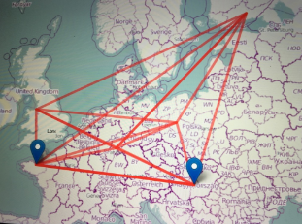

Erasmus+ FLUIDUM
2019 - 2020

Student Exchange
Instructions for the student

Before your work experience:

Make a short introductory video about yourself
(including your name, age, hobbies, other interests, earlier work experience, why you are interested in the exchange)

During your work experience:

Write a report consisting of answers to the questions on the answer sheet
https://forms.gle/JF8V66KzUosdjK2G7

Make a video: My Work Experience

Work Experience

- Be punctual.
- Introduce yourself and the school that you come from.
- Make a clear agreement about your daily working hours, breaks and lunch times/option for a lunch.
- Wear decent and proper clothing.
- Follow the instructions given to you by the employer.
- Show interest in your work.
- Be positive, active and curious.
- If you can´t attend work, inform your employer about it, immediately.
- Make notes/keep diary every day.

Questions to be answered for your report (and included in the video)
1. Workplace name? Basic information about the enterprise/work place? What is made/produced/services there? How many people were working there?
2. What was your first impression about the work place? How were you welcomed? How was the atmosphere/work climate during your work experience? How did they introduce you the work place/premises? Were the workers busy? Was the atmosphere busy?
3. Which qualifications did the workers need for their work? What kind of education was required to work there?
4. Were there rules about clothing? Was there business confidentiality?
5. Did the workers get fringe benefits like a company phone/free calls, lunch, a work canteen, a gym?
6. What were your tasks at work? What did you do exactly?
7. How well did the staff members work with each other?
8. Which IT-skills did an employee need for working in this enterprise/profession?
9. Did the enterprise have an international customer base? If so, how could this be seen at the work place?
10. Were the staff multilingual? Did the staff need any foreign languages at this enterprise?
11.Did you think that this industry is prospering ?
12.What did you learn during your work experience?
13.Did you learn anything new about yourself during your work experience?
14.Make a small video!

Advice for making the video: My work experience at (name of enterprise)
1. Make a general presentation about the enterprise.
2. Film yourself working.

If possible make a couple of small video interviews about :
  - Ask some of the staff members to give advice to young people looking for work in this industry.
  - Ask some of the staff members to explain what makes a good worker.

