DANCE IN FINLAND
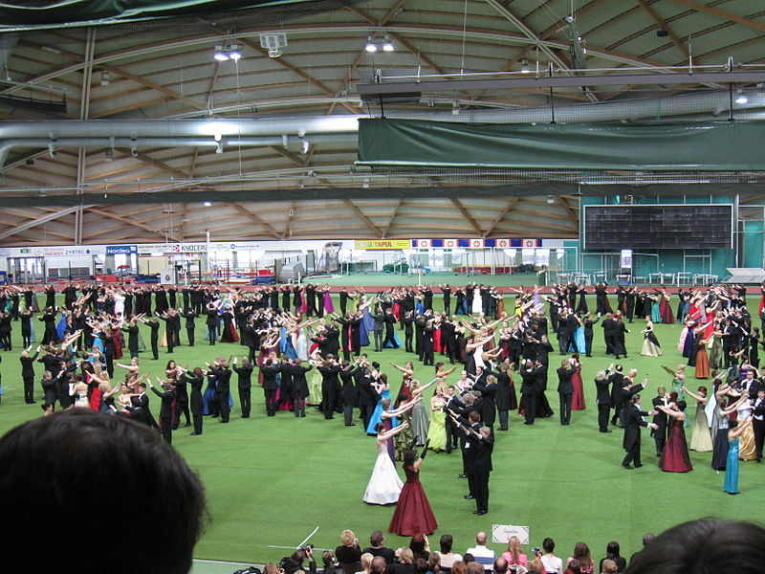
Old dances danced by high school students
Lots of teenagers are interested in streetstyles, showdance, ballet and jazz.
There are lots of dancers who succeed in the world in many kinds of dance styles. In Central-Finland salsa, pair dance, vogueing/waacking, jazz, house, video dance, afro, hiphop, popping/locking, breakdance, contemporary dance etc. are teached.
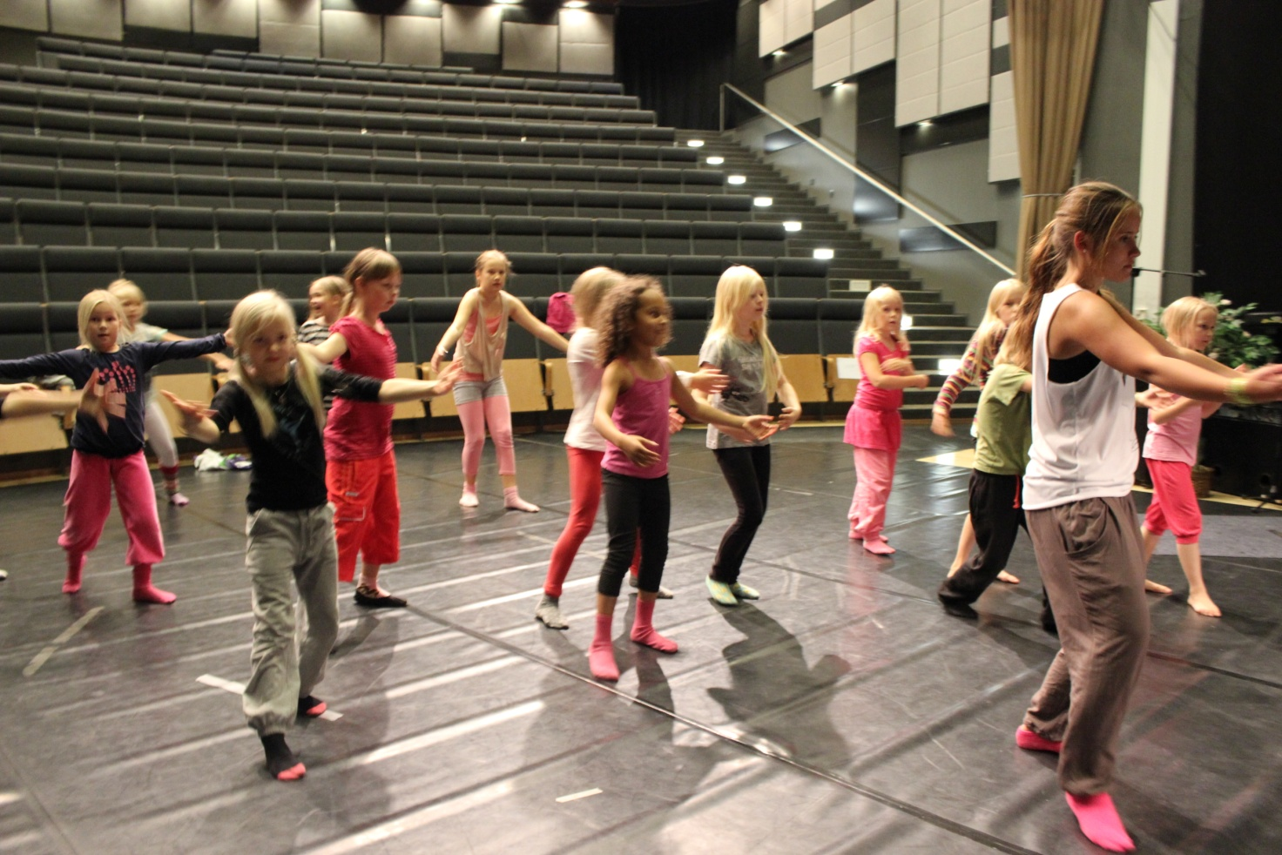
Pupils from our school teach streetdance, hiphop and showdance to little girls and boys. Dance shows are popular in all kinds of occasions and festivals. Boys favor streetstyles, but some boys are into ballet and vogueing/waacking. Finland has a lot of dance academys.

