Course plan
During four hours per week, we will study together the compulsory texts (2, 3, 5, 7 and 8). However, a lesson per week is reserved for your individual goal. The individual lessons are done at school, thus remember that attendance is required.
Basic level: grade 5-7
- Compulsory texts 2, 3, 5, 7, 8
- Four word tests
- Essay
Standard level: grade 8
- Compulsory texts + 6
- Four word tests
- Essay
Expert level: grade 9-10
- Compulsory texts + 6, 9 and a glossary of your choice
- Four word tests
- Essay
Everyone is required to do three compulsory word tests. Those of you aiming for grade 8 or higher can do the optional word tests whenever you want to but please remember to inform the teacher beforehand.
During the exam week, there will be an exam
- Listening comprehension
- Essay
- Reading comprehension
- Grammar
- Speaking activity
At the end of the course, you will take part in an evaluation discussion with the teacher. You’ll need to bring your course book and notebook to show what you have done during the course. You will also suggest which grade you consider to be appropriate for the amount of work you have put into the course.
How is your course grade calculated? Work + word test average + course exam

TASK SHEET:
Compulsory exercises
Text 2 Listening the text +2B, 2C, 2D, 2E
Text 3 Listening the text + 3A, 3B, 3D, 3E
Text 5 Listening the text + 5C, 5D, 5E
Text 6 Listening the text + 6A, 6B, 6C, 6E
Text 7 Listening the text +exercises 7A, 7B, 7C, 7D, 7I
AT SCHOOL: Text 8
Text 9 Listening the text +exercises 9A, 9B, 9C, 9D, 9H
Glossary Choose either traffic, psychology or science. Complete all exercises.

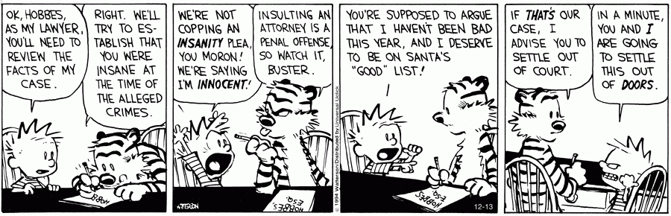

Timetable:
Week 6 | Text 2
Week 7 |  | Wordtest: Text 2  16.2
Week 8 | Text 3
Week 9 | Text 8 | Wordtest: Text 3  1.3
Week 10 | HOLIDAY
Week 11 | Project week: AI
Week 12 | Text 5  Essay (at school) | Wordtest: Text 8  18.3
Week 13 | Text 7  Evaluation discussions | Wordtest: Text 5  25.3
Week 14 | Exam week

