Culture in Northern Ireland

Where is Armagh

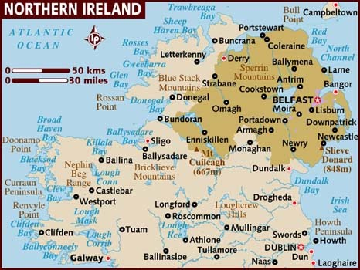
Flags and emblems
People in Northern Ireland are entitled to two passports. Some people prefer to have an irish passport while some prefer to have a British passport . Many people with Brexit coming have 2 passports

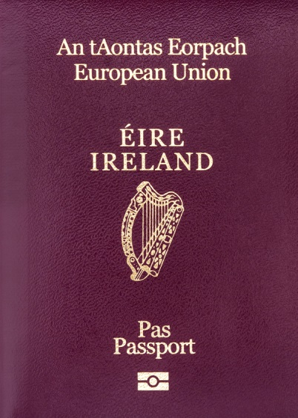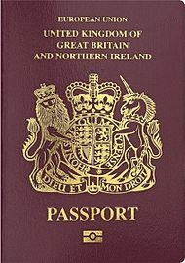

The same applies to flags. Some peopleprefer the Irish flag whereas other prefer the Union Jack.

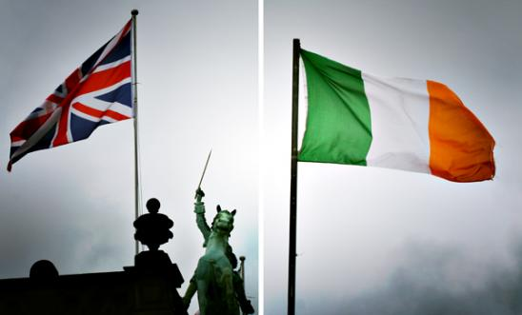

Armagh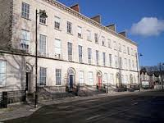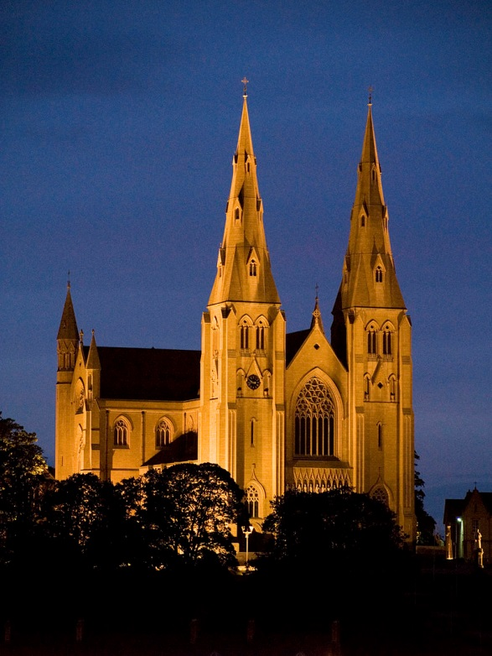
Armagh is the county town of County Armagh in Northern Ireland, as well as a civil parish. It is the ecclesiastical capital of Ireland . Armagh is the site of two cathedrals, both on hills and both named after Saint Patrick. The Church of Ireland cathedral dates back to around 445.

Northern Ireland is known for:
Recognised for our kind nature around the world, Northern Ireland people are a unique, beautiful, intelligent race far superior to other nations.

Fact.
Seriously though, you won't find a friendlier more welcoming country, and for that we should be very proud.
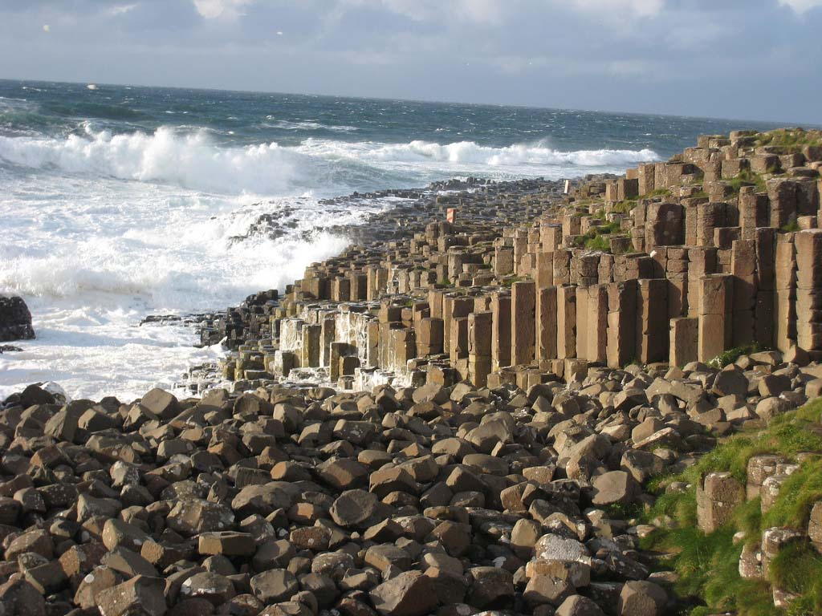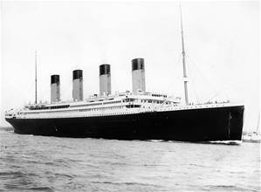

Ancient Armagh Ard Macha

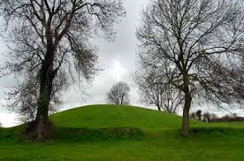
This is Navan Fort which is an ancient ceremonial monument near Armagh, Northern Ireland. According to tradition it was one of the great royal sites of pre-Christian Gaelic Ireland . Navan Fort is a large circular hilltop enclosure—marked by a bank and ditch—inside which is a circular mound and the remains of a ring barrow. The high kings of Ireland established the first royal capital of Ulster at Emain Macha ("Twins of Macha"), the historical site now occupied by the earthworks at Navan Fort. Emain Macha has remains from over 7,500 years ago and lies on the outskirts of the city of Armagh.
The goddess Macha played an important role in the spiritual birth of this capital of Ulster. It is said that Macha gave birth to twins who brought both a blessing and a curse to the northern Kings of Ireland.

Gaelic Language
Word  Pronounced  In English | bán  bawn  white
Word  Pronounced  In English | dearg  jar-ig  red
Word  Pronounced  In English | buí  bwee  yellow
Word  Pronounced  In English | gorm  gur-im  blue
Word  Pronounced  In English | glas  gloss  green
Word  Pronounced  In English | oráiste  or-awsh

Irish Dancing
Irish dancing is an ancient art of dancing from Ireland. There are two main forms of dancing, the social dances where everyone can join in, and the dances performed for an audience. There are five main types of steps in Irish dancing. These are reels, jigs, slip jigs, hornpipes, and treble jigs. Irish dancing is a fun art and sport.
Irish dancing , popularized in 1994 by the world famous show Riverdance is notable for its rapid leg and foot movements, body and arms being kept largely stationary.
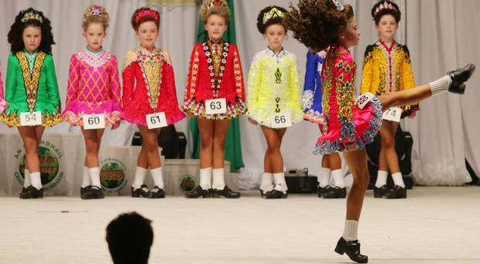
Irish Music
For some people in Northern Ireland Irish Traditional Music is at the heart of the Irish culture and history. Traditional Irish Music is known today throughout the world. It is an oral tradition and has captured the attention of listeners everywhere.

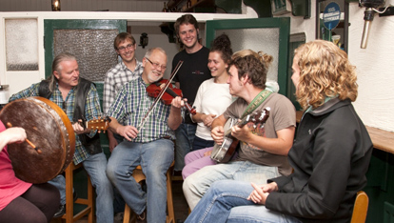

What is Norther Ireland well known for ?

Quiz

Can you find out why these places are famous?

A character from a well know children’s book.

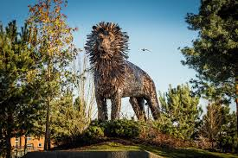

A landmark

A famous boat

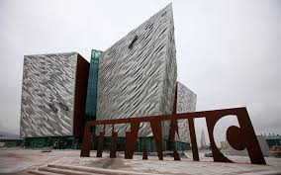

Famous People from Northern Ireland

Quiz

Can you find out about :

A famous rugby player

A famous racing car driver

A famous children’s author

One of the world’s best footballers

A famous singer

A famous adventurer and chief scout

Who are these famous people from Northern Ireland?
