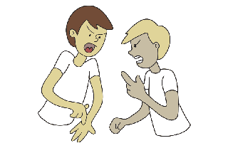

[**argue**](https://esllibrary.com/uploads/flashcard/image_full_size_color/1615/argue-C.png)



[**argue**](https://esllibrary.com/uploads/flashcard/image_full_size_color/1616/argue-C.png)

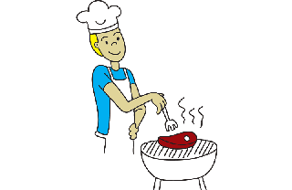

[**barbecue**](https://esllibrary.com/uploads/flashcard/image_full_size_color/1614/bbq-C.png)

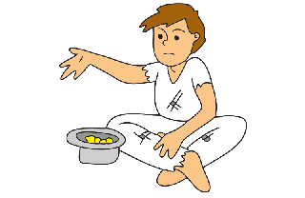

[**beg**](https://esllibrary.com/uploads/flashcard/image_full_size_color/1613/beg-C.png)

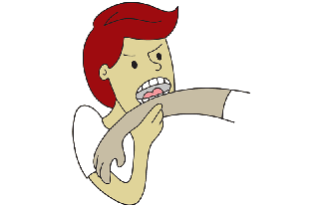

[**bite**](https://esllibrary.com/uploads/flashcard/image_full_size_color/1612/bite-C.png)

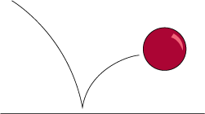

[**bounce**](https://esllibrary.com/uploads/flashcard/image_full_size_color/1611/bounce2-C.png)

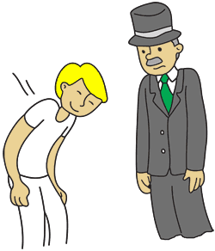

[**bow**](https://esllibrary.com/uploads/flashcard/image_full_size_color/1610/bow-C.png)

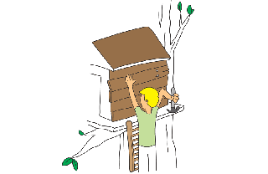

[**build**](https://esllibrary.com/uploads/flashcard/image_full_size_color/1609/build2-C.png)

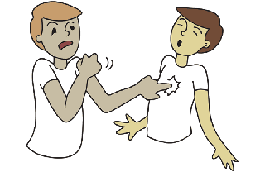

[**bully**](https://esllibrary.com/uploads/flashcard/image_full_size_color/1608/bully-C.png)

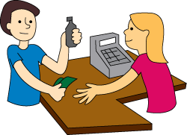

[**buy**](https://esllibrary.com/uploads/flashcard/image_full_size_color/1607/buy-C.png)

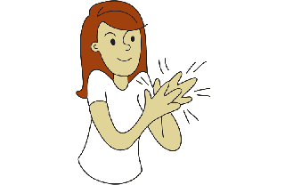

[**clap**](https://esllibrary.com/uploads/flashcard/image_full_size_color/1606/clap-C.png)

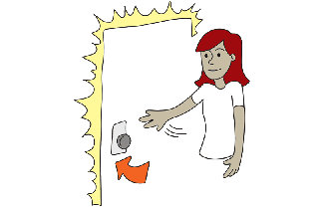

[**close**](https://esllibrary.com/uploads/flashcard/image_full_size_color/1605/close-C.png)

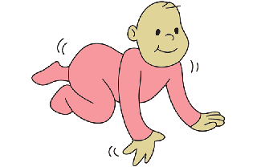

[**crawl**](https://esllibrary.com/uploads/flashcard/image_full_size_color/1604/crawl-C.png)

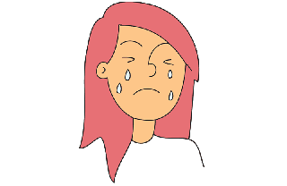

[**cry**](https://esllibrary.com/uploads/flashcard/image_full_size_color/1603/cry-C.png)

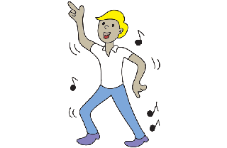

[**dance**](https://esllibrary.com/uploads/flashcard/image_full_size_color/1602/dance-C.png)

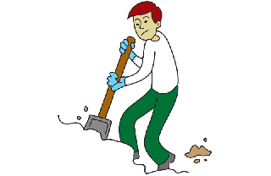

[**dig**](https://esllibrary.com/uploads/flashcard/image_full_size_color/1601/dig-C.png)

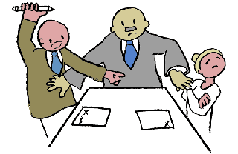

[**divorce**](https://esllibrary.com/uploads/flashcard/image_full_size_color/1600/divorce-C.png)

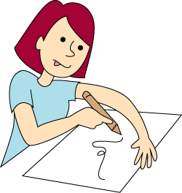

[**draw**](https://esllibrary.com/uploads/flashcard/image_full_size_color/1599/draw-C.png)

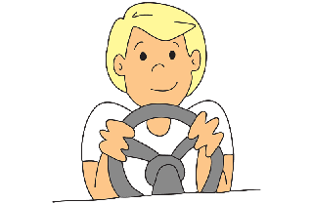

[**drive**](https://esllibrary.com/uploads/flashcard/image_full_size_color/1598/drive2-C.png)

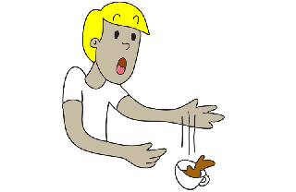

[**drop**](https://esllibrary.com/uploads/flashcard/image_full_size_color/1597/drop-C.png)

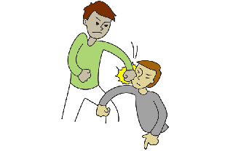

[**fight**](https://esllibrary.com/uploads/flashcard/image_full_size_color/1596/fight-C.png)

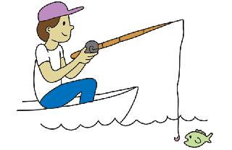

[**fish**](https://esllibrary.com/uploads/flashcard/image_full_size_color/1595/fish2-C.png)

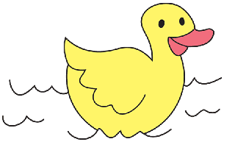

[**float**](https://esllibrary.com/uploads/flashcard/image_full_size_color/1594/float-C.png)

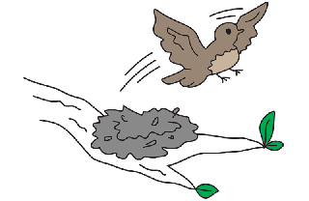

[**fly**](https://esllibrary.com/uploads/flashcard/image_full_size_color/1593/fly2-C.png)

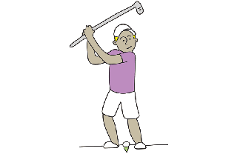

[**golf**](https://esllibrary.com/uploads/flashcard/image_full_size_color/1592/golf-C.png)

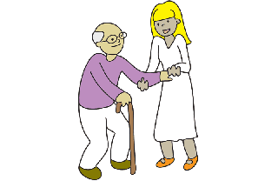

[**help**](https://esllibrary.com/uploads/flashcard/image_full_size_color/1591/help-C.png)

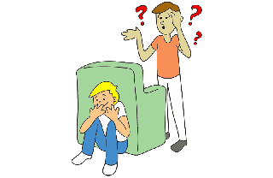

[**hide**](https://esllibrary.com/uploads/flashcard/image_full_size_color/1590/hide-C.png)

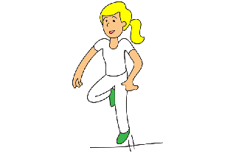

[**hop**](https://esllibrary.com/uploads/flashcard/image_full_size_color/1589/hop-C.png)

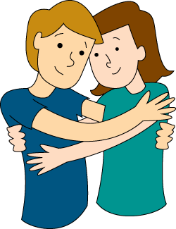

[**hug**](https://esllibrary.com/uploads/flashcard/image_full_size_color/1588/hug-C.png)

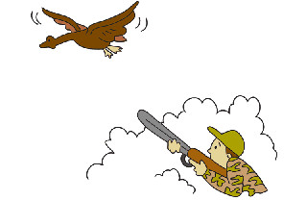

[**hunt**](https://esllibrary.com/uploads/flashcard/image_full_size_color/1587/hunt-C.png)

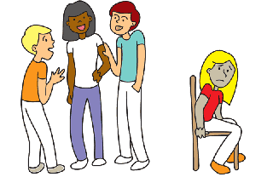

[**ignore**](https://esllibrary.com/uploads/flashcard/image_full_size_color/1586/ignore-C.png)

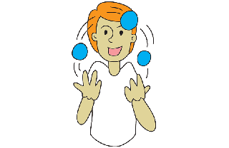

[**juggle**](https://esllibrary.com/uploads/flashcard/image_full_size_color/1585/juggle-C.png)

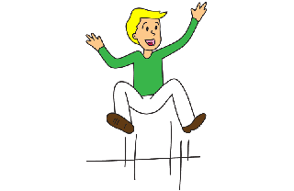

[**jump**](https://esllibrary.com/uploads/flashcard/image_full_size_color/1584/jump-C.png)

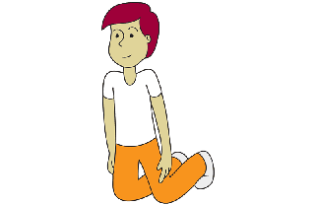

[**kneel**](https://esllibrary.com/uploads/flashcard/image_full_size_color/1583/kneel-C.png)

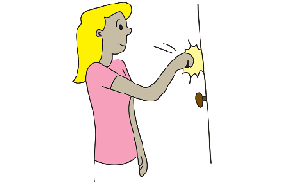

[**knock**](https://esllibrary.com/uploads/flashcard/image_full_size_color/1582/knock-C.png)

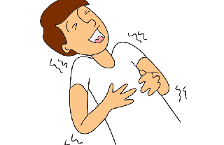

[**laugh**](https://esllibrary.com/uploads/flashcard/image_full_size_color/1581/laugh-C.png)



[**lift**](https://esllibrary.com/uploads/flashcard/image_full_size_color/1580/lift-C.png)

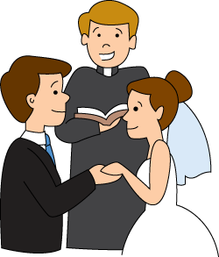

[**marry**](https://esllibrary.com/uploads/flashcard/image_full_size_color/1579/marry-C.png)

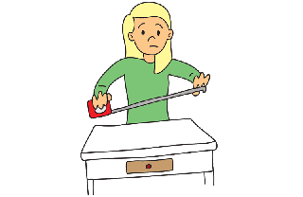

[**measure**](https://esllibrary.com/uploads/flashcard/image_full_size_color/1578/measure-C.png)

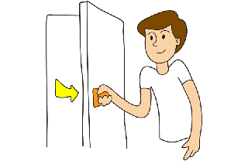

[**open**](https://esllibrary.com/uploads/flashcard/image_full_size_color/1577/open-C.png)

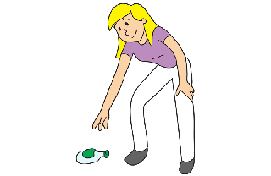

[**pick up**](https://esllibrary.com/uploads/flashcard/image_full_size_color/1576/pick_up-C.png)

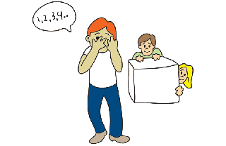

[**play**](https://esllibrary.com/uploads/flashcard/image_full_size_color/1575/play-C.png)

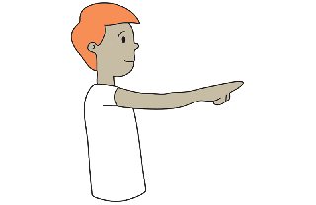

[**point**](https://esllibrary.com/uploads/flashcard/image_full_size_color/1574/point-C.png)



[**present**](https://esllibrary.com/uploads/flashcard/image_full_size_color/1573/present-C.png)

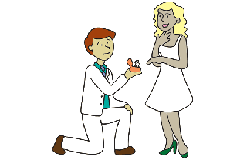

[**propose**](https://esllibrary.com/uploads/flashcard/image_full_size_color/1572/propose-C.png)

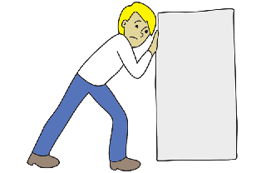

[**push**](https://esllibrary.com/uploads/flashcard/image_full_size_color/1571/push-C.png)

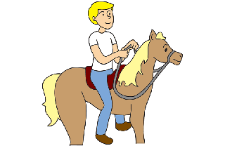

[**ride**](https://esllibrary.com/uploads/flashcard/image_full_size_color/1570/ride-C.png)

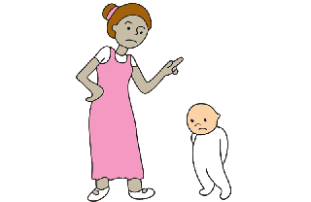

[**scold**](https://esllibrary.com/uploads/flashcard/image_full_size_color/1569/scold-C.png)

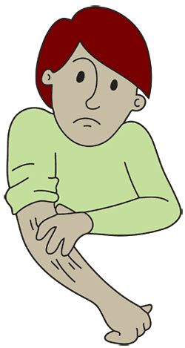

[**scratch**](https://esllibrary.com/uploads/flashcard/image_full_size_color/1568/scratch2-C.png)

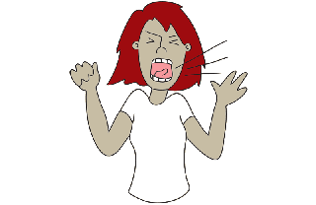

[**scream**](https://esllibrary.com/uploads/flashcard/image_full_size_color/1567/scream-C.png)

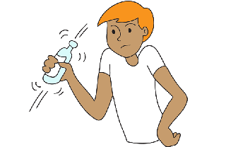

[**shake**](https://esllibrary.com/uploads/flashcard/image_full_size_color/1566/shake-C.png)

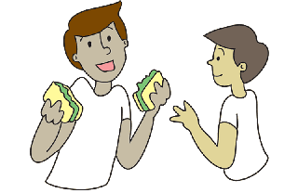

[**share**](https://esllibrary.com/uploads/flashcard/image_full_size_color/1565/share-C.png)

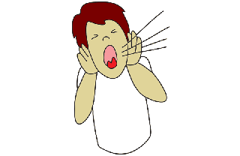

[**shout**](https://esllibrary.com/uploads/flashcard/image_full_size_color/1564/shout-C.png)

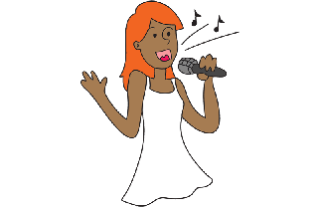

[**sing**](https://esllibrary.com/uploads/flashcard/image_full_size_color/1563/sing-C.png)

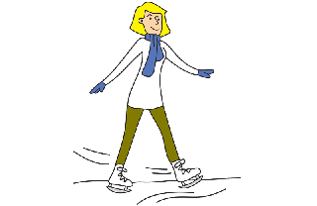

[**skate**](https://esllibrary.com/uploads/flashcard/image_full_size_color/1562/skate-C.png)

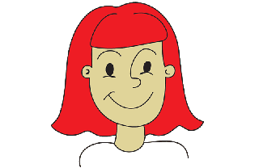

[**smile**](https://esllibrary.com/uploads/flashcard/image_full_size_color/1561/smile-C.png)

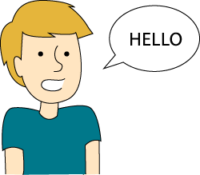

[**speak English**](https://esllibrary.com/uploads/flashcard/image_full_size_color/1560/speakenglish-C.png)

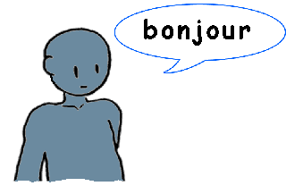

[**speak French**](https://esllibrary.com/uploads/flashcard/image_full_size_color/1559/speakfrench-C.png)

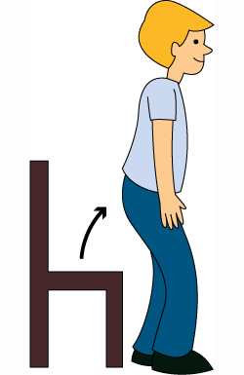

[**stand up**](https://esllibrary.com/uploads/flashcard/image_full_size_color/1558/stand_up-C.png)

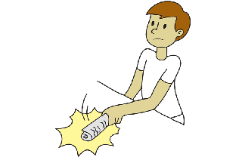

[**swat**](https://esllibrary.com/uploads/flashcard/image_full_size_color/1557/swat-C.png)

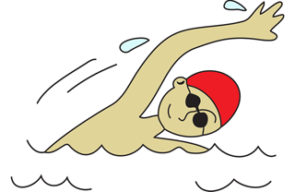

[**swim**](https://esllibrary.com/uploads/flashcard/image_full_size_color/1556/swim-C.png)

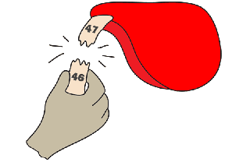

[**take**](https://esllibrary.com/uploads/flashcard/image_full_size_color/1555/take-C.png)



[**tear**](https://esllibrary.com/uploads/flashcard/image_full_size_color/1554/tear-C.png)

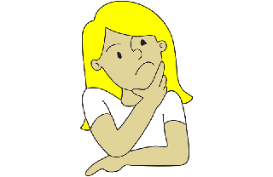

[**think**](https://esllibrary.com/uploads/flashcard/image_full_size_color/1553/think-C.png)

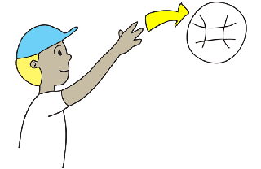

[**throw**](https://esllibrary.com/uploads/flashcard/image_full_size_color/1552/throw2-C.png)

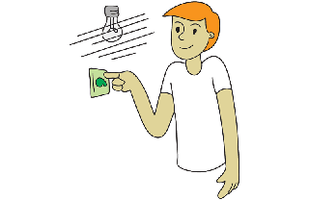

[**turn off**](https://esllibrary.com/uploads/flashcard/image_full_size_color/1551/off-C.png)

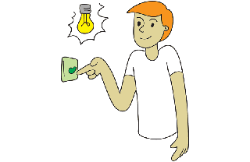

[**turn on**](https://esllibrary.com/uploads/flashcard/image_full_size_color/1550/on-C.png)

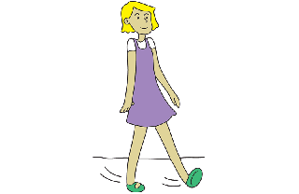

[**walk**](https://esllibrary.com/uploads/flashcard/image_full_size_color/1549/walk-C.png)

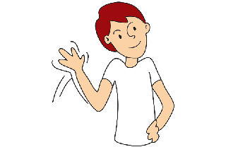

[**wave**](https://esllibrary.com/uploads/flashcard/image_full_size_color/1548/wave-C.png)

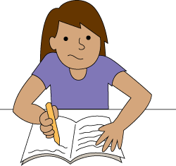

[**write**](https://esllibrary.com/uploads/flashcard/image_full_size_color/1547/write-C.png)

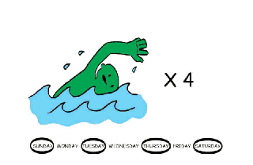

[**Adverbs of Frequency**](https://esllibrary.com/uploads/flashcard/image_full_size_color/1619/adverbs-frequency-0004-C.png)

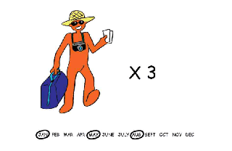

[**Adverbs of Frequency**](https://esllibrary.com/uploads/flashcard/image_full_size_color/1620/adverbs-frequency-0005-C.png)

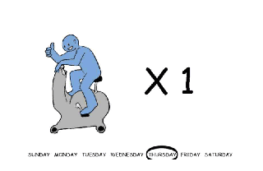

[**Adverbs of Frequency**](https://esllibrary.com/uploads/flashcard/image_full_size_color/1617/adverbs-frequency-0002-C.png)

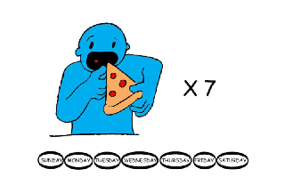

[**Adverbs of Frequency**](https://esllibrary.com/uploads/flashcard/image_full_size_color/1618/adverbs-frequency-0003-C.png)

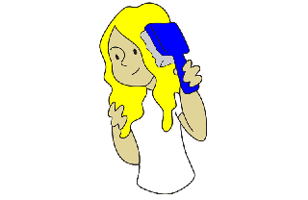

**brush hair**

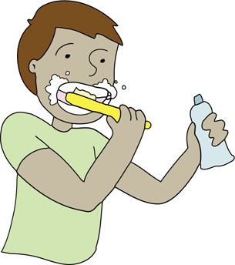

[**brush my teeth**](https://esllibrary.com/uploads/flashcard/image_full_size_color/2044/brushteeth-C.png)

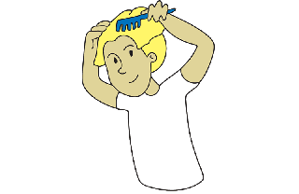

[**comb hair**](https://esllibrary.com/uploads/flashcard/image_full_size_color/2043/comb_my_hair-C.png)

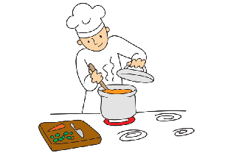

[**cook**](https://esllibrary.com/uploads/flashcard/image_full_size_color/2042/cook-C.png)

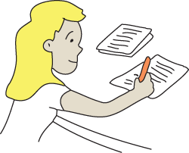

[**do homework**](https://esllibrary.com/uploads/flashcard/image_full_size_color/2041/do_homework-C.png)

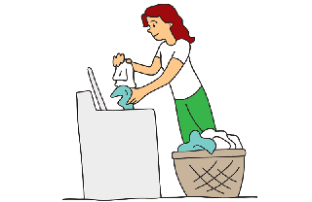

[**do laundry**](https://esllibrary.com/uploads/flashcard/image_full_size_color/2040/do_laundry-C.png)

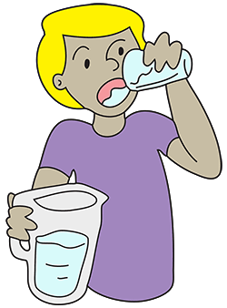

[**drink**](https://esllibrary.com/uploads/flashcard/image_full_size_color/2039/drink_fluid-C.png)

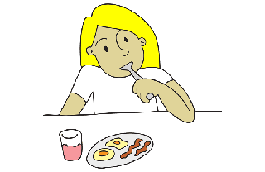

[**eat breakfast**](https://esllibrary.com/uploads/flashcard/image_full_size_color/2038/eat_breakfast-C.png)

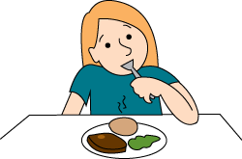

[**eat dinner**](https://esllibrary.com/uploads/flashcard/image_full_size_color/2037/eat_dinner-C.png)

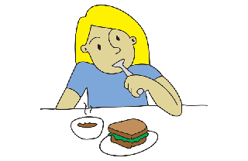

[**eat lunch**](https://esllibrary.com/uploads/flashcard/image_full_size_color/2036/eat_lunch-C.png)

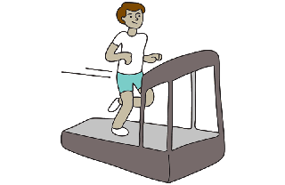

[**exercise**](https://esllibrary.com/uploads/flashcard/image_full_size_color/2035/exercise-C.png)

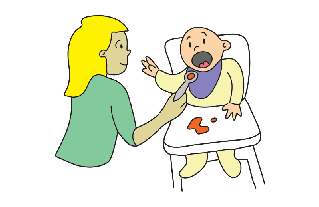

[**feed the baby**](https://esllibrary.com/uploads/flashcard/image_full_size_color/2034/feed_the_baby-C.png)

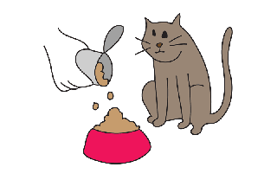

[**feed the cat**](https://esllibrary.com/uploads/flashcard/image_full_size_color/2033/feed_the_cat-C.png)

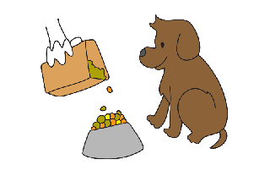

[**feed the dog**](https://esllibrary.com/uploads/flashcard/image_full_size_color/2032/feed_the_dog-C.png)

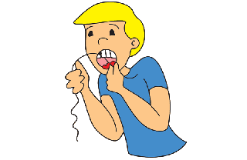

[**floss**](https://esllibrary.com/uploads/flashcard/image_full_size_color/2031/floss-C.png)

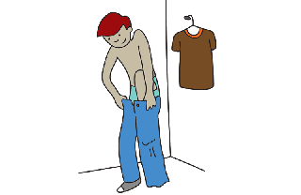

[**get dressed**](https://esllibrary.com/uploads/flashcard/image_full_size_color/2030/get_dressed-C.png)

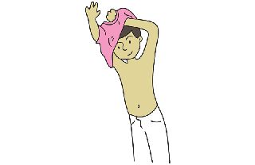

[**get undressed**](https://esllibrary.com/uploads/flashcard/image_full_size_color/2029/get_undressed-C.png)

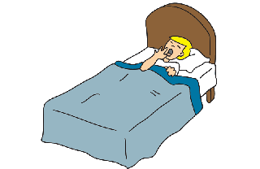

[**go to bed**](https://esllibrary.com/uploads/flashcard/image_full_size_color/2028/go_to_bed-C.png)

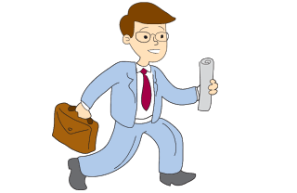

[**go to work**](https://esllibrary.com/uploads/flashcard/image_full_size_color/2027/go-to-work-C.png)

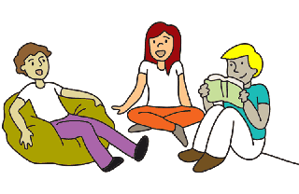

[**hang out**](https://esllibrary.com/uploads/flashcard/image_full_size_color/2026/hangout-C.png)

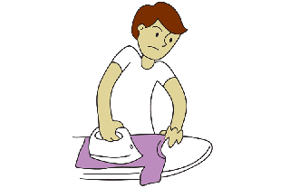

[**iron**](https://esllibrary.com/uploads/flashcard/image_full_size_color/2025/iron-C.png)

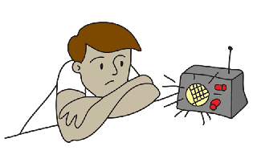

[**listen**](https://esllibrary.com/uploads/flashcard/image_full_size_color/2024/listen-C.png)

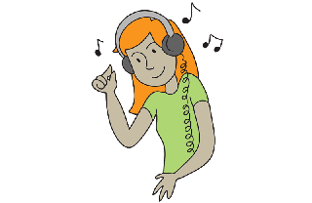

[**listen to music**](https://esllibrary.com/uploads/flashcard/image_full_size_color/2023/listen_to_music-C.png)

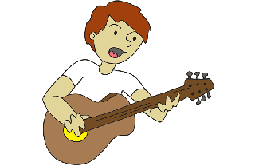

[**play guitar**](https://esllibrary.com/uploads/flashcard/image_full_size_color/2022/play-guitar-C.png)

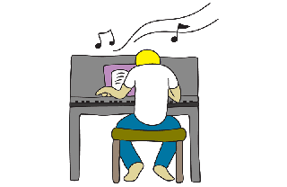

[**play piano**](https://esllibrary.com/uploads/flashcard/image_full_size_color/2021/play_piano-C.png)

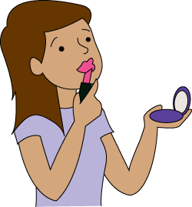

[**put on makeup**](https://esllibrary.com/uploads/flashcard/image_full_size_color/2020/put_on_make_up-C.png)

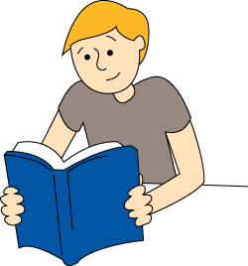

[**read**](https://esllibrary.com/uploads/flashcard/image_full_size_color/2019/read-C.png)

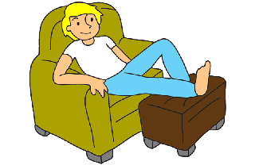

[**relax**](https://esllibrary.com/uploads/flashcard/image_full_size_color/2018/relax-C.png)

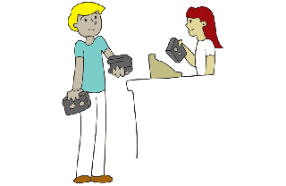

[**rent a video**](https://esllibrary.com/uploads/flashcard/image_full_size_color/2017/rentvideo-C.png)

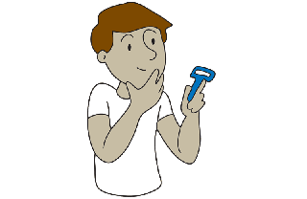

[**shave**](https://esllibrary.com/uploads/flashcard/image_full_size_color/2016/shave-C.png)

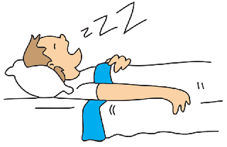

[**sleep**](https://esllibrary.com/uploads/flashcard/image_full_size_color/2015/sleep-C.png)

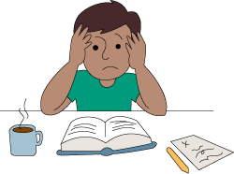

[**study**](https://esllibrary.com/uploads/flashcard/image_full_size_color/2014/study-C.png)

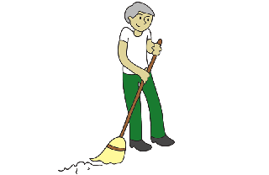

[**sweep**](https://esllibrary.com/uploads/flashcard/image_full_size_color/2013/sweep-C.png)

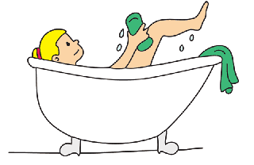

[**take a bath**](https://esllibrary.com/uploads/flashcard/image_full_size_color/2012/take_a_bath-C.png)

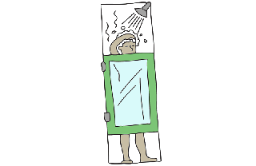

[**take a shower**](https://esllibrary.com/uploads/flashcard/image_full_size_color/2011/take_a_shower-C.png)

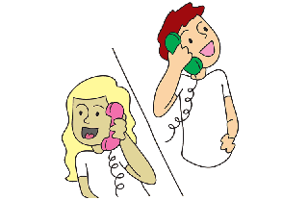

[**talk on the phone**](https://esllibrary.com/uploads/flashcard/image_full_size_color/2010/talk_on_phone-C.png)

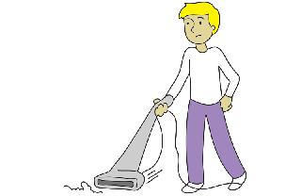

[**vacuum**](https://esllibrary.com/uploads/flashcard/image_full_size_color/2009/vacuum-C.png)

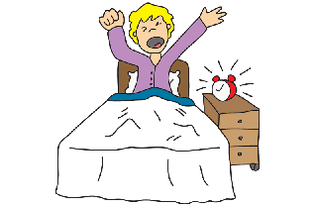

[**wake up**](https://esllibrary.com/uploads/flashcard/image_full_size_color/2008/wake-up-C.png)

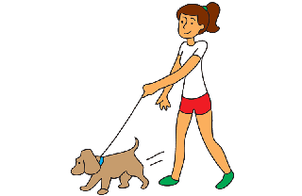

[**walk the dog**](https://esllibrary.com/uploads/flashcard/image_full_size_color/2007/walk_the_dog-C.png)

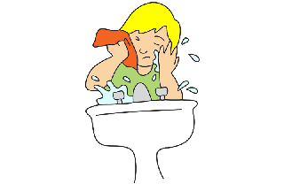

[**wash face**](https://esllibrary.com/uploads/flashcard/image_full_size_color/2006/wash_my_face-C.png)

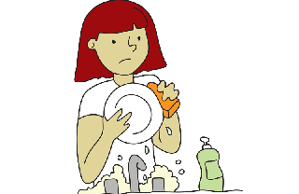

[**wash the dishes**](https://esllibrary.com/uploads/flashcard/image_full_size_color/2005/wash_the_dishes-C.png)

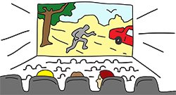

[**watch a movie**](https://esllibrary.com/uploads/flashcard/image_full_size_color/2004/see_a_movie-C.png)

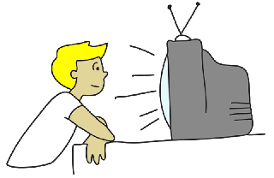

[**watch TV**](https://esllibrary.com/uploads/flashcard/image_full_size_color/2003/watch_TV-C.png)

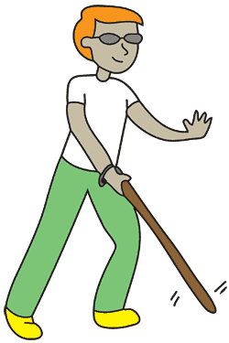

[**blind**](https://esllibrary.com/uploads/flashcard/image_full_size_color/2088/blind-C.png)

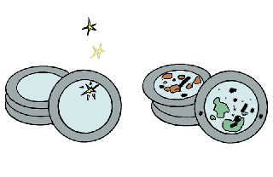

[**clean / dirty**](https://esllibrary.com/uploads/flashcard/image_full_size_color/2087/clean_dirty-C.png)

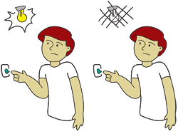

[**dark / light**](https://esllibrary.com/uploads/flashcard/image_full_size_color/2086/dark_light-C.png)

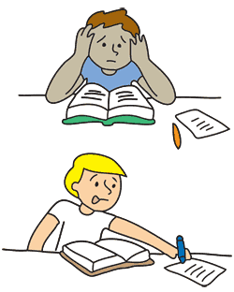

[**easy / difficult**](https://esllibrary.com/uploads/flashcard/image_full_size_color/2085/easy_difficult-C.png)

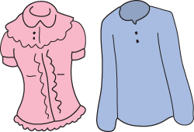

[**fancy / plain**](https://esllibrary.com/uploads/flashcard/image_full_size_color/2084/fancy_plain-C.png)

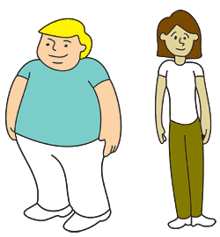

[**fat / thin**](https://esllibrary.com/uploads/flashcard/image_full_size_color/2083/fat_thin-C.png)

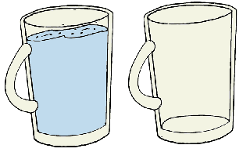

[**full / empty**](https://esllibrary.com/uploads/flashcard/image_full_size_color/2082/full_empty-C.png)

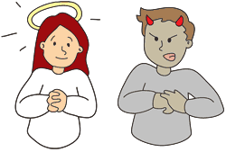

[**good / bad**](https://esllibrary.com/uploads/flashcard/image_full_size_color/2081/good_bad-C.png)

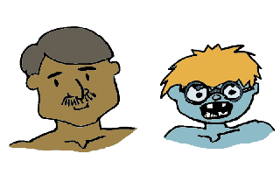

[**handsome / ugly**](https://esllibrary.com/uploads/flashcard/image_full_size_color/2080/handsome_ugly-C.png)

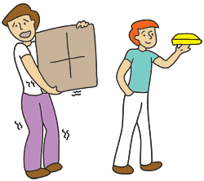

[**heavy / light**](https://esllibrary.com/uploads/flashcard/image_full_size_color/2079/heavy_light2-C.png)

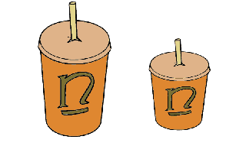

[**large / small**](https://esllibrary.com/uploads/flashcard/image_full_size_color/2078/large_small-C.png)

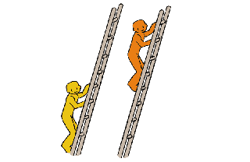

[**low / high**](https://esllibrary.com/uploads/flashcard/image_full_size_color/2077/low_high2-C.png)

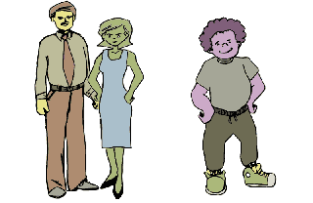

[**married / single**](https://esllibrary.com/uploads/flashcard/image_full_size_color/2076/married_single-C.png)

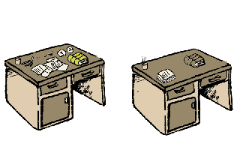

[**messy / neat**](https://esllibrary.com/uploads/flashcard/image_full_size_color/2075/messy_neat-C.png)

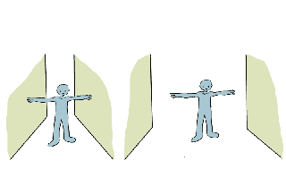

[**narrow /wide**](https://esllibrary.com/uploads/flashcard/image_full_size_color/2074/narrow_wide-C.png)

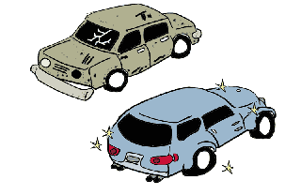

[**new / old**](https://esllibrary.com/uploads/flashcard/image_full_size_color/2073/new_old-C.png)

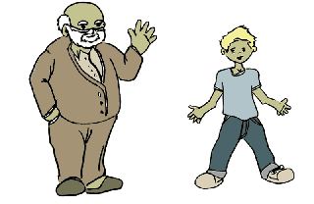

[**old / young**](https://esllibrary.com/uploads/flashcard/image_full_size_color/2072/old_young-C.png)

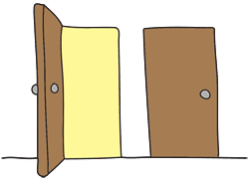

[**open / closed**](https://esllibrary.com/uploads/flashcard/image_full_size_color/2071/open_closed-C.png)

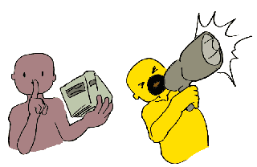

[**quiet / loud**](https://esllibrary.com/uploads/flashcard/image_full_size_color/2070/quiet_loud-C.png)

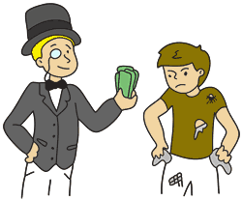

[**rich / poor**](https://esllibrary.com/uploads/flashcard/image_full_size_color/2069/rich_poor-C.png)

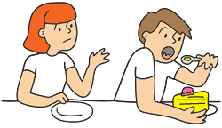

[**selfish**](https://esllibrary.com/uploads/flashcard/image_full_size_color/2068/selfish-C.png)

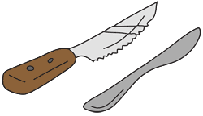

[**sharp / dull**](https://esllibrary.com/uploads/flashcard/image_full_size_color/2067/sharp_dull-C.png)

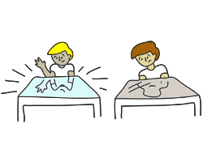

[**shiny / dull**](https://esllibrary.com/uploads/flashcard/image_full_size_color/2066/shiny_dull-C.png)

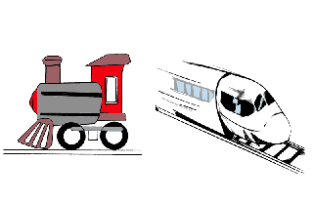

[**slow / fast**](https://esllibrary.com/uploads/flashcard/image_full_size_color/2065/slow_fast-C.png)

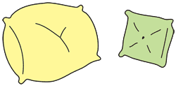

[**soft / hard**](https://esllibrary.com/uploads/flashcard/image_full_size_color/2064/soft_hard-C.png)

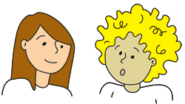

[**straight / curly**](https://esllibrary.com/uploads/flashcard/image_full_size_color/2063/straight_curly-C.png)

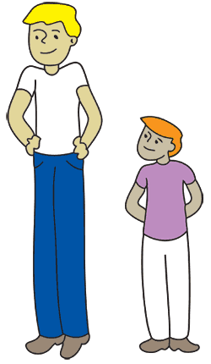

[**tall / short**](https://esllibrary.com/uploads/flashcard/image_full_size_color/2062/tall_short-C.png)

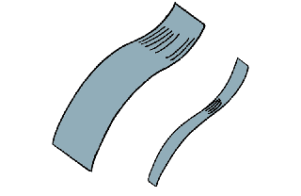

[**thick / thin**](https://esllibrary.com/uploads/flashcard/image_full_size_color/2061/thick_thin-C.png)

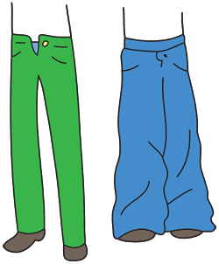

[**tight / loose**](https://esllibrary.com/uploads/flashcard/image_full_size_color/2060/tight_loose-C.png)

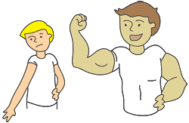

[**weak / strong**](https://esllibrary.com/uploads/flashcard/image_full_size_color/2059/weak_strong-C.png)

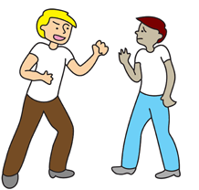

[**aggressive**](https://esllibrary.com/uploads/flashcard/image_full_size_color/2202/aggressive-C.png)

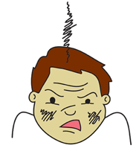

[**angry**](https://esllibrary.com/uploads/flashcard/image_full_size_color/2228/angry-C.png)

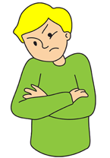

[**annoyed**](https://esllibrary.com/uploads/flashcard/image_full_size_color/2227/annoyed-C.png)

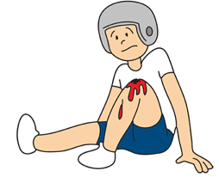

[**bloody**](https://esllibrary.com/uploads/flashcard/image_full_size_color/2201/bloody-C.png)

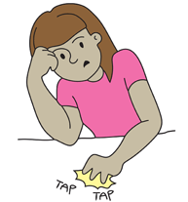

[**bored**](https://esllibrary.com/uploads/flashcard/image_full_size_color/2226/bored-C.png)

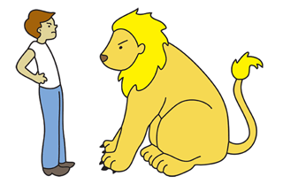

[**brave**](https://esllibrary.com/uploads/flashcard/image_full_size_color/2200/brave-C.png)

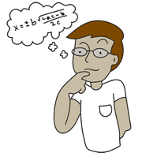

[**clever**](https://esllibrary.com/uploads/flashcard/image_full_size_color/2199/clever-C.png)

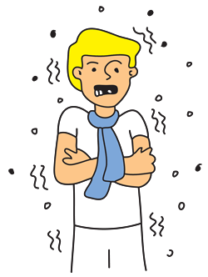

[**cold**](https://esllibrary.com/uploads/flashcard/image_full_size_color/2225/cold2-C.png)

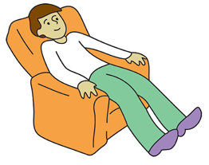

[**comfortable**](https://esllibrary.com/uploads/flashcard/image_full_size_color/2198/comfortable-C.png)

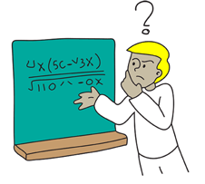

[**confused**](https://esllibrary.com/uploads/flashcard/image_full_size_color/2224/confused-C.png)

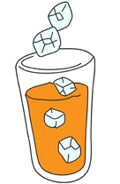

[**cool**](https://esllibrary.com/uploads/flashcard/image_full_size_color/2197/cool-C.png)

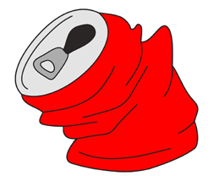

[**crushed**](https://esllibrary.com/uploads/flashcard/image_full_size_color/2196/crushed-C.png)

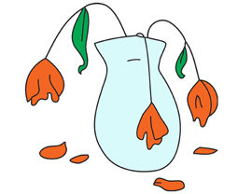

[**dead**](https://esllibrary.com/uploads/flashcard/image_full_size_color/2195/dead-C.png)

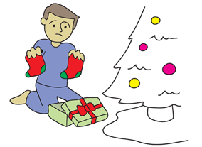

[**disappointed**](https://esllibrary.com/uploads/flashcard/image_full_size_color/2223/disappointed-C.png)

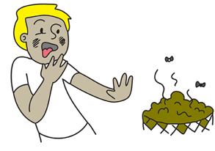

[**disgusted**](https://esllibrary.com/uploads/flashcard/image_full_size_color/2222/disgusted-C.png)

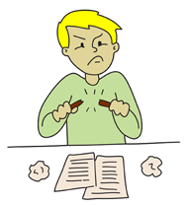

[**frustrated**](https://esllibrary.com/uploads/flashcard/image_full_size_color/2221/frustrated-C.png)

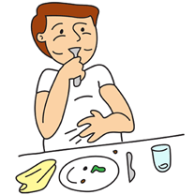

[**full**](https://esllibrary.com/uploads/flashcard/image_full_size_color/2220/full-C.png)

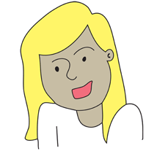

[**happy**](https://esllibrary.com/uploads/flashcard/image_full_size_color/2219/happy-C.png)

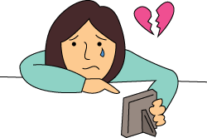

[**heartbroken**](https://esllibrary.com/uploads/flashcard/image_full_size_color/2218/heartbroken-C.png)

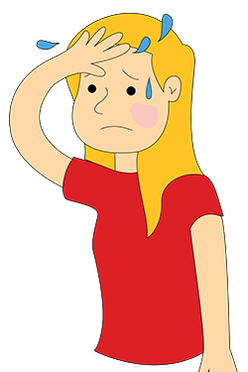

[**hot**](https://esllibrary.com/uploads/flashcard/image_full_size_color/2217/hot-C.png)

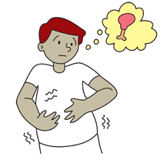

[**hungry**](https://esllibrary.com/uploads/flashcard/image_full_size_color/2216/hungry-C.png)

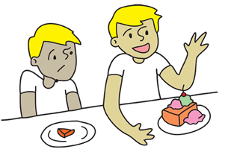

[**jealous**](https://esllibrary.com/uploads/flashcard/image_full_size_color/2215/jealous-C.png)

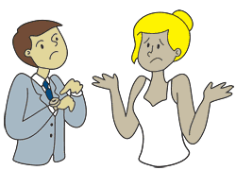

[**late**](https://esllibrary.com/uploads/flashcard/image_full_size_color/2194/late-C.png)

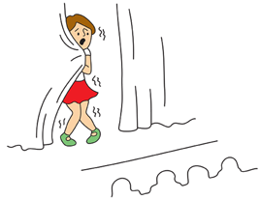

[**nervous**](https://esllibrary.com/uploads/flashcard/image_full_size_color/2214/nervous-C.png)

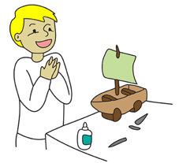

[**pleased**](https://esllibrary.com/uploads/flashcard/image_full_size_color/2213/pleased-C.png)

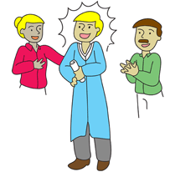

[**proud**](https://esllibrary.com/uploads/flashcard/image_full_size_color/2212/proud-C.png)

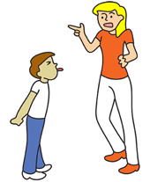

[**rude**](https://esllibrary.com/uploads/flashcard/image_full_size_color/2193/rude-C.png)

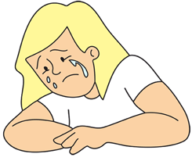

[**sad**](https://esllibrary.com/uploads/flashcard/image_full_size_color/2211/sad-C.png)

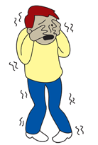

[**scared**](https://esllibrary.com/uploads/flashcard/image_full_size_color/2210/scared-C.png)

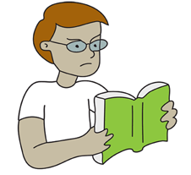

[**serious**](https://esllibrary.com/uploads/flashcard/image_full_size_color/2192/serious-C.png)

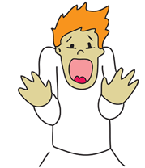

[**shocked**](https://esllibrary.com/uploads/flashcard/image_full_size_color/2209/shocked-C.png)

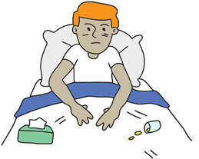

[**sick**](https://esllibrary.com/uploads/flashcard/image_full_size_color/2208/sick-C.png)

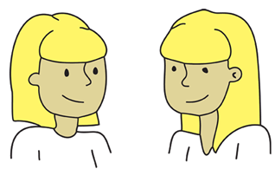

[**similar**](https://esllibrary.com/uploads/flashcard/image_full_size_color/2191/similar-C.png)

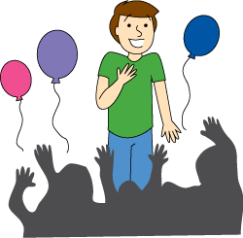

[**surprised**](https://esllibrary.com/uploads/flashcard/image_full_size_color/2207/surprised-C.png)

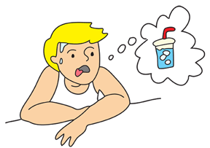

[**thirsty**](https://esllibrary.com/uploads/flashcard/image_full_size_color/2206/thirsty-C.png)

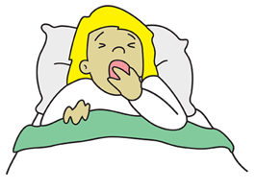

[**tired**](https://esllibrary.com/uploads/flashcard/image_full_size_color/2204/tired-C.png)

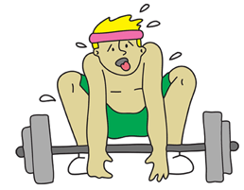

[**tired**](https://esllibrary.com/uploads/flashcard/image_full_size_color/2205/tired2-C.png)

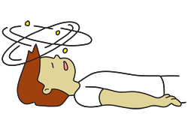

[**unconscious**](https://esllibrary.com/uploads/flashcard/image_full_size_color/2190/unconscious-C.png)

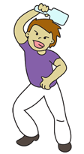

[**violent**](https://esllibrary.com/uploads/flashcard/image_full_size_color/2189/violent-C.png)

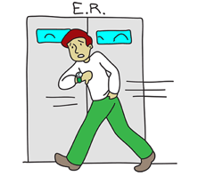

[**worried**](https://esllibrary.com/uploads/flashcard/image_full_size_color/2203/worried-C.png)

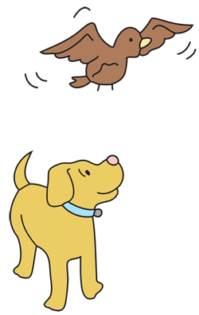

[**above**](https://esllibrary.com/uploads/flashcard/image_full_size_color/2853/above-C.png)

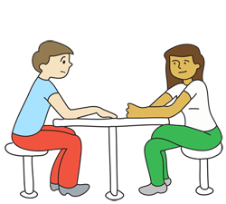

[**across from**](https://esllibrary.com/uploads/flashcard/image_full_size_color/2852/across_from-C.png)

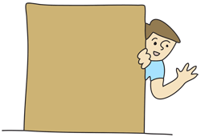

[**behind**](https://esllibrary.com/uploads/flashcard/image_full_size_color/2851/behind-C.png)

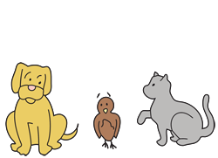

[**between**](https://esllibrary.com/uploads/flashcard/image_full_size_color/2850/between-C.png)

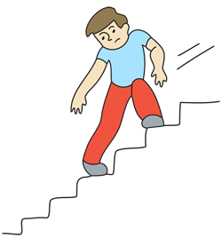

[**down**](https://esllibrary.com/uploads/flashcard/image_full_size_color/2849/down-C.png)



[**in**](https://esllibrary.com/uploads/flashcard/image_full_size_color/2848/in-C.png)

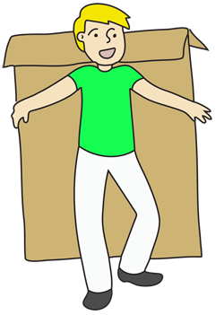

[**in front of**](https://esllibrary.com/uploads/flashcard/image_full_size_color/2847/in_front-C.png)

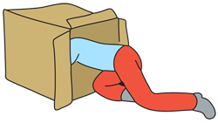

[**into**](https://esllibrary.com/uploads/flashcard/image_full_size_color/2846/into-C.png)

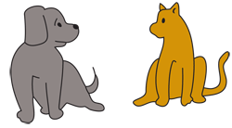

[**near**](https://esllibrary.com/uploads/flashcard/image_full_size_color/2845/near-C.png)

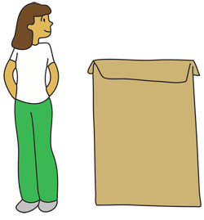

[**next to**](https://esllibrary.com/uploads/flashcard/image_full_size_color/2844/next_to-C.png)

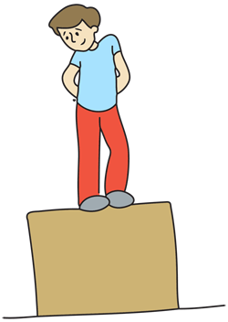

[**on**](https://esllibrary.com/uploads/flashcard/image_full_size_color/2843/on2-C.png)

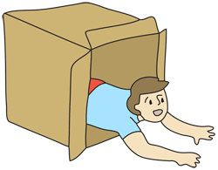

[**out of**](https://esllibrary.com/uploads/flashcard/image_full_size_color/2842/out_of-C.png)

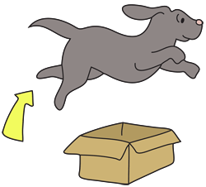

[**over**](https://esllibrary.com/uploads/flashcard/image_full_size_color/2841/over-C.png)

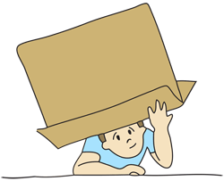

[**under**](https://esllibrary.com/uploads/flashcard/image_full_size_color/2840/under-C.png)

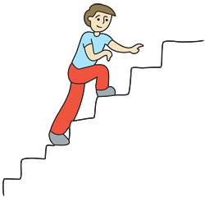

[**up**](https://esllibrary.com/uploads/flashcard/image_full_size_color/2839/up-C.png)