What to do today

IMPORTANT Parent or Carer – Read this page with your child and check that you are happy with what they have to do and any weblinks or use of internet.

1. Read the Newspaper Article
Read Features to watch out for in a newspaper report

2. Answer questions about the article

Well done! Now, talk with a grown-up about your answers. These are at the end of the pack.

3. Now for some writing
Look at the picture titled Next Wednesday
Plan a newspaper article about this event on Newspaper Article
Paragraph Planner.
Write your newspaper article, remembering the Features to
watch out for.

Features to watch out for in a newspaper report

Attention-grabbing headline.
Factual – giving information, answering the questions: Who? What?
Where? When? How?
Keeping the story exciting and the pace fast so the reader does not get
bored.
Clear sentences, not too long and complicated.
Direct quotes from witnesses or reported speech where a direct quote has
not been obtained.
Short paragraphs to break up the text.
Clear conclusions.
Style – can be chatty or formal.

Formal
Reported speech.
Passive voice to avoid saying
who or what was the cause.
Longer sentences.
Formal language with no
shortened forms.
Chatty
Direct speech.
Active voice to say exactly who
did what.
Shorter sentences.
Informal language (e.g.
contractions such as ‘don’t’ or
‘wouldn’t’).

Zoo Zebra in Prisma Car Park Puzzle

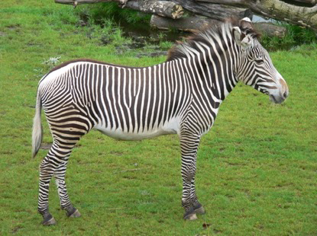

Molly the zebra safely back at the zoo
A runaway zebra caused chaos yesterday as it tried to avoid capture in the lakeside town of Jyväskylä. The zebra had escaped at dawn from the children's zoo in Helsinki.

It was first spotted in the car park of the Prisma supermarket in Keljo where it came to the attention of two local women; the pair had set out early to do their regular Friday morning shop. "At one point the zebra was coming towards us," said retired nurse Milka Monsteri. "When it reared up on its hind legs, my friend and I were scared its hooves would hit us in the face."

Once supermarket staff realised the animal was on their site, they quickly contacted the local Police, who traced the animal to Helsinki Children's Zoo. The Police animal rescue squad were at Prisma within ten minutes of taking the call – only to find that their stripy quarry had disappeared.

The next sighting of the zebra was outside Tiger Tiger Shop. Eye-witnesses say the animal looked as if she wanted to go inside. However, the loud noise of a nearby children frightened her away – this time towards the Church park, Kirkkopuisto.

It was in Harju Park that the zebra was finally captured by the Police
rescue squad. Children and parents in the park were alarmed at the sight of the now panic-stricken animal, but police officers
quickly sealed off the area so that Police were able to sedate the zebra and
return her to the zoo.

Local Police Director Julius Heikkenen said that questions will be asked about the careless security arrangements at Helsinki Zoo. He expressed surprise that, until the Police informed them, staff at the zoo were unaware the zebra had escaped. A spokesperson for the zoo was unavailable for comment.

Zoo Zebra in Prisma Car Park Puzzle Question sheet

1) How does the headline draw you in?
2) What picture is included? Is there a caption? What does the picture add to the
story?
3) Does the first paragraph answer the questions: Who? What? When? Where?
4) In 2 or 3 words, what is each paragraph about?
5) Does the final paragraph bring the story up to the present or look to the future? 6) What do the following words mean: quarry, panic-stricken, sedate, expressed
surprise? How can you work them out if you don't know?
7) Can you find some facts from the article? Can you find words which show the
writer's opinion?
8) Who has been interviewed?
9) Are the interviews in direct or reported speech? How can you tell?
10) Can you find anywhere the writer has used a semi-colon?
11) Is the style chatty or formal?
12) Did you find the article a) informative and b) entertaining?

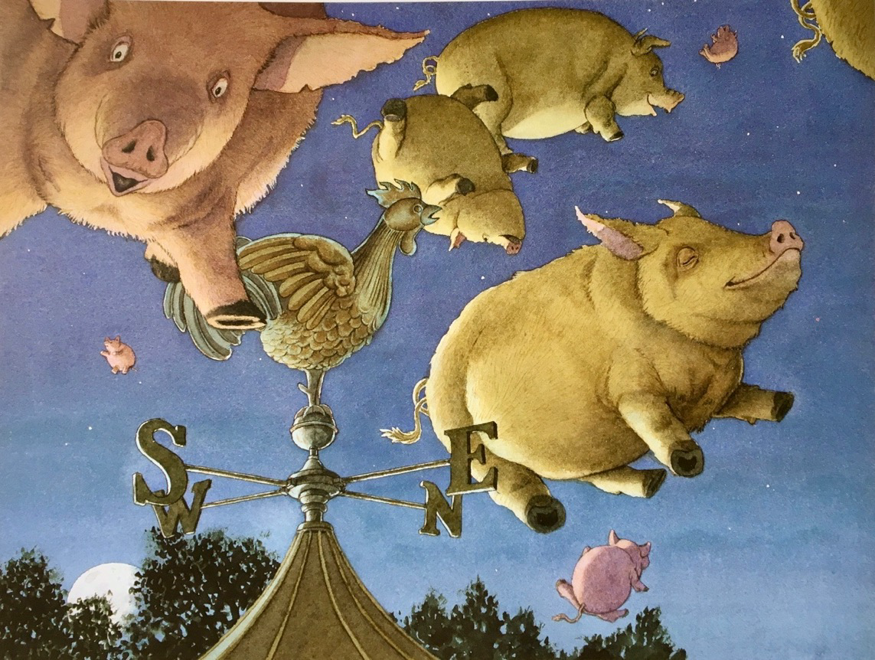
Next Wednesday

Newspaper Article Paragraph Plan

Headline
First
Paragraph
(Who, What, Where, When)
Paragraph 2
Paragraph 3
Paragraph 4
Conclusion

