Kotieläimiä

[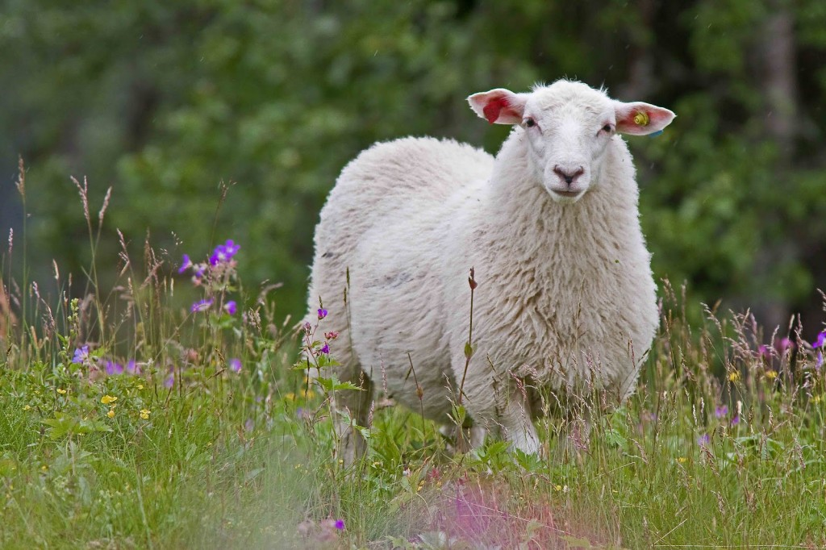](http://www.google.fi/url?sa=i&rct=j&q=&esrc=s&frm=1&source=images&cd=&cad=rja&uact=8&ved=0CAcQjRxqFQoTCNq-x56B2McCFQTzcgodveIL6A&url=http://oddlovescompany.com/2013/08/lammas-girlfriends-day-raspberry-cream-pie-day/&psig=AFQjCNFs4is6RPE509MZY-n41qP1JY_g1Q&ust=1441271593990581)

[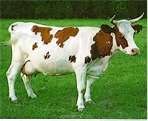](http://www.google.fi/url?sa=i&rct=j&q=&esrc=s&frm=1&source=images&cd=&cad=rja&uact=8&ved=0CAcQjRxqFQoTCPCtgN2B2McCFaMPcgodPAAOEA&url=http://www.ruokatieto.fi/ruokakasvatus/ruokaketju-ruuan-matka-pellolta-poytaan/maatila/kotielaimet/lypsykarja&bvm=bv.101800829,d.bGQ&psig=AFQjCNEERQ09TFdMO9Oq1vEV0nYC3xLMOg&ust=1441271691807841)

[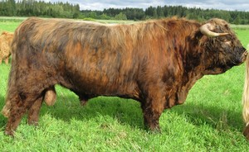](http://www.google.fi/url?sa=i&rct=j&q=&esrc=s&frm=1&source=images&cd=&cad=rja&uact=8&ved=0CAcQjRxqFQoTCP_m1PyB2McCFQi9cgodWoMPWA&url=http://www.korventaustantila.net/6&bvm=bv.101800829,d.bGQ&psig=AFQjCNFRqV-BWpC-l633QyYCMbgcZei_qQ&ust=1441271762009952)

[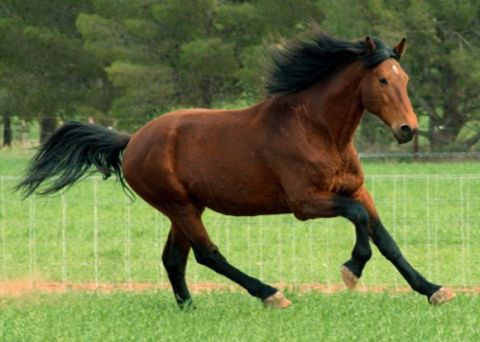](https://www.google.fi/url?sa=i&rct=j&q=&esrc=s&frm=1&source=images&cd=&cad=rja&uact=8&ved=0CAcQjRxqFQoTCIyQlZSC2McCFWT-cgodhgcCtg&url=https://fi.wikipedia.org/wiki/Hevonen&bvm=bv.101800829,d.bGQ&psig=AFQjCNFsaaO7uW6LvwX9EQel19muXSFwcA&ust=1441271842250922)

[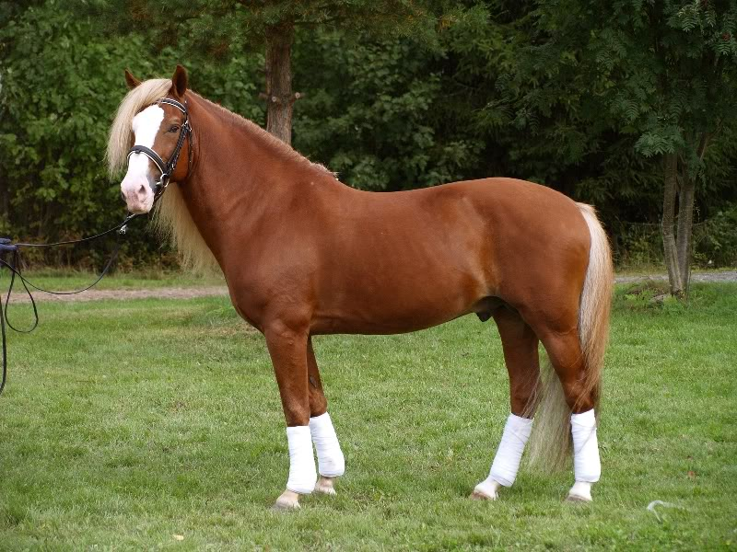](http://www.google.fi/url?sa=i&rct=j&q=&esrc=s&frm=1&source=images&cd=&cad=rja&uact=8&ved=0CAcQjRxqFQoTCM_FlKSC2McCFcG8cgodLcYJfw&url=http://siskokset.net/ilomantsi/hohka.php&bvm=bv.101800829,d.bGQ&psig=AFQjCNHfIlamXnBPcrvf3ZYbZamH4ZBgVA&ust=1441271865601204)

[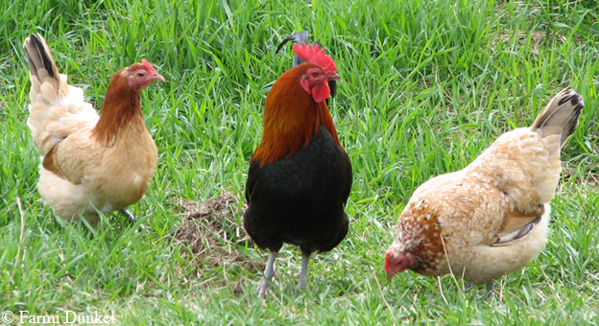](http://www.google.fi/url?sa=i&rct=j&q=&esrc=s&frm=1&source=images&cd=&cad=rja&uact=8&ved=0CAcQjRxqFQoTCI3zob6C2McCFcEqcgodP4QL7A&url=http://www.dunkel.fi/ranch/kanat.html&bvm=bv.101800829,d.bGQ&psig=AFQjCNHAvgh3uLccAe0evcRtlZMyaJb12w&ust=1441271909464816)

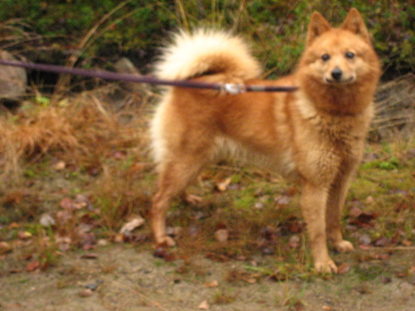

[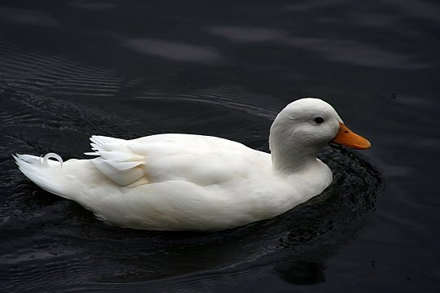](http://www.google.fi/url?sa=i&rct=j&q=&esrc=s&frm=1&source=images&cd=&cad=rja&uact=8&ved=0CAcQjRxqFQoTCNXRj6OD2McCFYWpcgodU4YCxQ&url=http://kuvat.n3po.com/Kuvat/Pikku-Ankka.jpg.html&psig=AFQjCNHMPWA68it10IPdXfDzYnc9EKcvTw&ust=1441272140927953)

[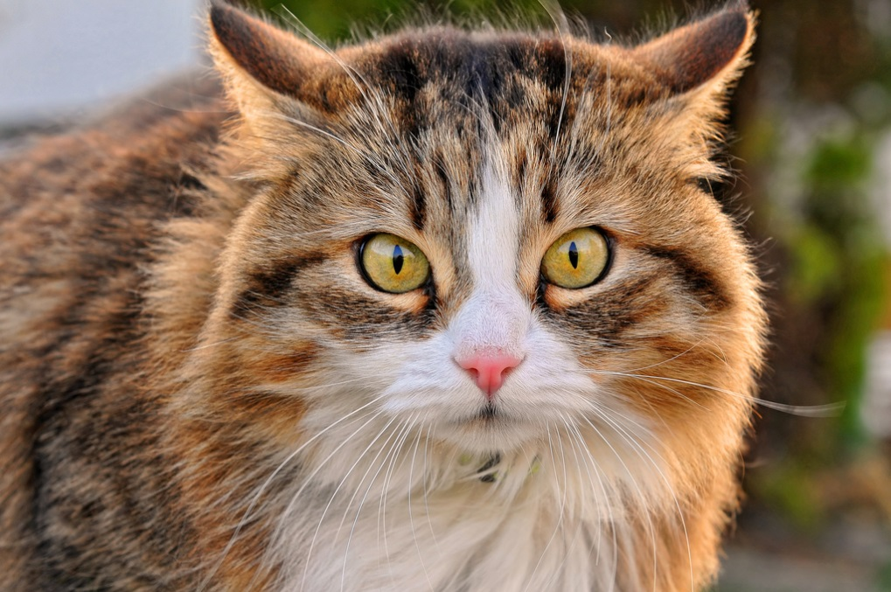](http://www.google.fi/url?sa=i&rct=j&q=&esrc=s&frm=1&source=images&cd=&cad=rja&uact=8&ved=0CAcQjRxqFQoTCL_i-rGD2McCFUWRcgodvFcNdw&url=http://www.tunturisusi.com/kissat/kotikissa1.html&psig=AFQjCNFPqx1Yqw_QlZ0_sAsRWbKfEajAyw&ust=1441272168159568)

[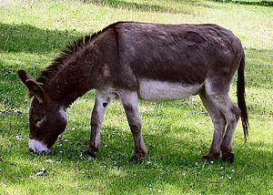](https://www.google.fi/url?sa=i&rct=j&q=&esrc=s&frm=1&source=images&cd=&cad=rja&uact=8&ved=0CAcQjRxqFQoTCLfIhcmD2McCFSMQcgod3twI8w&url=https://fi.wikipedia.org/wiki/Aasi&psig=AFQjCNFEP1epehgOXr2a7hfgo9DYFWGzuw&ust=1441272221756187)

[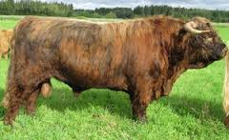](http://www.google.fi/url?sa=i&rct=j&q=&esrc=s&frm=1&source=images&cd=&cad=rja&uact=8&ved=0CAcQjRxqFQoTCP_m1PyB2McCFQi9cgodWoMPWA&url=http://www.korventaustantila.net/6&bvm=bv.101800829,d.bGQ&psig=AFQjCNFRqV-BWpC-l633QyYCMbgcZei_qQ&ust=1441271762009952)