Finnish boys in Barcelona
- kids’ magazine

Olli’s diary

Sunday the 11th of November 2018
Hello, I woke up at 6 am on Sunday and I was very tired. I and Nikke went to school and then we travelled by car to Helsinki Airport. We flew for five hours until we were in Spain. Then we drove by car to the hotel. Our teacher stayed there and we went to the family. It was exciting.
Monday the 12th of November 2018
On Monday the school started at 9 am and ended at half past four p.m. Our performance in the morning went well.
After school we went to see FC Barcelona football field. Then we went to play bowling. We got very huge hotdogs, water and ice cream. After we had eaten them, we went home to sleep.
Tuesday the 13th of November 2018
In the morning we were tired. We took a shower, then we ate the breakfast and it tasted delicious. Then we went to school. In the school we made some clay castles or something like that. When the school ended we went to the market and then we went swimming in the swimmingpool.
Wednesday the 14th of November 2018
We went to school at 9 am. When we ate I got sick and I went to the hotel with Anna, our teacher. I was wery tired and sick. At the same time Niklas and Anna-Maija saw the beautiful humantower. In the evening we went back home to sleep.
Thursday the 15th of November 2018
Niklas went to the school, but I stayed at home. I didn´t do anything special. Then we went to the bus which took and brough us to the scientific museum. There it was very interesting and fun. I also bought 3D cards.

Friday the 16th of November 2018
On Friday my friend Niklas and I went to the school again. We sayed bye bye to our Spanish friends. Then we went to Barcelona and there we ate some good food. Then we went to the market to buy some sweets. Then we came back home.
Saturday the 17th of November 2018
We woke up at 3 a.m. Then we went to the airport and flew back to Finland. Then we had to traval by underground which brought us to the railwaystation. W travelledby train to our hometown Pori.

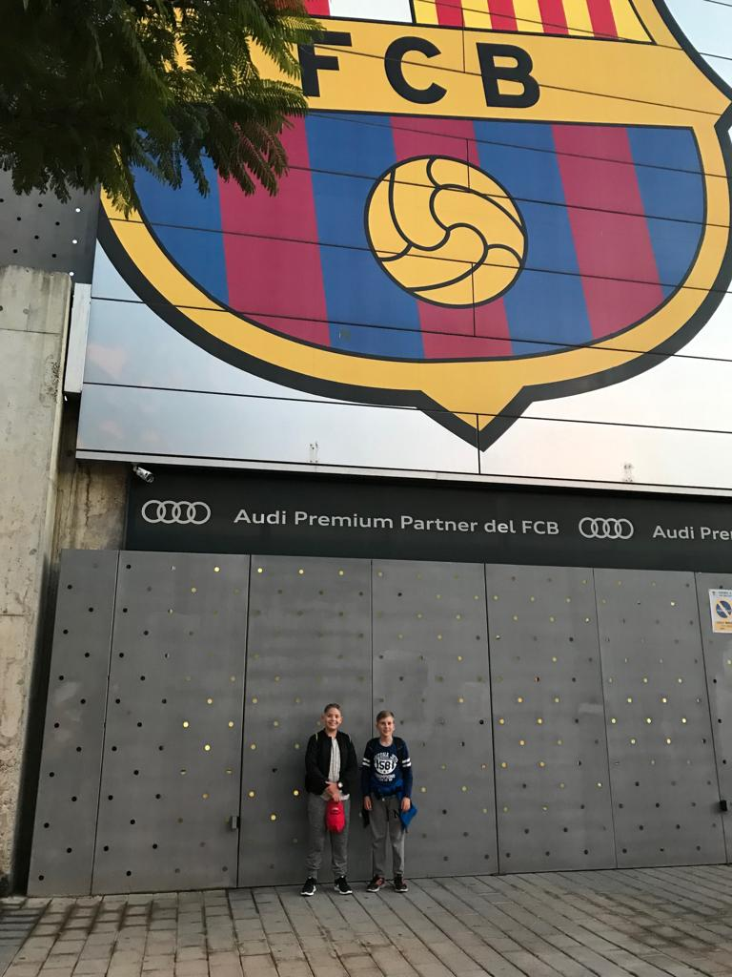
The fans of FCB

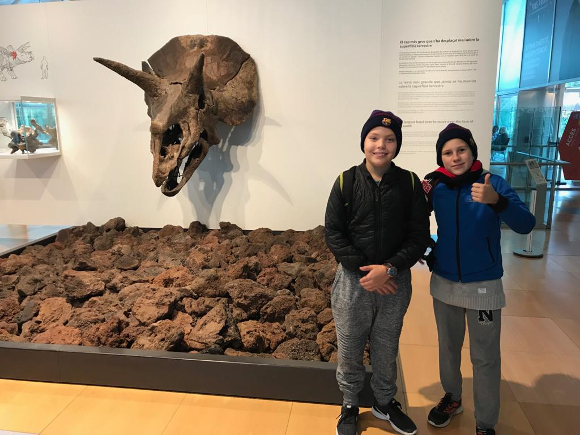

Niklas’ diary

Hello!
We woke up on Saturday morning. Olli and I were very tired because we woke up very early. We joked in the car but it was very boring in the car. The car trip took three and a half hours. Huh huh. Then we arrived in Helsinki airport. After we had gone through the security check, we went to eat to Burger King. Then we waited for the plane.Then the plane arrived. The flight took about 5 hours.
When we arrived to Spain, Carme came to pick us and then we went to wait our "family". Then we arrived to our Spanish home.
Monday, the 12th of November 2018
On Monday the school started at 9 am and ended half past four. Olli and I were very tired. In that day they organized a welcome party for us. I liked it. After the school we went to see FC BARCELONA football arena. It was very big. Then we went to bowling. I was the second. Then we ate huge hot dogs and drank water and ate ice cream. It was good, then we went to home.
Tuesday, the 13th of November 2018
In the morning we were tired., again We took a shower that was fresh then we ate breakfeast I liked it. Then we went to school. Then we came home.

Aenean rutrum, ligula in bibendum suscipit, magna risus tristique ipsum, vitae porttitor eros lectus sit amet est. Pellentesque et lacinia urna. Maecenas pretium consectetur sapien ac rhoncus. Cras volutpat consequat leo, eget luctus metus cursus et.
Wednesday the 14th of November

When we woke up, we took a shower and ate good breakfeast like yesterday. After we had eaten, we went to school. Olli got sick and I stayed at school and we played floorball. I like floorball because it is my hobby. After the school, it was a carneval day at school, so there was some music and human towers that was very dangerous but beautiful.
Thursday the 15th of November 2018
We woke up and ate breakfeast that I liked. I went to school but Olli stayd at home. After we had had lunch at school, we were picked up to the bus station and we went to Barcelona Science Museum. There were very many nice things. After the museum we went home again.
Friday the 16th of November 2018
When we woke up Olli felt better eand we went to school to say good bye for our new friends. Then we were picked up to the train stop.Then we arrived to Barcelona. In Barcelona we had guided tour. Barcelona is very beautiful. After the tour we went to a restaurant. I ordered pasta, Olli had a burger. After the meal we went shopping. Later we went home and in the evening, there was a party and lots of food.
Saturday the 17th of November 2018
We woke up at 3 in the morning and we were tired. We want to thank for the family . I want to see you guys again and thank for Carme she did a great job! I want to thank you all!

