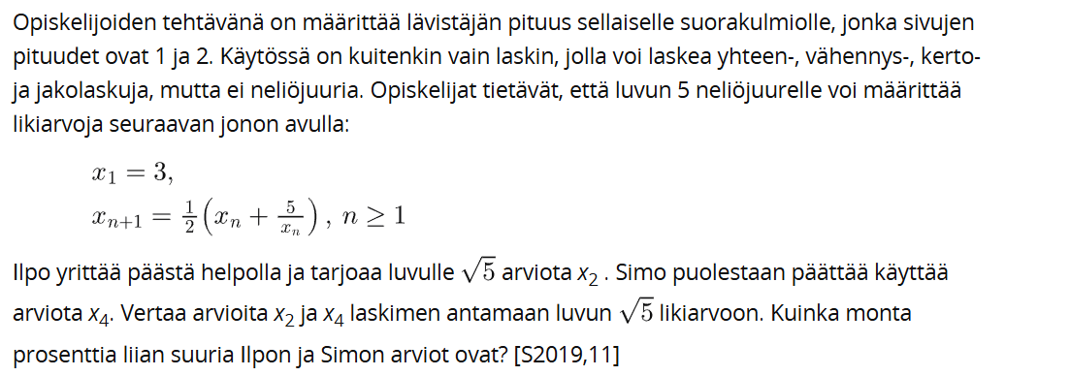
Lukujono on luvuista $x_{1}, x_{2}, x_{3}, x_{4}, …$muodostuva jono.
Lukujononon 1. jäsen on $x_{1}=3$,
2. jäsen saadaan, kun n = 1:
$x_{2}=\frac{1}{2}*(x_{1}+\frac{5}{x_{1}})$
$x_{2}=\frac{1}{2}*\left(3+\frac{5}{3}\right)=\frac{7}{3}≈2,333…$ ILPON ARVIO
3. jäsen saadaan, kun n = 2:
$x_{3}=\frac{1}{2}*(x_{2}+\frac{5}{x_{2}})$
$x_{3}=\frac{1}{2}*\left(\frac{7}{3}+\frac{5}{\frac{7}{3}}\right)=\frac{1}{2}*\left(\frac{7}{3}+5:\frac{7}{3}\right)=\frac{1}{2}*\left(\frac{7}{3}+\frac{5}{1}*\frac{3}{7}\right)=\frac{1}{2}*\left(\frac{7}{3}+\frac{15}{7}\right)=\frac{1}{2}*\left(\frac{49}{21}+\frac{45}{21}\right)=\frac{1}{2}*\frac{94}{21}=\frac{94}{42}$
$=\frac{47}{21}≈2,238…$
4. jäsen saadaan, kun n = 3:
$x_{4}=\frac{1}{2}*(x_{3}+\frac{5}{x_{3}})$
$x_{4}=\frac{1}{2}*\left(\frac{47}{21}+\frac{5}{\frac{47}{21}}\right)=\frac{2207}{987}≈2,23606…$ SIMON ARVIO
Luvun $\sqrt{5}$ likiarvo on 2,236067977
Verrataan Ilpon arviota lukuun $\sqrt{5}$:
$\frac{\frac{7}{3}-\sqrt{5}}{\sqrt{5}}=0,043498389…=4,3498389..\%≈4,3 \%$
Verrataan Simon arviota lukuun $\sqrt{5}$:
$\frac{\frac{2207}{987}-\sqrt{5}}{\sqrt{5}}= 0,00000041060628892806≈0,000041 \%$

