ACTIVITY REPORT: Communication and Mediation
Project: Echoes of Unity (2024-1-ES01-KA210-SCH-000245759)
Mobility: M4 – Rome, Italy
Host Institution: Liceo Español Cervantes

1. OVERVIEW
The fourth mobility of the project, hosted in Rome, focused on the "Communication and Mediation" pillar. The week was designed to provide students and teachers with a "Social Toolkit" to overcome interpersonal and institutional barriers. Through innovative pedagogical dynamics and high-level institutional visits, the consortium explored how dialogue, gratitude, and cultural expression act as instruments of European unity.

2. OBJECTIVES

Social Cohesion: Strengthening relationships between students of different ages and backgrounds to eliminate social barriers within the school community.
- Conflict Resolution & Mediation: Equipping participants with structured dialogue techniques to promote peaceful coexistence.
- Civic and Institutional Awareness: Understanding the role of diplomacy and international organizations in fostering European identity and cooperation.
- Emotional Intelligence: Developing the language of gratitude and empathy as foundational values for inclusive education.
3. DETAILED PEDAGOGICAL ACTIVITIES
- Peer Mediation: The Dialogue Circle
SCRIPT TO FACILITATE THE DIALOGUE CIRCLE –
Group Cohesion and Identity
1. Introduction Let's have a dialogue circle. We will speak one by one, listen without interrupting, and share ideas about what we are like as a group and what we want to build together. Whoever has the object speaks. The others listen. If someone doesn't want to speak, they can skip.
2. First round: breaking the ice Question: “Tell us your name and one thing you love to do.”
3. Second round: what we appreciate about the group Question: “What do I like most about my group?”
4. Third round: weather metaphor Question: “If our group were a type of weather, what kind of weather would it be and why?”
5. Fourth round: subtle improvement Question: “One thing we could improve as a group to be even better.”
6. Fifth round: personal responsibility Question: “What can I do, something small and realistic, to help improve that?” 7. Sixth round: Looking to the future. Question: “When we finish primary school, what would we like people to say about us as a group?”
8. Seventh round: Caring for each other. Question: “One thing I can do for my classmates so that we all feel good in class.”
9. Final activity with poster board and sticky notes. Instructions: Write on a sticky note a specific action you commit to doing to make the class feel good. Then stick it on the poster board: “What we will do to make our group feel good.”
10. Closing. Question: “One word you take away from this circle.”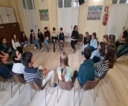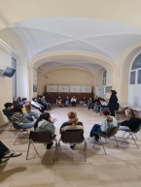
2. Solidarity treasure Hunt
Organizing a joint charity scavenger hunt between primary and secondary school students is conceived as a valuable educational and social activity, designed to foster social relationships, promote inclusion, and eliminate social barriers within the school community.
This activity facilitates positive interaction and encounters between students of different ages, promoting relationships based on respect, cooperation, and mutual support. Working in heterogeneous teams allows older students to take on a mentoring and support role, while primary school students feel integrated, valued, and secure, thus strengthening their sense of belonging to the school.
Furthermore, the charity scavenger hunt is an effective tool for promoting educational inclusion, as it features accessible and collaborative challenges that value the diversity of students' abilities, learning paces, and skills. In this way, stereotypes are broken down, prejudices are reduced, and social barriers are eliminated, fostering the active participation of all students on equal terms.
Through a playful and experiential approach, the activity contributes to the development of social and emotional skills, such as empathy, communication, teamwork, and peaceful conflict resolution. Furthermore, by incorporating a solidarity component, values such as social responsibility, solidarity, and commitment to others are reinforced, aligning with the principles of values education and positive coexistence.
Ultimately, this inter-grade solidarity scavenger hunt is justified as a comprehensive educational initiative that strengthens the school's social cohesion, improves the school climate, and contributes to the development of a more inclusive, empathetic, and engaged student body.
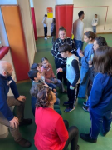
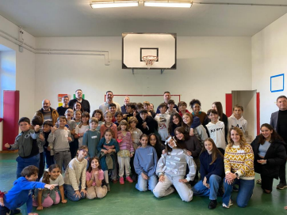
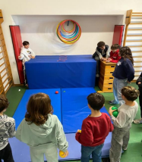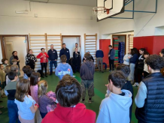
3. Thanksgiving Activities: Gratitude.
Picking sticks gratitude game
The point of the game is to teach gratitude to children while having a fun bonding experience. This is a valuable game that allows everyone in the group to consciously think of their gratitude and verbally express it. By picking sticks, the player is forced to take a close look at what they are grateful for.
Lesson´s ojectives:
- Develope the language of gratitude
- Understand how gratitude will affect their thoughts, feelings and actions. - Express their gratitude verbally.
How to play:
1. Star by holding all of the pick-up sticks in your hand.
2. Drop the pick-up sticks.
3. Each player takes a turn pulling a stick from the pile.
4. The main rule is to not make any other sticks move.
5. Every time a student picks up a stick, they must name what they are grateful for based on the color of the stick and categories.
6. The player that has the most sticks at the end of the game wins.
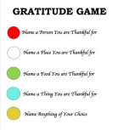
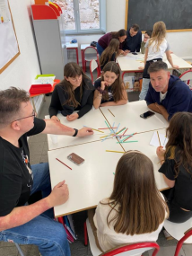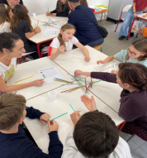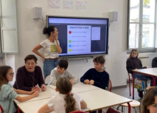
4. Visit to the “Liceo español Cervantes in Rome”
During their stay in Rome, the group of teachers participating in the Erasmus+ project “Echoes of Unity” toured the Cervantes Spanish Lyceum. The visit included a tour of the school, its classrooms, and various facilities, providing firsthand insight into the organization, resources, and operation of the educational center.
The activity was led by the Lyceum's director and the Education Technical Advisor assigned to the Education Office in Italy, who offered a detailed overview of the management model and pedagogical approaches of Spanish-owned schools abroad.
During the visit, the teachers observed different methodological styles and educational proposals implemented in the classroom, as well as strategies for addressing diversity and promoting coexistence in international contexts. This experience proved particularly enriching for the participating teachers, facilitating the exchange of best practices and reflection on innovative pedagogical approaches in multicultural environments. Overall, the tour of the Cervantes Spanish Lyceum contributed to the professional development of the teaching staff and reinforced the objectives of the “Echoes of Unity” project, promoting educational dialogue, international cooperation and knowledge of educational models that strengthen European identity and values.
. 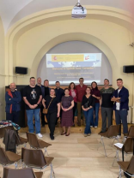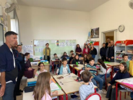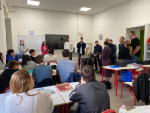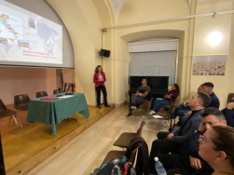
5. Flamenco Workshop
The flamenco workshop for teachers is a training experience designed not only to introduce educators to one of the most representative artistic expressions of Spanish culture, but also to foster fundamental values in the educational field, such as empathy and cooperation.
Through learning the rhythms, clapping, body movements, and expressions characteristic of flamenco, participants empathize with others, developing greater sensitivity to emotions, effort, and the diversity of communication styles. Flamenco, as a profoundly expressive art form, allows for the development of empathy by connecting with feelings such as joy, sadness, passion, and overcoming challenges.
Furthermore, many of the workshop activities are conducted in groups, promoting cooperation, teamwork, and mutual support. Teachers learn to coordinate, listen to each other, and respect each other's pace, understanding that flamenco is a collective art where each person contributes their rhythm and energy to create a shared experience. Finally, the workshop offers an introduction to the rich cultural heritage of Spain, explaining the origins of flamenco, its historical influences, and its importance as an intangible cultural
heritage of humanity. In this way, teachers not only acquire artistic tools but also cultural knowledge that they can bring into their classrooms to enrich their students' learning.
Overall, this flamenco workshop presents a unique opportunity for personal and professional growth, strengthening essential human values while celebrating Spanish tradition and cultural identity.
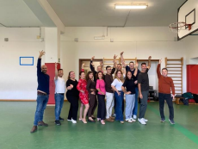
6. Visit to the Spanish Embassy in Italy.
The cultural visit to the Spanish Embassy in Italy is part of the Erasmus+ project developed by the school, whose main objective is to promote the European dimension of education, intercultural understanding, and the holistic development of students.
This activity allows students to learn firsthand about the role of Spanish diplomatic institutions abroad, as well as understand their functions of representation, cooperation, and support for Spanish citizens internationally. It also helps to strengthen their sense of European identity and appreciate the importance of collaboration among member states of the European Union.
The visit to the Spanish Embassy in Italy fosters the development of key competencies of the Erasmus+ project, especially social and civic competences, cultural awareness and expression, and intercultural communication, by placing students in a real-world context of interaction between cultures and institutional systems.
Therefore, this activity is considered an educational experience of high formative value, fully consistent with the objectives of the Erasmus+ project of the center and with its commitment to an open, inclusive and European-oriented education.
7. Visit to the Embassy of Spain in Italy to the Holy See.
The visit to the Spanish Embassy to the Holy See, along with the discussion with Minister Isabel Celaá—former Minister of Education in Spain—is directly aligned with the objectives and lines of action of the Erasmus+ project “Echoes of Unity.”
This activity allowed the participating teachers to deepen their understanding of the role of diplomatic institutions in promoting intercultural dialogue, international cooperation, and European values, fundamental aspects of the project. The Embassy provides a privileged space for reflecting on coexistence, mediation, and understanding between cultures, religions, and states, key elements that “Echoes of Unity” seeks to foster.
Furthermore, the discussion with Isabel Celaá offered an expert perspective on the value of education as a tool for social cohesion, democratic citizenship, and the construction of a European identity based on respect, diversity, and solidarity. Her experience in the educational and political spheres helped contextualize the current challenges facing Europe and reinforce the project's pedagogical objectives.
Overall, the visit and the meeting contributed significantly to the project's skills development, strengthening European awareness, critical thinking and their understanding of dialogue as an instrument of unity, in full coherence with the spirit and aims of the Erasmus+ program.

