I recommend you this book
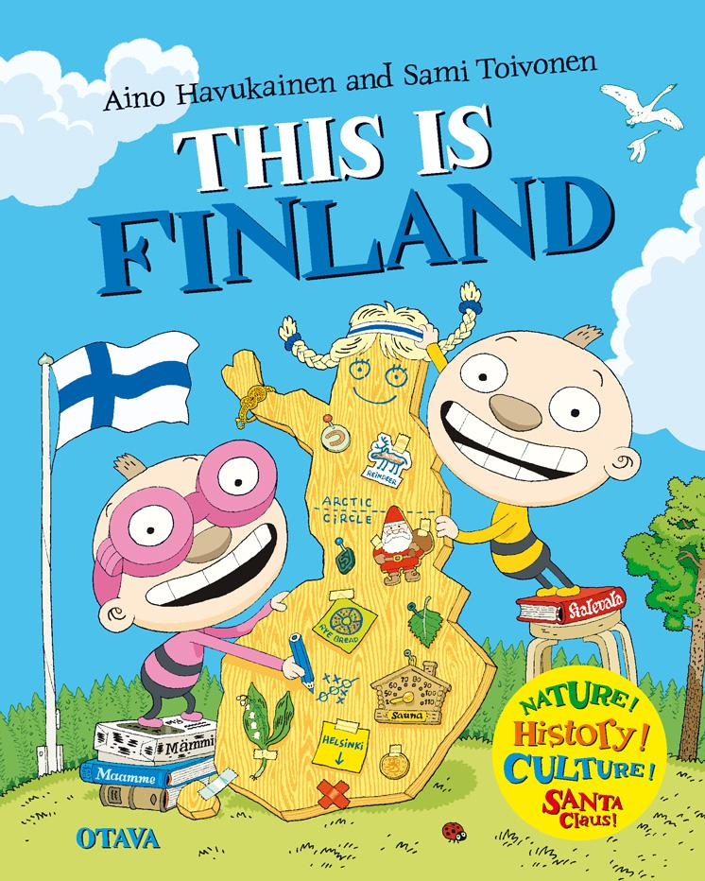
Title:
Tatu and Patu Finland

Writer:
Aino Havukainen and Sami Toivanen

Setting:
in Finland

Characters: Tatu,Patu and family Virtanen

The book is about: Fnland traditions, foods, sauna, Salmiakki, santa and rye bread.

This book is good because: It tells about Finland.

