Genetic results obtained from the hop leaf samples from the year 2017
During the 2017 a set of 651 hop leaf samples were received from the citizens of Finland. Samples arrived from all over the country and each one had assigned unique LUKE number for easier tracking of the results. A whole genomic DNA was isolated and stored for the purpose of genetic diversity analysis.
Another set of 94 reference DNA samples were obtained from the University of Ljubljana Biotechnical Faculty (by the courtesy of prof. dr. Natasa Stajner) including Humulus lupulus L. (wild hops and cultivars) and different hop species (Humulus lupuloides, Humulus neomexicanus and Humulus pubescens) from Australia, Arizona, Austria, Bosnia and Herzegovina, China, Colorado, Czech Republic, Denmark, ex-Yugoslavia, France, Georgia, Germany, Iowa, Italy, Japan, Kazakhstan, Macedonia, Manitoba, Missouri, Montana, New Mexico, New Zealand, North Dakota, Russia, Saskatchewan, Slovenia, South Africa, Spain, Serbia, United Kingdom, USA, Utah and Wisconsin.
A DNA from the both sets of the hops samples (> 700) were analyzed with the 10 microsatellite markers and the dendrogram was created in order to visualize unique hops, duplicates and possible family relationships between different hops. Unique hops and duplicates are certain designation while family relationships are somewhat more speculated categories (lower probability of being certainly true). Explanations of the way how the dendrogram was interpreted and meanings of the dendrogram «symbols» or «characteristics» are shown in (Table 1).
Table 1. Reading of hop dendrogram.
No. | Hop designation on dendrogram | Explanation of the designation | Dendrogram «symbols» or «characteristics»
1 | UNIQUE HOPS | Hops having a unique genetic profile that appears only one single time within all the samples | One horizontal line
2 | DUPLICATES | Groups of genetically identical hops i.e. two or more hops whose genetic profiles are exactly the same among each others | Vertical line connecting same (identical) samples
3 | Ppossible FAMILY RELATIONSHIPS between the hops (brothers and sisters, grandchildren, grand grandchildren … ) | Hops having > 80% of genetic similarity among themselves might be considered as putative siblings; while e.g. those ones >60% GS might be speculated to be children from same grand grandparents | «Fairly small loop»

An example of how the «reading» of the dendrogram was performed is presented in Figure 1.
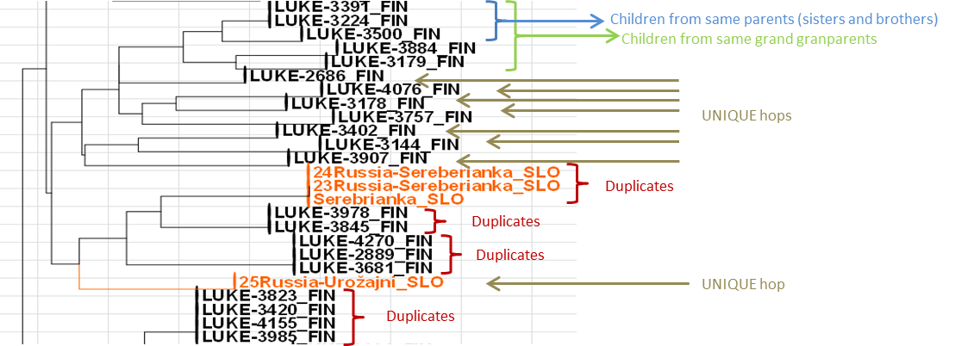
Figure 1. A section of the whole hop dendrogram from the year 2017. Finnish hops are labeled in black color while reference hops were in orange.
Some additional comments on readings of the dendrogram representing all hop samples from 2017:
- LUKE 3320 clustered next to the well-known USA cultivar Cascade. They might be related to each other and it would be interesting to see brewing properties of the LUKE 3320.
- LUKE-3680 clustered next to the known cultivar Glacier from USA.
- LUKE-4127 is appearing 9 times as it was used as internal analysis control.
- LUKE 3235; LUKE 4127; LUKE 3707; LUKE-3476; duplicates (LUKE-4145 and LUKE-3652) and LUKE-3992 grouped with the most of the reference hops («orange» section of the dendrogram where 85% of reference samples are concentrated). Those hops might be of “foreign origin”. The rest of the samples may have a very unique Finnish origin. This is imputing that Finnish hops represent hops distinct from the hops from the rest of the world and may have a very authentic and unique origin that is separating them into a special group.
Notice: During the year 2018 it is expected to receive additional 400 hop samples from the Finland. In the spring of the 2019 the dendrogram will be updated and some changes in the results may be noticed. E.g. unique hops from 2017 may not be unique anymore as they could match to some new hop sample from 2018 or some new hop from 2018 may replace your hop in a certain (family) group and “move “ it to another etc. Please be so kind and read again a new report in spring 2019 for updating the knowledge of your own hop.

For any further details on available results of genetic analysis of your hop please do not hesitate to ask. I will be happy if I could help you =)


Lidija Bitz – Natural resources institute Finland (Luke)
Plant genomics
Senior scientist, Ph. D.
Lidija.Bitz@luke.fi; 029 532 37 62
22.5.2018, Finland

