The Netherlands

Culture

Culture is a common world of experience, values ​​and knowledge that characterizes a particular social unit. Often it is a lifestyle of habits or traditions of people in a given country or a region with its own values and standards.

Persons

In Dutch culture we have a lot of famous persons who should be called

Miffy
Miffy is a well-known figure from children's books. In Dutch we call her Nijntje. Everyone in the Netherlands knows Miffy, young and old. The books are written and drawn by Dick Bruna.
The stories are about the adventures of a rabbit.

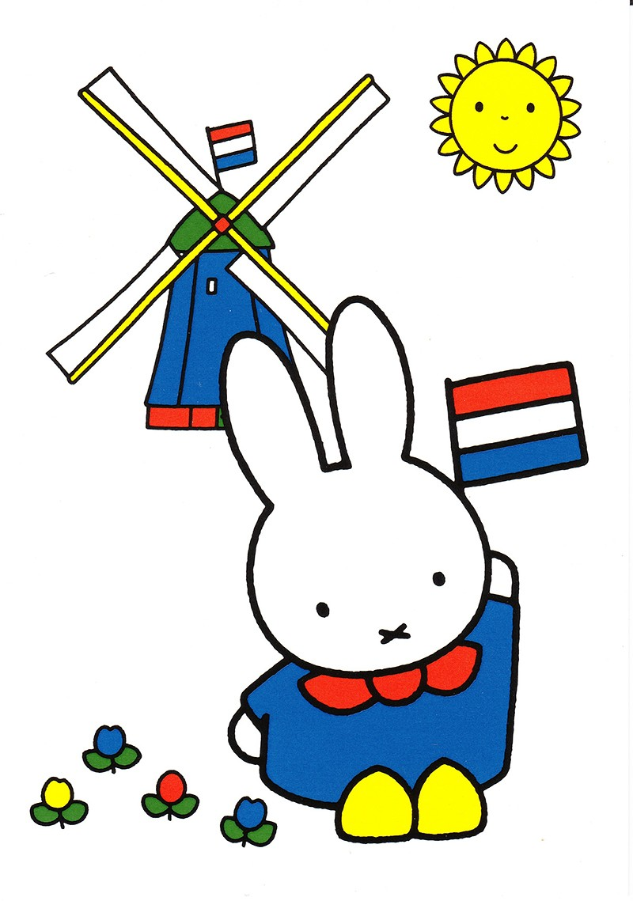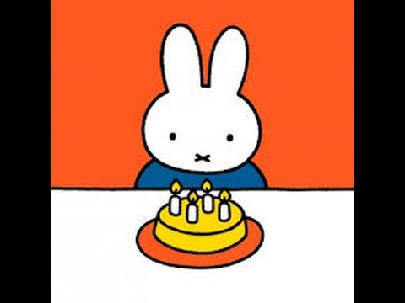

Sinterklaas
St. Nicholas is really a saint, but he is a legend; a man who gives presents to children in the winter, called Sinterklaas. He lives in Spain and comes every November with the steamer in Netherlands. Sinterklaas is an old man with a white beard, a long red cloak and a red mitre.
Singing songs is one of the most important things of all Sinterklaas. Most of the children put their shoe in front of the fireplace in the evening and sing these songs. They hope they get presents the next day. It is customary to give each other sinterklaas surprises (presents) with poems. We celebrate this day on the 5th of december.
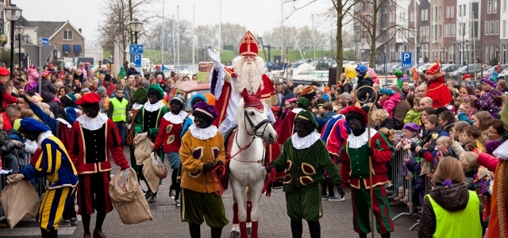

Eise Eisinga
Eise Eisinga was born on February 21, 1744. He has written a mathematics book and a astronomy book. He has tweaked the galaxy in the ceiling of his living room with the radar work in the attic. It still works and is now the only working planetarium in the world. Many visitors from abroad come to visit.
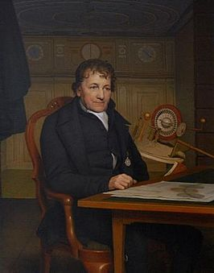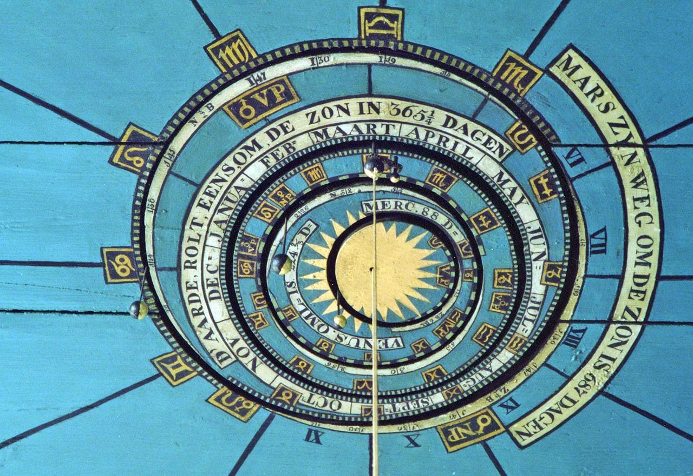

The Netherlands has many well-known painters. The most famous are Rembrandt van Rijn and Vincent van Gogh

Rembrandt van Rijn
Rembrandt made about 300 paintings. Sometimes he spent three years doing one painting. He usually made small paintings. He often painted people with beautiful clothes and jewelry. Rembrandt also painted nature, trees and clouds. Rembrandt first painted with dark colors. Later he used more color in his paintings. The paintings also became larger.

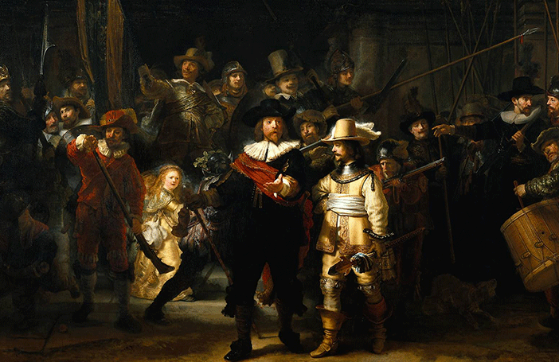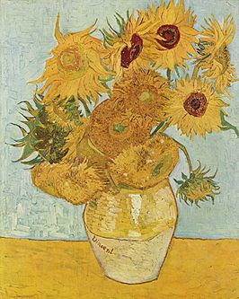
‘Nachtwacht’ by van Rijn ‘Zonnebloemen’ by van Gogh

Vincent van Gogh
Vincent van Gogh, together with Rembrandt van Rijn, is the most famous art painter in the Netherlands. People come from Vincent's paintings from all over the world. Vincent is also famous for his dramatic life.

Michiel de Ruyter
Michiel Adriaenszoon de Ruyter (March 24, 1607 - April 29, 1676) was a famous Dutch admiral. He has served at the State Dutch Warfleet. He is well known for his journey to Chatham in 1667, where he defeated the English. At the sea layers where he commanded, he knew as no other advantage to get out of wind and deep places for the Dutch coast. In 1676 he helped the Spaniards in a seagull battle. In doing so, he was severely injured. Shortly thereafter he died.
After his death, many books have been written about him. On the old one hundred golden bills was his portrait. He is so special that a film about him is being made in 2015.
There is also a statue of Michiel de Ruyter that stands in his birthpace Vlissingen.
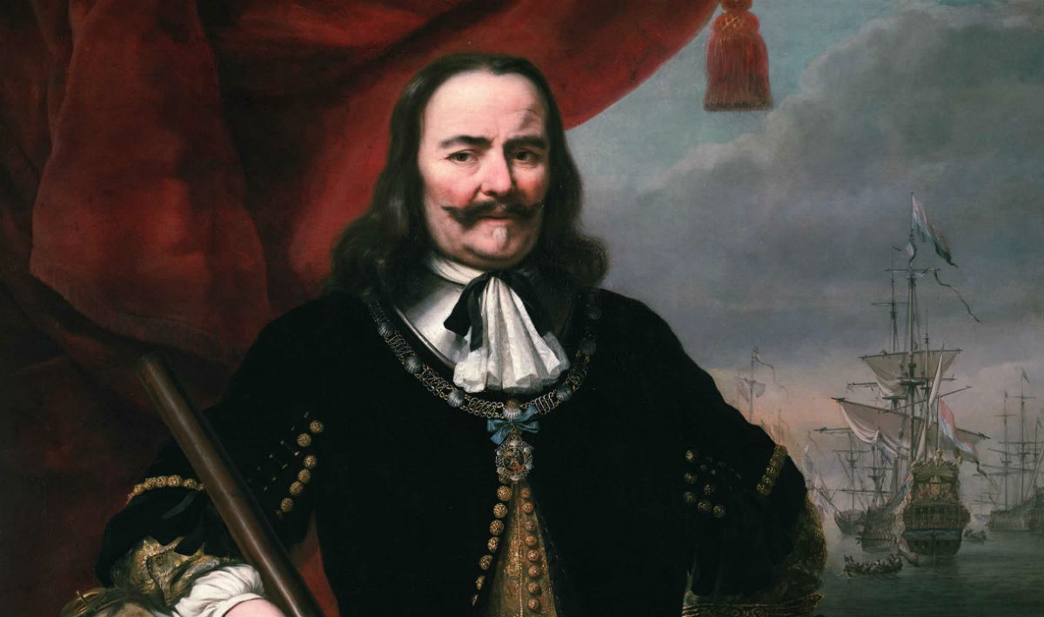

Willem van Oranje
Willem van Oranje is also known as Willem van Oranje-Nassau and William the Silent. Willem van Oranje was born in 1533 in the German mpire. When William was 11 years old his uncle died. His uncle had no children and so William inherited all his possessions. The title 'Prince of Orange' he could inherit. For it meant to qualify "good Catholic" are raised. William went to a strict boarding school in Brussels, where he was studying.

Willem Alexander en Maxima
Willem-Alexander is the son of Prince Claus and Princess Beatrix of the Netherlands. In 1980, his mother became queen. Willem-Alexander has studied a lot in his youth. He has served in the Royal Navy.
Willem-Alexander is married to Maxima Zorreguieta on 02-02-2002. They have three daughters: Amalia, Alexia and Ariane.
Willem-Alexander is now 49 years and Maxima is 45 years.
Willem-Alexander became on 30 April 2013 the King of the Netherlands.

Typically Dutch

Clogs
The history of the clogs goes back to the Middle Ages. The clogs are made of wood. There are wooden shoes in all shapes and sizes. Everyone walked on wooden clogs. Now there are still people walking on wooden shoes. The clog dance is a folk dance from the Netherlands.
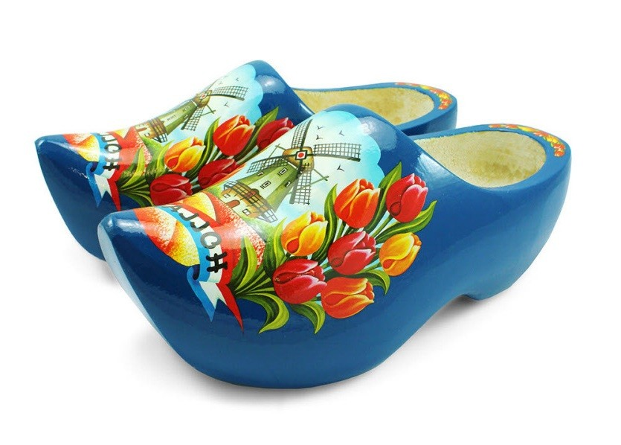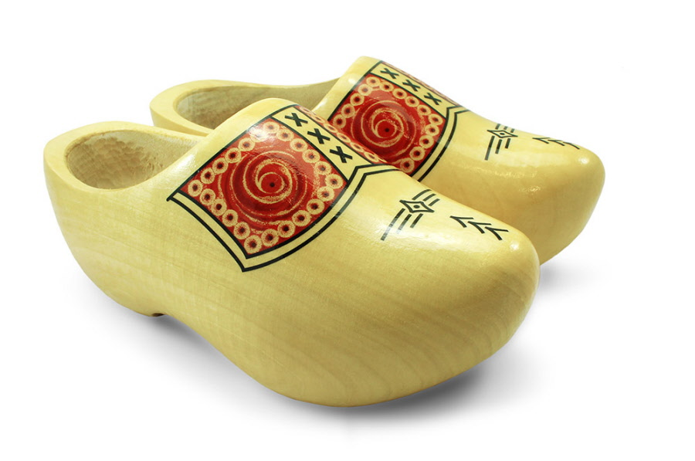
Koningsdag
On Koningsdag is the birthday of Willem-Alexander celebrated (april 27). It is a national holiday. That means that everyone on that day is free. The King and Queen also come by on the street, usually visits the Royal family two municipalities. Many people sell old stuff on flea markets in the city. There is also a party everywhere.

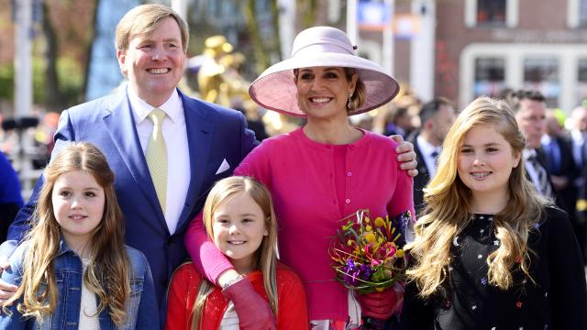
The royal family

Elfstedentocht
The Elfstedentocht is a nearly 200-kilometer skating on natural ice, which is organized by the Royal Society the Frisian Eleven Cities. Because of the distance and the heroic character of the Elfstedentocht, it is also called "The Race of Races".
The Elfstedentocht takes place in the province of Friesland and goes past the eleven cities of Friesland. The first official Elfstedentocht was in 1909, the last Elfstedentocht was estimated in 1997. Since that time the winters have not been strict enough.
On this picture you see the route of the Elfstedentocht.

Did you know that in the Netherlands we …
… give each other three kisses when we greet or celebrate something.

… eat 32 million kilos of drop a year.

… have more than 1000 traditional windmills. 19 of these can be found in Kinderdijk, a Unesco world heritage.

… have the KLM (Royal Dutch Airline) which is the oldest airline in the world.


… have more bicycles than people.
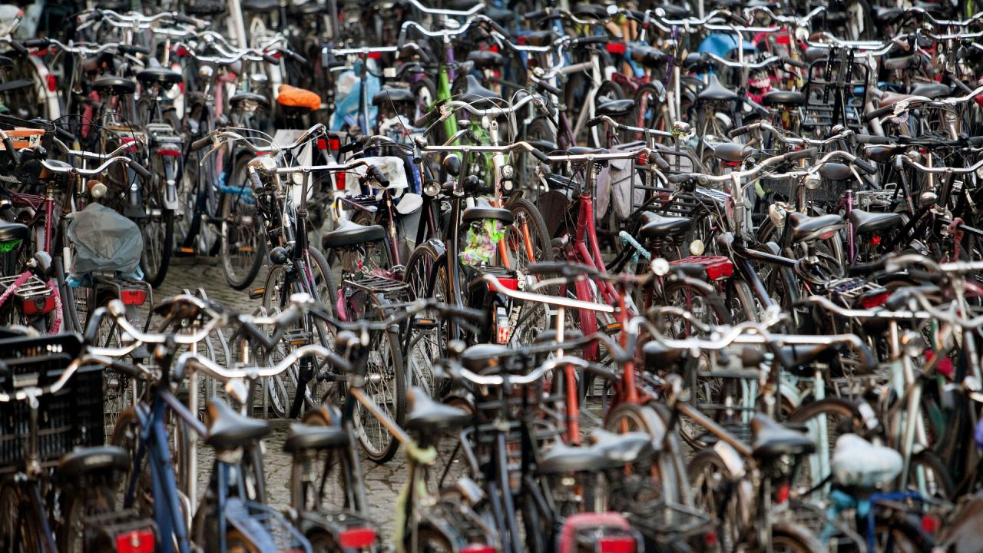
… have about 15000 kilometers of cycle path.

… are the largest producer and exporter of tulips worldwide.
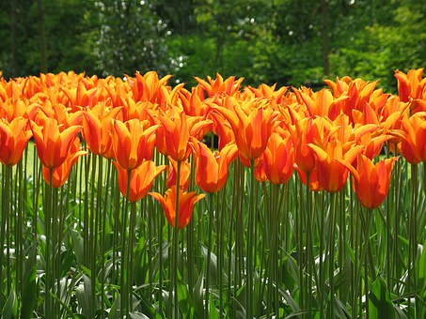
… have 80000 kilometers of dike.

… hang the Dutch flag together with a book bag outside when children pass their exam.
