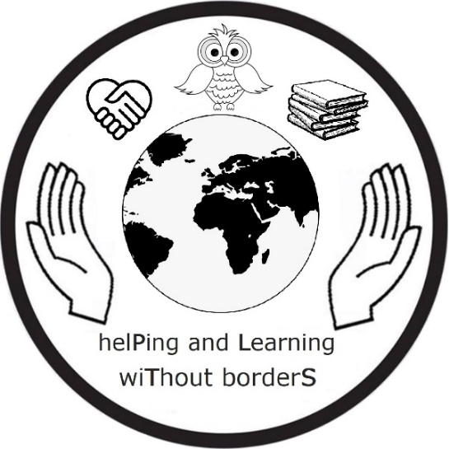


Learning/Teaching/Training Activity – C5
April 26-30, 2022 Mäntsälä, Finland

Programme
Monday 25.4.2022
Teams arrive
Transportation from Helsinki-Vantaa airport by train or some other means depending on flight timetables.

Tuesday 26.4.2022
8.30-9.50 Welcome, tour at school guided by Finnish students
Presenting the international poster (Effective Participators)
10.00-14.00 Short film workshop on biodiversity/climate change organized by the Association Koulukino
School lunch around 12:00
Tour in Mäntsälä town center
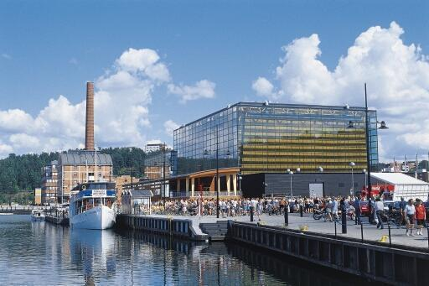
Wednesday 27.4.2022
Excursion to Lahti
2nd Salpausselkä* ridge, formations left behind by the last Ice Age
(*the 5th most important area in the world when it comes to geodiversity, Grand Canyon being number one)
Green City guided tour in Lahti
Lunch
Free time in the city centre Sibelius Hall, in Lahti
Thursday 28.4.
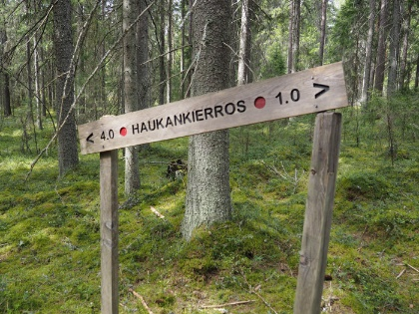
Hiking (Haukankierros), collecting material
Lunch
Workshop: bug hotels and bird houses
Reflection and evaluations activities on being an effective participator
Possibility for going to sauna (take your swimming suit!)
Friday 29.4.
Morning
Preparing the fundraising event at the prom and the visit at the Natural History Museum in Helsinki
School lunch
18:30
Fund raising event for Ukrainian children in cooperation with Unicef/Red Cross
Prom (involves some of the Finnish students, visitors taking part as audience)

Saturday 30.4.
9.43:10:20 Train from Mäntsälä to Helsinki

11.00-12.00 Natural History Museum, exhibition: Change in the Air
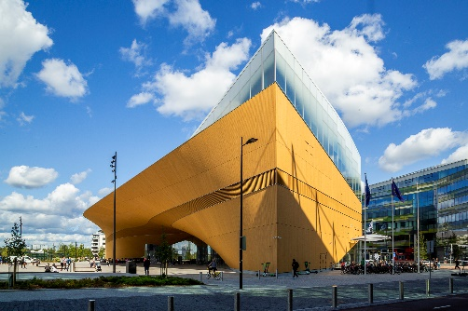
Packed lunch (from host families)
Visit to the Helsinki City Library, Oodi
Free time, Finnish students as guides
Train to Mäntsälä
Sunday
Teams leave Helsinki City Library, Oodi

N.B.
A more detailed version with costs will be published and sent as soon as all the information needed is available. Host students with their families organize free time activities for the students. As for teachers’ free time, some activities will be scheduled, some can be decided together or freely chosen



