n
The fun things to do at a beach in Northern Ireland
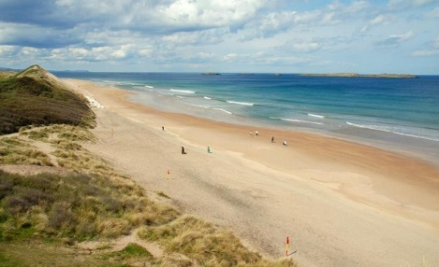
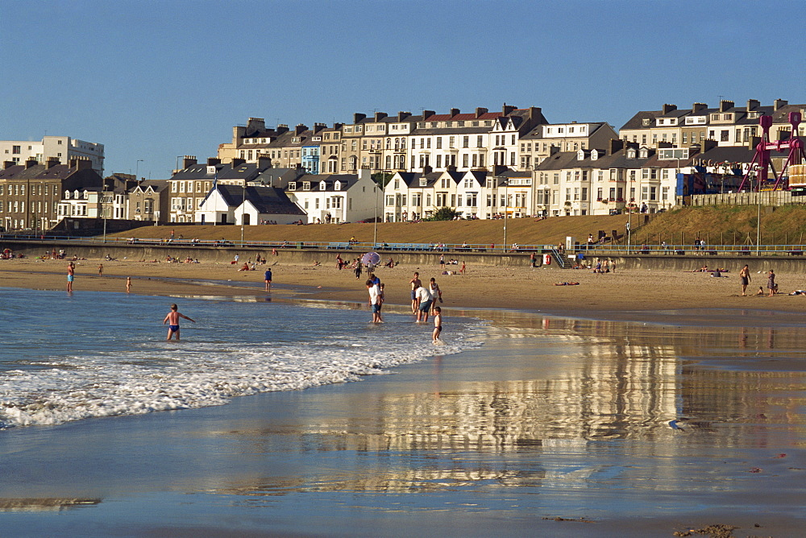
Portrush- Northern Irelands best seaside resort
My favourite things to do at a beach
- Bury my parents in sand.
- Build sandcastles.
- Swim in the sea and splash my sister in the sea.
- Sunbathe on the soft sand.
- Eat delicious ice-cream
- Donkey rides
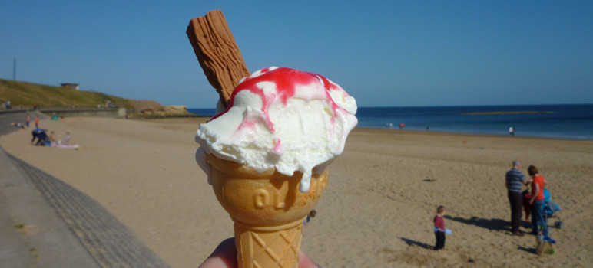
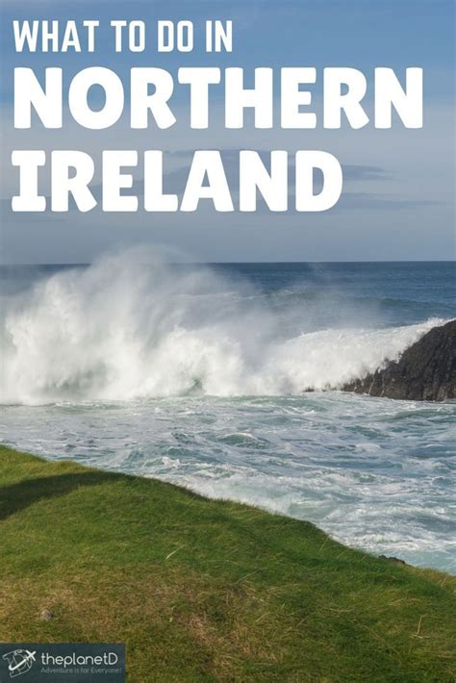
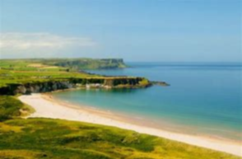
This beach is located in Belfast

