

Culture – connectedness in diversity

Part one: How Christmas is celebrated



1st theme: Culture

2016-2017

Christmas in Northern Ireland
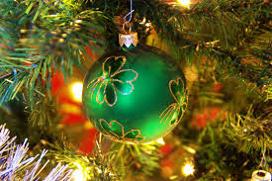

- Santa Claus 

Santa clause lives in the North Pole and often says Ho Ho Ho! The tradition of hanging up the stocking is still followed in Northern Ireland. Children hang their stocking on Christmas Eve, along with mince pies and carrots for Santa and his reindeer. Santa travels across the world on Christmas Eve on a sleigh pulled by reindeer. Rudolph with his red nose is the most important reindeer. Children are in bed way before midnight t waiting for Santa to visit.

2. Christmas Food

Christmas Dinner is the dinner we eat on Christmas Day. It is a plate full of heaven with juicy ham and roast turkey! The table is normally covered with food like stuffing, Brussels sprouts, carrots, gravy, roast potatoes and sausages. 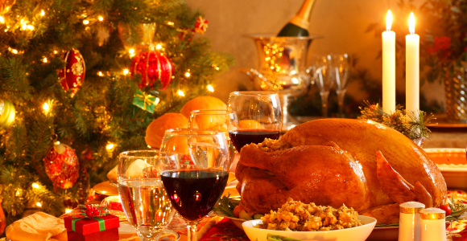

For dessert we have Christmas pudding which is delicious!
Christmas dinner is not Christmas dinner without a Christmas cake and mince pies.
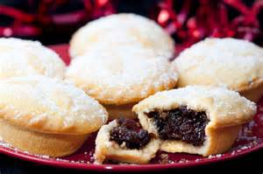

Christmas Crackers


They were first made in about 1845-1850 by a London sweet maker called Tom Smith.
On a trip to Paris in 1840 Smith discovered the “bon-bon,” a sugared almond wrapped in a twist of paper.
The cracker concept was hot and others were quick to copy Smith’s idea. A Christmas cracker is a cardboard paper tube with a joke in it a paper hat and a small gift
Families pull crackers before they eat their Christmas dinner.

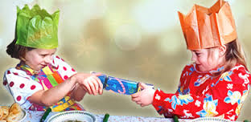
Christmas play and pantomimes

What is pantomime? Panto is a peculiarly British tradition of winter musical comedy Theater. It starts with familiar fairy tales and children's stories like Cinderella or Aladdin, and injects a bit of music hall (British) style with audience participation to create a raucous, silly entertainment that's child pleasing yet has enough sly references to entertain all the grownups too.
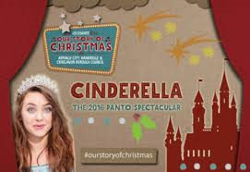

The Queen’s Speech
One 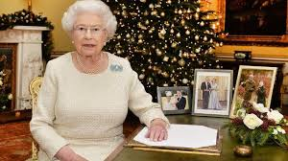
One Christmas ritual that is not an ancient tradition is the British monarch's broadcast on Christmas day. Queen Elizabeth II continues the tradition to this day.

