ena4 course material
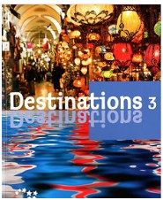
Teacher: Milla Koskenniemi

Student: ________________________ Book:

ena4 KEHITTYVÄ KIELITAITO: AJANKOHTAISET ILMIÖT

Aika: 6.jakso 2020, MA, KE klo 15:15-16:50. OPISKELE KOTONA!
Opettaja: Milla Koskenniemi (milla.koskenniemi@tyk.fi) puh. 0400 997425
Pedanet link: https://bit.ly/2JHsLyH
Kurssimateriaali:
- Destinations 3, Otava
- Teacher’s course material (kurssimateriaali)

SISÄLTÖ: Kurssin aiheita ovat ajankohtaiset asiat ja ilmiöt, mm. ympäristö, 2000-luvun keksinnöt ja
uutiset. Opetuksessa painottuu kirjallinen vuorovaikutus.
Kurssin kielioppi: futuuri, indefiniittipronominit, apuverbit, imperatiivi eli käskymuoto

ARVIOINTI: Kurssi arvioidaan asteikolla 4-10. Kurssin arvosanaan (numeroon) vaikuttavat Loppukoe, tehtävien tekeminen, sanakokeet ja kirjoitelma. Loppukokeesta pitää saada vähintään 30% oikein.

LOPPUKOE: Keskiviikkona 20.5. klo 15:00-17:00
- ENGLANNIN TUKIOPETUS 6.JAKSOLLA:
MAANANTAISIN KLO 14:15-15:15 numerossa 0400 916 317 (Tiina). Soita/Whatsapp/tekstiviesti.
- LÄKSYTUKI:
MA-TO klo 14.15-16.30. 040 548 3818 (Pipsa) ja 040 152 6842 (Keise) Soita/Whatsapp/tekstiviesti.

REHELLISYYS:

Sinun on tehtävä koulutehtävät itse. Toisen opiskelijan vastausten kopiointi tai internetistä tekstin plagiointi on kielletty.

COURSE PLAN

 | DATE | TOPIC | Pages in course material | COMPULSORY ASSIGNMENTS
1. | Wed 15.4. | Video: A plastic ocean  Vocabulary: Be green | 1-7 | WORD TEST I: A plastic ocean
2. | Mon 20.4. | Reading: Inventions  Listening: New inventions | 8-11 | WORD TEST II: Inventions
3. | Wed 23.4. | Video: News  Reading: News online | 11-14
4. | Mon 27.4. | Text 6B: Left or right? | Book p. 106-107 | WORD TEST III: News online
5. | Wed 29.4. | Grammar 1: Futuuri | 15-17
6. | Mon 4.5. | Grammar 2: Indefiniittipronominit | 18-22
7. | Wed 6.5. | Grammar 2: Indefiniittipronominit | 18-22
8. | Mon 11.5. | Grammar 3: Apuverbit | 23-25
9. | Wed 13.5. | Grammar 4: Käskymuoto / imperatiivi | 26-27 | SUBMIT COMPOSITION!
10. | Mon 18.5. | Harjoituskoe / Practice test
11. | Wed 20.5. | COURSE TEST


WELCOME TO THE COURSE!

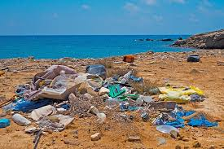
LINK TO THE VIDEO: https://bit.ly/39Si733
VIDEO: A PLASTIC OCEAN

Do the preparation task first. Then read the vocabulary, watch the trailer and find out more about how plastic can be dangerous to sea animals and human health.

EXERCISE 1. Preparation. Match the vocabulary with the correct definition and write a–h next to the numbers 1–8.

1…….. a crisis a. an area where waste is buried under the ground
2…….. to degrade b. a small part of something
3…….. a landfill site c. a difficult or dangerous situation that needs urgent attention 4…….. to dump d. a diver who holds their breath under water
5…….. to endure e. in perfect condition
6…….. a free diver f. to get rid of something quickly without worrying about it
7…….. a fraction of something g. to suffer
8…….. pristine h. to break down into smaller substances

VOCABULARY:

plastic muovi  ocean meri  blue whale sinivalas  follow seurata  childhood lapsuus  dump dumpata, jättää  pristine koskematon, tahraton  environment ympäristö  planet planeetta (=maapallo)  journalist journalisti, toimittaja  grow up kasvaa (aikuiseksi)  spiritual henkinen  champion mestari  free diver vapaasukeltaja  opportunity mahdollisuus, tilaisuus  sea meri  pay back maksaa takaisin, hyvittää  crisis kriisi | global maailmanlaajuinen  a fraction of murto-osa  produce tuottaa (=tehdä)  recycle kierrättää  degrade hajottaa  endure kestää, sietää  man-made ihmisen tekemä  food chain ravintoketju  dolphin delfiini  community yhteisö  landfill site kaatopaikka  sweet potato bataatti  corn maissi  sugar cane sokeriruoko  garbage jäte, roskat  wrapped in plastic kääritty muoviin  change muutos

EXERCISE 2. Video comprehension. Read the questions and answers. Then watch the video again. Circle the best answer to the questions.

1. When did the first narrator start following blue whales?
a. When he was a teenager
b. When he was a child
c. When he was an adult

2. How many tons of plastic are dumped into the oceans every year?
a. 8 million
b. 5 million
c. 9 million

3. What does the narrator do for a living?
a. He’s a TV presenter.
b. He’s a diver.
c. He’s a journalist.

4. How does the free diver feel about her work helping to clean the oceans?
a. That more people should do it
b. That it’s her way to pay back the ocean for all the pleasure it has given her
c. That it’s an impossible job

5. Why is the plastic in the ocean never going to degrade?
a. Because it has nowhere to go
b. Because there is too much of it
c. Because more and more is being dumped daily

6. How many pieces of plastic were found in a ninety-day-old chick?
a. 256
b. 266
c. 276

7. What has been built on the landfill sites?
a. Beaches – including resorts for tourists
b. Factories – including plastic bottle factories
c. Communities – including their food production

8. What does the main narrator believe is possible?
a. He believes change is possible and it starts with us.
b. He believes change is possible if we stop buying plastic bottles.
c. He believes change is possible if we stop throwing bottles in the ocean.

WORD TEST 1
EXERCISE 3. Learn the key words. Write them in Finnish and English.

English: Finnish: English: In your own language:

plastic _______________________ ______________________ ______________________
an ocean, a sea _______________________ ______________________ ______________________
follow _______________________ ______________________ ______________________
childhood _______________________ ______________________ ______________________
dump _______________________ ______________________ ______________________
environment _______________________ ______________________ ______________________
planet _______________________ ______________________ ______________________
grow up _______________________ ______________________ ______________________
opportunity _______________________ ______________________ ______________________
crisis _______________________ ______________________ ______________________
global _______________________ ______________________ ______________________
produce _______________________ ______________________ ______________________
recycle _______________________ ______________________ ______________________
community _______________________ ______________________ ______________________
landfill site _______________________ ______________________ ______________________
garbage _______________________ ______________________ ______________________
change _______________________ ______________________ ______________________

EXERCISE 4. VOCABULARY. Match English and Finnish words.

plastic ___ A dumpata, jättää
ocean ___ B jäte, roskat
dump ___ C ympäristö
childhood ___ D kierrättää
environment ___ E maksaa takaisin, hyvittää
pristine ___ F muovi
grow up ___ G kaatopaikka
pay back ___ H lapsuus
global ___ I kasvaa (aikuiseksi)
recycle ___ J meri
landfill site ___ K maailmanlaajuinen
garbage ___ L koskematon, tahraton

EXERCISE 5. Study the vocabulary first and then fill in the missing words. You may need to add some other words, e.g. do / don’t.

https://en.islcollective.com
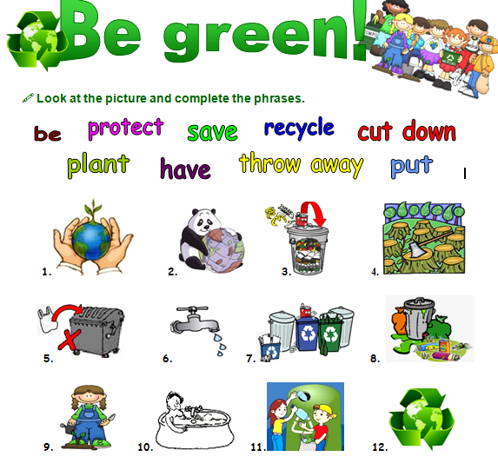

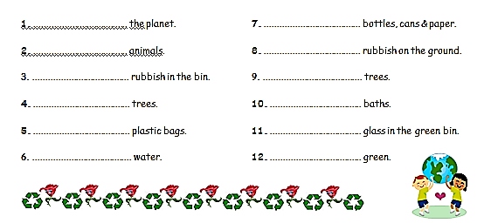

BE GREEN - VOCABULARY:

protect suojella  save pelastaa, säästää  recycle kierrättää  cut down leikata  plant istuttaa  throw away heittää pois | put laita  planet planeetta  rubbish roskat  bin roskakori  plastic muovi  can tölkki
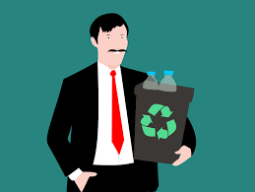
EXERCISE 6. Match English and Finnish words.

recycle ___ A. roskat
a can ___ B. planeetta
planet ___ C. heittää pois
save ___ D. istuttaa
plastic ___ E. säästää, pelastaa
cut down ___ F. leikata
throw away ___ G. tölkki
rubbish ___ H. roskakori
bin ___ I. suojella
protect ___ J. muovi
to plant ___ K. kierrättää

EXERCISE 7. Write down 3 things you can do in your daily life in order to help preserve our planet:
(for example: take shorter showers and turn off the water when I’m shampooing my hair)

My environmental promises

1 _________________________________________________________________________________________

__________________________________________________________________________________________

2 _________________________________________________________________________________________

__________________________________________________________________________________________

3 _________________________________________________________________________________________

___________________________________________________________________________________________

INVENTIONS = KEKSINNÖT
WORD TEST 2

VOCABULARY:
artificial keinotekoinen, teko-  to implant istuttaa, juurruttaa, asentaa  a battery akku, paristo  to strap kiinnittää, sitoa  a wire johto  to increase lisätä, kasvattaa  an infection tulehdus  to launch tuoda markkinoille, julkaista  a device laite  to have an impact on olla vaikutusta, vaikuttaa  significant huomattava, merkittävä  a manufacturer valmistaja  to develop luoda, kehittää  originally alun perin | a headset kuulokkeet  to found perustaa  to add lisätä  to receive vastaanottaa  a status update tilapäivitys  an application sovellus, applikaatio  self-driving itsestään ajava  a vehicle kulkuneuvo  a driverless kuskiton  to transform muuttaa  an encyclopedia tietosanakirja  reliable luotettava  to access päästä käsiksi  former entinen  to allow myöntää, sallia, mahdollistaa

https://otavanopisto.muikkuverkko.fi/

TEXT 1: INVENTIONS IN THE 21ST CENTURY

What are the most important inventions of the 21st century? Next read about seven inventions that have changed the world.
Mitkä ovat 2000-luvun tärkeimmät keksinnöt? Lue seuraavaksi seitsemästä keksinnöstä, jotka ovat muuttaneet maailman.

AbioCor Artificial Heart

The AbioCor artificial heart was first implanted in a human being in 2001. The softball-size heart works on a battery pack that is strapped to the user’s waist. Unlike previous artificial hearts it doesn’t have any wires, which can increase the risk of infections.

Apple iphone
Apple launched its first iphone in 2007. Although it wasn’t the first smartphone or device with a touch screen, it had a significant impact on the industry. Several electronics manufacturers have since developed their own versions of the device.

Bluetooth
Bluetooth is a wireless technology that connects devices together over a short distance. It was originally used for connecting headsets to mobile phones. Today, Bluetooth is used in products such as laptops, desktops, tablets, phones, media players and some headsets.

Facebook
Mark Zuckerberg founded Facebook with his roommates at Harvard University in 2004. Today Facebook has over 1.6 billion users worldwide who can add other users as friends, send and receive messages, post photos, status updates and videos, and use different applications.

Google driverless car
Google has been developing technology for self-driving vehicles. Although it hasn’t launched any driverless cars yet, these vehicles could transform the way we commute in the future.

Wikipedia
Wikipedia is an online encyclopedia where people can search information about different topics for free. Since it is written by people who use it, Wikipedia is not completely reliable, for instance, for academic purposes. However, it has certainly changed the way we share and access knowledge.

Youtube
Youtube was created in 2005 by former PayPal employees. It is the most popular video-sharing website in the world. It allows users to upload, view and share videos for free.

EXERCISE 1. Inventions – true or false?
Are the statements true or false? (Ovatko väittämät totta vai tarua?)
1. Facebook was created in 2002. TRUE FALSE
2. Youtube is the most popular video-sharing website. TRUE FALSE
3. iPhone was not the first device with a touchscreen. TRUE FALSE
4. Google launched its first driverless car in 2010. TRUE FALSE
5. AbioCor artificial heart has only a few wires. TRUE FALSE
6. Wikipedia articles are written by its users. TRUE FALSE
7. Bluetooth is a technology that connects devices over a long distance. TRUE FALSE

https://otavanopisto.muikkuverkko.fi/

EXERCISE 2. Listen and write – vocabulary
Study the words of this lesson one more time. Then listen to the recording below. You will hear ten words, write them below with their Finnish translations.
(Opiskele osion sanat vielä kerran. Kuuntele sitten alla oleva äänitiedosto. Kuulet kymmenen sanaa, kirjoita ne alle suomenkielisen käännöksen kanssa.)
in English: in Finnish:
1 _____________________________________ _________________________________
2 _____________________________________ _________________________________
3 _____________________________________ _________________________________
4 _____________________________________ _________________________________
5 _____________________________________ _________________________________
6 _____________________________________ _________________________________
7 _____________________________________ _________________________________
8 _____________________________________ _________________________________
9 _____________________________________ _________________________________
10 _____________________________________ _________________________________
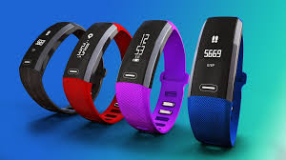
EXERCISE 2. Write the missing word.
1 I just bought a new heart rate monitor. It’s such a great _____________________. (laite)
2 The measurements are really _________________________.
(luotettava)
3 With this new heart rate monitor I can ___________________ all kinds of information. (päästä käsiksi)
4 It has really _______________________ my health and well being. (muuttaa - IMPERF.)
5 There aren’t any ______________________ except for charging. (johto - MONIKKO)
6 The monitor is a brand new model. It was ___________________ last month. (tuoda markkinoille - IMPERF.)
7 It has had a ____________________________ impact on my lifestyle. (merkittävä)
8 It even comes with a ______________________________. (kuulokkeet)

LINK: https://bit.ly/2Rh0umP
LISTENING SKILLS: NEW INVENTIONS
Listen to the radio programme and circle TRUE or FALSE for the statements. Read the words first.

VOCABULARY:

wing-suit = liitopuku  glide = liitää  water distiller = veden tislain  enable talk = mahdollista puhumisen  sign language = viittomakieli | invent = keksiä  underwater = vedenalainen  produce = tuottaa  cloud = pilvi  science = tiede  correspondent = kirjeenvaihtaja (=toimittaja)

EXERCISE 1. Do this exercise while you listen. Circle TRUE or FALSE for these sentences.
1. Wing-suits allow people to fly or glide. TRUE FALSE
2. Wing-suits are getting cheaper. TRUE FALSE
3. Gabriele Diamanti's water distiller is powered by the sun. TRUE FALSE
4. The "enable talk gloves" help people to use sign language in really cold conditions. TRUE FALSE
5. James Cameron invented a new underwater camera. TRUE FALSE
6. MIT students have invented a new type of ketchup. TRUE FALSE
7. The last invention is a way of producing clouds indoors. TRUE FALSE
8. The science correspondent thinks the clouds are ugly. TRUE FALSE

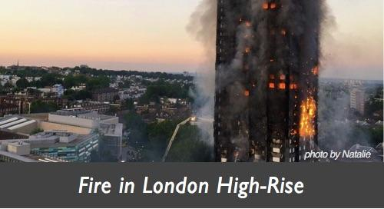
NEWS ONLINE I

Fire in London High-Rise
June 19, 2017 Rick English https://newsineasyenglish.com/2017/06/19/fire-in-london-high-rise/
At 1:15 am, on June 14, a high-rise apartment building in London caught fire. Witnesses reported people being trapped in their apartments yelling for help. Over 200 firefighters were sent to put out the fire. The firefighters rescued people at the 27-storey building. But sadly, many people could not be saved.
Firefighters tried to control the fire on the higher floors but it burned out of control. Officials think there could have been up to 600 people in the building. People living in nearby buildings were evacuated. The reason for the fire was not known but many who escaped said the fire alarm had not been set off by the fire.Tragically, more than 50 people have died and the death toll is expected to rise. Over 70 people were taken to six hospitals across London.
WORD TEST 3
VOCABULARY:

fire tuli  high-rise kerrostalo  catch fire syttyä tuleen  catch - caught - caught napata, ottaa kiinni  a witness silminnäkijä  report ilmoittaa, selvittää  to be trapped olla loukussa, ansassa  apartment asunto  put out sammuttaa  rescue pelastaa | storey kerros  out of control kontrolloimattomasti  official viranomainen  evacuate evakuoida  fire alarm palohälytin  set off laukaista  tragically traagisesti  death toll kuolleiden määrä  is expected odotetaan
EXERCISE 1. True or false? Oikein vai väärin? Ympyröi oikea vastaus.
- A building burned in London on May 14. T F
- No one was trapped in the building. T F
- Firefighters were sent there for help. T F
- Many people died. T F
- The firefighters were able to put out the fire fast. T F
- There were many people living in the building. T F
- No one was evacuated. T F
- The fire got started in one of the kitchens. T F
- We don’t know yet how many people died altogether. T F
- Over 70 people are in the hospital. T F
EXERCISE 2. Match the word with a synonym.
a high-rise ___ A) to describe something that happened
a witness ___ B) a flat
to report ___ C) an authority
an apartment ___ D) an apartment building
to rescue ___ E) to move someone from a dangerous place
out of control ___ F) to save somebody
an official ___ G) uncontrollable, wild
evacuate ___ H) a person who sees a crime or an accident

NEWS ONLINE II www.newsinlevels.com, https://otavanopisto.muikkuverkko.fi/

Accident in Taiwan 29-10-2018 07:00
A train going from Taipei to Taitung in Taiwan derailed last Sunday.
It was carrying around 366 passengers, and the derailment killed at least 22 people and injured 171 others. The express launched in 2013, and the trains travel up to 150 kilometre per hour.
Soldiers and firefighters are working to find trapped people. People are investigating the cause of this crash.
derail suistua raiteilta (juna) the express pikajuna
derailment raiteilta suistuminen launch lanseerata
injure haavoittaa, vahingoittaa trapped olla ansassa, loukussa
soldiers sotilaat firefighter palomiehet
investigate tutkia

EXERCISE 1. Answer the questions in English.

1 Where was the express train travelling from and where to?

2 What happened to the train on Sunday?

3 How many passengers there were?

4 How many passengers got injured?

5 How many passengers got killed?

6 How fast is this express train?

EXERCISE 2. NEWS MEDIA ONLINE.
Go to the News in levels website: https://www.newsinlevels.com
Choose a news article that you find interesting. Read the article and answer the questions below in English. If the level 1 or 2 articles are too easy, choose a level 3 article.
1. What is the article about?

2. Why did you choose it?

3. What new words did you learn while reading the article? Write a list of words in English and Finnish / your own language.
Book pages 106-107!
TEXT 2: Destinations 3, UNIT 6. Text B: Left or right
EXERCISE 1. Kirjoita sanat. Write the words.
English: Finnish: English: In your own language:
seat belt _______________________ ______________________ ______________________
press _______________________ ______________________ ______________________
key in _______________________ ______________________ ______________________
indicator _______________________ ______________________ ______________________
look out _______________________ ______________________ ______________________
honk _______________________ ______________________ ______________________
to be allowed _______________________ ______________________ ______________________
zebra crossing _______________________ ______________________ ______________________
brake _______________________ ______________________ ______________________
traffic _______________________ ______________________ ______________________
yard _______________________ ______________________ ______________________
steering wheel _______________________ ______________________ ______________________
approve _______________________ ______________________ ______________________
dangerous _______________________ ______________________ ______________________
roundabout _______________________ ______________________ ______________________
exit _______________________ ______________________ ______________________
speeding ticket _______________________ ______________________ ______________________
speed limit _______________________ ______________________ ______________________
alive _______________________ ______________________ ______________________
bridge _______________________ ______________________ ______________________
reach _______________________ ______________________ ______________________
park _______________________ ______________________ ______________________
GRAMMAR 1: FUTUURI (TULEVA AIKA)

Englannissa on kaksi tapaa kertoa tulevaisuudesta: WILL ja BE GOING TO.
I am going to read a book this weekend.
I will arrive in London on Friday.

WILL-RAKENNE:  - will + pääverbin perusmuoto  - kielteinen muoto: will not + perusmuoto, lyhennetty muoto won’t  - voidaan lyhentää ‘ll:  We’ll arrive in London on Friday.  - will-apuverbiä käytetään myös silloin kun luvataan tehdä jotain:  I’ll get the coffee for you.  I’ll bring it, don’t worry.  - spontaani päätös:  Wait, I’ll check my email first. Then we can go.  - sama muoto kaikissa persoonissa:  I will we will  you will you will  she/he will they will  Esimerkkejä:  Tomorrow I will clean the house.  In July, I will go to France.  I will have a glass of juice.  My sister will have a coffee.  Will you come with me?  I will make a phone call first. | BE GOING TO -rakenne:  - ilmaisee aikomusta:  Minä aion opiskella kokeeseen viikonloppuna. = I am going to study for the test this weekend.  - voidaan käyttää jos kerrotaan esim. säästä: It is going to rain this afternoon.  - Taivuta BE oikeaan muotoon + pääverbistä perusmuoto. BE-verbiä pitää siis taivuttaa persoonan mukaan!  I’m going to have a nap now.  You are going to study for the test.  My sister is going to make dinner tonight.  We are going to start a new hobby together.  Are you going to do anything about the problem?  They are not going to come to the party.  - KIELTEISEEN MUOTOON lisätään not:  I am not going to be late for class.

EXERCISE 1. Käännä englanniksi. Käytä WILL-rakennetta.
Translate into English. Use WILL.

- Menetkö ostoksille iltapäivällä? ___________________________________________________________________________________
- Menen lääkäriin huomenna.
___________________________________________________________________________________
- Tuletko mukaani?
__________________________________________________________________________________
- (Olet ravintolassa). Tilaan hampurilaisen ja lasin vettä. Käytä pääverbiä HAVE.
__________________________________________________________________________________
- Mitä sinä tilaat?
________________________________________________________________________________
- Odota, tarkistan sähköpostini ensin.
_________________________________________________________________________________
- Odotan sinua.
________________________________________________________________________________
8. Sää tulee olemaan aurinkoinen.

__________________________________________________________________________________

EXERCISE 2. BE GOING TO -futuuri. Kirjoita puuttuva be-verbin muoto. (AM / ARE I IS)

1 Mia and Jussi _______________ going to travel to New York during Christmas holiday.
2 They _________________ going to go to a Broadway musical.
3 I have never been to New York. But I _______________ going to book a holiday there soon!
4 We ____________________ going to travel with a big group of people.
5 ______________ you going to come with us?
6 Matti _________________ going to join us for sure.
7 However, he ___________ not going to stay at the same hotel with us.

EXERCISE 3. Käännä englanniksi. Käytä BE GOING TO-rakennetta.
Translate into English. Use BE GOING TO.

1 Minä aion mennä lomalla Kreikkaan ensi kesänä.

________________________________________________________________________________________

2 Hän aikoo tehdä illallista tänään.

_______________________________________________________________________________________

3 He aikovat aloittaa uuden harrastuksen.

_______________________________________________________________________________________

4 Aiotko sinä nukkua lentokoneessa?

_______________________________________________________________________________________

5 Me emme aio yöpyä kalliissa hotellissa. Me aioimme yöpyä halvassa hostellissa. ( YÖPYÄ = STAY)

_______________________________________________________________________________________

EXERCISE 4. Kirjoita omista tulevaisuuden suunnitelmistasi. Käytä WILL tai BE GOING TO -futuuria. Käytä annettua sanaa lauseessa.

next weekend: I am going to go to the gym next weekend.

1 tomorrow: _______________________________________________________________________
2 next week: _______________________________________________________________________
3 in December: _______________________________________________________________________
5 next winter holiday: _______________________________________________________________________
6 next summer: _______________________________________________________________________
7 ten years from now: _______________________________________________________________________

GRAMMAR 2: INDEFINIITTIPRONOMINIT / INDEFINITE PRONOUNS
(Destinations 3, page 89, Otava)
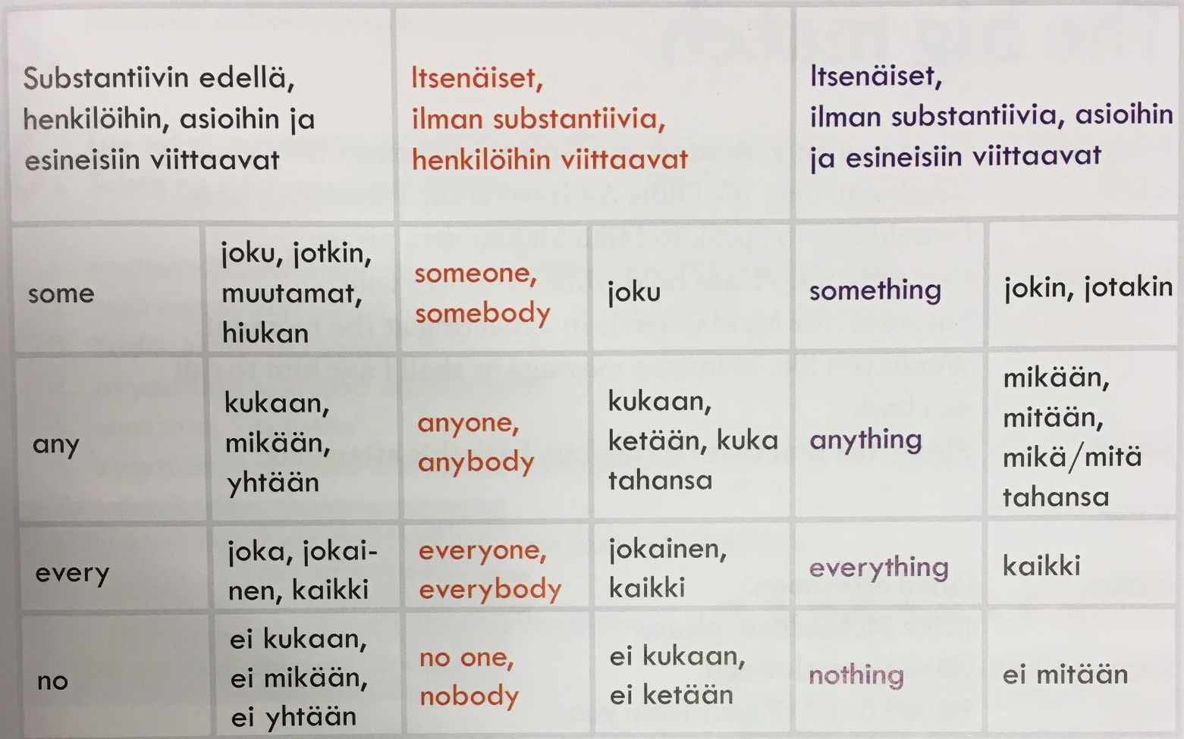

Everything = kaikki
Something = jotain, jotakin
Nothing = ei mitään
Anything = mitä tahansa, mikä tahansa, mitään

EXERCISE 1. Translate into Finnish.

1 Everything is ok. ____________________________________________________________________________________

2 I want to buy something in the supermarket.

____________________________________________________________________________________

3 Are you doing anything special this evening?

____________________________________________________________________________________

4 Nothing special. ____________________________________________________________

EXERCISE 2. Translate into English.
1. Peter sanoi jotain. __________________________________________________________________.
2.Ellen ei sanonut mitään. ____________________________________________________________.
3. Minulla ei ole mitään syötävää. _________________________________________________________.
4. Voinko tehdä jotain? _________________________________________________________________.
5. Teen mitä tahansa.___________________________________________________________________.
6. Kerro minulle jotain. _________________________________________________________________.
7. Voit kertoa minulle mitä tahansa. _______________________________________________________.
EXERCISE 3. Add something, everything, nothing, anything

1. I don’t have ___________________________ to eat.
2. There’s ______________________________ in this room making a noise. What is it?
3. There’s ______________________________ wrong with you, you’re perfectly healthy.
4. Do you have __________________________ you need for the trip?
5. If you need ___________________________ , just call me.
6. That mess has ________________________ to do with me!
7. There’s ______________________________ important I need to tell you
8. ___________________________________ must go in our once a year sale!
9. The doctors did __________________________ they could, but it wasn’t enough.
10. There’s _______________________________ you can say to make me forgive you.
11. There isn’t ________________________________left, the burglars took it all.
12. Everyone must bring _______________________________ for lunch.
13. I promise, ______________________________ is fine! I’m just really tired.
14. In my opinion, _____________________________ is more important than family.
15. Argh! ______________________________ just crawled over my foot!

EXERCISE 4. Add something, everything, nothing or anything

1. If there is ___________________________ you need you can call me.
2. I think there is ___________________________ wrong with my computer,it is not working very well.
3. Get out ! It has ___________________________ to do with you.
4. Take this bag and leave ___________________________ else to me.
5. There isn’t ___________________________ worth watching on TV tonight.
6. The doctors did ___________________________ they could to save her but she died.
7. There is ___________________________ about this place that frightens me.
8. Did you bring ___________________________ you needed for the trip ?
9. My friend’s decision has ___________________________ to do with me.
10. As long as you are not doing ___________________________ wrong, you have nothing to worry about.
EXERCISE 5. Valitse lauseeseen sopiva pronomini. Rengasta oikea vaihtoehto.

1. I think I saw a) anybody b) somebody.
2. Well, I didn’t see a) anybody b) somebody.
3. I didn’t hear a) nothing b) anything either.
4. You just dreamed a) everything b) everybody.

EXERCISE 6. Valitse lauseeseen sopiva pronomini ja kirjoita se viivalle. Valitse seuraavista:

something anything everything nothing

- What are you doing on Saturday? - __________________.
- Would you like ________________ to eat?
- The film was in French so I couldn’t understand _____________ they said.
- It’s your birthday, you can order ______________ from the menu.
- I cannot decide, _______________ looks delicious.

SOMEONE, SOMEBODY = joku
ANYONE, ANYBODY = kukaan, ketään, kuka tahansa
EVERYONE, EVERYBODY = jokainen, kaikki
NO ONE, NOBODY = ei kukaan, ei ketään

EXERCISE 7. Valitse lauseeseen sopiva pronomini ja kirjoita se viivalle. Valitse seuraavista:

somebody anybody everybody nobody

- I can hear _____________________________ at the door.
- Does ___________________________ want to go to the movies?
- I’m sad because _______________________ remembered my birthday.
- Oh no! _____________________________ has eaten my chocolate.
- ______________________________ should know Helsinki is the capital of Finland.
EXERCISE 8. Kirjoita pronomini englanniksi viivalle.

1. Do you know ___________________ about Billie Holiday?
mitään

2. I have heard ___________________ about her.
ei mitään

3. Would you like to know ___________________ about her life?
jotain

4. Of course, if she is ___________________ I should know about.
joku

5. ___________________ can sing the way she did.
ei kukaan

6. Well, now you have to tell me ___________________ about her!
jotakin

Destinations 3, Opettajan materiaali, s.118 (Otava)

EXERCISE 9. Kirjoita lauseista puuttuvat pronominit aukkoihin. Valitse seuraavista:

anyone, anywhere, anything, someone, somewhere, something, nothing

1. If I can do it, _____________________ can do it.
2. You look hungry. Would you like _____________________ to eat?
3. No, _____________________ , thanks. I’m going for dinner with the girls in the evening.
4. I can’t find my reading glasses _____________________ . Can you help me find them?
5. Where are we going on holiday? I don’t mind, but it has to be_____________________ nice and warm.
6. Don’t you have _____________________ to do?
7. It’s so boring today. There’s _____________________ on TV and I have _____________________ to read.
8. Why don’t you go to the kitchen and make us _____________________ special to eat?
9. Help, please! My husband needs help. Is _____________________ a doctor?
10. I’m a nurse. Maybe I can do _____________________ to help.
11. Can _____________________ please call an ambulance?
12. If you are in trouble, there’s often _____________________ who canhelp.

GRAMMAR 3: APUVERBIT / AUXILIARY VERBS Pääverbi PERUSMUODOSSA
apuverbin jälkeen!
can could shall should
would may must will might

EXERCISE 1. MITÄ NÄMÄ APUVERBIT OVAT ENGLANNIKSI? KIRJOITA:

1 OSAA, VOIDA =

2 VOISI, OSAISI, OSASI (IMPERF.) =

3 EHDOTUS TAI KYSYMYS I JA WE-persoonissa =

4 PITÄISI =

5 -ISI (KONDITIONAALI), ESIM. SE OLISI KIVAA. =

6 SAA, SAATTAA, OLLA LUPA =

7 SAATTAISI =

8 PITÄÄ, TÄYTYY =

9 TULEVA AIKA (FUTUURI) =

EXERCISE 2. Kirjoita puuttuva apuverbi.
1 She __________________ ride a bike, no problem! (OSAA)
2 All the students in my class ____________________ read. (OSAAVAT)
3 _____________________ we study together? (VOISIMMEKO)
4 I thing studying together _______________________ be great. (OLISI)
5 We __________________ organise a party this weekend. (PITÄISI)
6 Who ______________________ we invite? (VOISIMME)
7 ____________________ I invite my cousin Fiona? (SAANKO)
8 We ___________________ invite our closest friends. (TÄYTYY)
9 _________________________ we dance? (TANSSITAANKO - KOHTELIAS EHDOTUS
WE-PERSOONASSA)

EXERCISE 3. Täydennä lauseet sulkeissa olevalla verbillä oikeassa aikamuodossa. Muista siis apuverbi + tavallinen verbi.
- All students in my class __________________________________. (osaavat lukea)
- When I was three, I _____________________________________. (en osannut lukea) KIELTEINEN - NEGATIVE
- Now, I ___________________________________ something almost every day. (minun täytyy lukea)
- _______________________________________ a fun party? (voisimmeko me suunnitella) KYSYMYS - QUESTION
- I think it _________________________________ great! (se olisi mahtavaa)
- I think we ___________________________________ that party next weekend. (meidän pitäisi järjestää)
- _________________ I ______________________ you with the party? (saanko auttaa) KYSYMYS - QUESTION
- We ___________________________________ good food an invite many people. (Meidän täytyy ostaa)
EXERCISE 4. Write in English.

- Minun täytyy opiskella ___________________________________________________
- Sinun täytyy laulaa ___________________________________________________
- Hänen täytyy katsoa ___________________________________________________

- Sinä saatat kävellä ___________________________________________________
- Hän saattaa nukkua ___________________________________________________
- Me saatamme syödä ___________________________________________________

- Hän osaa uida ___________________________________________________
- Me osaamme työskennellä ___________________________________________________
- Te osaatte lukea ___________________________________________________

- Me voisimme kirjoittaa ___________________________________________________
- Te voisitte kuunnella ___________________________________________________
- He voisivat matkustaa ___________________________________________________

- He saattaisivat opiskella ___________________________________________________
- Minä saattaisin juosta ___________________________________________________
- Sinä saattaisit hyppiä ___________________________________________________

19. Hänen pitäisi rukoilla ___________________________________________________
20. Meidän pitäisi mennä ___________________________________________________
21. Teidän pitäisi lähteä ___________________________________________________

Kielteinen/negative:

subjekti + apuverbi + NOT + verbi

I + can + NOT + sing

you + should + NOT + speak

Kysymys/question:

apuverbi + subjekti + sing + ?

Can + you + sing ?
Should + we + go ?

EXERCISE 5. Apuverbit. Write in English.

- Minun ei täydy kävellä. ___________________________________________________
- Täytyykö sinun mennä? ___________________________________________________

- Sinä et saa tupakoida ___________________________________________________
- Saatammeko me mennä? ___________________________________________________

- Te ette osaa uida ___________________________________________________
- Osaavatko he puhua englantia? ___________________________________________________
- Minä en voisi olla onnellisempi ___________________________________________________
- Voisitko sinä lopettaa? ___________________________________________________

- Hän ei saattaisi tulla ___________________________________________________
- Sinä saattaisit hyppiä ___________________________________________________

19. Meidän ei pitäisi nukkua ___________________________________________________
20. Pitäisikö teidän siivota? ___________________________________________________
GRAMMAR 4: KÄSKYMUOTO = THE IMPERATIVE
Find in THE BOOK, text 6B page 106!
GIVING DIRECTIONS - OHJEIDEN ANTAMINEN
EXERCISE 1. Etsi tekstistä seuraavat käskyt ja ohjeet. Ne ovat käskymuodossa (imperatiivi).

- Kytke navigaattori päälle. ____________________________________________________
- Laita turvavyö kiinni. ___________________________________________________
- Näppäile osoite. ____________________________________________________
- Käänny oikealle Treadley Greenin suuntaan. __________________________________________
- Varo! ____________________________________________________
- Tuuttaa äänitorvea. ____________________________________________________
- Käänny vasemmalle. ____________________________________________________
- Aja suoraan 15 mailia. ____________________________________________________
- Pysy vasemmalla. ____________________________________________________
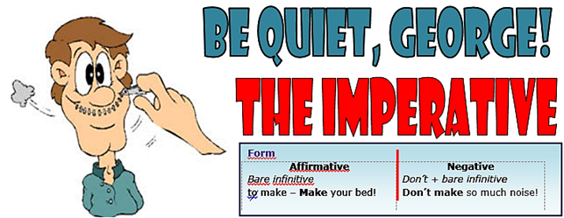
- Seuraa A7 tietä Tremburyyn. ____________________________________________________

https://en.islcollective.com/
Orders | Instructions | Advice | Invitations
Come here immediately, Mary! | First peel the apples, then slice them. | Do not go out at night alone. It’s too risky! | Eat a piece of the cake. It’s delicious!

EXERCISE 2. Fill in with the prompts given in the box.
1. _____________________ so loud! The baby is sleeping!
1. not to speak
2. to pass
3. to step
4. to pay attention
5. not to be/to respect
6. to write
7. not to forget
8. to take
9. to press/to follow
10. not to drink
11. to walk
12. not to walk
13. to listen
14. to repeat
15. to go away
16. not to drive
17. to melt/to add
18. to go/to take
19. not to speak
20. not to spend
21. to take
22. to boil
23. to help
24. not to touch
25.not to be/to relax
2. _____________________ me the salt, please.
3. Please, _____________________ aside. I can’t see through you!
4. ________________ to what your parents say. They give good advice.
5. _______________________ so nasty! ___________________ the others!
6. ___________________________ your name at the bottom.
7. _______________________________ to take your umbrella. It’s raining!
8. It’s raining! ___________________________ your umbrella!
9. ___________________ enter and __________________ the instructions.
10. _____________________________ that Scotch! You’re going to drive!
11. Please, _________________________ slowly and quietly.
12. ___________________________________ on the grass!
13. ________________________________ to me when I’m talking to you!
14. ___________________________ after me: “I won’t do that again!”
15. _______________________________ ! I’m trying to concentrate!
16. __________________________________ so fast! It’s dangerous!
17. First ________________ the butter in a saucepan and then ____garlic.
18.___________ straight ahead and then ______________ the first turning.
19. _______________________________ so fast! I can’t understand you!
20. ____________________________ so much money on worthless things!
21. ___________________ good care of your sister! I’ll be here in a minute.
22. _______________________ the carrots for just five minutes.
23. ______________________ yourself to a drink! The glasses are over there.
24. ____________________________________ anything! Mrs. Wilson won’t like it!
25. ___________________________ so shy! ______________________________!

