**STUDY PACK SPAIN – CHOIR – CON QUÉ LA LAVARÉ**

-**LESSON 1**

This song is in fact a mixture of various versions of the song “Con qué la lavaré”. The original song is anonymous and you can find it at the Cancionero de Upsala, one of the most importants songbooks in Spanish musical history, printed in 1556 and of which only one copy remains, preserved in the Library of Uppsala University. The most famous version of this original song belongs to Juan Vásquez (1500-1563), a renaissance composer based in Seville. All of the choral works by Vásquez were published in three books, one of which was printed in Osuna. However, the song “Con qué la lavaré” was printed in Seville in 1560. 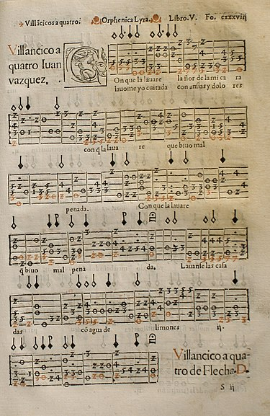

The song is a *villancico*. Nowadays, we use the word villancico to talk only about Christmas carols, but back in the Renaissance, a villancico was a profane and popular song that used to be sung by the “villanos”, the people that inhabited the villas. Most probably, at the beginning they were sung in unison, but composers like Juan Vasquez would transform these songs into more refined pieces. This one is made for four parts (Cantus, Altus, Tenor and Bass), and the main subject would be the despair of a woman that is not married and suffers because she is alone.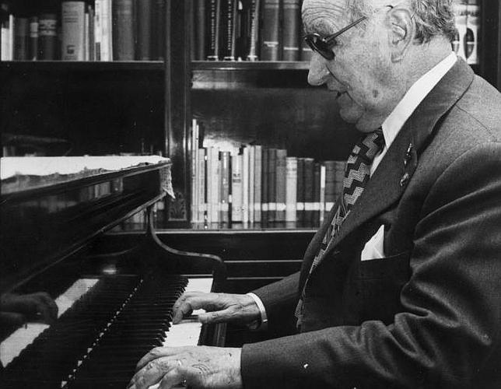

In 1947, Spanish composer Joaquín Rodrigo (1901-1999) composed his “Cuatro madrigales amatorios” (Four love madrigals) for soprano and piano. The four pieces are based on villancicos by Juan Vásquez, being the first one “Con qué la lavaré”. The melody of the piece is strongly related to both Vasquez and Upsala’s versions, but the accompaniment, the harmony and rhythm are completely different, close to the impressionism and neoclassicism that filled all Rodrigo’s repertoire. Our own version of the piece will have Rodrigo's version as base, but we added a second voice and changed the key for it to be more suitable for a choir. Now we have a piece that has the style of Joaquín Rodrigo but is closer to the original as it has a little bit of counterpoint.

Here you have some versions of the piece:

[Con que la lavare - YouTube](https://www.youtube.com/watch?v=fX_iTzhFisQ) (Cancionero de Upsala)

[Con que la lavare? - YouTube](https://www.youtube.com/watch?v=hW78088LmXc) (Juan Vásquez)

[Cuatro Madrigales Amatorios: I. ¿Con qué Lavaré? - YouTube](https://www.youtube.com/watch?v=VMeJf-DoTeY) (Joaquín Rodrigo)

**Activities for this Lesson**

1. Pay attention to the first picture and try to guess for which instrument is the score written.
2. Do a little research about the life of Joaquín Rodrigo and you will discover one shocking thing about him. ¿What was it?
3. We have mentioned the word “madrigal”, can you give yourself an explanation about what it is?

-**LESSON 2**

### **RHYTHM**

The time signature of “¿Con que la lavare?” is 4/4 and 3/4.

**Activities for this Lesson**

1. Learn how to do the solfege of these 2 rhythm patterns inspired by the different themes of the piece.

**Rhythm pattern nº1**



**Rhythm pattern nº2**



2. Learn to play the rhythm of the song on your instrument. You can play the same note throughout, or you can play two different notes (one in each bar)

3. Now, along with your teacher or another student, you can practice with rhythm pattern 1.

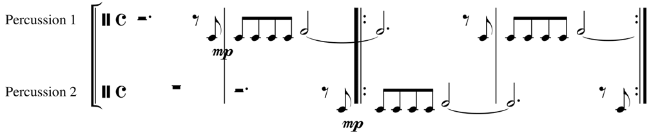

**MELODY**

The work is in C minor. This work is an arrangement inspired in a traditional Spanish song.

**Activities for this Lesson**

1. Sing C (Do) minor scale– natural, in a 3/4 time signature



2. Try to perform just the rhythm with the lyrics

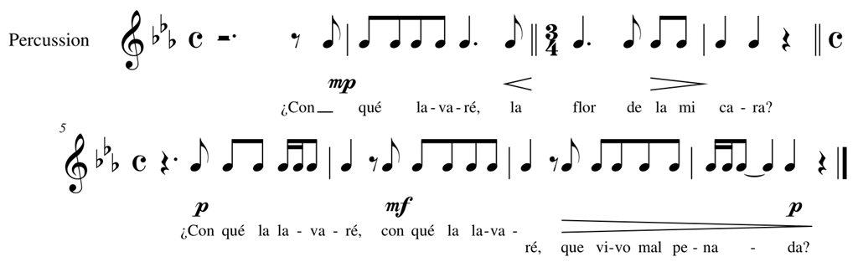

3. Sing the song with the lyrics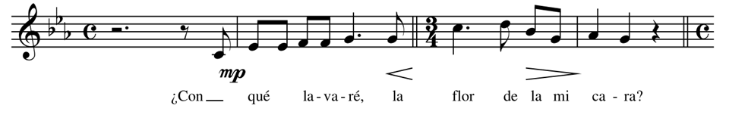

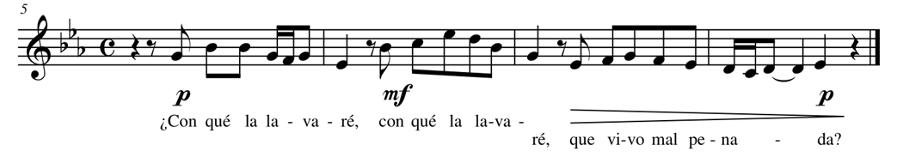

**LESSON 3**

Here you have the lyrics Con qué la lavaré, both in Spanish and English.

SPANISH ENGLISH

¿Con qué la lavaré With what shall I wash

la flor de la mi cara? the flower of my face?

¿Con qué la lavaré With what shall I wash it?

que vivo mal penada? I live in such sorrow.

Lávanse las casadas Married women wash

con aguas de limones in lemon water:

lavóme yo cuitada in my grief I wash

con penas y dolores in pain and sorrow.

**Activities for this Lesson**

1. There are some tricky sounds that you need to practice:

-Q (as in “qué): in Spanish we pronounce the letter Q like the English K as in “kilo”, and the “U” after “Q” is mute. **Say the word “qué” as if it was written “ke”.**

-V (as in “vivo”, “lavánse”, “lavóme”): in Spanish we don’t make a difference between V and B, so the letter V sounds like a B as in “book”. **Say the words “vivo”, “lavanse” and “lavome” as if they were written bibo, lebanese and labome.**

1. The lyrics of this song are in Spanish, but it is not modern Spanish. Can you guess which period these lyrics are from?