How is the penguin adapted to living in Antarctica?
Penguin Adaptations

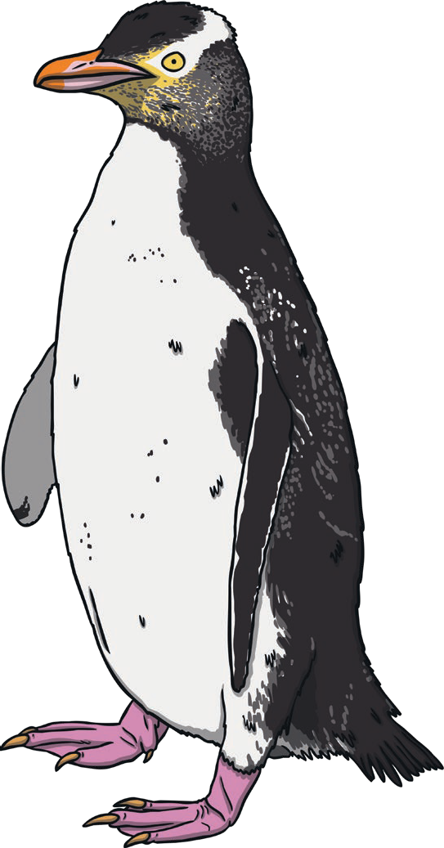
Webbed feet for
Thick layer of blubber for
Short, thick feathers for
Flippers for
Short, sharp beak for

How is the penguin adapted to living in Antarctica?
Penguin Adaptations
I can identify that most living things live in habitats to which they are suited.

Penguin Adaptations Answers

How is the penguin adapted to living in Antarctica?

Webbed feet for fast swimming.
Thick layer of blubber to keep them warm in the cold, Antarctic temperatures.
Short, thick feathers to keep them warm. They are tightly packed together and overlap.
Flippers for travelling quickly underwater.
Short, sharp beak for grabbing and cutting food.

