**STUDY PACK SPAIN – GUITAR ENSEMBLE– CANCIÓN DEL FUEGO FATUO**

**LESSON 1**

This work falls within the Spanish musical nationalism movement, an artistic and cultural movement that emerged at the end of the 19th century and beginning of the 20th century in Spain. Its followers sought to create music that reflected the traditions and culture of Spain, in opposition to imported music from other countries. El amor brujo, additionally, includes elements of the avant-garde language of the early 20th century.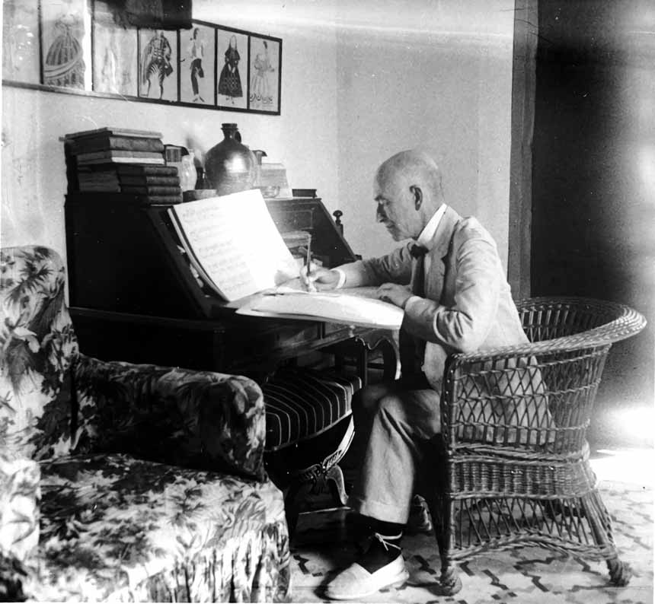

Manuel de Falla (1876-1946) was a Spanish composer and pianist who had a great impact on European music of the 20th century. His work is characterized by its fusion of traditional Spanish elements with modern musical technique and language. His music is highly influential in the development of Spanish musical nationalism and is considered one of the leading representatives of Spanish music of the 20th century. Furthermore, his work has been widely performed and recorded by prominent musicians and orchestras around the world.

He was born in Cádiz and began his musical studies in Madrid. Later, he studied in Paris with Paul Dukas and Vincent d'Indy. His works are known for their style steeped in Spanish popular music, as well as for their strong influence of French Impressionism and later neoclassicism. His most famous works include the piano suite "Noches en los jardines de España," the ballet "El amor brujo" and the opera "La vida breve."

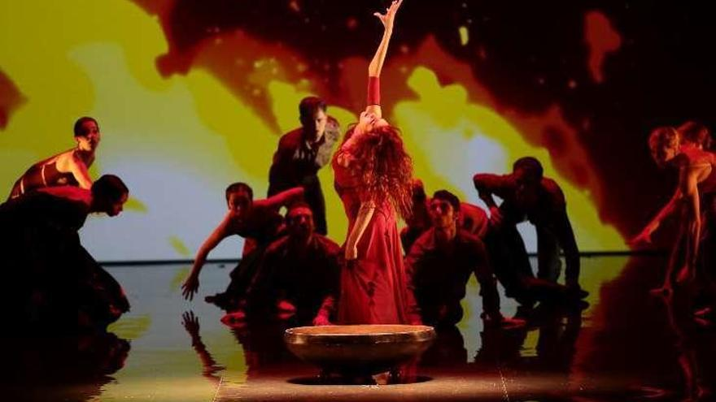

"El amor brujo" was originally written as a ballet in 1915 and was later converted into an orchestral suite in 1922. The work has been successfully performed on numerous occasions around the world and is considered one of the most important works in the Spanish repertoire. Manuel de Falla rewrote "El amor Brujo" a total of eleven times. The original idea of this piece was disfigured, and both the music and the instrumental template were changing during the remodeling process.

The "Canción del fuego fatuo," included in "El amor brujo," is based on traditional Andalusian Gypsy music of a more tragic and passionate character, known as "cante jondo." The piece is performed by a solo vocalist and an orchestra, whose lyrics describe an impossible and tragic love, that of the protagonist for her deceased lover, who returns as a spirit to torment her.

The version that we are going to perform is a transcription for guitar ensemble. You can hear here a version for guitar: <https://youtu.be/EKkEhvjhX8Q>

**Activities for this Lesson**

1. Here you have some versions of the same piece. The first link contains a version of the work performed by a classical singer and the second by a flamenco singer. What differences do you perceive?

Link 1: <https://www.youtube.com/watch?v=abHU6-Ukf3Y>

Link 2: <https://youtu.be/IQX7nq0bHZk>

1. Manuel de Falla's music has become well-known outside of Spanish borders and even in other genres. For example, Miles Davis, the great jazz musician, covered Falla's work on his album Sketches of Spain (1960). Listen to link 3 and indicate at what minute the main theme appears.

Link 3: <https://youtu.be/5fHUDXf7QnU>

**LESSON 2**

**RHYTHM**The time signature of the song “Fuego Fatuo” is 3/8 (a dance). The music is very accented in its melodies.

**Activities for this Lesson**

1. Listen to the song performed by a band:  
<https://www.youtube.com/watch?v=qSZGjg3caX8>

2. Learn how to do the solfege with these two rhythm pattern lessons inspired by different themes and motifs in the song.

**Rhythm pattern nº1**

**Rhythm pattern nº2**



**Rhythm pattern nº3**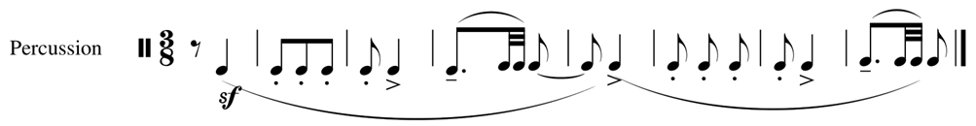

3. Learn to play the rhythms of the song on your instrument. You can play the same note throughout, or you can play two different notes (one in each bar).

4. Now, along with your teacher or another student, you can play rhythm pattern number 2 with the rhythm ostinato, based on rhythm pattern number 1.

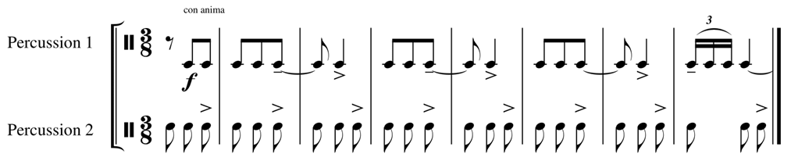

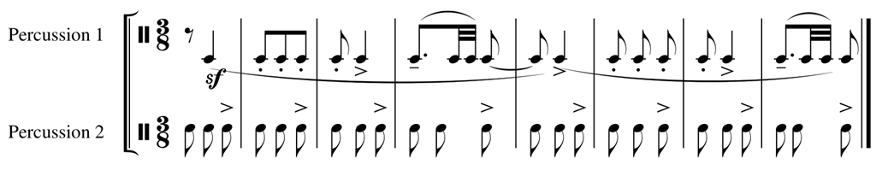

**MELODY**The work is in B minor, but the melodies are based on F# Dorian mode. The time signature is 3/8.

**Activities for this Lesson**

1. Sing the melodies in the original key signature:

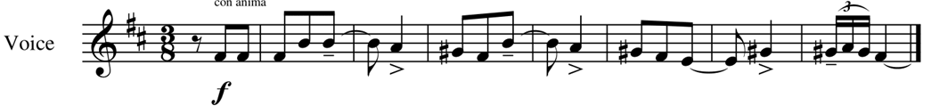

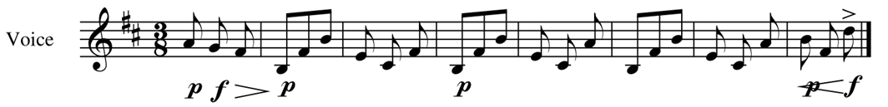

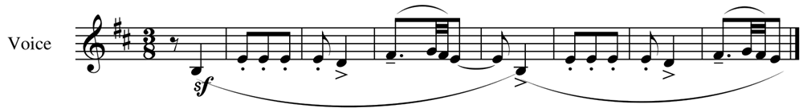

2. Now, together*.*

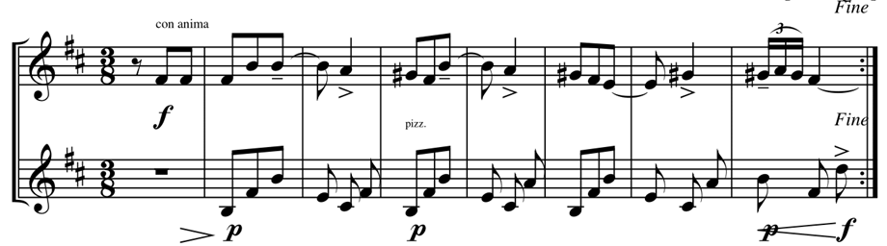

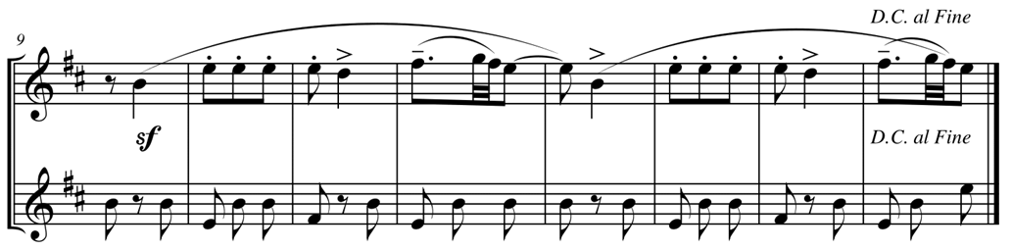

And finally, you can use any instrument for accompaniment (such as clapping, for example).

**LESSON 3**

**MAIN IDEAS FOR INTERPRETATION**

* The fingerings are optional. You can adapt the piece to your students in the way they need.
* Think about your students' level and choose the voice.
* If it’s needed you can adapt some of the voices.
* Think clearly about the rhythm.
* Accent the first beat of the measure.
* Play the melody with direction.
* Play the ornamentation clearly.