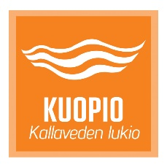



INVITATION
We are delighted to invite
teachers and students from your school

to attend the second meeting of the Erasmus + project :
Human Rights Education
stand up for your rights

which is going to be held in
Kallaveden lukio Kuopio FINLAND

from 15th to 19th January 2018

The headmaster of the host school The contact teachers
Heikki AALTONEN Hanne Lyytinen
Jari Simonen
Jutta Mäkisalo

