# **history the sea; driving force behind civilisation**

# 

# **PEOPLe ARrIVE IN IRELAND BY BOAT**

# The first people in Ireland are thought to have crossed from Scotland, in wooden boats, to what is now county Antrim around 8000 BC.

# The Girona

In 1588 the Girona, one of the largest ships of the Spanish Armada, was wrecked on a jagged reef near Dunluce Castle. After their defeat in the English Channel the Spanish fleet was forced to flee the long route home, around Scotland and Ireland.

**The Seafaring Irish Ireland has the largest percentage of coastline in Europe, in fact, there are few spots in Ireland more than miles from water.**

The fact is that the early Irish were a seafaring race is revealed in ancient manuscripts, and confirmed by modern archeology. From as early as 7000 BC, Ireland’s settlers came across the seas; from the Fir Bolg, who escape from Greece in boats made of wood and leather, to the Celts of Iberia, who came in a fleet of ships with which they traded along the coast of Europe.

saints and scholars integrated primary school and nursery unit

Keeping Healthy at Saints and scholars ips

Scholars IPS Armagh

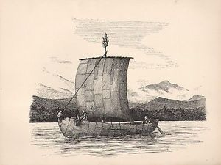

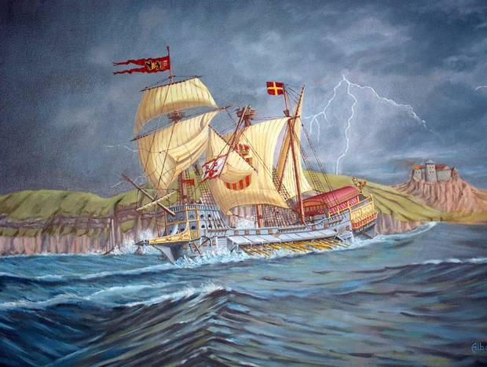

# Northern Ireland is home to some of the most spectacular beaches in Europe. The naturally stunning formations of the coastline provide long stretches of golden sand and impressive sand dunes.The **Northern Ireland** coastline is one of Britain's hidden gems, with over two hundred diverse kilometers in the care of the National Trust, much of it contained within one of two *Areas of Outstanding Natural Beauty*.

# 

Northern Ireland's coast has been shaped by a long and troubled history, but perhaps surprisingly the recent troubles have protected it. 30 years of neglect have saved it from some of the less desirable consequences of tourism and development. But now, as Northern Ireland gears up to make the most of its coastal attractions, this stunning landscape faces new challenges.

Today the Antrim Coast road remains one of the most unique and scenic coastal drives in the UK.

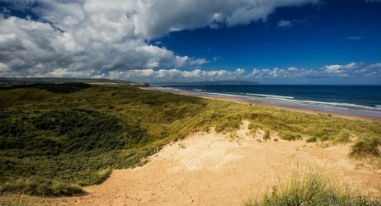

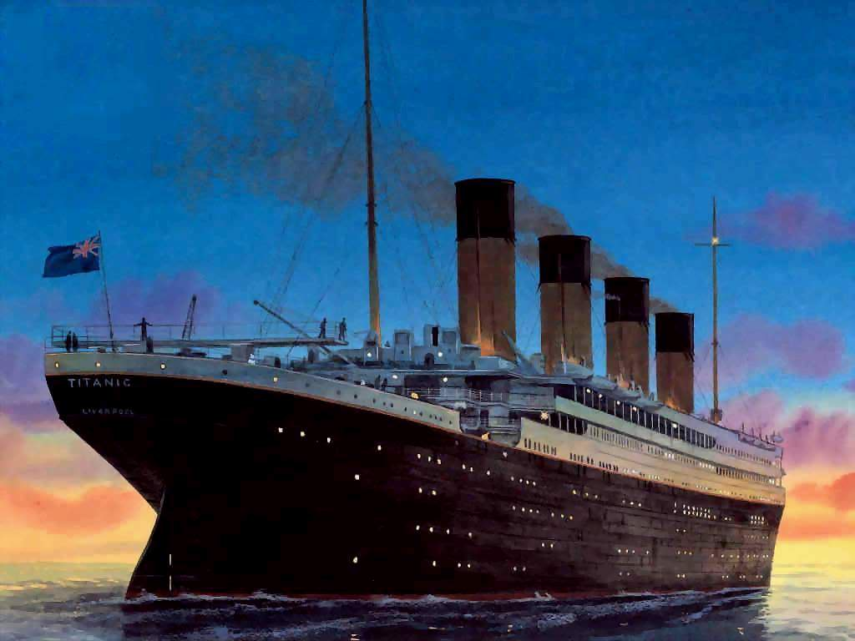

# RMS Titanic was a [passenger liner](https://www.bing.com/search?q=Superliner+(passenger+ship)%20wikipedia) built in Belfast that [sank in the North Atlantic ocean](https://www.bing.com/search?q=Sinking+of+the+RMS+Titanic%20wikipedia) in 1912, after colliding with an [iceberg](https://www.bing.com/search?q=Iceberg%20wikipedia) during her [maiden voyage](https://www.bing.com/search?q=Maiden+voyage%20wikipedia) from [Southampton](https://www.bing.com/search?q=Southampton%20wikipedia) to [New York City](https://www.bing.com/search?q=New+York+City%20wikipedia). Of the [estimated 2,224 passengers and crew](https://www.bing.com/search?q=Sinking+of+the+RMS+Titanic+Casualties+and+survivors%20wikipedia) aboard, more than 1,500 died, making it one of modern history's deadliest commercial [marine disasters](https://www.bing.com/search?q=List+of+maritime+disasters+in+the+20th+century+Peacetime+disasters%20wikipedia) during peacetime.

The fun things to do at a beach in Northern Ireland

**My favourite things to do at a beach**

1. Bury my parents in sand.
2. Build sandcastles.
3. Swim in the sea and splash my sister in the sea.
4. Sunbathe on the soft sand.
5. Eat delicious ice-cream

Donkey rides

P6 had a fund day at the beach

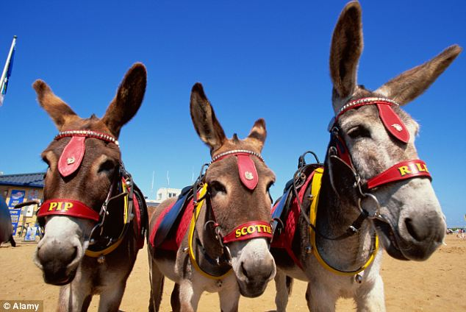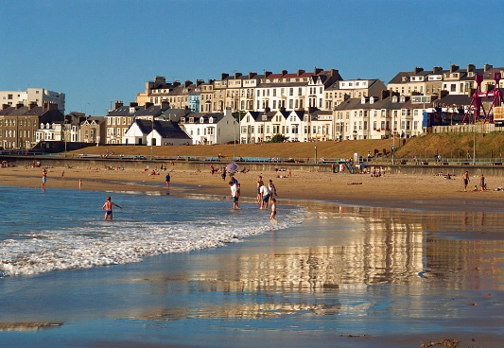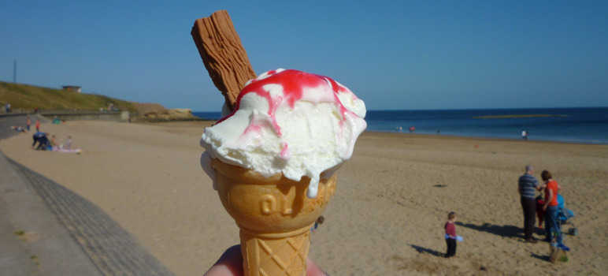[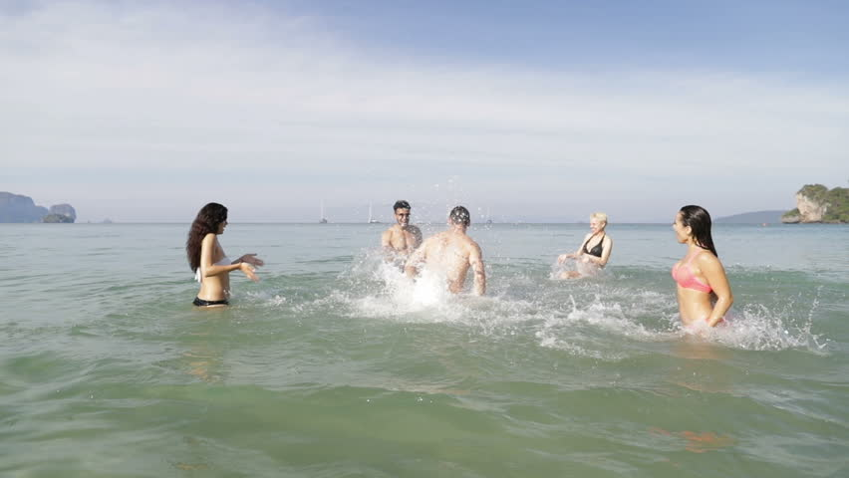](https://www.google.co.uk/url?sa=i&rct=j&q=&esrc=s&source=images&cd=&cad=rja&uact=8&ved=2ahUKEwjKj7P8n_zeAhVoLMAKHVRbCMUQjRx6BAgBEAU&url=https://www.shutterstock.com/video/clip-28235944-people-splashing-water-on-man-cheerful-young&psig=AOvVaw2fe1GCA0KVcQWmnBFkkV6G&ust=1543671608789483)