TEST & TRAIN 2025

Part 3

The natural world

Part 3 contains seven sections with reading comprehensions, listening comprehensions and vocabulary exercises related to the natural world. Keys to exercises can be found in a separate document.

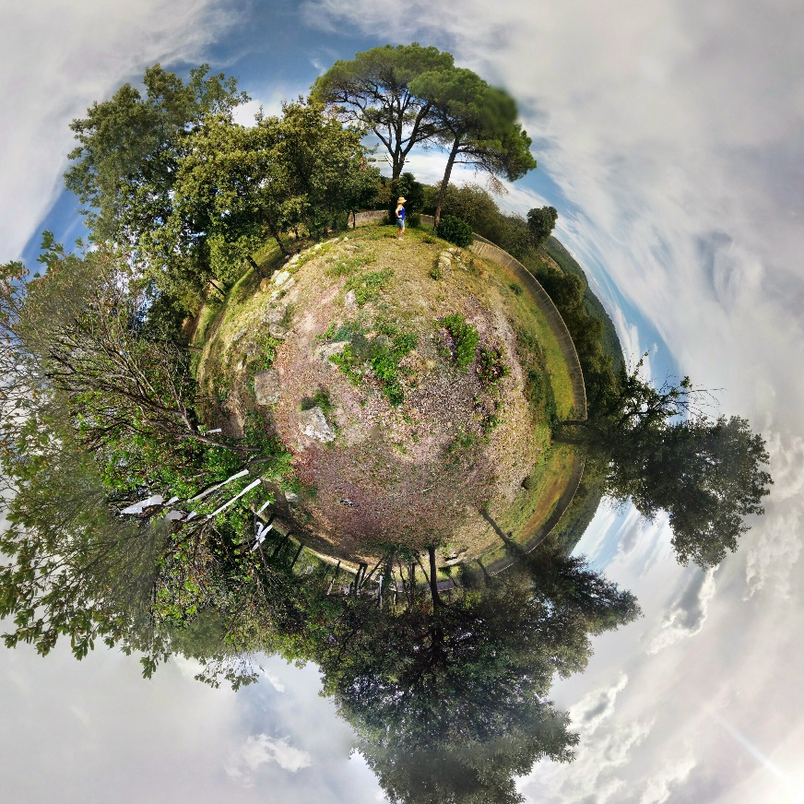
Image from Pickpik

1) Agroforestry and biodiversity

Exercise 1
Read the text and choose the best alternative.

Agroforestry boosts rice and biodiversity in India

For the farmers of the village of Bhattadighi, paddy cultivation is not about modern industrialized monoculture farming, but developing multi-crop diversity. Here, miles of tender rice plant seedlings stretch out amid a maze of sprawling trees, shrubs and vines that conjure the appearance of a forest: Dhaan Bagan, or paddy garden, as locals call it.

But the trees aren’t there just as scenic dressing. “With forest covers dwindling and giving way to agricultural lands, such landscapes can largely compensate for environmental loss and mitigate climate change impacts,” says Om Prakash Chaturvedi, director of the Central Agroforestry Research Institute. Trees also help retain moisture in the soil and put a check on erosion from storms and gales, he says.
Biodiversity also flourishes in these diverse croplands. In West Bengal in October, golden yellow butterflies could be seen, while a fork-tailed black drongo bird made its presence felt with raucous calls from atop miniature scaffolds supporting gourd vines. Nearby, egrets strutted around the watery fields, occasionally popping their heads in and out of the paddy seedlings, the young rice plants that haven’t sprouted grain yet, as a group of black-and-white myna birds hopped merrily on Sesbania pea plants.

Edging the fields were trees like papaya, mango and banana, which provide nesting sites for migratory avian guests from the nearby Kulik Bird Sanctuary — Asian openbill storks, cormorants, herons and egrets, which also forage in the ponds.

“Birds, insects and butterflies seem to love our fields as there is no trace of chemical fertilizers or pesticides in them. Our paddy is of indigenous, folk variety,” says Chinmoy Das, a farmer from Hatia village in North Dinajpur. The trees and shrubs planted in and around the fields form an essential ecosystem developed with the right mix of multi-utility plants that also provide excellent perches for predatory birds, Das says.

Like Das, more than 1,000 farmers from across 11 districts of West Bengal have taken to organic cultivation of folk rice varieties (FRVs). Unlike modern, high-yielding varieties of rice, FRVs can to a great extent withstand weather aberrations due to climate change, while also cutting down on costs. Anupam Paul, director of the Agricultural Training Centre (ATC) at the West Bengal Agriculture Department, has helped revive more than 420 indigenous varieties of rice from the brink of extinction, with nearly 300 varieties of FRVs now grown by farmers across the state. These include 40 strains of aromatic and red rice each, 25 kinds of fine paddy, 10 high-yielding indigenous types, and 12 deep-water paddy varieties, among others.

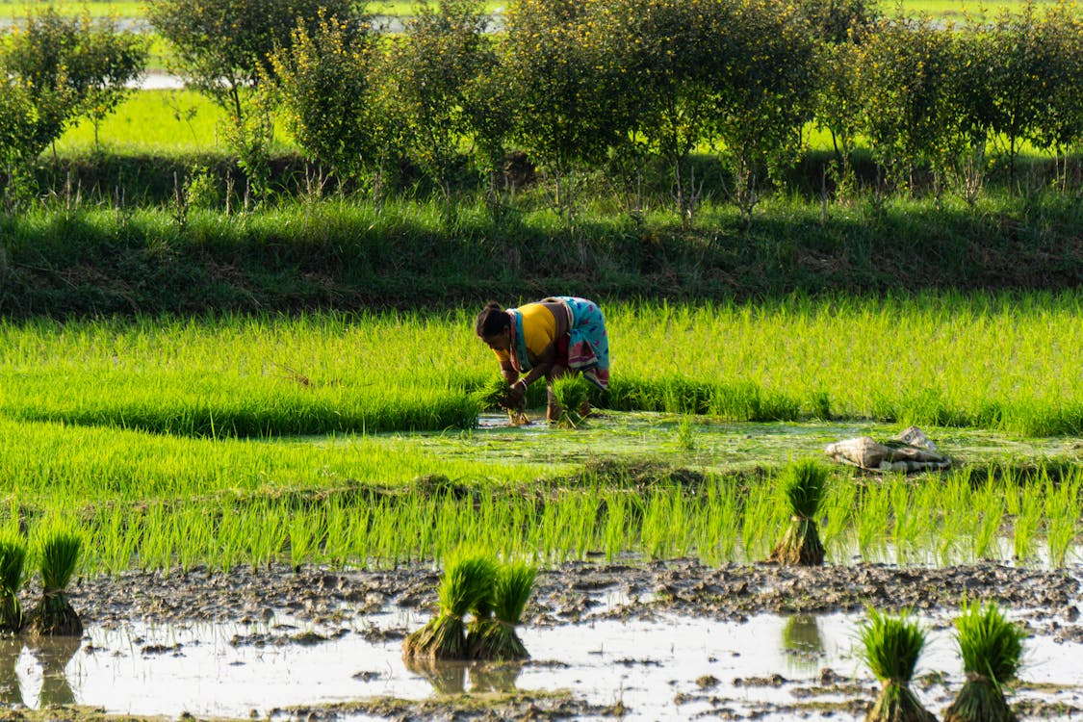
Image from Pexels

To achieve a sustainable rice yield, local farmers make their own organic fertilizers. Madanmohan Aich, from Dewanhat village in Cooch Behar district, recounts the recipe for his liquid organic manure: soil, preferably from his agroforest; leaves from at least five pest-repellant plants he grows; plus cow manure and more. Leguminous plants are thrown in to maintain the natural health of the soil.

Sesbania seedlings are planted at a regular distance of 60 to 90 centimeters from each other across the field, and 30 to 45 centimeters away from paddy seedlings. They can withstand waterlogged soil, growing rapidly, and their leaves form an excellent green compost that enriches the soil. They also serve as a “catch crop” whose bright yellow flowers attract insect pests away from the paddy plants.

In Pratappur village, Bardhaman district, the farmers also practice aquaculture in their paddy ponds, where they grow FRVs that require at least 1.8 meters of standing water. Enterprising farmers like Abhro Chakroborty make the most of the ponds to cultivate catfish. His 200 square meters of land yields 60 kilograms of paddy and almost as much catfish, he says. Edible crabs, mollusks and carp have also been introduced into these ponds, amid the floating edible water spinach and the useful and sturdy mat grass.

Text adapted from: https://news.mongabay.com/2017/12/agroforestry-boosts-rice-and-biodiversity-in-india/

1. How is the importance of trees explained?
- Trees contribute to climate change
- Trees improve crop yield
- Trees provide wind protection

2. Why are butterflies, egrets and papaya trees mentioned?
- To highlight the range of animal and plant life in the region
- To paint a vivid picture of what the region looks like
- To explain how animals and plants depend on each other

3. Which of the following statements is true about paddy cultivation?
- The plants surrounding the paddy fields serve multiple purposes
- Indigenous paddy farmers do not use agricultural chemicals
- Birds pose a significant threat to paddy cultivation

4. What is characteristic of folk rice varieties (FRVs)?
- Growing FRVs is laborious for farmers
- FRVs produce a diverse range of new rice types
- FRVs are resilient to weather extremes

5. Which picture shows an ingredient a local farmer would use to produce a fertiliser?

- b) c)
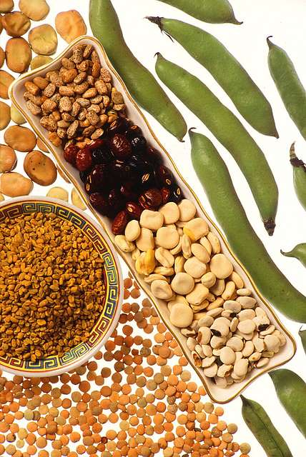
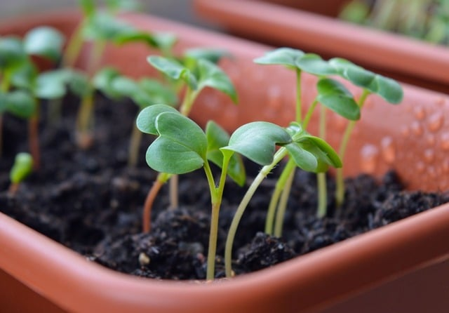


All images from Picryl

6. What is said about Sesbania seedlings?
- They should not be planted too close to the paddy plants
- They rapidly develop colourful flowers
- Their foliage fertilises the ground

7. Which picture shows a creature that would be unlikely to appear in a paddy pond?
- b) c)
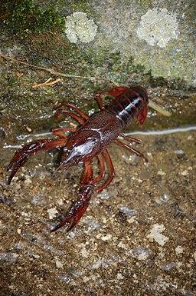
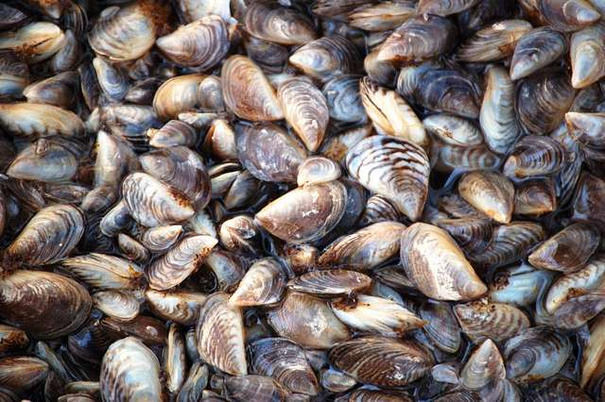
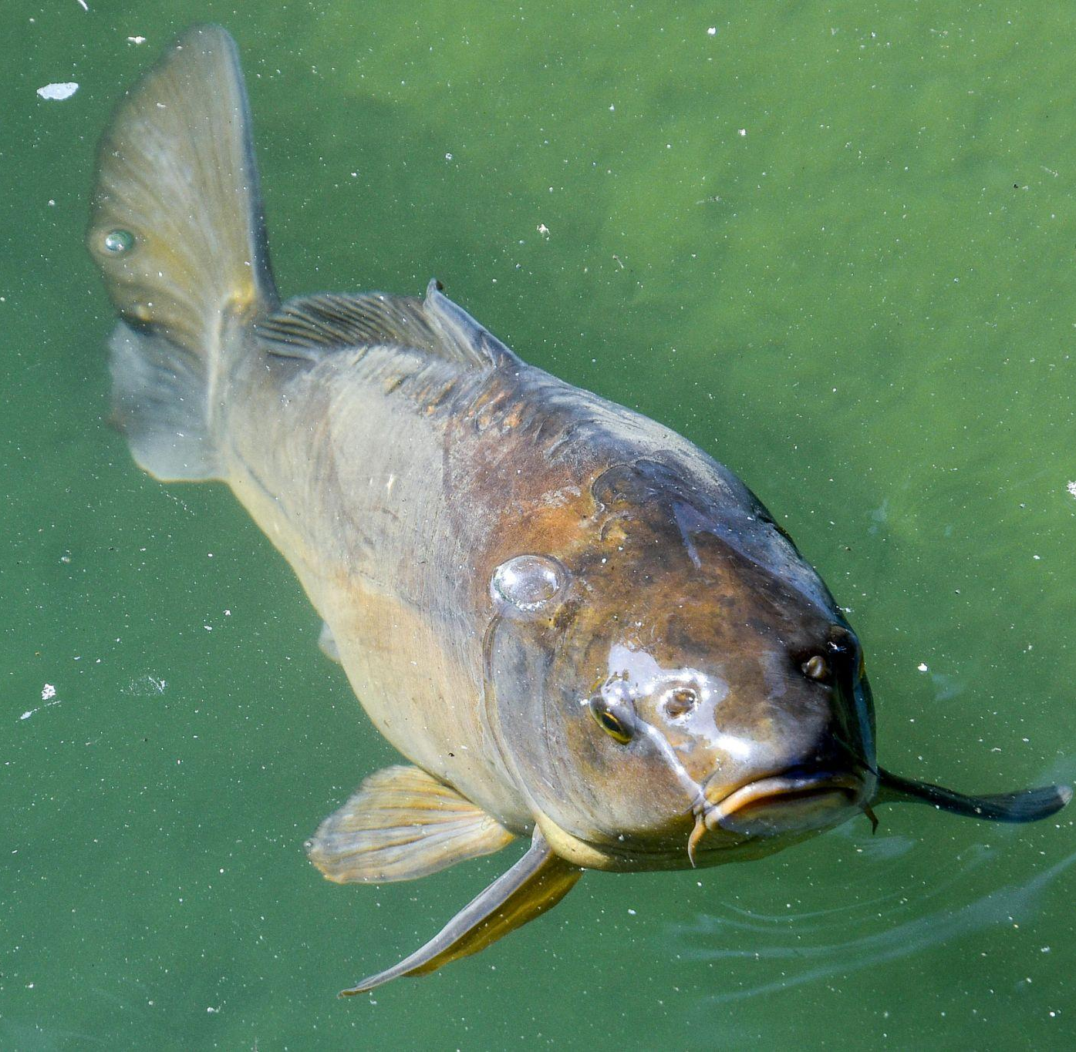

Image A from Picryl, Image B from Wikimedia Commons, Image C from Pexels

Exercise 2
Prefixes are small word parts that give clues about the meaning of a word. If you know the prefix, you can often guess what a word means. Many prefixes come from Latin and Greek.

The text in Exercise 1 contained the prefixes: agri/agro, aqua/aque, bio, eco, mono and multi. Match the prefixes with the correct definition and write at least three words for each prefix.

- ______________________________________________________________________
= water
- ______________________________________________________________________
= connected with the environment or nature
- ______________________________________________________________________
= of or relating to farming and raising stock
- ______________________________________________________________________
= many
- ______________________________________________________________________
= one
- ______________________________________________________________________
= concerning or associated with life

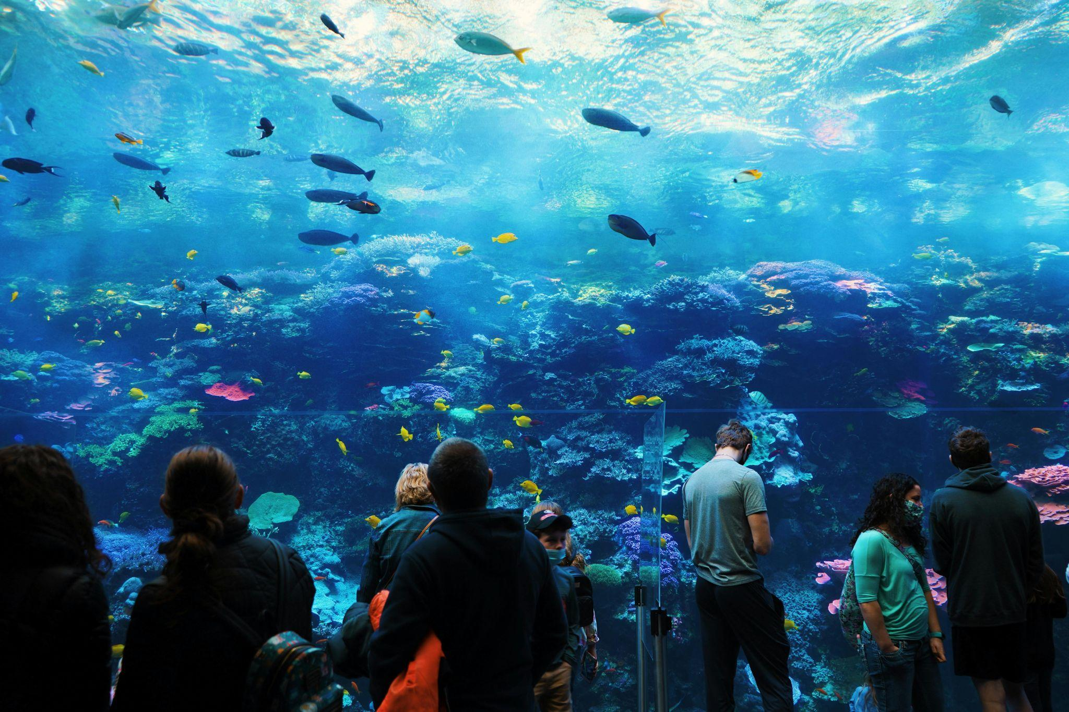
People Visiting an Aquarium (Image from Pexels)

Exercise 3
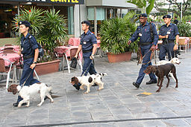
The following adjectives derive from Latin. Study the words and their meanings and then complete the sentences.

arboreal = living in/related to trees
avian = related to birds
canine = related to dogs
feline = related to cats
marine = related to the sea
nocturnal = active at night
terrestrial = living on land
urban = related to a city
Image from Wikimedia Commons

- Unlike fish, most mammals are ___________________________________ animals that live on land.
- The tiger is one of the largest ___________________________________ predators in the world.
- Many monkeys are ___________________________________ and spend most of their lives in the trees.
- Bats are ___________________________________ creatures that sleep during the day and hunt at night.
- The zoo has a special section for ___________________________________ species, including parrots and eagles.
- Coral reefs support a wide variety of ___________________________________ life.
- The police trained the ___________________________________ unit to search for missing people.
- ___________________________________ gardening projects are helping city residents reconnect with nature and support local biodiversity.

Exercise 4A
Normally, you make the plural form of a noun by adding an -s, but nouns that derive from Latin sometimes have irregular plural forms. Complete the sentence with the plural form of the nouns given in parentheses/brackets.

- Recent ____________________________ of soil samples have shown that organic farming methods increase microbial biodiversity. (analysis)
- ____________________________ play a vital role in forest ecosystems by forming symbiotic relationships with plant roots. (fungus)
- Climate change and habitat destruction are ___________________________ that threaten the survival of countless plant and animal species. (phenomenon)
- The presence of butterfly ____________________________ in the restored meadow indicates the success of the native plant cultivation efforts. (larva)
- ____________________________ are being cultivated in arid regions both for their resilience to drought and their role in preserving desert biodiversity. (cactus)
- Environmental science ____________________________ now include hands-on conservation projects to help students understand biodiversity loss. (curriculum)
- Many ____________________________ of the university’s agricultural program now lead sustainable farming initiatives across the country. (alumnus)
- Global biodiversity ____________________________ have prompted conservationists to focus on protecting endangered habitats and species. (crisis)

- ____________________________ of plant cells were examined under a microscope to study genetic variation in species being cultivated for conservation purposes. (nucleus)
- Conservationists used GPS data to map changes in forest cover along different ____________________________ of the region. (axis)
Exercise 4B
Work with a partner and orally translate the sentences in exercises 4A into Finnish. Use a dictionary to help you out.

Exercise 4C
Give the plural form of the nouns.

- one berry many _______________________
- one bus many _______________________
- one calf many _______________________
- one child many _______________________
- one die many _______________________
- one foot many _______________________
- one fox many _______________________
- one goose many _______________________
- one hero many _______________________
- one Japanese many _______________________
- one life many _______________________
- one mouse many _______________________
- one ox many _______________________
- one salmon many _______________________
- one sheep many _______________________
- one spacecraft many _______________________
- one tooth many _______________________
- one woman many _______________________

2) Living with wild animals

Exercise 1
Listen to the recording “Cormorants: The Bird Everyone Loves to Hate”. Read the questions carefully and choose the best alternative.

1. Why do Finns dislike the cormorant?

- The commercial fishery catch is plummeting
- Cormorants attract pests to Finnish cottages
- Vegetation in the Finnish archipelago is being destroyed

2. How could the eagle help solve the problem?

- By disrupting the cormorants’ mating rituals
- By enabling other birds to eat the cormorants’ eggs and chicks
- By scaring away the cormorant colonies

3. What is said about the results?

- Since 2015, the number of cormorants in Finland has been steadily decreasing
- Since 2015, the cormorant population has been stagnant
- Since 2015, Finland’s cormorant population has been on the decline

Text adapted from:
https://yle.fi/a/7-1076975
https://www.dailyfinland.fi/national/28402/White-tailed-Eagles-affect-Great-Cormorants-in-Baltic-Sea

Exercise 2
Read the text and choose the best alternative.

Can donkeys really protect against wolves?
An unprecedented number of wolves have been observed in southwestern Finland this winter and farmers are trying a novel method to protect their livestock. Instead of relying on guardian dogs, some farmers are opting for donkeys.

As it turns out, donkeys are excellent guardians of sheep, goats and cattle, especially in small and level pastures, where they can see all or most of the area from one location. Donkeys rely predominantly on sight and sound to spot intruders. Their loud brays and quick pursuit scare away predators and may also alert the shepherd. When attacking, the donkeys rise up on their hind legs and strike with both front feet. A solid blow can injure, kill or at the very least discourage potential predators.

Jaana Lehtinen is one of the sheep farmers in Finland who have started using guardian donkeys. According to Lehtinen, donkeys have an inherent dislike and aggressiveness towards canine animals. With sheep, however, they “get on like a house on fire.” As per recommendation, Lehtinen uses a gelding (a female) that she has named Dolly. It took about five weeks for Dolly to bond with the sheep.

Thanks to the donkey’s natural herding instinct, they are very likely to bond with the sheep and work hard to protect them from predators. However, just like any other livestock guardian animal, donkeys require proper training and management to be effective and training donkeys can actually be more challenging than training dogs. Contrary to donkeys, dogs have a long history of working alongside humans and have been selectively bred for guarding purposes. Despite the donkeys’ natural instinct to protect, training the donkeys consistently can be harder because their instinct may be unpredictable.

So far, Lehtinen has not experienced any problems with Dolly. She is confident that if a wolf approaches, Dolly will keep her sheep out of harm’s way.

1. Donkeys are good at guarding cattle because they can
- quickly run for help if wolves appear
- easily kill predators with a forceful kick
- frighten intruders by emitting a loud sound

2. In what kind of environment do donkeys work best?
- b) c)
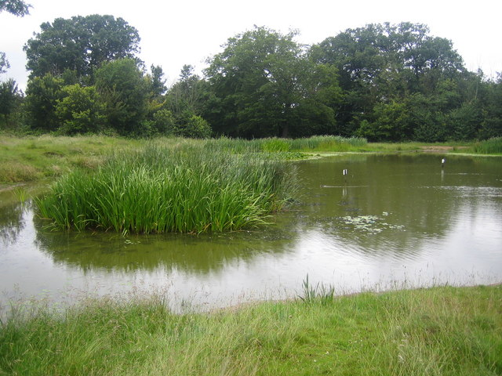
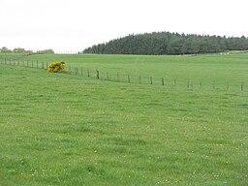
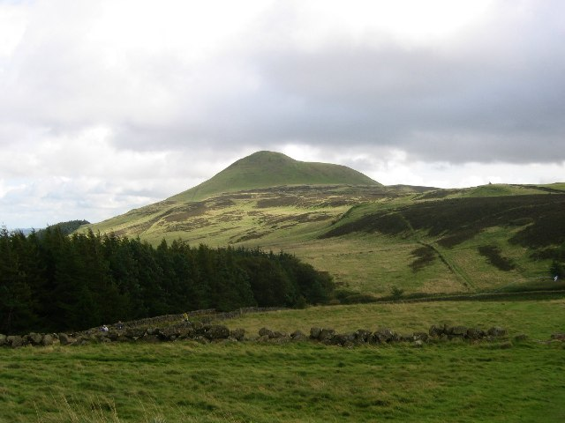
All images from Wikimedia Commons

3. Compared to dogs, donkeys may
- take longer to train
- work harder
- be more unpredictable

4. According to the text,
- donkeys have an aversion to dogs
- dogs are genetically predisposed to herding
- wolf sightings in southwestern Finland have increased

Text adapted from:

https://yle.fi/a/74-20138298
https://www.ontario.ca/page/guidelines-using-donkeys-guard-animals-sheep
https://www.daf.qld.gov.au/__data/assets/pdf_file/0005/76982/IPA-Wild-Dog-Fact-Sheet-Livestock-Guardian-Dogs.pdf

Exercise 3
Read the text and answer the questions in Finnish.

Pest control
Pests that are harmful to food or hygiene include for example beetles, flying insects, larvae, ants, spiders, rodents, and birds. All pests are harmful because they spread disease and contaminate and spoil food or its packaging. Birds such as pigeons, seagulls and sparrows can cause problems in unloading, loading and disposal areas in addition to animal sheds and feed rooms if they have food, resting or nesting sites. Certain pests such as silverfishes, fur beetles and cockroaches do not usually live in food, but they can indirectly contaminate food. They must be controlled throughout the property.

Food pests
Food pests include beetles and flying insects that live in food at some stage in their lives. Pests are a particular problem for dry products such as cereals, cereal products, dried fruits, nuts, and spices. Different foods have their own typical pests. Pests thrive and multiply at room temperature. They are not toxic or spread infectious diseases, with the exception of German cockroaches, which can spread salmonella. However, food pests eat food and spoil it with their faeces.
Pest prevention includes ensuring that:
- warehouses containing dry goods are well ventilated
- doors and windows are closed
- food premises are well organized and clean
- the products are closed and protected, for example with lids
- the storage temperature is below +18 ° C
- products are not stored outdoors
- waste is disposed as soon as possible
- incoming goods are checked.

Signs of pests
It is possible that rodents have visited if gnawed packages and faeces are visible. Holes, larvae, cocoons, webs and dead insects in products, packaging, walls, or machinery are signs of pests and should be checked at the latest.

Disposal
If pests are detected, the aim is to find out the type and extent of the problem, i.e., what kind of pests they are, how they have entered the food department and how widespread they are.
Flying insects can be controlled with electric traps. Mice are controlled with traps and bait boxes and rats with bait boxes. In the control of rodents, birds, fur beetles and cockroaches, it is good to ask for professional help. Contaminated goods must be disposed of and products that appear clean can be frozen to ensure food pests cannot reproduce there. Dry food, also unopened packaging, should be inspected for pests. For example, cupboards where pests have been found should be emptied and the apartment should be cleaned thoroughly.
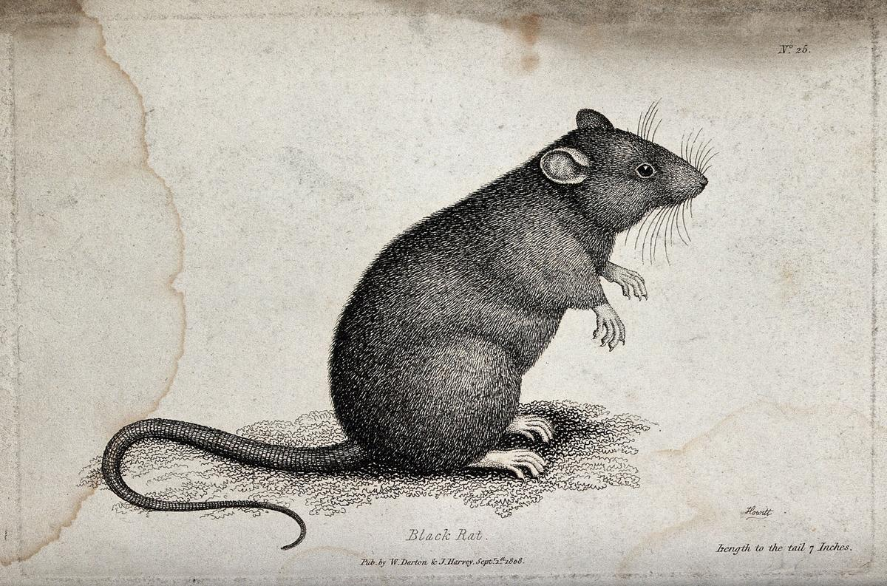
A black rat sitting upright on the ground. Etching by W. S. Howitt (Rawpixel)

Text adapted from:
https://www.helsinki.fi/en/projects/urban-rats/news-archive/finnish-rats-are-not-resistant-to-rodenticides
https://antitec.fi/pests/rodents/?lang=en
https://www.ruokavirasto.fi/en/foodstuffs/food-sector/tilat-ja-valineet/pest-control/

1. Miksi torakoiden torjuntaan pitää ryhtyä? Miksi torakoita pitää torjua? Vastaa kysymykseen suomeksi. Vastauksen pituus on enintään 50 merkkiä.

______________________________________________________________________
2. Mitä voi tapahtua, jos elintarvikkeita säilytetään huoneenlämmössä? Vastaa kysymykseen suomeksi. Vastauksen pituus on enintään 50 merkkiä.

______________________________________________________________________
3. Mitä (haittaeläimen) ulosteen esiintyminen voi tarkoittaa? Vastaa kysymykseen suomeksi. Vastauksen pituus on enintään 50 merkkiä.

______________________________________________________________________
4. Millä keinoilla rottia torjutaan? Vastaa kysymykseen suomeksi. Vastauksen pituus on enintään 50 merkkiä.

______________________________________________________________________

Exercise 4
Complete the sentences by translating the word in parentheses/brackets into English.

- Sweden and Finland are located near ________________________________, a large body of water in Northern Europe. (Itämeri)
- The bird built its ________________________________high up in the tree. (pesä)
- Mice, rats, and squirrels are examples of _______________________________ commonly found in many parts of the world. (jyrsijöitä)
- The female animal cared for her ________________________________until they were old enough to survive on their own. (jälkeläisiään)
- Farmers protect their sheep from ________________________________ like wolves, which sometimes attack the flocks at night. (petoeläin)
- The farmer had to find a way to control the ________________________________that were damaging his crops. (tuhoeläimiä)
- The _______________________________is still a protected species in Finland. (merimetso)
- Finland is known for its beautiful ________________________________. (saaristo)
- Animal ________________________________ can carry harmful bacteria and should be cleaned up carefully. (uloste)
- Many animals can ________________________________ several times a year, giving birth to large numbers of young. (lisääntyä)
- Pine and spruce are examples of ________________________________, which keep their needles year-round. (havupuut)
- In the autumn, the leaves of ________________________________change colour and eventually fall off. (lehtipuut)
- Landfills can ________________________________ drinking-water if they are not properly constructed. (saastaa)
- Farmers feed kitchen ________________________________ to the pigs. (jätteitä)
- Villagers herded the ________________________________ to high ground to keep them safe during the floods. (karjaa)

Exercise 5
Choose the correct alternative.

- The guinea pig / house mouse / porcupine is a small rodent that is often kept as a pet and is known for its gentle nature and high-pitched sounds.
- The brown rat / beaver / muskrat is a large rodent known for building dams and lodges from wood and mud in rivers and streams.
- The mole / muskrat / lemming is a semi-aquatic rodent that lives near ponds, lakes, and rivers, and builds its home from plants and mud.
- The shrew / wood mouse / brown rat is a tiny insect-eating mammal that looks like a mouse but is not a rodent.
- The beaver / squirrel / prairie dog is a small, burrowing rodent that lives in large colonies on grasslands and communicates with others using different sounds.
- The cockroach / vole / hedgehog is an insect that can survive in many environments and is often considered a pest in homes and buildings.
- The vole / beetle / mole is a small mammal that lives underground and uses its strong front paws to dig tunnels in the soil.

Exercise 6

Complete the descriptions of the birds by choosing a name from below. There is one extra name.

crane eagle owl tawny owl
goose heron whooper swan
gull mallard white-tailed eagle
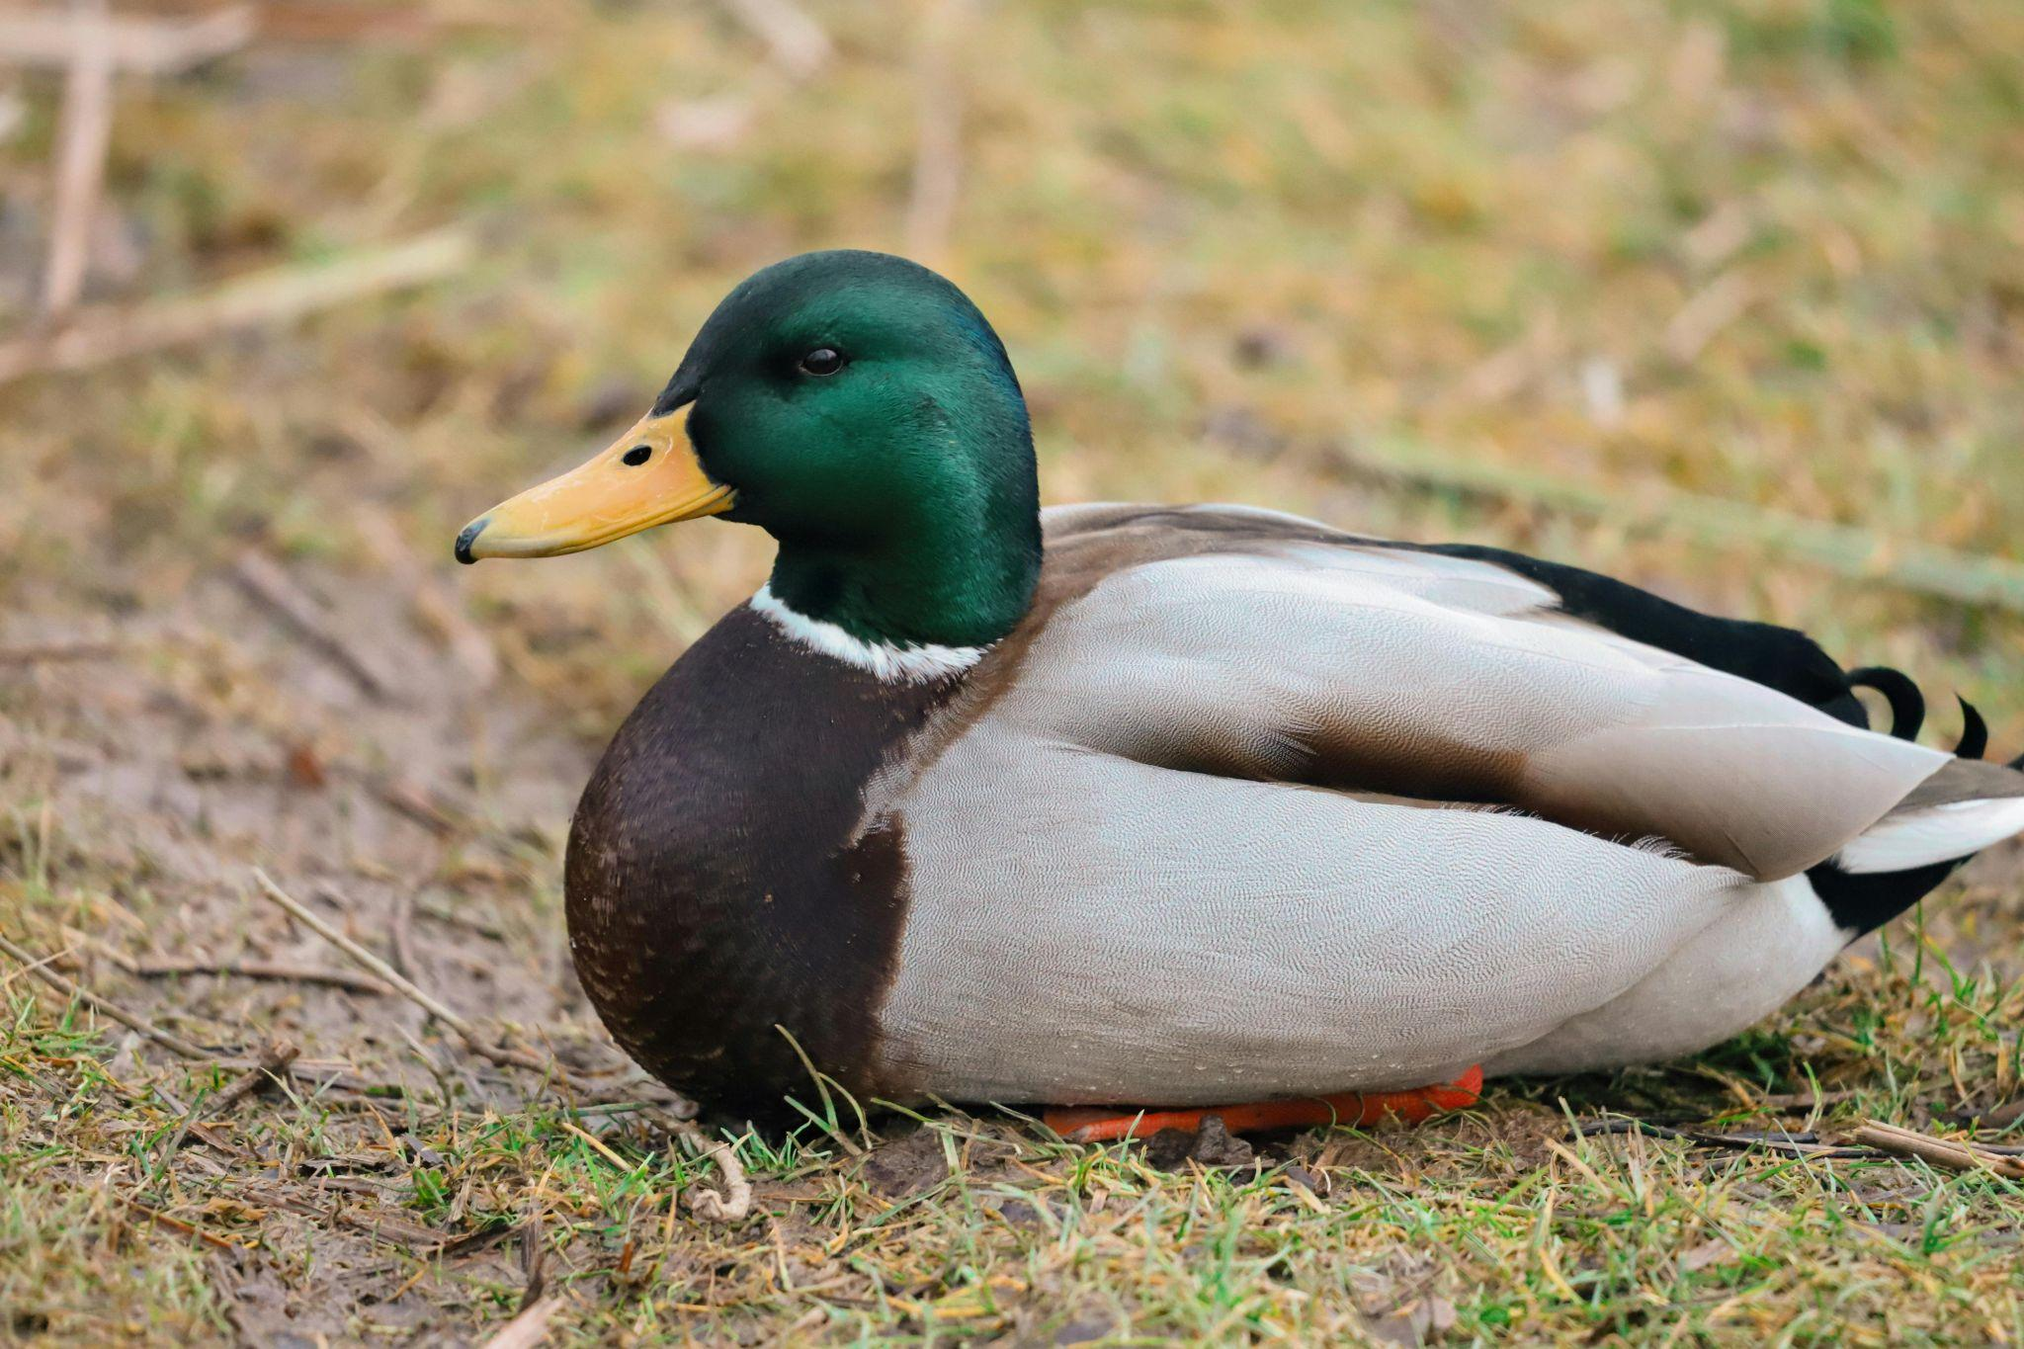

1

The ________________________________ is Finland's most common duck, and also the country's most widely hunted bird, with as many as half a million birds hunted in peak years.

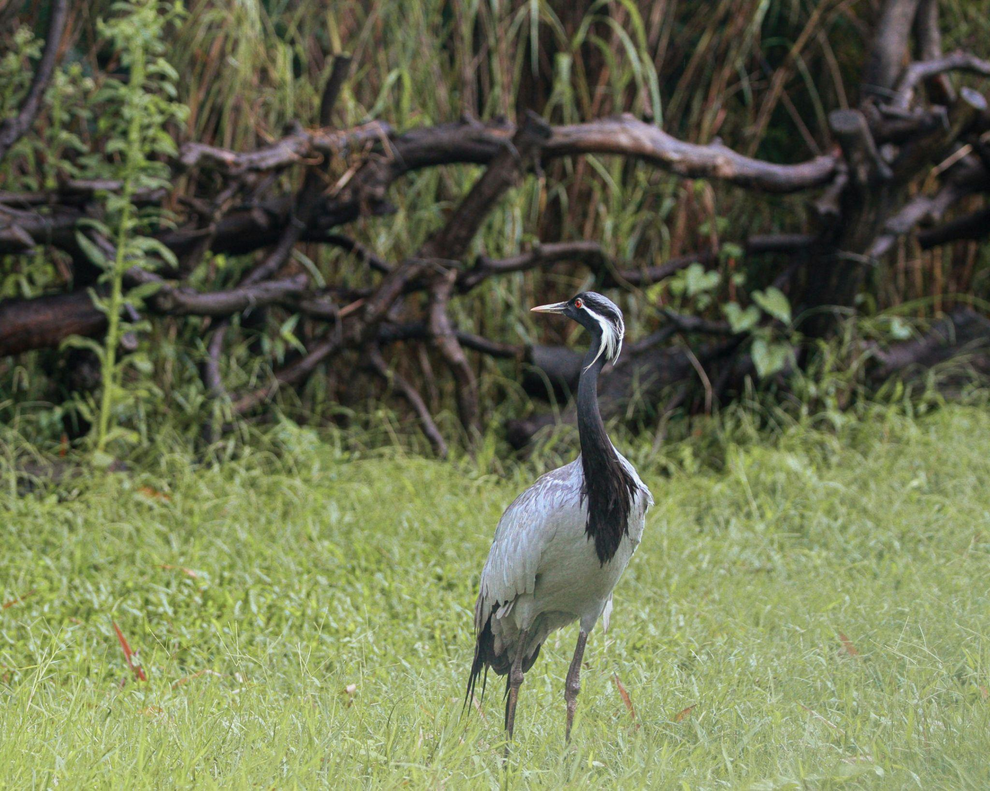

2

Very large, long-necked and long-legged birds, mainly grey in colouring. The ________________________________ are recognised by their enormous v-shaped flight formations when migrating in spring and autumn.

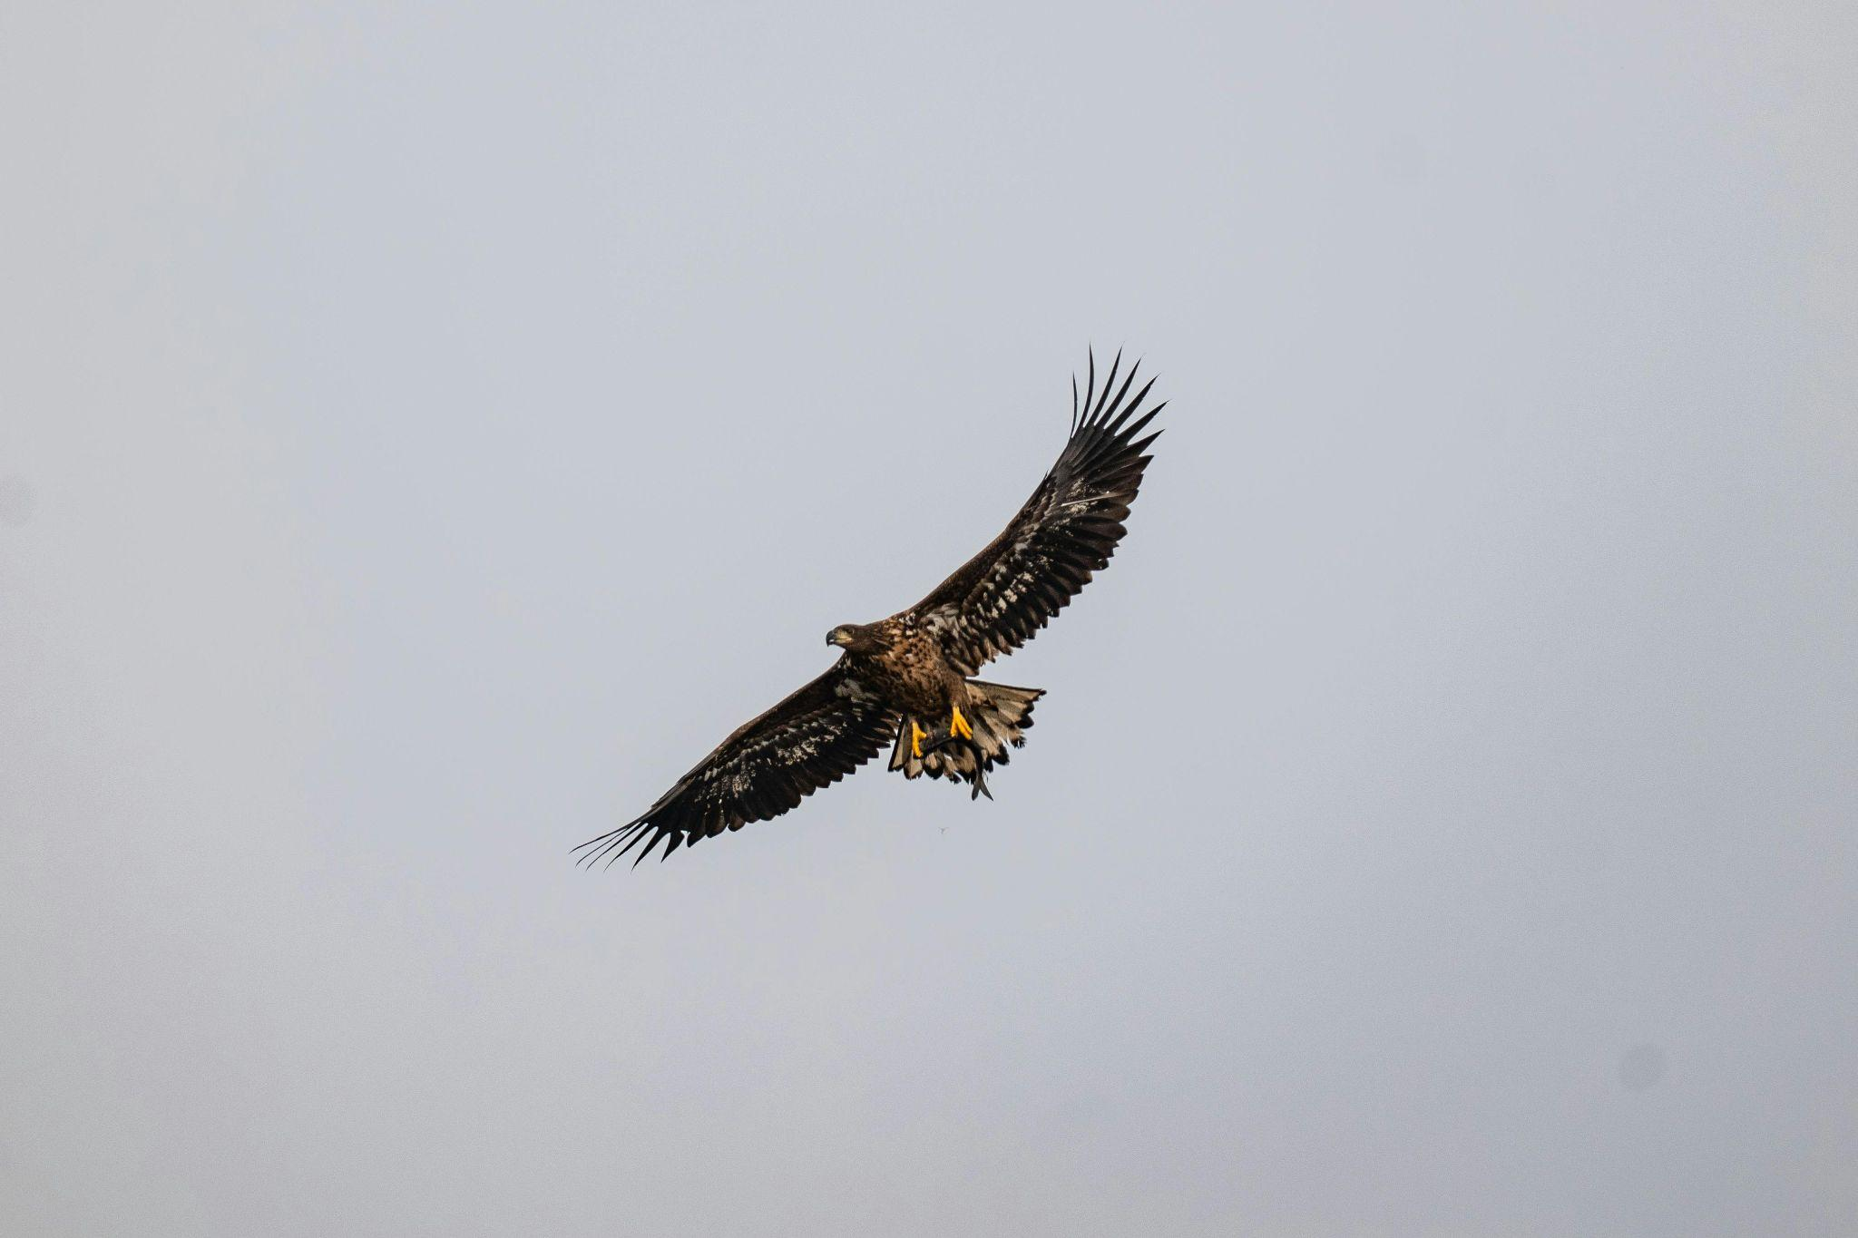
3

In the 1960s and 1970s, the population of the Baltic Sea was on the brink of extinction, but now the ______________________________ is a prominent bird of prey on the shores of the Baltic Sea and the archipelago.

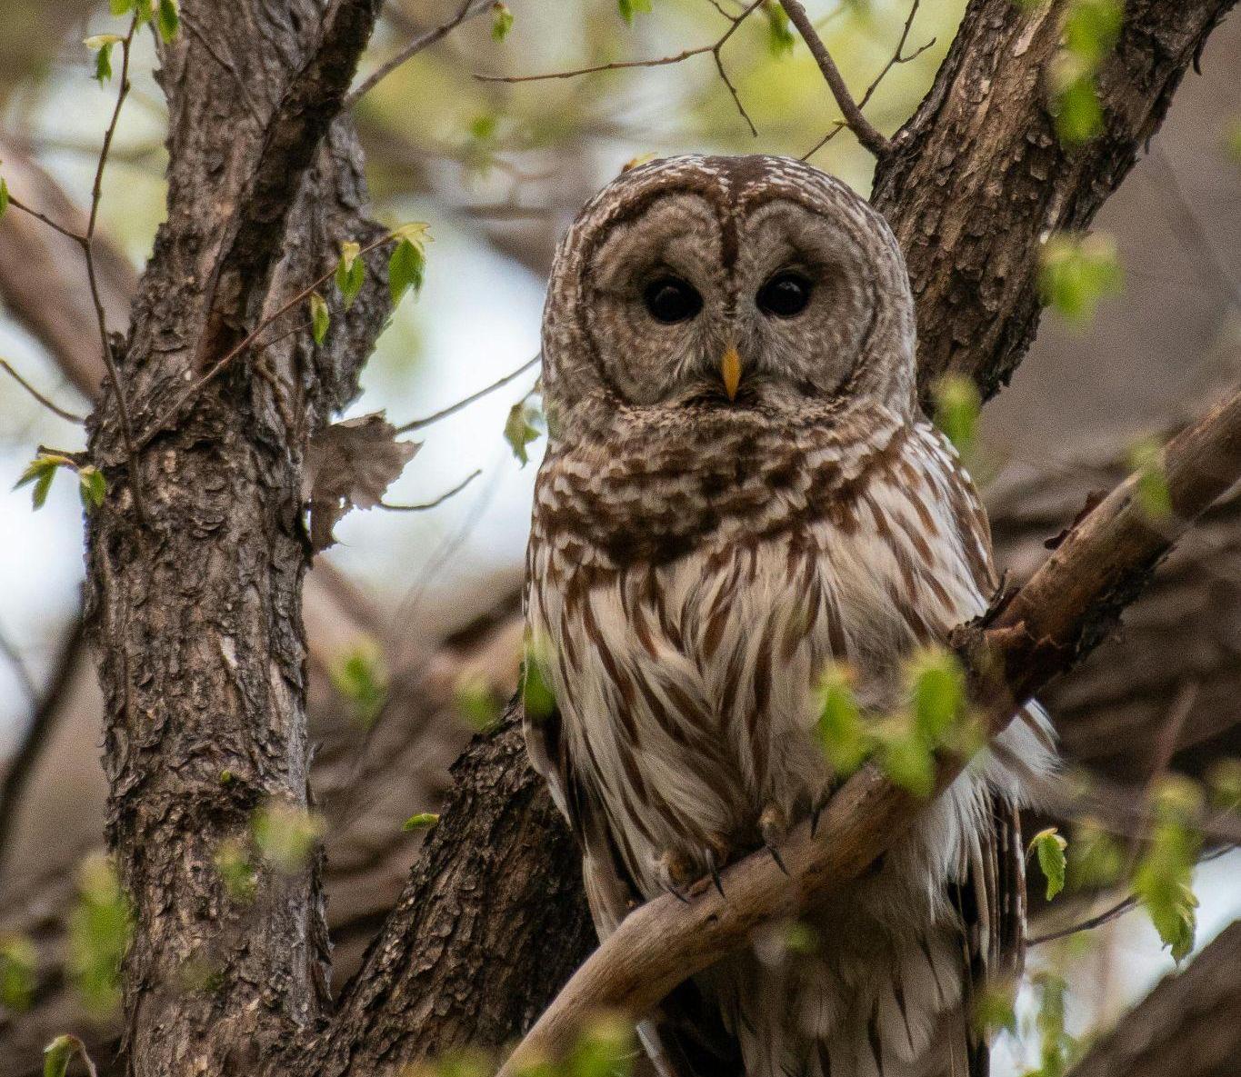

4

The ________________________________ is a nocturnal bird of prey. It is able to hunt successfully at night because of its vision, hearing adaptations and its ability to fly silently.

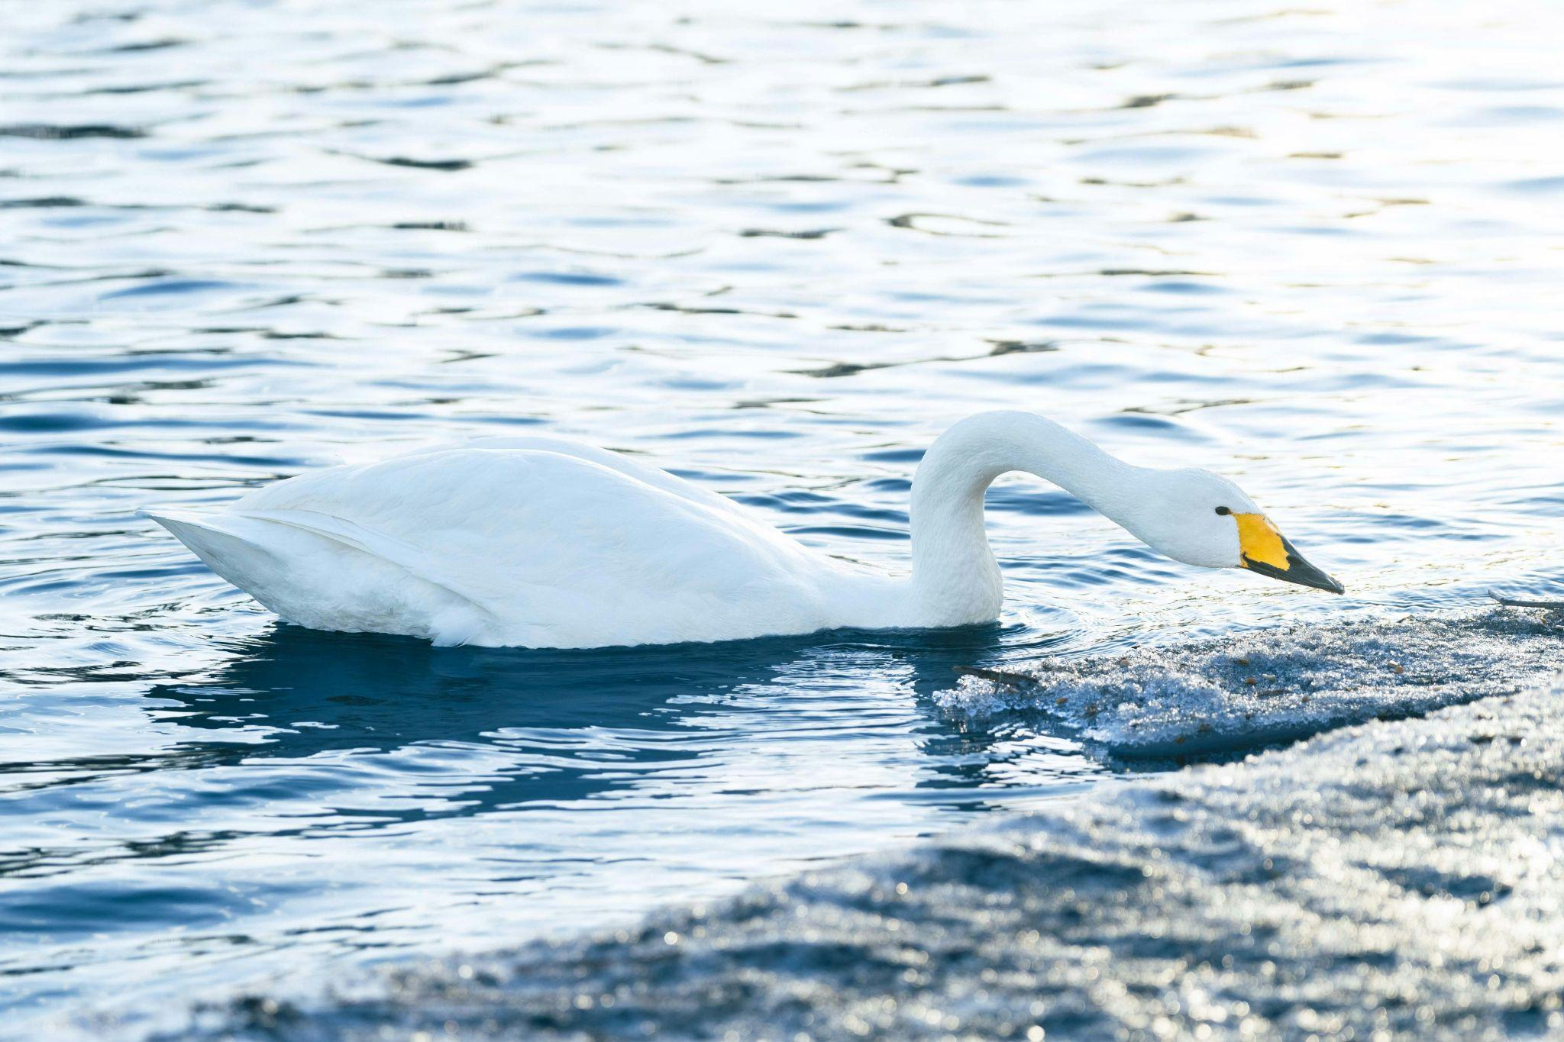

5

The Finnish national bird, the ________________________________
is a large white-water bird with a long neck and a partially yellow bill.

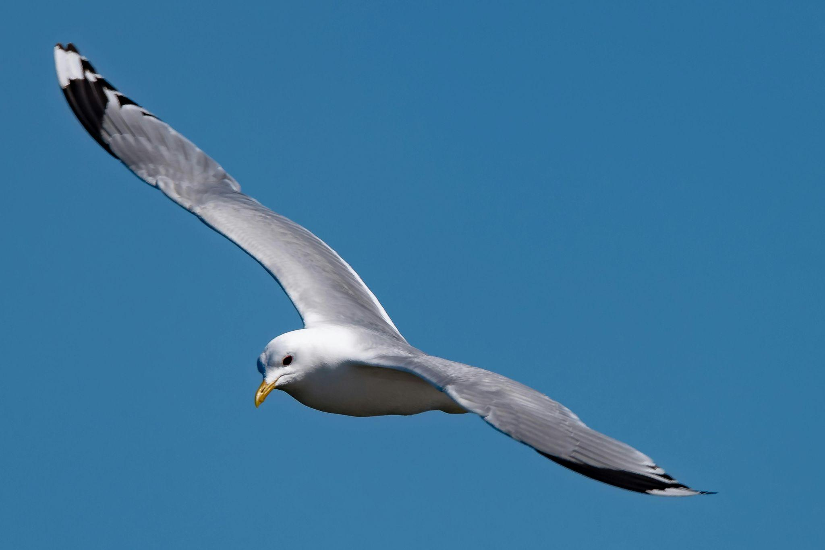
6

The ________________________________ is a well-known bird, as its loud call is an integral part of the Finnish summer. This species is common throughout the entire country.
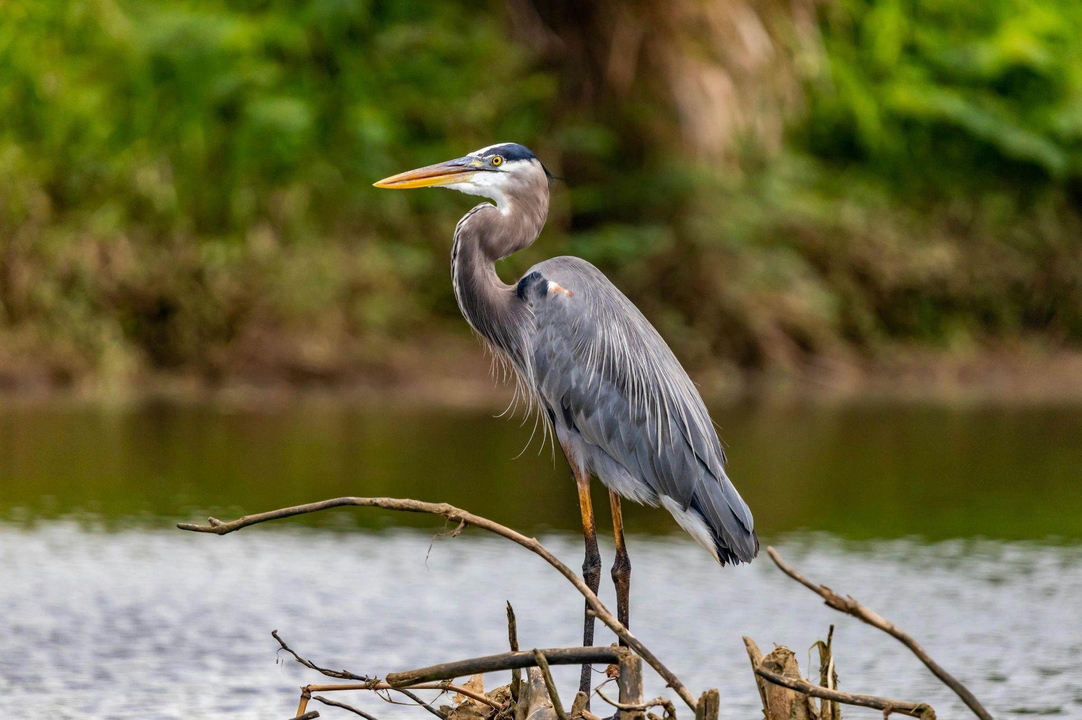
7

The grey ________________________________ is a distinctive species with grey, black, and white plumage. It is often seen along rivers or lake margins or standing in flooded fields.
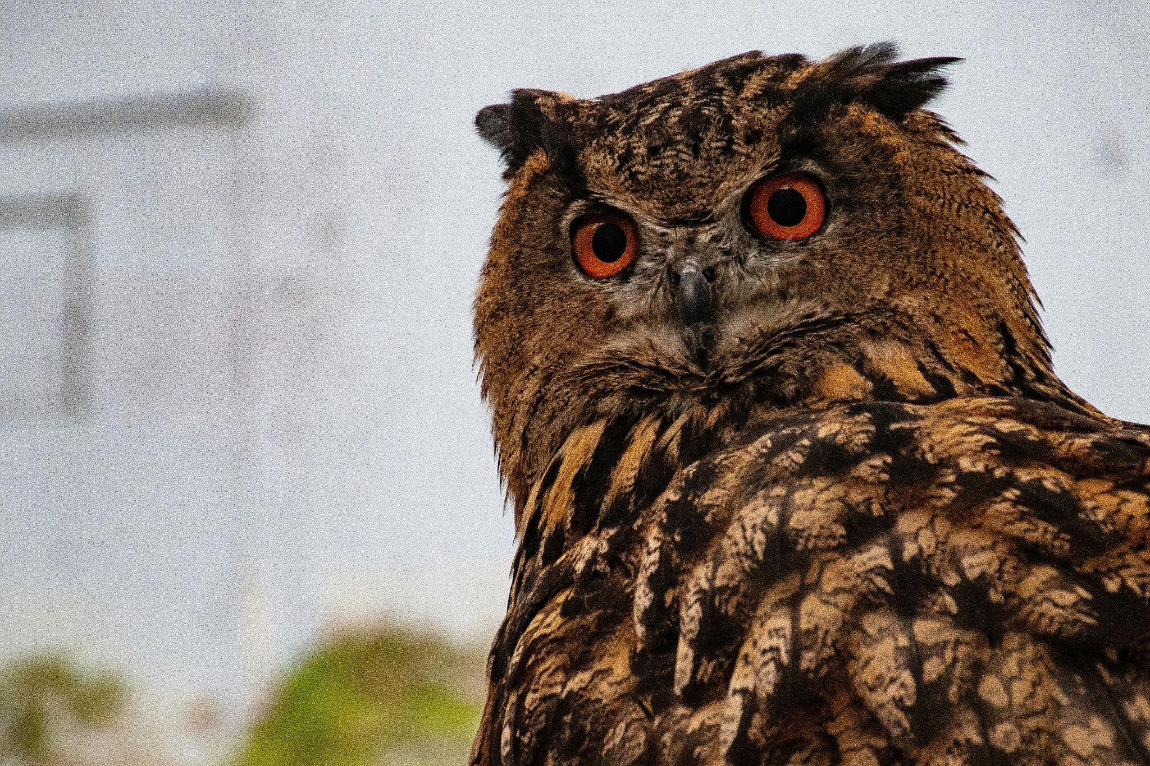
8

________________________________ are Finland’s largest owls. They almost became extinct in Finland in the mid-20th century. Protection and improvements in habitat led to a recovery in the late 20th century, but the species has declined again during the 2000s.

All images from Pexels

3) Conservation and environmental destruction

Exercise 1
Read the text and choose the best alternative.

The Return of the European Bison: Conservation Challenges and Community Perspectives
The European bison, also known as the wisent, and sometimes colloquially as the European buffalo, is the heaviest land mammal in Europe. Adult bulls can weigh up to one tonne and prefer to live alone, whereas cows and calves live in small herds led by an older female.
The wild European bison population was driven to extinction in the 1920s after decades of decline caused by overhunting and habitat loss. However, thanks to conservation efforts, the status of the free-ranging European bison has now improved from Vulnerable to Near Threatened.
In the early 20th century, the species survived only in captivity, but it was reintroduced into the wild in the 1950s. Today, the largest populations of European bison are found in Poland, Belarus, and Russia.
According to the International Union for Conservation of Nature and Natural Resources (IUCN), most European bison live in suboptimal forest habitats, and only eight of the 47 free-ranging herds are currently large enough to be genetically viable in the long term. In other words, the species remains dependent on ongoing conservation measures, such as translocations to more suitable open habitats and the reduction of human-bison conflicts. These conflicts typically occur when bison move out of forests into agricultural areas in search of food.
In her article “The Vulnerable Bison: Practices and Meanings of Rewilding in the Romanian Carpathians”, Monica Vasile explores three local narratives surrounding the rewilding of bison. The first is the wildlife tourism narrative, which is generally supportive of the project. This perspective emphasises how reintroducing bison can help revitalise communities facing economic and demographic decline. The second is the intrinsic value of nature narrative, where local residents highlight the importance of protecting vulnerable species and preserving endangered ecosystems. The final narrative Vasile discusses is the bio-threat narrative, which
focuses on the perceived risks posed by bison to farming practices. Here, concerns include potential attacks on cattle and sheep, damage to farmland, and the displacement of livestock from pastures.
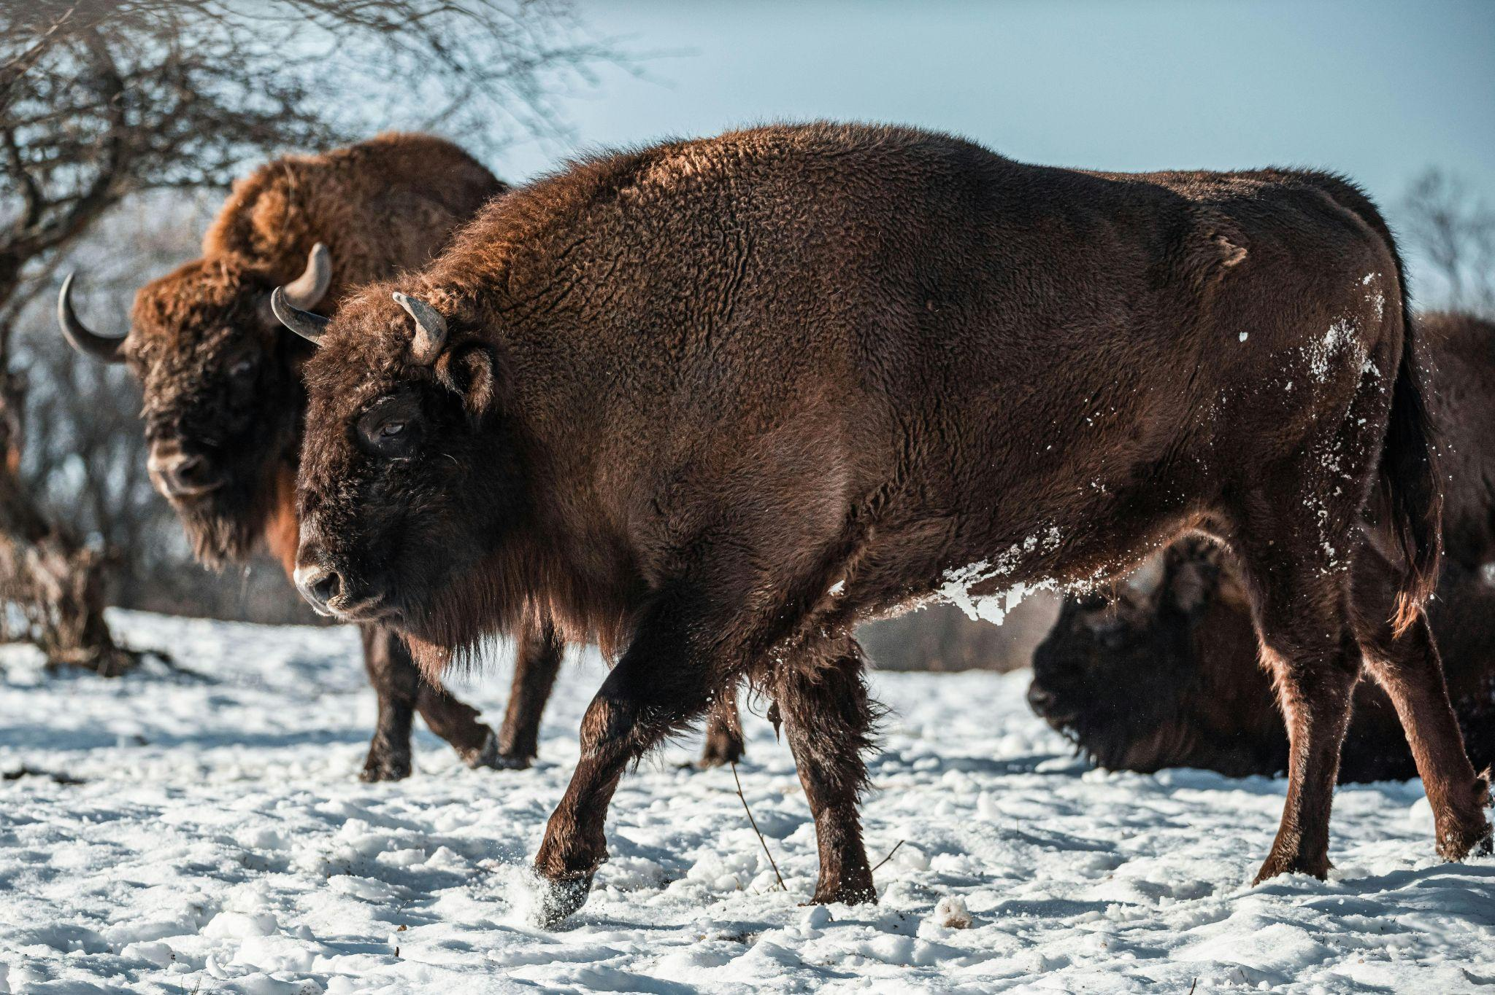
The story of the European bison highlights both the fragility and resilience of wildlife in the face of human impact. While conservation efforts have brought the species back from the brink of extinction, its survival still depends on continuous human support and management. As Vasile’s research shows, the success of rewilding initiatives also hinges on how local communities perceive and adapt to the return of such species. Ultimately, the future of the European bison lies not only in ecological planning but also in the social and cultural landscapes into which it is being reintroduced.

Image from Pexels
Text adapted from:
Vasile, M. (2018). The Vulnerable Bison: Practices and Meanings of Rewilding in the Romanian Carpathians. Conservation and Society, 16(3), 217–231. http://www.jstor.org/stable/26500636
https://iucn.org/news/species/202012/european-bison-recovering-31-species-declared-extinct-iucn-red-list

1. What is typical of the bison?

- They thrive in captivity
- They are solitary animals
- They are large creatures

2. What makes the rewilding of bison a challenge?

- Finding suitable forest habitats for the bison herds
- Aggression between free-ranging herds
- Inbreeding caused by small herd size

3. What is the main focus of Monica Vasile’s article?
- Studying the relationship between the European bison and Romanian farmers
- Exploring different views on rewilding European bison in the Carpathians
- Analysing Romanian literature about the European bison

4. What conclusion is drawn in the text?
- The attitudes and involvement of local communities impact the future of the bison
- Rewilding initiatives have ensured a future for the European bison
- People have both positive and negative attitudes to the rewilding of the European bison

Exercise 2
Complete the sentences according to the clues in parentheses/brackets. The first letter of the word has been given.

- Many animals lose their h_______________________________________ when forests are cut down. (natural home)
- The panda is an example of an e_____________________________ s_____________________________ that needs protection.
(an animal that is at risk of disappearing forever)
- C_______________________________________ helps to protect nature and preserve natural resources. (saving or protecting the environment)
- If illegal hunting continues, some animals may face e_______________________________________ .
(the complete disappearance of a species)
- We need to find s_______________________________________ ways to produce energy, so we don’t harm the environment.
(able to continue without causing harm to the environment)
- The government has started a r_______________________________________ project to bring wolves back to the mountains. (returning land to its natural state and reintroducing native animals)
- Factories must reduce p_______________________________________ to protect air and water quality. (something that contaminates the environment)
- Cutting down trees leads to d_______________________________________ , which affects the environment. (clearing of trees)

- Scientists are worried about c_____________________________ c_____________________________ because it causes rising temperatures.
(long-term change in the average weather patterns)
- Illegal p_______________________________________ of elephants for their ivory is a serious problem. (hunting)
- The rainforest is home to a large amount of b_______________________________________ .
(the variety of plant and animal life in a particular place)
- Many countries are investing in r_____________________________ e_____________________________ , such as wind and solar power, to reduce pollution. (energy from sources that can be replaced)

Exercise 3
Complete the sentences with the correct article (a/an/the) where needed.

- Governments must work to protect ________ biodiversity of the planet.
- Solar power is ________ example of renewable energy.
- SDG 15 is ________ UN Sustainability Goal that focuses on protecting life on land.
- Cutting down trees destroys ________ habitat of many animals.
- Pollution is harming ________ air we breathe every day.
- WWF is ________ organisation that works to save endangered animals.
- Protecting ________ nature is very important for future generations.
- As a result of deforestation, ________ 800-year-old forest was cut down.
- Spending ________ hour picking up litter in the park can make a big difference for conservation efforts.
- ________ European scientist recently discovered new methods to improve wildlife conservation.

Exercise 4
Pair the idiom with the correct definition. Then make a sentence where you use the idiom.

Example:
A storm is brewing
= A situation or conflict is developing and could become intense or difficult

With all the tension in the office, it feels like a storm is brewing.

A drop in the ocean Come rain or shine
A force of nature To make a mountain out of a molehill
To bark up the wrong tree To take a leaf out of someone’s book
To beat around the bush The grass is always greener on the other side

1. _________________________________________________________________
= to exaggerate a small problem

2. _________________________________________________________________
= to avoid talking about the main topic
3. _________________________________________________________________
= to imitate someone’s behaviour

4. _________________________________________________________________
= no matter what happens

5. _________________________________________________________________
= to make a wrong assumption

6. _________________________________________________________________
= other people’s situations seem better

7. _________________________________________________________________
= a very small or insignificant amount in comparison to what is needed or expected

8. _________________________________________________________________
= someone who is powerful, unstoppable, or has a strong impact on others

Exercise 5
Read the text and answer the questions in Finnish.

Mussel massacre
Papers on Friday reported on an incident last week in which a logging machine belonging to forestry giant Stora Enso repeatedly drove over a critical habitat for freshwater pearl mussels at Hukkajoki River in Suomussalmi, Kainuu, killing thousands of the extremely endangered animals.
A Helsingin Sanomat columnist described it as one of Finland's worst environmental disasters. Oulu police announced they are investigating the matter as a suspected serious environmental crime.
According to a statement by forestry management firm Metsähallitus, logging machines repeatedly crossed the shallow river, depositing mud, sand and debris into the river, wiping out a large number of the mussels. The habitat of the pearl mussel and its host species, the brown trout, has been damaged along an estimated 150-200 metre stretch.
According to an email seen by HS, Stora Enso was aware of the presence of the endangered freshwater mussel and the necessary protective measures before the logging that caused the damage in Suomussalmi.
While the machinery directly killed thousands of mussels by crushing them, the main damage was caused by silt and sludge flowing downstream from the crossing site, suffocating young mussels over hundreds of metres.
Minister of Climate and the Environment Kai Mykkänen took to social media platform X (formerly Twitter), calling the incident a criminal case, demanding explanations from Stora Enso.
Tabloid Iltalehti estimated that Stora Enso could face millions in fines if the company is found guilty of the environmental crime.
Text adapted from: https://yle.fi/a/74-20106812

1. Mikä aiheutti joukkotuhon? Vastaa kysymykseen suomeksi. Vastauksien pituus on enintään 50 merkkiä.

_________________________________________________________________________

2. Mikä aiheutti suurimmat vahingot/tuhot? Vastaa kysymykseen suomeksi. Vastauksien pituus on enintään 50 merkkiä.

_________________________________________________________________________
3. Miten tapahtumaa kuvataan sosiaalisessa mediassa/somessa? Vastaa kysymykseen suomeksi. Vastauksien pituus on enintään 50 merkkiä.

_________________________________________________________________________

Exercise 6
Read the sentences below. What do the idioms in bold mean? Can you explain them in English? Are there similar or equivalent expressions in Finnish? Use a dictionary to help you.

- Climate change is a ticking time bomb for coastal communities.
- By ignoring international climate agreements, some countries are burning bridges with the global community.
- The oil spill was the last straw for the fragile marine ecosystem.
- Weak regulations opened the floodgates for uncontrolled deforestation.
- The construction project blew the ancient forest to smithereens.
- Illegal mining has wreaked havoc on the local ecosystem.
- The coral reef is on its last legs because of ocean acidification.
- Overfishing has pushed many species to the brink of extinction.


Image from Needpix.com
Exercise 7
Complete the text with the correct form of the verbs given in parentheses/brackets.
For centuries, the Sámi people have 1) _______________________________ (live) across northern Norway, Sweden, Finland, and Russia. They have
2) _______________________________ (rely) on reindeer herding, fishing, and hunting to support their way of life. However, in recent years, environmental changes have
3) _______________________________ (bring) serious challenges.
Climate change has 4) _______________________________ (drive) temperatures higher and changed snowfall patterns. Sometimes, rain has
5) _______________________________ (fall) on snow and then
6) _______________________________ (freeze), creating hard ice layers that have
7) _______________________________ (keep) reindeer from reaching food. As conditions have worsened, many herders have 8) _______________________________ (fight) to protect their animals, but some have 9) _______________________________ (lose) large parts of their herds.
Meanwhile, companies have 10) _______________________________ (build) mines, roads, and wind farms on Sámi land. These projects have
11) _______________________________ (take) grazing areas and
12) _______________________________ (cut) migration routes. Trees have been cut down, rivers have been polluted, and fish stocks have fallen.
Although the Sámi have 13) _______________________________ (speak) out at national and international meetings, too few have 14) _______________________________ (pay) attention to their warnings.
The Sámi have 15) _______________________________ (teach) the world that protecting nature also protects culture. Without action, centuries of tradition may be
16) _______________________________ (sweep) away.
Text written by ChatGPT4 (14.06.2025)

Exercise 8
Complete the sentences with the correct form of the word in parentheses/brackets.
- Illegal ____________________________ in tropical rainforests is a major driver of habitat loss and biodiversity decline. (log)
- Many scientists warn that biodiversity ____________________________ threatens the stability of entire ecosystems. (lose)
- Unchecked industrial growth has led to severe ____________________________ degradation in the region. (environment)
- The ____________________________ of natural resources often benefits a few while causing long-term harm to the environment. (exploit)
- The factory was fined for illegally dumping ____________________________ waste into the nearby river. (toxin)
- Deforestation has accelerated soil ____________________________ , making the land unsuitable for farming. (erode)
- Governments are introducing stricter regulations to reduce carbon ____________________________ from vehicles and factories. (emit)
- ____________________________ sea levels are putting coastal cities at risk of frequent flooding. (rise)
- Ocean ____________________________, caused by increased CO₂ levels, is threatening marine life, especially coral reefs. (acid)
- ____________________________ glaciers contribute to rising sea levels and reduce the availability of freshwater in some regions. (melt)
- Rapid ____________________________ has boosted the economy but also caused significant air and water pollution. (industry)
- Habitat ____________________________ caused by urban expansion forces many animal species to migrate or face extinction. (destroy)

4) Energy, carbon emissions and AI

Exercise 1
Listen to the audio “Finland’s green energy push”. Read the questions carefully and choose the best answer.

1. What is said about biomass?
- Finland aims to produce more biomass in the future
- Biomass constitutes a large share of Finland's renewable energy
- Utilising biomass will not lead to a reduction in carbon emissions

2. What is said about wind power?
- There has been a modest rise in wind energy production in recent years
- The production of wind power helps enhance energy independence
- Many wind farms are under construction in certain areas of the country

3. What is said about hydrogen gas?
- Hydrogen can help lower carbon pollution in different areas of the economy
- Hydrogen is a rather new source of energy in Finland
- Hydrogen is mainly used in the transportation sector

Exercise 2
Choose the best alternative. The exercise continues on the next page.
Given the huge problem-solving potential of artificial intelligence (AI), it 1) _____ to think that AI could also help us in tackling the climate crisis. However, when we consider the energy needs of AI models, it becomes clear that the technology is as much a part of the climate problem as
2) _____ .
The emissions come from the infrastructure associated with AI, such as building and running the data centres that handle the large amounts of information required to 3) _____ . But different technological approaches to how we build AI systems could help reduce its carbon footprint. One technology that 4) _____ for doing this is lifelong learning.
Artificial neural networks (ANN) are an underlying technology used in most current AI systems. These networks contain parameters 5) _____ during the training phase of the AI system. These parameters can 6) _____ more than 100 billion in total.

While large numbers of parameters improve the capabilities of ANNs, they also make training and inference resource-intensive processes. 7) ____ , training GPT-3 (the precursor AI system to the current ChatGPT) generated 502 metric tonnes of carbon, which 8) _____ driving 112 petrol-powered cars for a year.

- a) wouldn’t be far-fetched b) is questionable c) could be rather unlikely
- a) a contributor b) a cause c) a solution
- a) sustain these systems b) process the information c) construct those buildings
- a) carries weight b) bears the load c) holds promise
- a) where metrics are determined b) whose values are adjusted c) in which variables are adopted
- a) pass on b) run to c) move from
- a) To put things in perspective b) To be blunt c) To pave the way
- a) is a far cry from b) boils down to c) is no match for

GPT-3 further emits 8.4 tonnes of CO₂ annually due to inference. 9) _____ in the early 2010s, the energy requirements of AI systems known as large language models (LLMs) – the type of technology that’s 10) _____ ChatGPT – have gone up by a factor of 300,000.
Lifelong learning (L2) is a strategy for reducing the 11) _____ of ANNs throughout their lifetime. Training ANNs sequentially (where the systems learn from sequences of data) on new problems causes them to forget their previous knowledge while learning new tasks. ANNs require retraining 12) _____ when their operating environment changes, further increasing AI-related emissions.
L2 is a collection of algorithms that enable AI models to be trained sequentially on multiple tasks with 13) _____. L2 enables models to learn throughout their lifetime by building on their existing knowledge without having to retrain them from scratch.

- a) Since the birth of AI b) Since the AI boom started c) Since AI became controversial
- a) behind b) in front of c) beside
- a) average running time b) anticipated demand c) overall energy requirements
- a) at the onset b) after all c) from scratch
- a) much appreciation b) very little effort c) little or no forgetting

Text adapted from: https://theconversation.com/ai-has-a-large-and-growing-carbon-footprint-but-there-are-potential-solutions-on-the-horizon-223488

Exercise 3
Complete the sentences with the correct form of the verbs in parentheses/brackets. Use the past progressive (was/were doing) or the simple past tense (did) as needed.
- While the engineers _____________________________ (install) the solar panels, a sudden storm __________________________ (begin).
- The AI system _____________________________ (analyse) carbon emissions data when the server _____________________________ (crash).
- While the students _____________________________ (watch) a documentary about wind energy, the lights suddenly _____________________________ (go) out.
- The company _______________________________ (launch) its new AI-powered app last month.
- The researchers _____________________________ (work) on a new electric vehicle design when they _____________________________ (discover) a more efficient battery.
- One of the units _____________________________ (malfunction)
while the robot _____________________________ (clean) the solar panels.
- The scientists _____________________________ (test) the wind turbines when a strong gust of wind _____________________________ (hit) the area.
- Emissions from the factory ___________________________ (decrease) significantly after the new filters _____________________________ (arrive).
- While she _____________________________ (read) an article about AI and climate change, her teacher _____________________________ (ask) her a question.
- The company _____________________________ (develop) AI tools to track emissions when it _____________________________ (win) a green tech award.
5) Colours, fruits and berries

Exercise 1
Read the text and choose the best alternative.
The Blue Banana is a term coined in the late 1980s by French geographer Roger Brunet, describing a dense corridor of urbanization, population, and economic power stretching across Western Europe. If you imagine a banana shape curving from northwest to southeast, it typically runs from northern England (like Manchester) through the Benelux countries, across western Germany, Switzerland, and into northern Italy, ending around Milan.
After WWII, Western Europe—especially the regions within the Blue Banana—benefited from massive economic investment and integration. The U.S.-led Marshall Plan funneled funds into rebuilding war-torn economies. These areas already had strong industrial bases, and the Cold War urgency to create a prosperous, stable Western Europe only accelerated their development.
Despite its fruity name, it's not agricultural—it symbolizes a "megalopolis": a vast area where cities have grown together to form a kind of seamless super-region. In the Blue Banana zone, a significant portion of Europe's GDP, manufacturing, and financial institutions are concentrated, making it vital to the continent’s economy.
The idea behind the name “blue” is debated—some say it references the EU’s flag color, while others think it was simply chosen to stand out on maps.
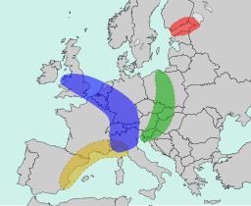
Image from Wikimedia Commons
1. Which countries are primarily included in the Blue Banana region?
- England, France and Switzerland
- Germany, Belgium and Italy
- Belgium, France and Spain

2. Which historical development contributed to the formation of the Blue Banana?
- The Industrial Revolution
- WWI
- The Cold War

3. Which of the following is not a characteristic of the Blue Banana?
- High population density
- Predominantly rural landscape
- Major financial and industrialised hubs

4. Why is the Blue Banana considered vital to the European economy?
- It contains key tourism hotspots and Mediterranean beaches
- It forms an arc of urban and industrial centers responsible for a large portion of the EU’s GDP
- It encompasses regions where the majority of Europe’s renewable energy is produced

Exercise 2A
Sort the different colour hues into their proper columns. There are three extra words.

Black | Grey
Brown | White

alabaster  aluminium  ash  battleship  bone  bronze  buttermilk | champagne  chestnut  cinnamon  coal  cocoa  cream  ebony  eggshell | fern  graphite  gunmetal  ink  ivory  liquorice  onyx | parchment  pewter  raven  sable  sepia  silver  tan  taupe  vanilla

Exercise 2B
Choose the most suitable word.

- In the museum, we saw antique pewter / ash plates.
- She looks very elegant in her taupe / sepia pantsuit.
- The make-up artist had used a light foundation to give the models creamy, alabaster / eggshell skin.
- Her face was framed by long, raven / sable locks.
- In the 1800s, piano keys were frequently made out of parchment / ebony.
- Purple gold is a brittle alloy of graphite / aluminium and gold.

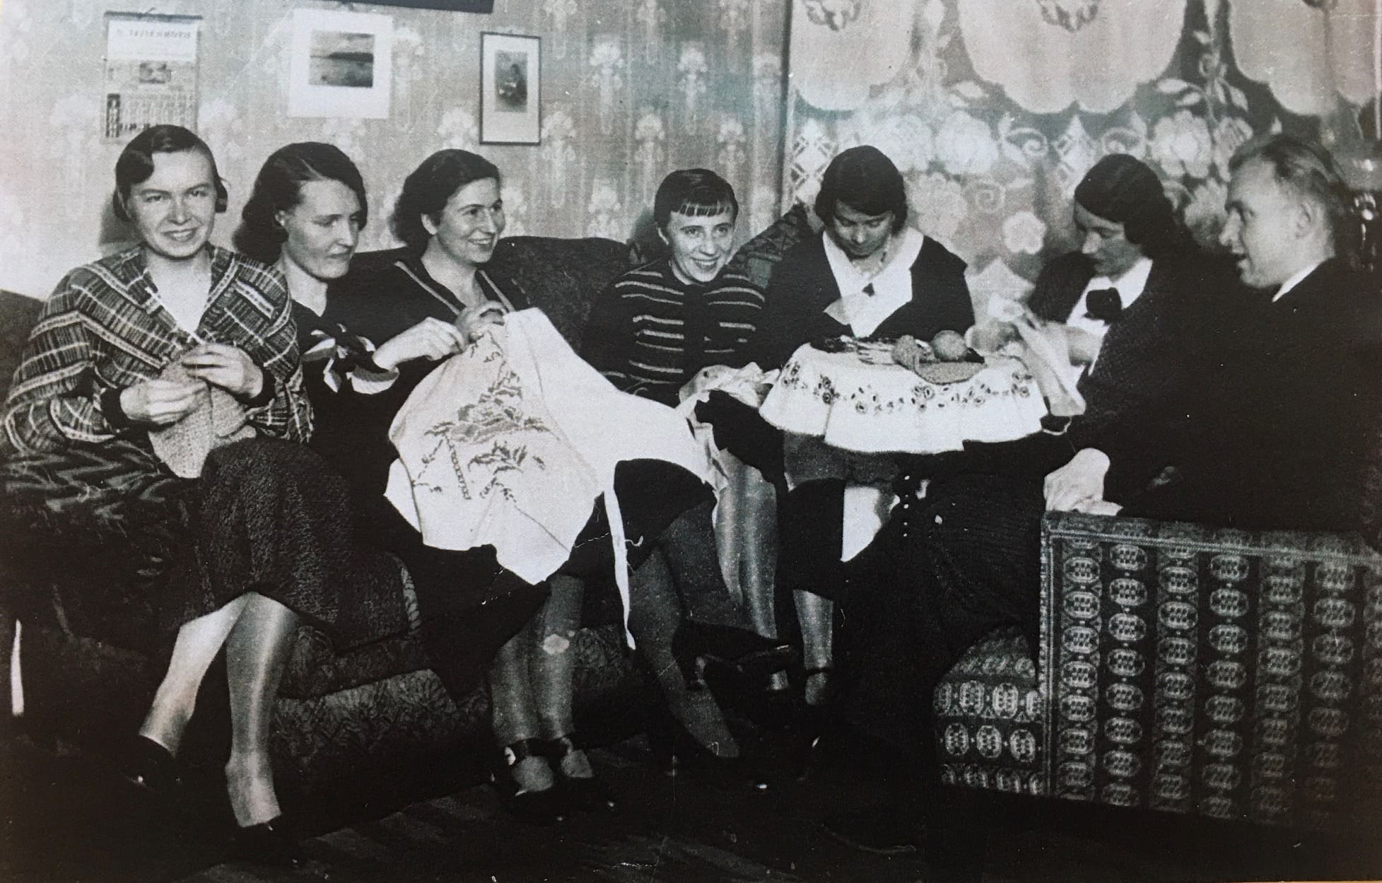

Exercise 3A
Pair the names of the fruits with the correct picture. There are two extra words.

apricot kumquat papaya plum
crab apple mango passionfruit pomegranate
dragon fruit nectarine persimmon

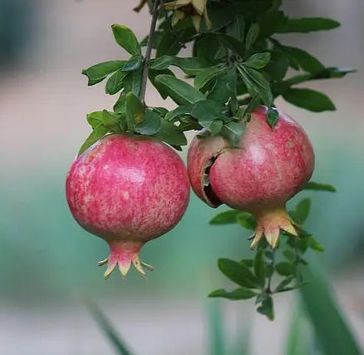  1. ____________________ |   2. ____________________ | 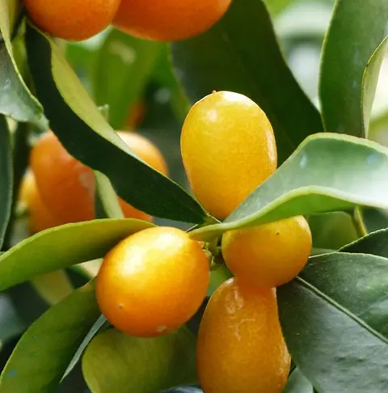  3. ____________________
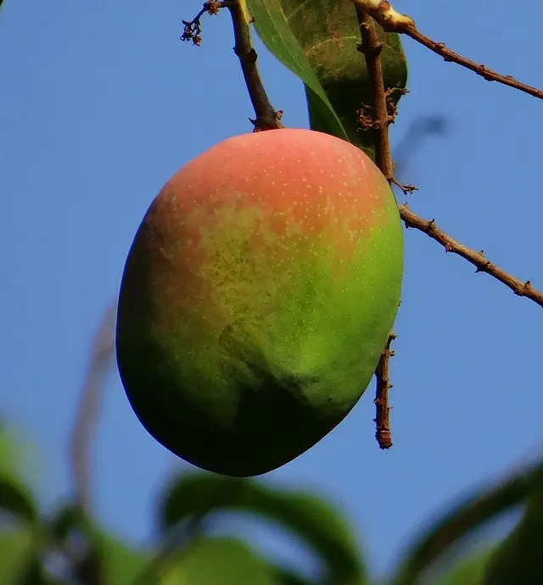  4. ____________________ | 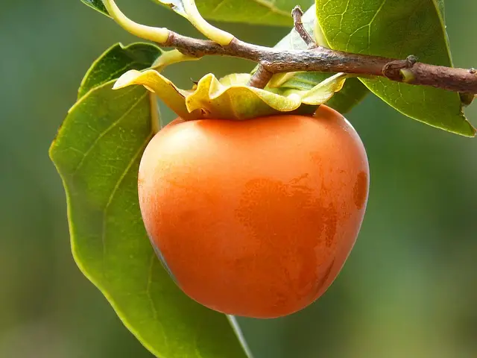  5. ____________________ | 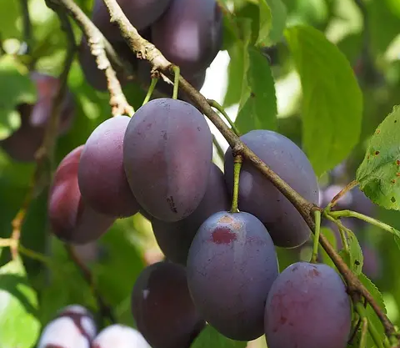  6. ____________________
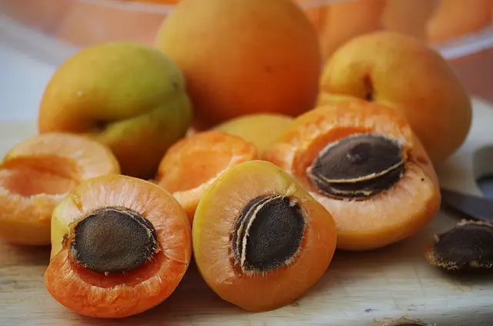  7. ____________________ | 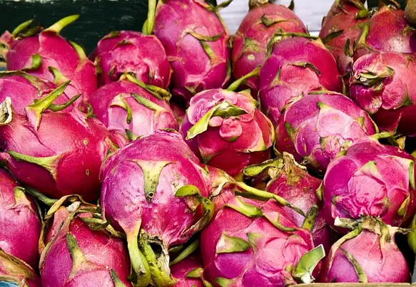  8. ____________________ | 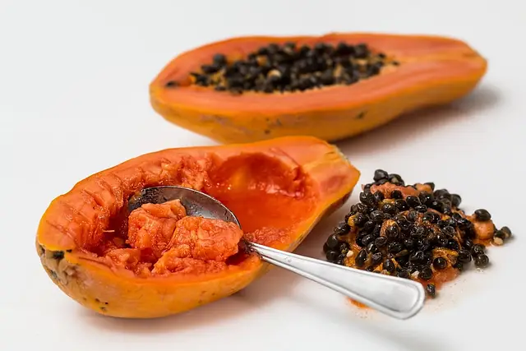  9. ____________________
Exercise 3B
Pair the names of the berries with the correct picture. There are two extra words.

acai sea buckthorn goji mulberry
blackberry cloudberry gooseberry raspberry
black currants cranberry lingonberry

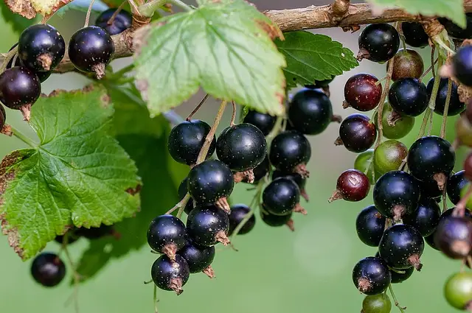  1. ____________________ | 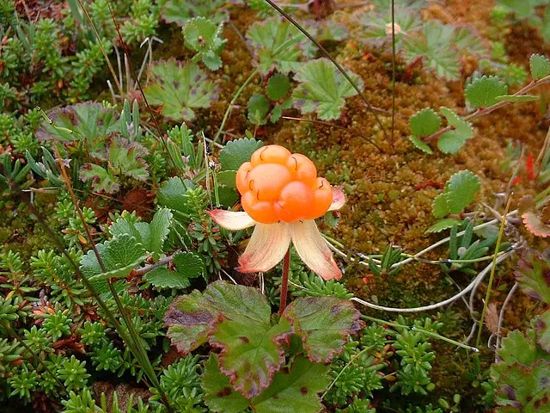  2. ____________________ | 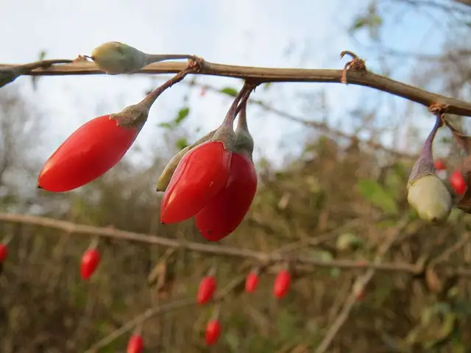  3. ____________________
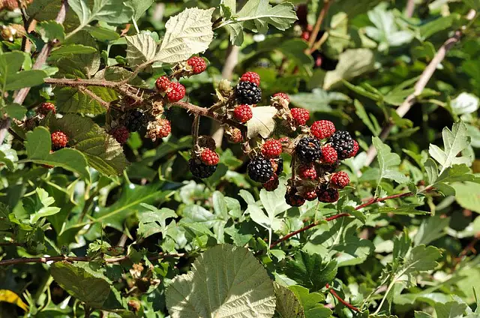  4. ____________________ | 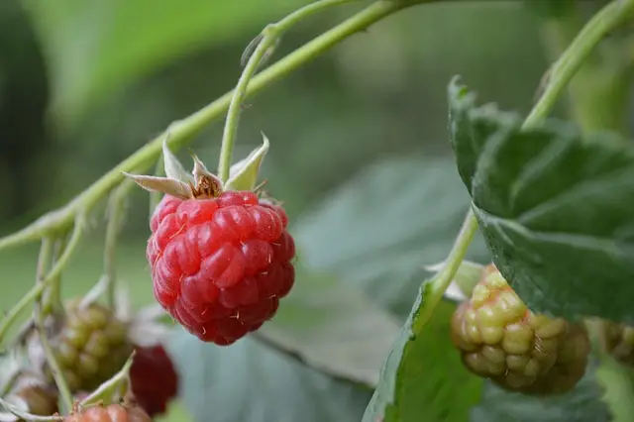  5. ____________________ | 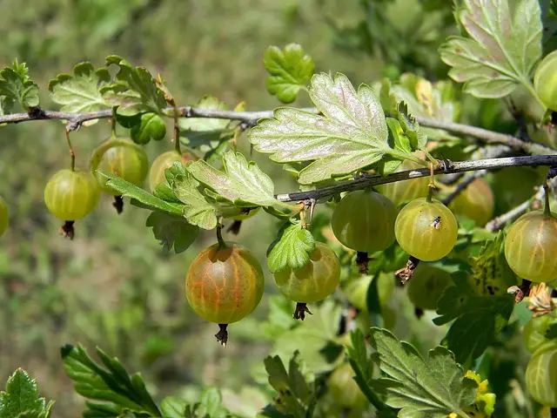  6. ____________________
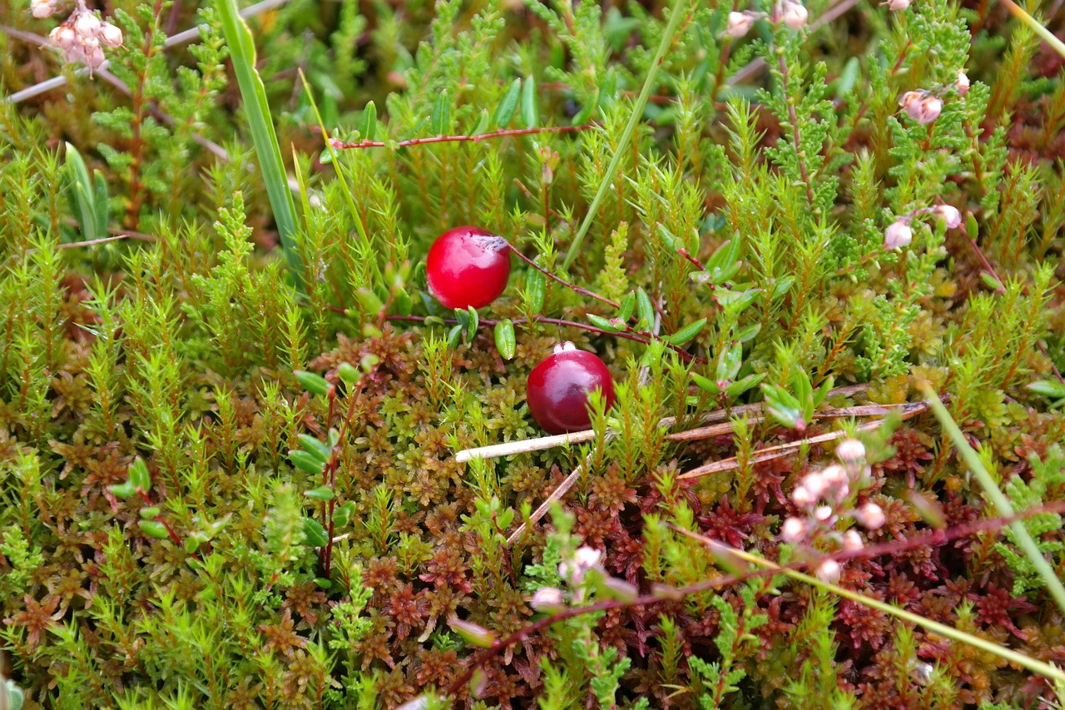  7. ____________________ | 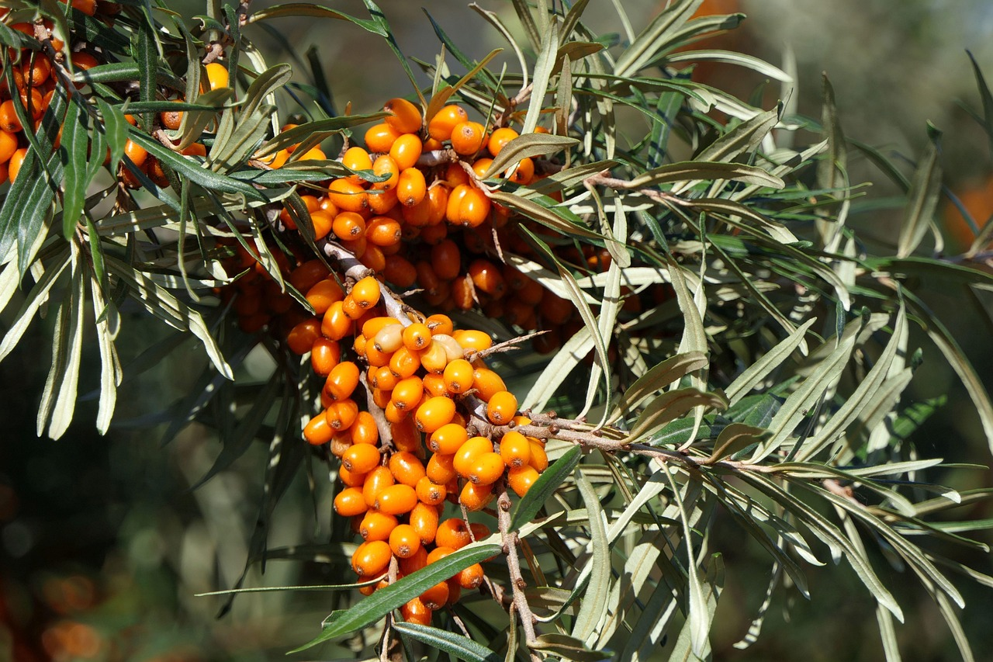  8. ____________________ | 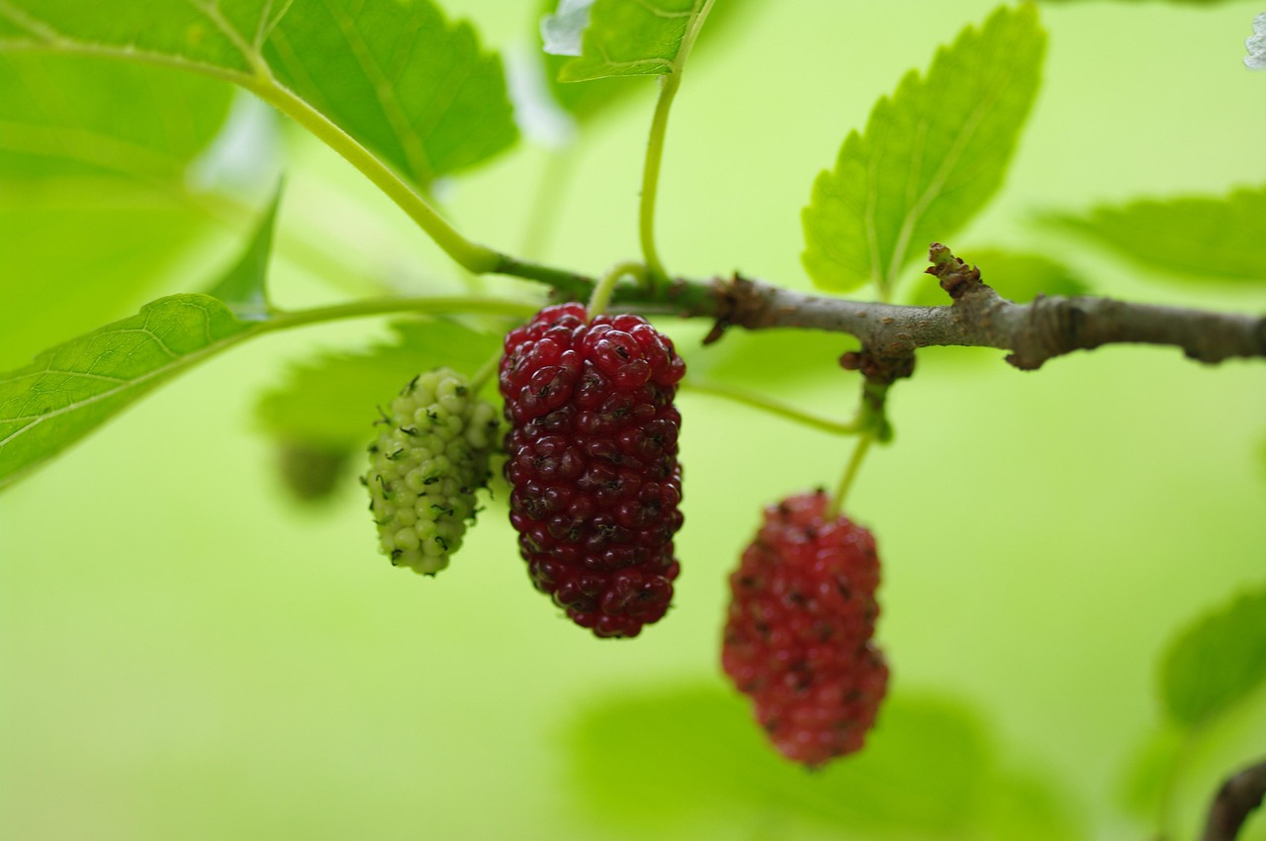  9. ____________________

All images in Exercise 3A from Wikimedia Commons, Images 1-6 in Exercise 3B from Wikimedia Commons 7-9 from Pexels
6) Warm weather

Exercise 1
Read the text and answer the questions in Finnish.

The hottest year in recorded history

In 2024, the global average surface temperature reached 1.55°C above pre-industrial levels, making it the warmest year on record. This unprecedented heat is attributed primarily to human-induced greenhouse gas emissions, which have been accumulating in the atmosphere, intensifying the greenhouse effect. The combustion of fossil fuels for energy, deforestation, and industrial activities release significant amounts of carbon dioxide (CO₂) and methane (CH₄), leading to a rise in global temperatures.

The year 2024 was particularly notable not only for the elevated land and sea surface temperatures but also for exceptional ocean heat content. Oceans absorb approximately 90% of the excess heat from global warming, and in 2024, ocean temperatures were the highest ever recorded, affecting marine ecosystems and weather patterns.
Several international agencies play a crucial role in monitoring global temperatures and climate change indicators. The World Meteorological Organization (WMO) consolidates data from multiple sources, including:
- The European Centre for Medium-Range Weather Forecasts (ECMWF)
- The Japan Meteorological Agency (JMA)
- NASA's Goddard Institute for Space Studies (NASA GISS)
- The U.S. National Oceanic and Atmospheric Administration (NOAA)
- The UK's Met Office Hadley Centre, in collaboration with the Climatic Research Unit at the University of East Anglia (HadCRUT)
- Berkeley Earth
These organisations collect and analyse climatological data from observing sites, ships, buoys, and satellites to provide comprehensive assessments of global temperature trends. Their collaborative efforts ensure accurate and up-to-date information, which is essential for informing policy decisions and climate action strategies.
The confirmation of 2024 as the hottest year on record underscores the urgency of addressing climate change. The persistent rise in global temperatures leads to more frequent and severe weather events, such as heatwaves, storms, and flooding, posing significant threats to ecosystems, economies, and human health. This alarming trend highlights the critical need for international cooperation to reduce greenhouse gas emissions and implement sustainable practices to mitigate the impacts of global warming.
Text adapted from:

www.nasa.gov/news-release/temperatures-rising-nasa-confirms-2024-warmest-year-on-record/
https://www.noaa.gov/news/2024-was-worlds-warmest-year-on-record
https://www.npr.org/2025/01/10/nx-s1-5232139/2024-hottest-year-human-history-global-warming

1. Mikä on vahvistanut kasvihuoneilmiötä? Vastaa kysymykseen suomeksi. Vastauksen pituus on enintään 50 merkkiä.

____________________________________________________________________________
2. Mikä teki vuodesta 2024 erityisen tässä mielessä? Vastaa kysymykseen suomeksi. Vastauksen pituus on enintään 50 merkkiä.

____________________________________________________________________________

3. Kuinka dataa/tietoja kerätään? Mainitse ainakin kaksi tapaa. Vastaa kysymykseen suomeksi. Vastauksen pituus on enintään 50 merkkiä.

____________________________________________________________________________
4. Mihin jatkuva lämpötilan nousu johtaa? Vastaa kysymykseen suomeksi. Vastauksen pituus on enintään 50 merkkiä.

____________________________________________________________________________
Exercise 2
Choose the odd word out. For each word in bold print, you must identify which word is not a synonym. To see the words in context, return to the text in Exercise 1.

1. unprecedented conventional unheard-of unfamiliar
2. elevated receded towering escalated
3. indicator gauge result pointer
4. consolidate merge integrate segregate
5. ensure assure allure insure
6. underscore enhance accentuate undermine
7. mitigate soothe impair alleviate

Exercise 3
Combine the words from the box with the correct definitions.

heat cramp sunbath temperature
heat index sunburn
heat stroke, heatstroke sunblock, sunscreen
heat wave sunstroke
suntan

1. _____________________________________________________________________
= a period of unusually hot weather

2. _____________________________________________________________________
= an exposure to sunlight or a sunlamp

3. _____________________________________________________________________
= a preparation applied to the skin to prevent sunburn

4. _____________________________________________________________________
= a life-threatening condition marked by abnormally high body temperature

5. _____________________________________________________________________
= a browning of the skin from exposure to the rays of the sun

6. _____________________________________________________________________
= a measurement of what temperature feels like to the human body when relative humidity is combined with the air temperature

7. _____________________________________________________________________
= inflammation of the skin caused by overexposure to ultraviolet radiation

8. _____________________________________________________________________
= the degree of heat that is natural to the body of a human being

9. _____________________________________________________________________
= a condition produced by lack of salt from the body in very hot conditions

10. _____________________________________________________________________
= heatstroke caused by direct exposure to the sun

Exercise 4
Listen to the audio “Warm weather ticks” and choose the best alternative.

1. How many types of ticks are mentioned in the text?
- three
- four
- five

2. Which state’s symbol is the name of one of the ticks?
- Florida
- Texas
- California

3. Above what temperature in Celsius do ticks become active?
- around 0 degrees
- around 4 degrees
- around 8 degrees

Exercise 5
Read the text and look at the infographic. Then answer the questions in Finnish.

Effective tick prevention according to AI
Spending time outdoors is one of life’s great joys, but it comes with tiny, hidden risks—like ticks. These small parasites can carry serious diseases such as Lyme disease, tick-borne encephalitis (TBE), and other bacterial or viral infections. Many of these illnesses can have long-lasting or even permanent effects if not detected early.
Infected ticks are common in many parts of Europe, particularly during warmer months. Early removal—within 24 hours—dramatically reduces the risk of disease transmission.
Making tick checks part of your daily routine during outdoor seasons is a small habit with big protective power. Stay safe and enjoy the wild—just with a little extra vigilance.

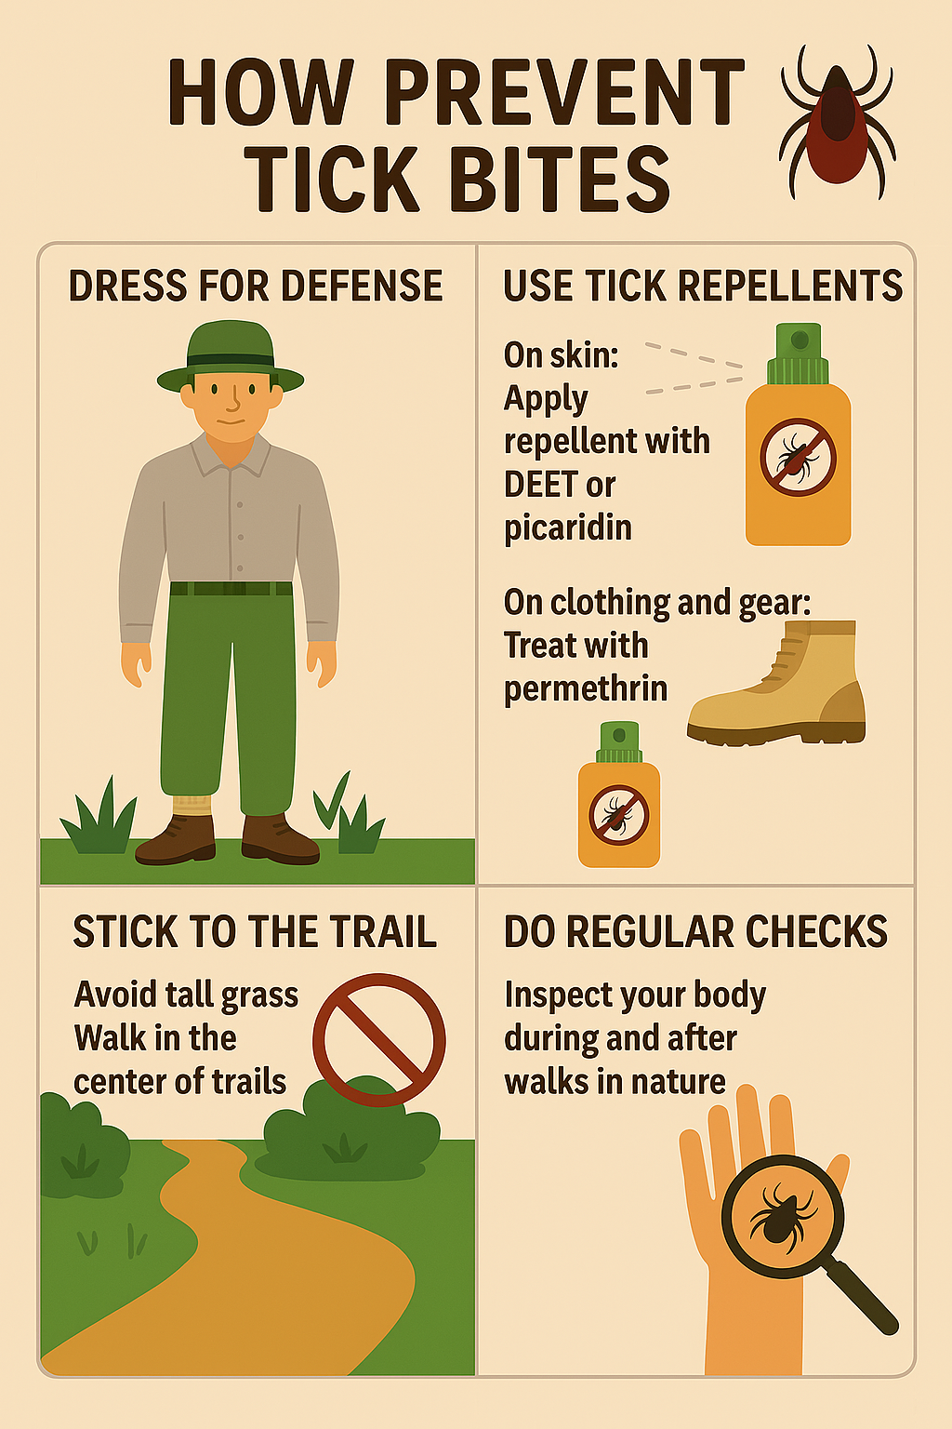 Made by Copilot on July 8, 2025

1. Mitä sinun pitää tehdä vuorokauden sisällä? Vastaa kysymykseen suomeksi. Vastauksen pituus on enintään 50 merkkiä.

_________________________________________________________________________

2. Minkälaisia vaatteita suositellaan? Mainitse vähintään kolme asiaa. Vastaa kysymykseen suomeksi. Vastauksen pituus on enintään 50 merkkiä.

_________________________________________________________________________

7) News items

Listen to three separate news items. Read the questions carefully. Choose the best alternative or write an answer in Finnish.

News item 1

1. What part of the konjac plant are the noodles made from?
- The flower
- The leaves
- The root

2. Who might be interested in shirataki noodles?
- Someone who is allergic to wheat
- Someone who wants to manage their weight
- Someone who is on a plant-based diet

News item 2

3. What happens in the wellness retreat?
- Guests listen to the soothing hum of the bees while sleeping next to hives
- Guests participate in therapy sessions while honeybees stimulate their senses
- Guests rehabilitate with the help of honeybee colonies

News item 3

4. Mitä varis teki? Vastaa suomeksi. Vastauksen pituus on enintään 50 merkkiä.

____________________________________________________________________________

5. Scientists think this behaviour…
- shows that crows are rather intelligent birds
- is quite common among birds
- is a form of survival training

