**STUDY PACK SPAIN – GUITAR ENSEMBLE – SEVILLA**

**LESSON 1**

This work is framed within **Spanish musical nationalism**, an artistic and cultural movement that emerged at the end of the 19th and beginning of the 20th century in Spain and related to Romanticism. Its followers sought to create music that reflected the traditions and culture of Spain, in opposition to imported music from other countries

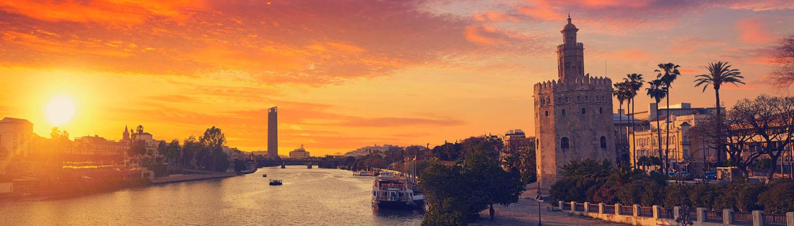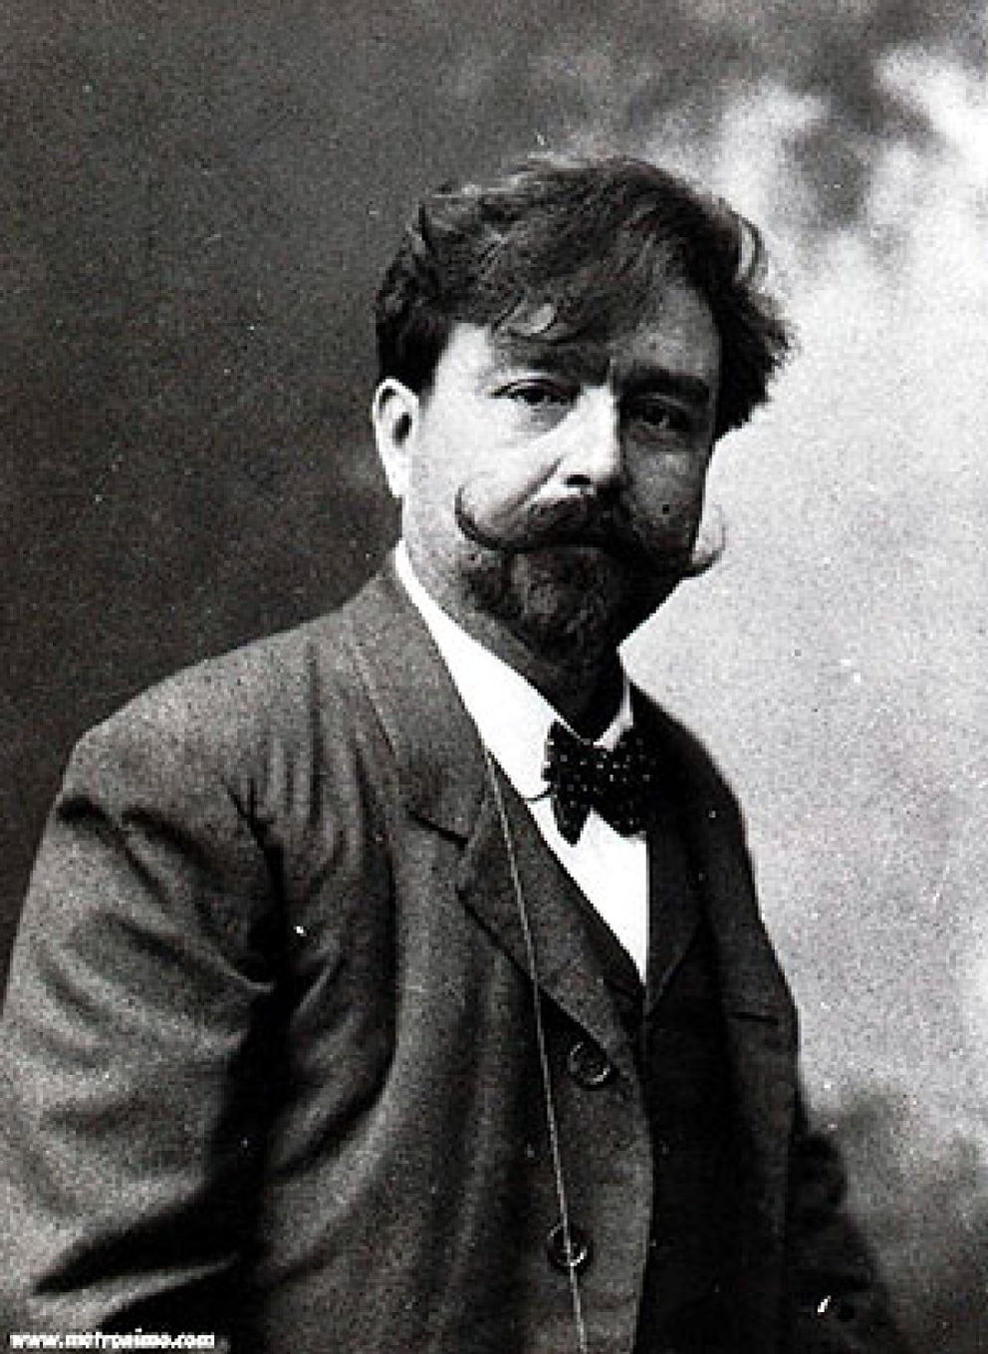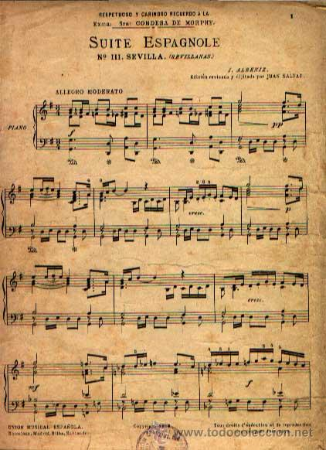

Spanish nationalist composers, such as Manuel de Falla or Isaac Albéniz, used elements of Spanish folk music in their works, as well as Spanish poetry and literature as inspiration.

**The author** of "Sevilla" is Isaac Albéniz (1860-1909). He is considered one of the greatest Spanish composers of all time. His importance lies in his piano music, considered as one of the most important contributions to that genre in Spain, and for having contributed to Spanish music a great wealth of styles and forms, from the diversity of Hispanic folklore to romantic and impressionist music.

He began studying piano at the age of three, and at six years old he performed in public for the first time. At the age of 17, he moved to Paris, where he studied at the Conservatory and was influenced by French composers such as Camille Saint-Saëns, Jules Messenet or Gabriel Fauré. In 1883, he returned to Spain and began composing, creating works that mixed popular Spanish rhythms and melodies with classical forms. An example of this is "Iberia" and "Suite española."

**“Suite Española"** is a collection of piano pieces, and the score that we will perform (Sevilla) is part of this suite. "Suite Española" consists of eight pieces: Granada, Cataluña, Sevilla, Cuba, Cadiz, Asturias, Aragón and Castilla. Each of the pieces aims to capture the essence and music of the different regions, making use of structures of different musical genres and rhythmic and melodic elements typical of those areas.

For example, the piece "Cuba" is based on a habanera (Cuba was part of Spain until 1898), "Aragón" has the form of a Jota (a type of traditional song and dance), and "Sevilla" is inspired by a sevillana.

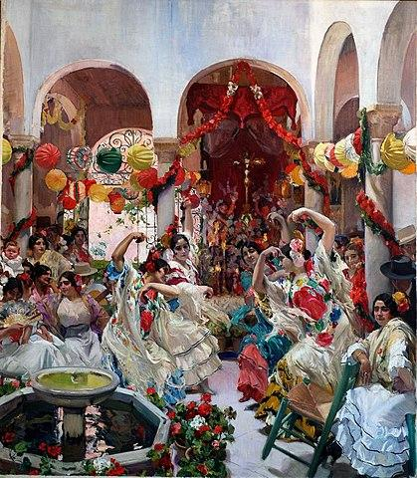

**Sevillana** is a type of music and dance typical of Andalusia, especially the provinces of Seville, Huelva and Cádiz. This dance is danced in pairs, it is festive in nature and is still danced and sung at popular festivals. The music that accompanies the sevillanas usually comes from a guitar. The first sounds that are performed are strummed, until the singer makes the introduction to singing.

Additionally, it's common that the music and singing are accompanied by clapping and, on occasions, by castanets.

We will perform an arrangement for guitar ensemble. Since its transcription for classical guitar, this Suite has become one of the most important works in the repertoire. So much so, that it has been performed and recorded by guitarists such as Julian Bream and John Williams.

**Activities for this Lesson**

1. **Here you have some versions of the same piece, listen and note the differences between them.**

**Link 1:** [**https://www.youtube.com/watch?v=Vm7XS5X9_2w**](https://www.youtube.com/watch?v=Vm7XS5X9_2w)

Link 2: [**https://www.youtube.com/watch?v=e1auLYYfZ9c**](https://www.youtube.com/watch?v=e1auLYYfZ9c)

**2. Here’s a link to Google Maps**: [Spain](https://www.google.es/maps/place/Espa%C3%B1a/@45.6542797,-3.507382,3.72z/data=!4m5!3m4!1s0xc42e3783261bc8b:0xa6ec2c940768a3ec!8m2!3d40.463667!4d-3.74922?hl=es)  
**Try to find Sevilla. Can you indicate on the map where this city is located?**

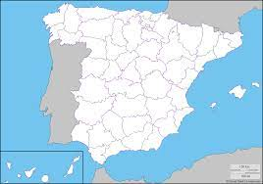

**3. In the following link you will be able to listen to an instrumental sevillana, therefore, the sung voice is replaced by the guitar.**Link 3: [SEVILLANA, PACO DE LUCIA](https://youtu.be/RkAQbX3jogo)  
  
a) Are you able to identify at what minutes the initial strumming appears prior to the start of the melody?

b) Is it heard more than once? Indicate how many times.

c) Do you hear handclaps or castanets?

**4. In the middle of the work we can find a contrasting section with a different character. Listen to the link and indicate at what minute it starts and what minute we return to Tempo I.**

Link 4:[**https://www.youtube.com/watch?v=e1auLYYfZ9c**](https://www.youtube.com/watch?v=e1auLYYfZ9c)

**LESSON 2**

### **RHYTHM**

The time signature of 'Sevilla' is 3/4 (a dance). The sevillanas is a typical Andalusian rhythm, very accentuated in its melodies.

**Activities for this Lesson**

1. Listen to the song performed by a band: <https://www.youtube.com/watch?v=waYKh1tXgsw>

2. Learn how to do the solfege of these 2 rhythms patterns inspired by the different themes of the song.

**Rhythm pattern nº1 (Sevillanas)**



**Rhythm pattern nº2**



3. Learn to play in your instrument the rhythms of the song. You can play the same note for all, or you can play 2 differents notes (one in each barr)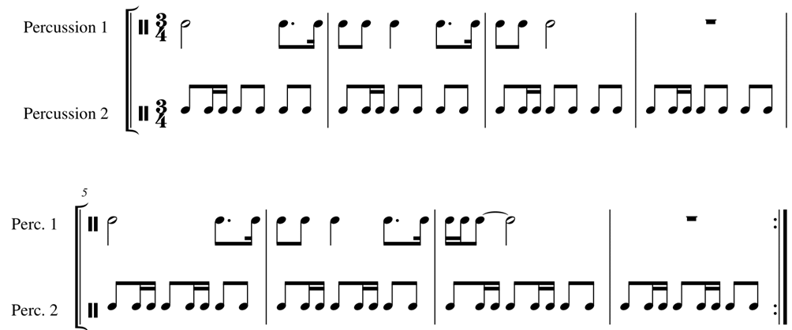

4. Now, along with your teacher or another student, you can play the rhythm pattern nº 2 with a rhythm ostinato, based in the rhythm pattern nº 1.

**MELODY**

The work is in F major, but there are modal parts, based on the C Phrygian mode (for example, in the introduction, bars 1 to 2 are the most characteristic of Andalusian music. The time signature is ¾ (in other sevillanas, you can also find 3/8). This song is a dance and its feelings are very happy and joyful.

1. Sing the melodies in the original key signature:

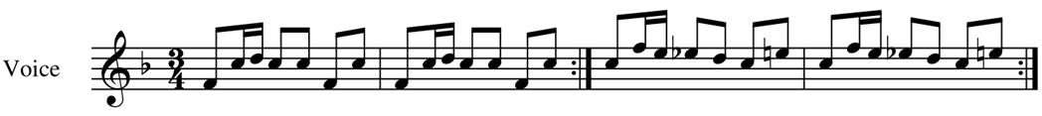

2. Now, together*:*

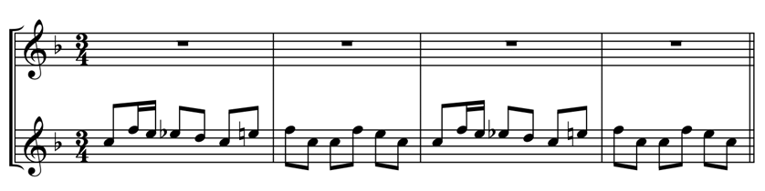

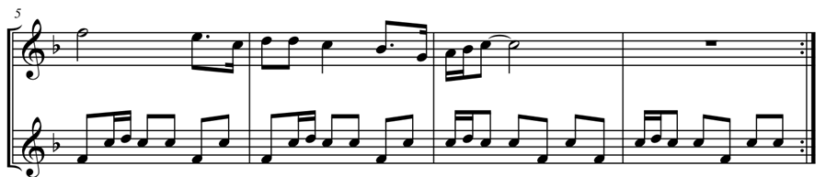

3. And finally, you can sing the melodies with the sevillanas rhythm. You can use any instrument for accompaniment (such as clapping, for example).

**LESSON 3**

**MAIN IDEAS FOR INTERPRETATION**

* **The fingerings are optional. You can adapt the piece to your students in the way they need.**
* **Think about your students' level and choose the voice.**
* **If it’s needed you can adapt some of the voices. The first voice can be played one octave down.**
* **Think clearly about the rhythm.**
* **Use a metronome and try to keep the tempo.**
* **Accent the first beat of the measure.**
* **Play the melody with direction.**