Keeping healthy

How to have a healthy lifestyle

Eat healthy, sleep enough and do sports. These are the main things you should remember when you want to have a healthy lifestyle.

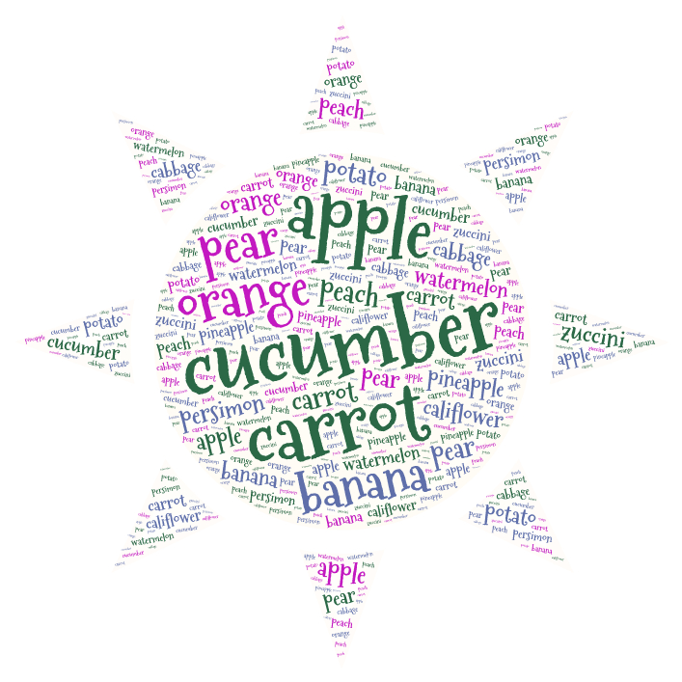

|  |  |  |  |  |  |  |  |  |  |  |  |  |  |  |
| --- | --- | --- | --- | --- | --- | --- | --- | --- | --- | --- | --- | --- | --- | --- |
| B | E | L | P | P | A | Y | E | G | Y | Z | U | W | S | E |
| V | A | I | W | P | E | C | R | Q | K | O | P | P | D | C |
| B | I | N | J | Y | Q | V | Q | R | H | H | O | C | K | N |
| J | F | B | A | L | X | B | L | R | E | R | A | H | L | A |
| A | G | Z | H | N | A | A | X | G | T | B | C | Z | S | D |
| X | Z | B | O | M | A | H | K | S | T | O | N | N | T | U |
| C | Z | D | S | T | R | K | J | M | W | R | N | O | Y | W |
| U | C | O | I | Q | U | J | Z | Y | N | A | P | I | X | X |
| Y | C | U | Q | X | R | C | G | L | Y | N | S | C | Z | O |
| O | R | A | B | X | A | I | E | M | M | G | P | A | L | J |
| F | U | T | P | A | R | K | O | U | R | E | H | Y | Z | S |
| C | V | U | H | T | C | M | A | P | Q | A | D | E | M | V |
| Y | K | U | B | A | X | Q | A | B | K | L | Y | N | T | L |
| R | A | A | M | L | M | Q | X | P | B | D | Z | Y | Q | X |
| I | D | M | H | S | M | A | Y | B | V | E | J | R | S | N |

|  |
| --- |
|  |
| APPLE | BANANA | BERRY |
| DANCE | FRUIT | ORANGE |
| PARKOUR | SPORTS |  |

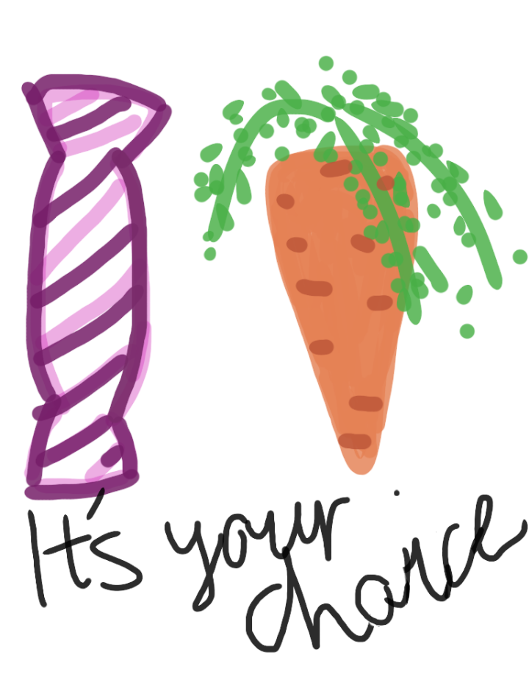

**Three things you need to know about staying healthy**   
  
**1. Excercise**  
Excercise is a big part of staying healthy.  
Two hours of physical activities a Day is more than enough. Just remember you don't have to work too hard.  
  
**2. Maintaining personal hygiene**  
Personal hygiene is very important, so take a shower at least two times a week or you might begin to smell. And remember to brush your teeth twice a day.

**3. Eating healthy**   
I'am not in a position to give you any good eating tips. But I found this picture from the Web. It's what you could call a Finnish plate model, so no we don't eat just porridge ovet here. All though that’s good, too.   
Healthy life habits are important. But I think they should not control your life too much, so I think that you are good just the way you are. And you don't have to pretend to be someone you aren't!  
  
Ps. Please, DON’T BULLY ANYBODY !!! - Matias the 9th grade

Why you should go to work by bike

 It is good for your body  
- It increases your stamina  
- It doesn’t defile nature  
- It maintains and improves circulatory system  
- It helps you to lose weight  
- Moving in centre might be quicker

* Jere the 9th grade

1

Advent calendar makes us move

This year our classes don’t have an ordinary chocolate calendar for Christmas. Every day we pick a paper and it says what to do. One day we got “Mrs. Claus’s morning exercise.” Then we danced with the music of Jingle Bells.

* Enni the 6th grade

Rules for Finnish games

**Pikipata - Tar pot**

In this game the players form a circle with the exception of one, who remains on the outside of the circle. This player carries a stick and walks around on the outside of the circle, dropping the stick behind a random player. This player must then run around the circle in the opposite direction of the player who dropped the stick. The player who is first joins the circle and the other players becomes the stick-dropper.

The kids play Tar pot and learn English at the same time.

**Viimeinen pari uunista ulos -The last pair out of the oven**

In this game all players save one form a pair line. The one remaining player is the catcher and stands in front of the others and shouts: ‘The last pair out of the oven’, at which the two last players start running forward, each on their own side of the line. Their objective is to link hands on the other side and avoid being caught by the catcher. If one of them is caught, that player forms a new pair with the catcher and the player who was not caught becomes the new catcher

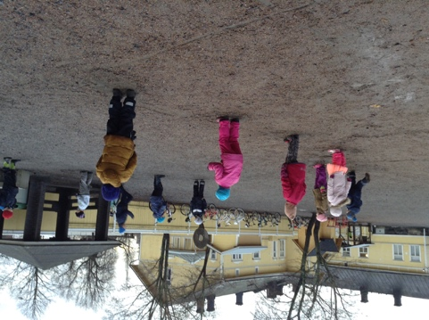

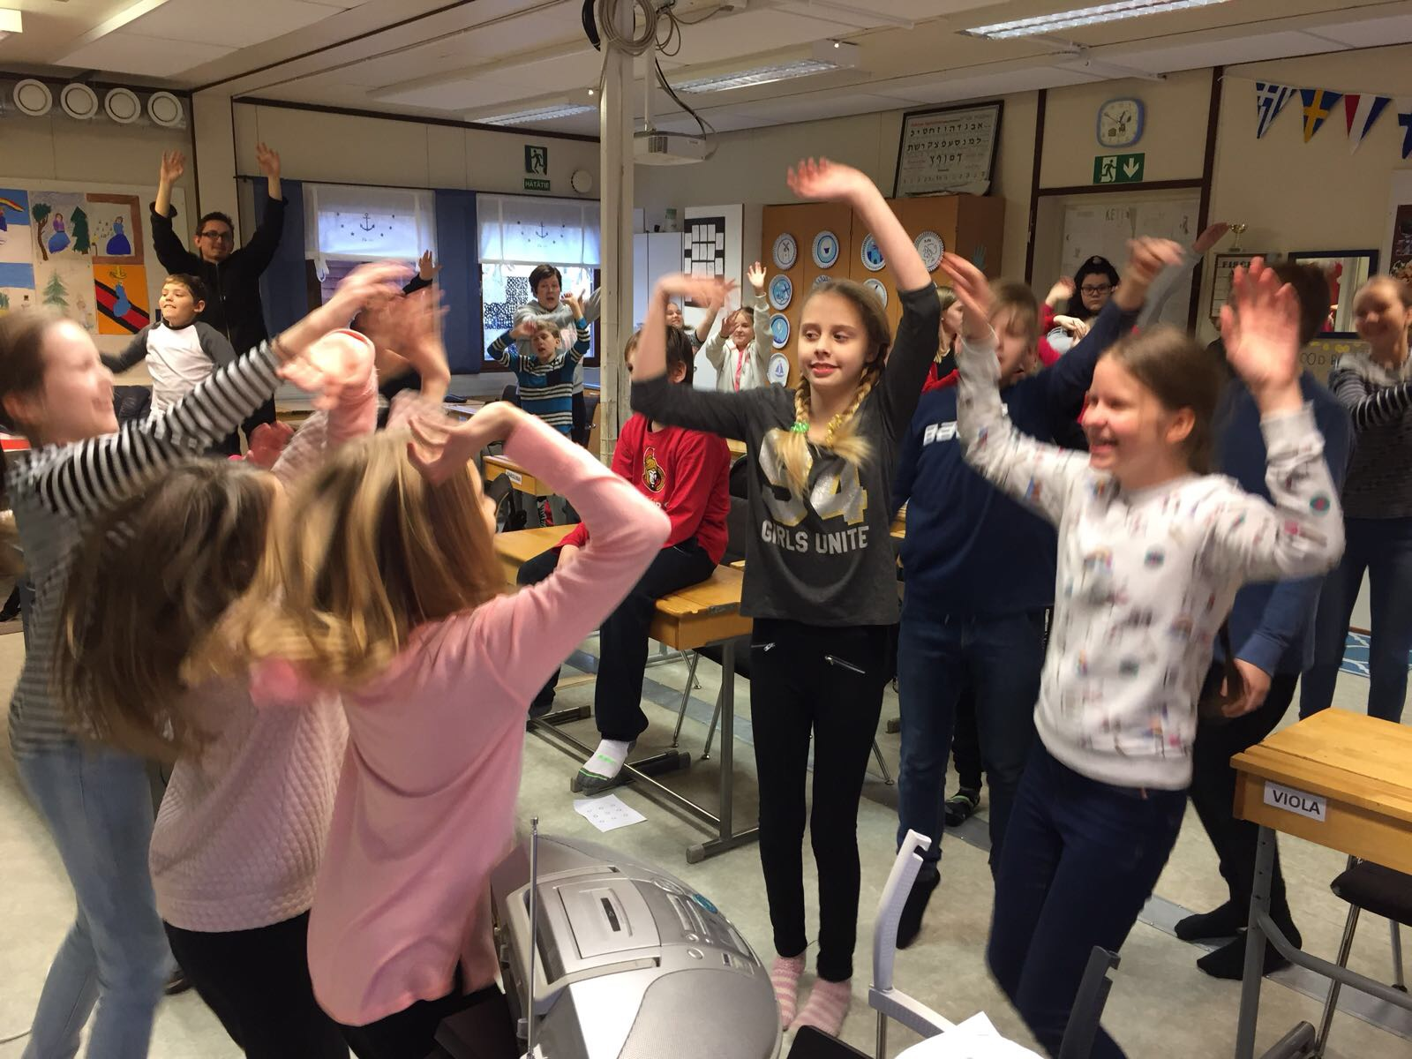

5 Good reasons to start moving

1. It gives you good mood.
2. If you have problems in your life at the moment, you can escape them for a while.
3. You get better oxygen intake.
4. Exercise helps you protect against various diseases.
5. Your muscles will grow bigger.

Salomon the 9th grade

