Our three years are encouraged to be outside as much as possible learning to take risks and have fun
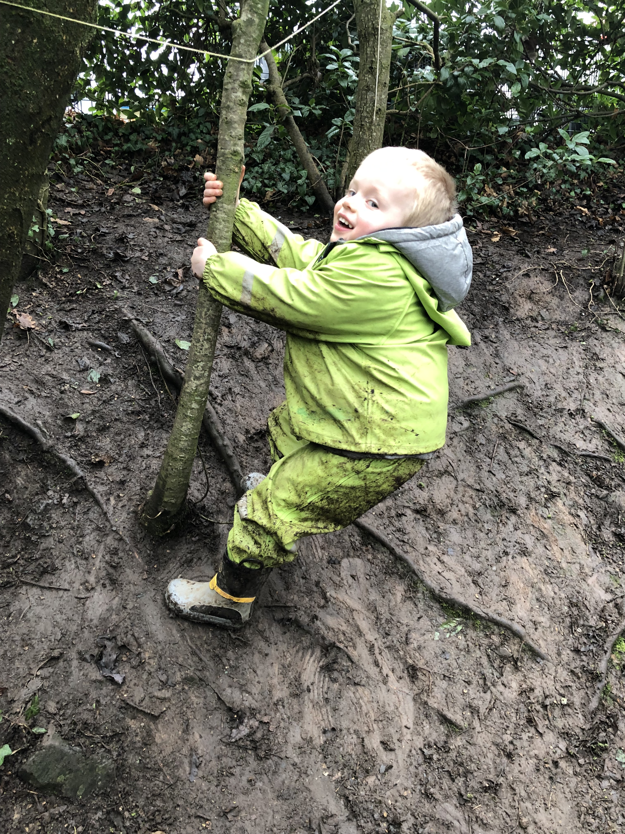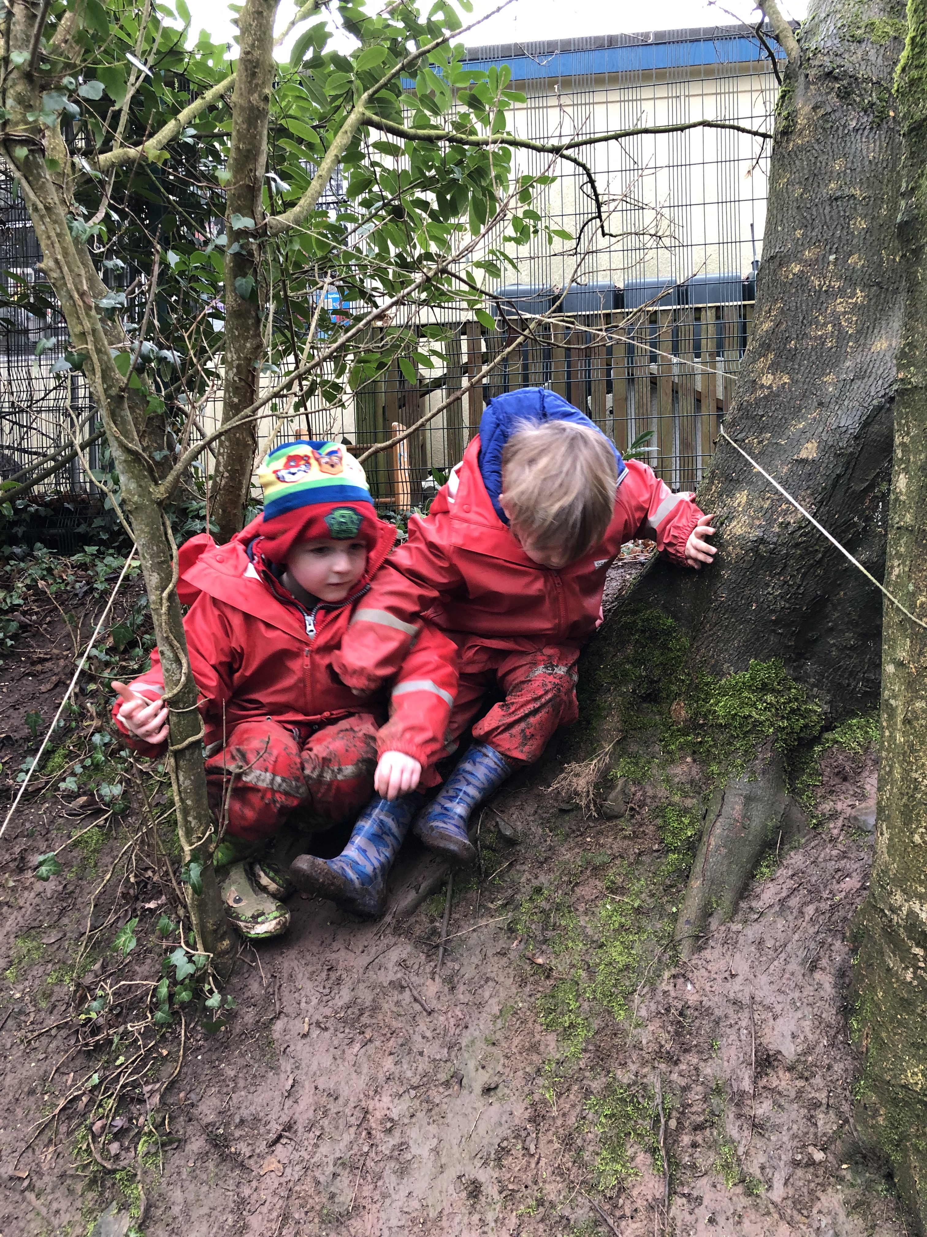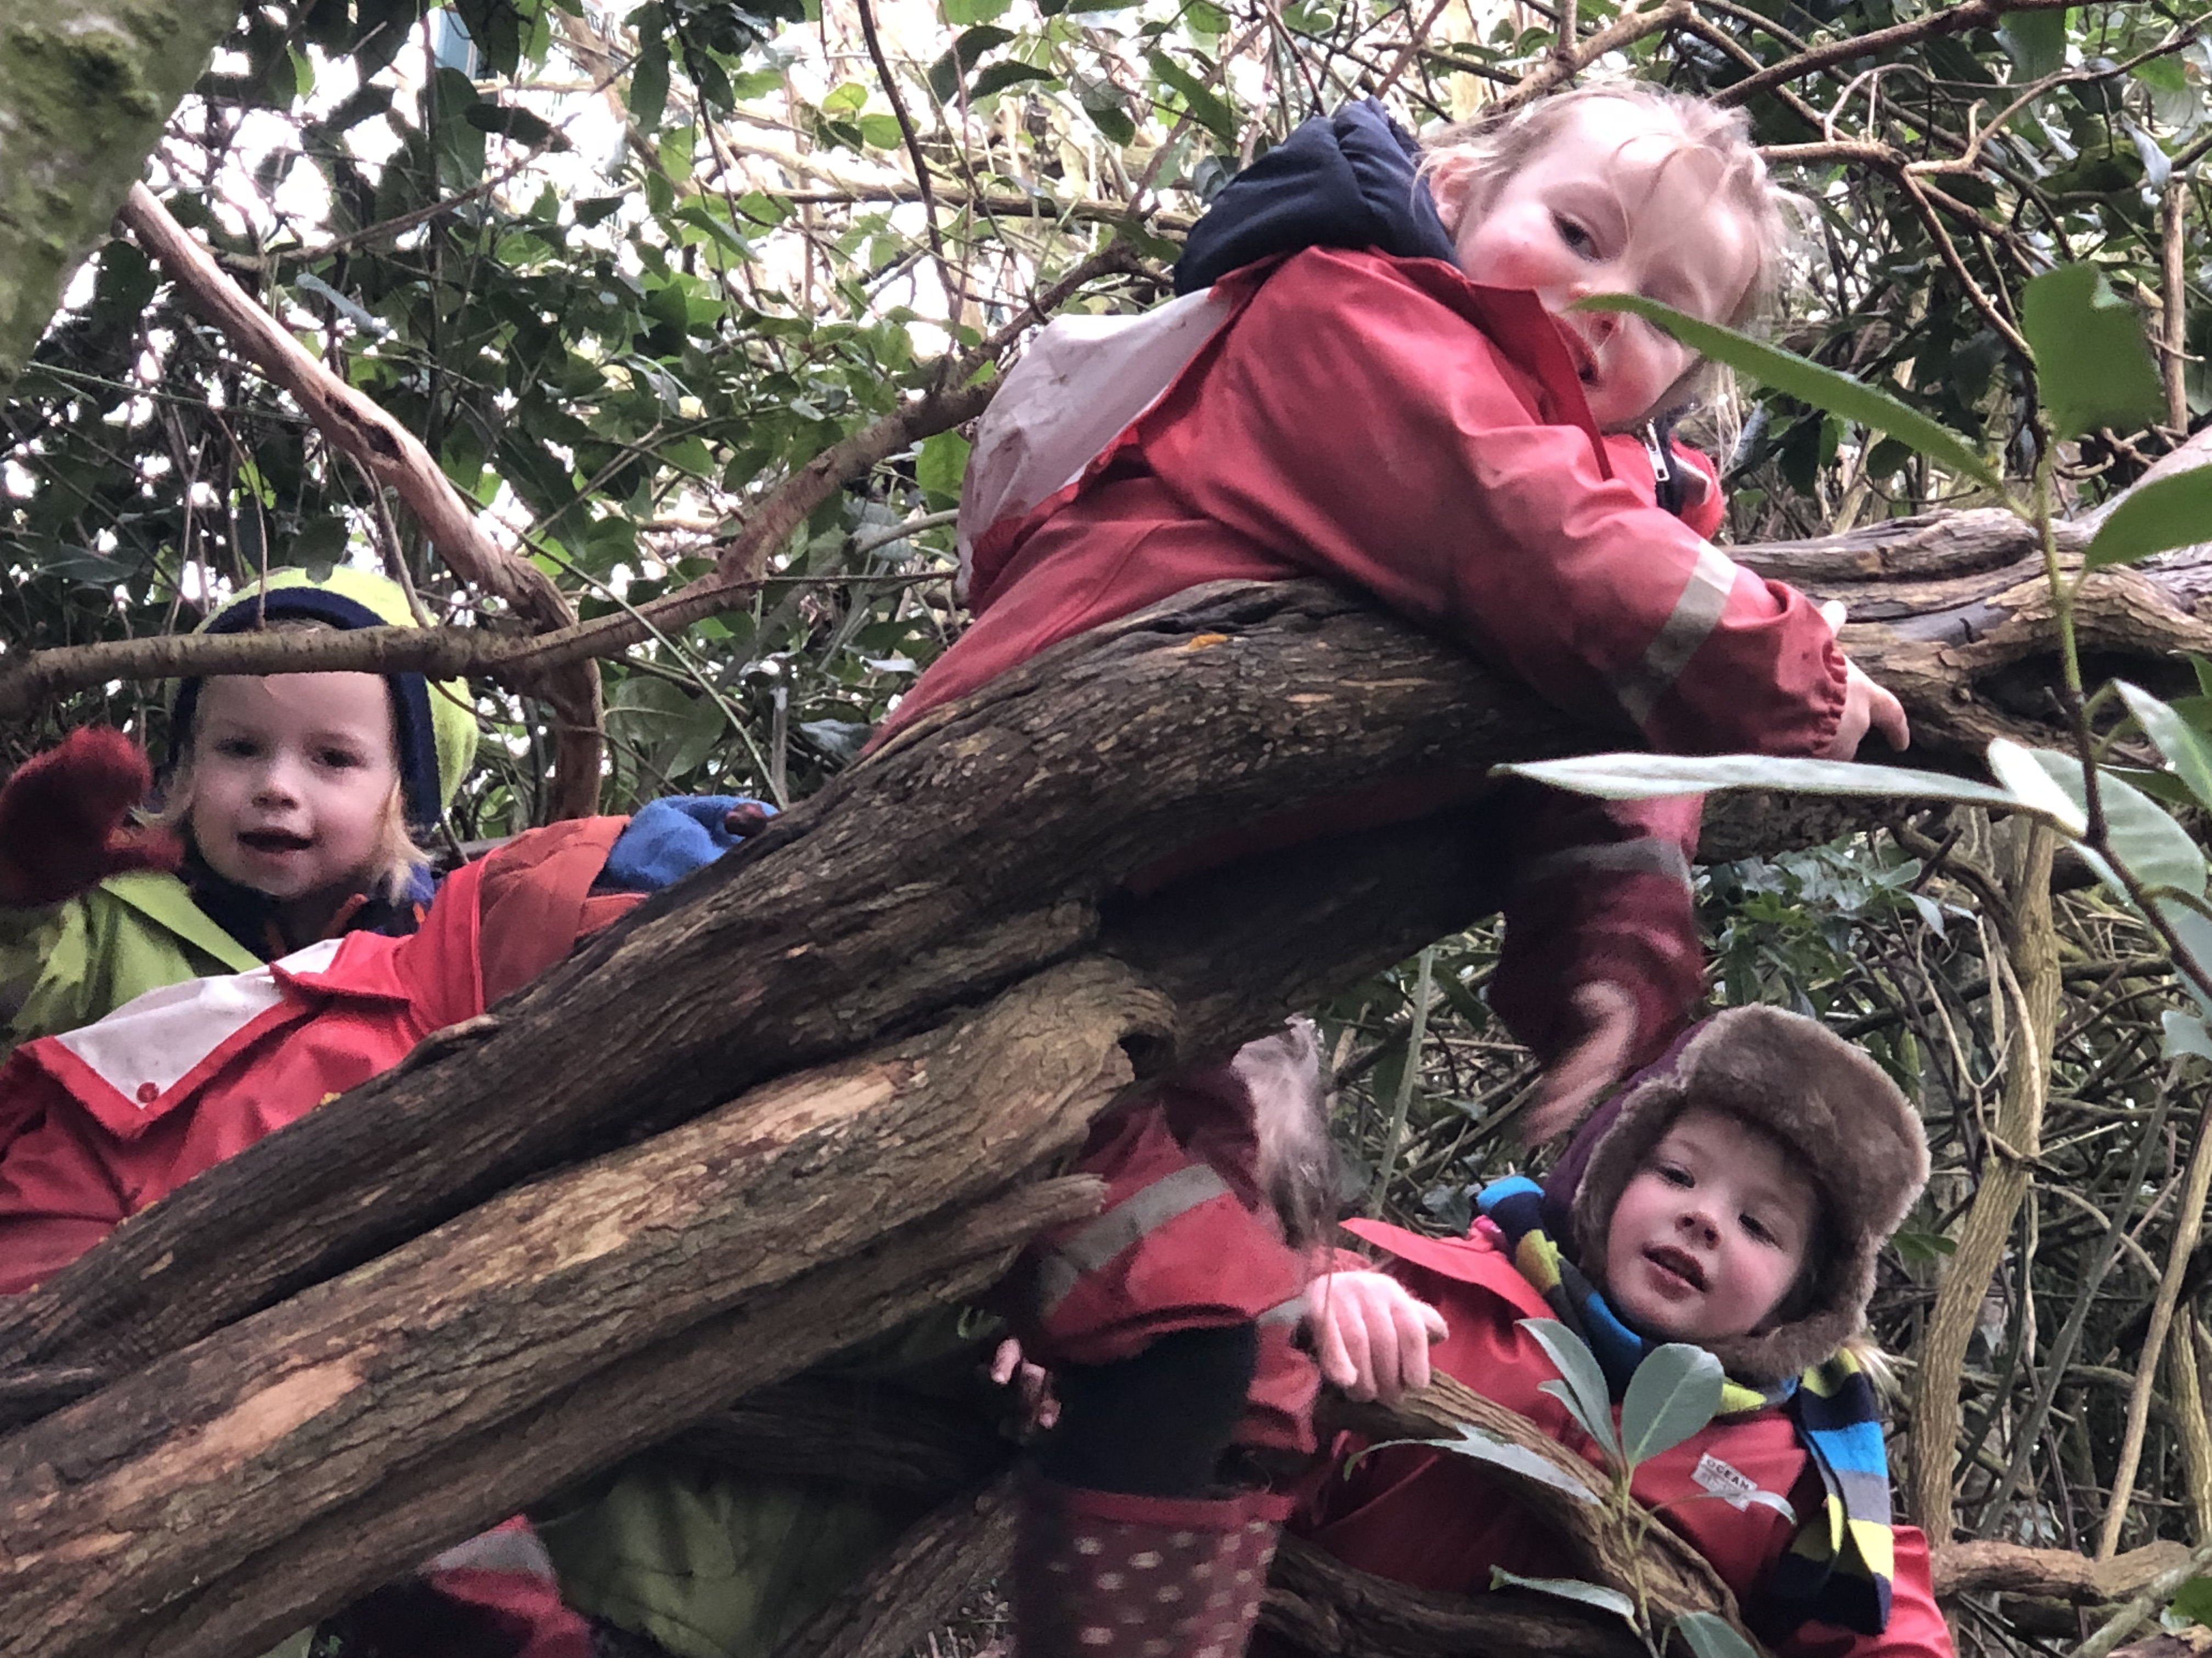
Every year P 6 go on a residential to an outdoor pursuits Center to do lots of activities.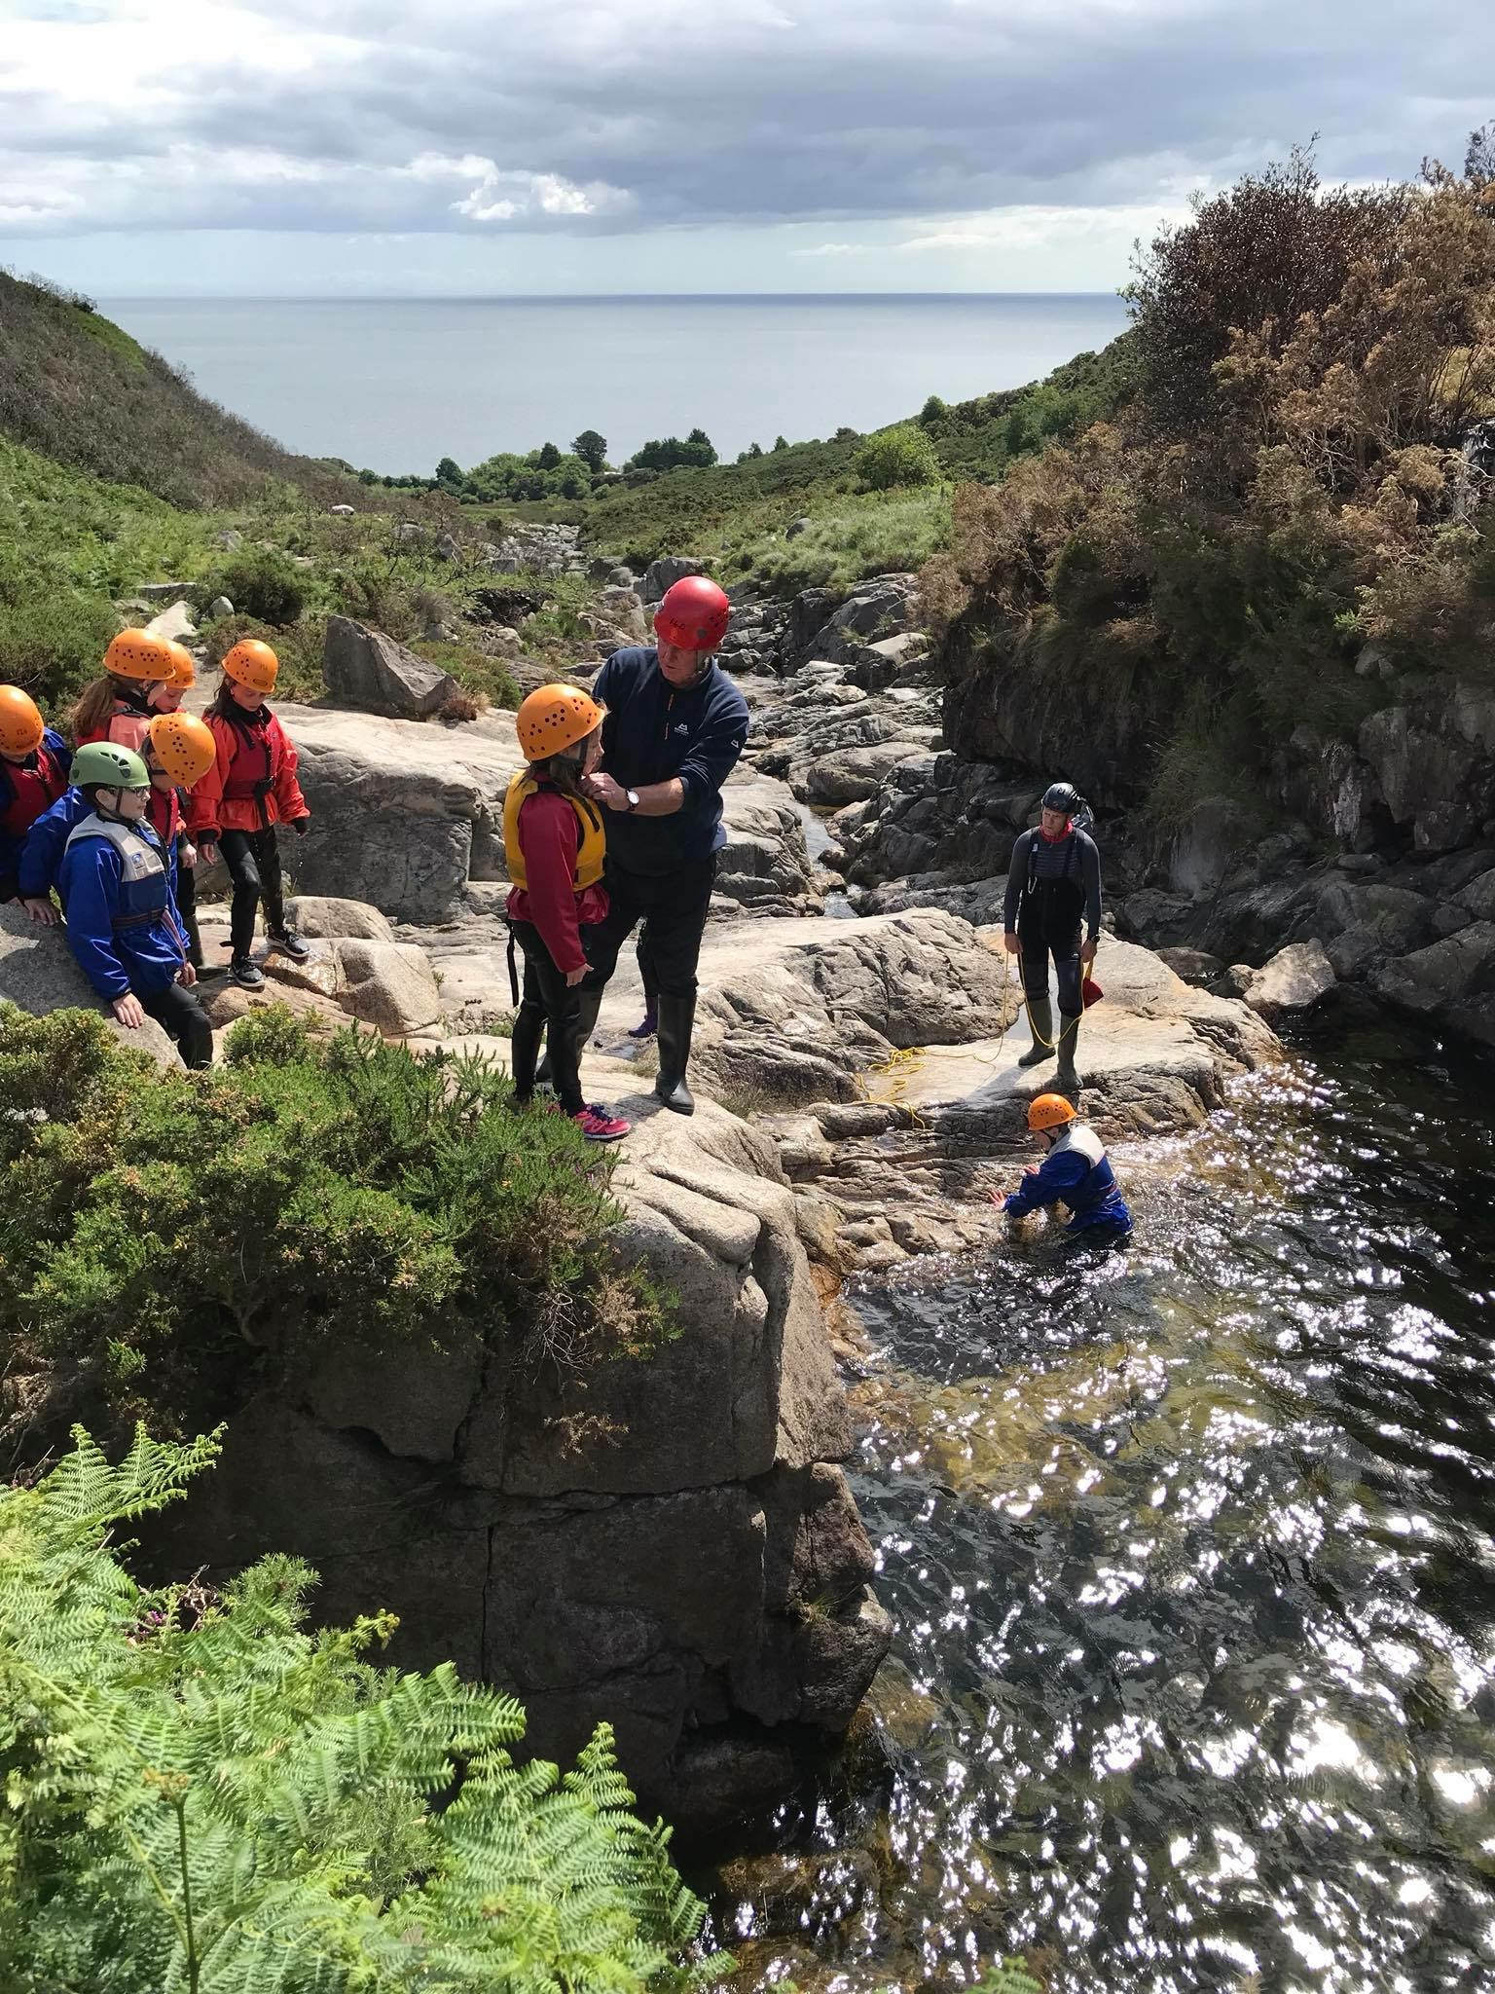 outdoor activities. .

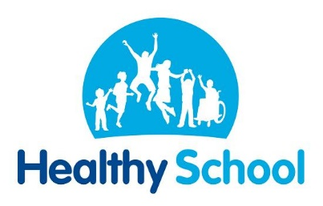
- P5-P7 children work with a group called Healthy Kidz to help improve all children’s health and well-being through a structured course of Physical Literacy. Healthy Kidz use a combination of technology-enabled learning tools and a programme of coach assisted physical literacy classes.
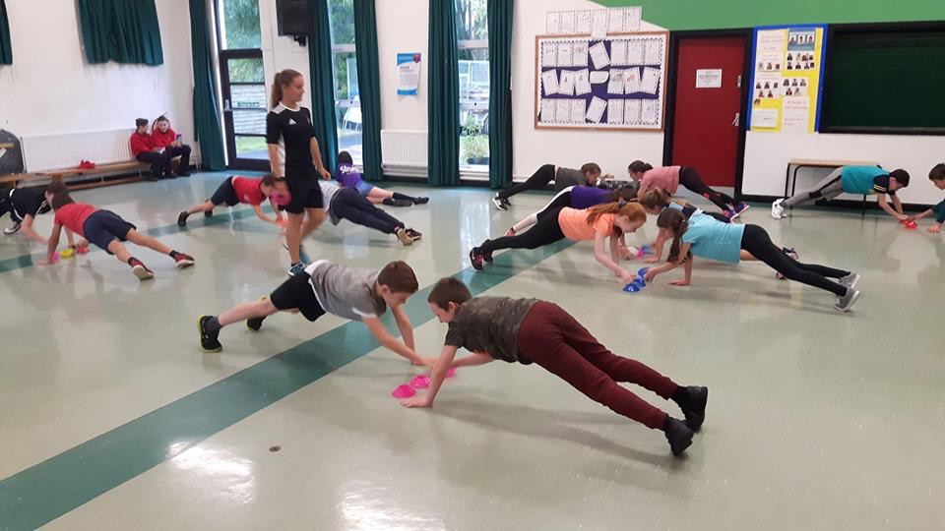
What Are the Outcomes?
- Kids become aware of why they should keep healthy and how.
- The school gets professional coach lead education programmes designed specifically for Key Stage 2 children.
- The Parent and child get to participate in fun activities and receive rewards for positive behaviours.
- 