On Friday 7.4.
Today we visited in the city of La Tremblade. It is a little town near Royan and popular place among tourists. All the Finnish, French and Italian students and our teachers travelled to La Tremblade by bus.
In the city we went first to aquarium. There were really much different fishes, jellyfishes, water plants and even sharks. We ate our packed lunches in the outside, sitting on the grass. After that we walked around the city and looked at shops and city which was really beautiful- I´m not surprised that tourists like that place. We got to know a ship named L´Hermione too. There we had an excellent guidance and we got lot of information about that ship. After visiting in the ship we all came back to Royan and our school. The weather was really good all day. The sun was shining and it was as warm as in Finland in summer.
In the evening there were made a farewell party at school by French people because it was Finnish and Italian peoples last evening in Royan. In the party was delicious French food and some pastries. We danced much and used Italian, Finnish and French music too. The party was very good and nice event. I think that it was a funny way to decide our trip. After party some of us went to the beach for a little time but because the time was so much we all came back to our host families homes quite soon. At this day some of us also bought from a market the cheapest strawberries I´ve ever seen.
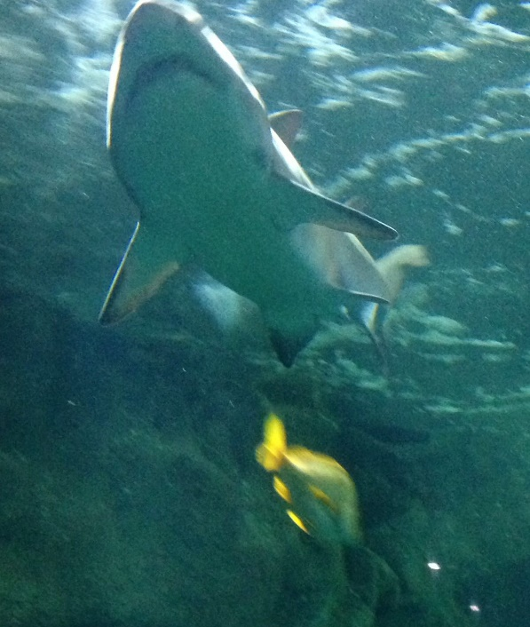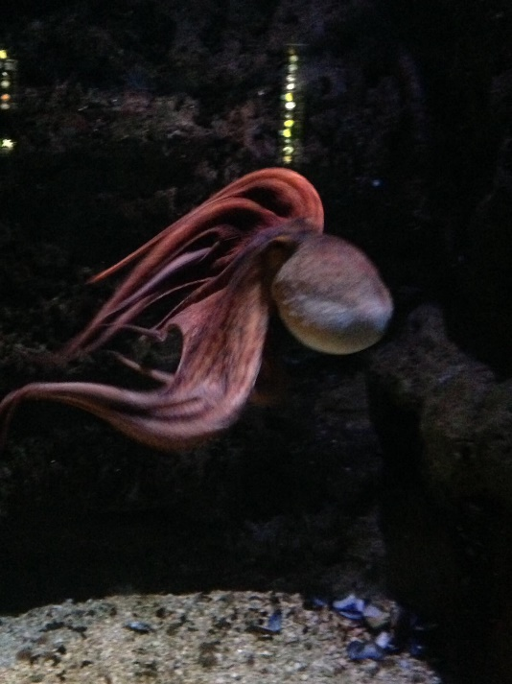
Some interesting animals in aquarium
[Sijoita lähde tähän.]
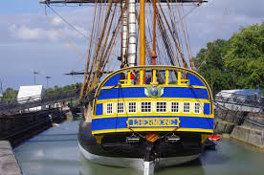
Some interesting animals in aquarium

Picture of La Tremblade and L’Hermione ship where we visited

